Advanced Database

Technology

Final Project Report



Student Name: David Martin

Student Number: A00128473

MSc. Software Engineering

Contents

1. Project Introduction 4

1.1. Project Proposal 4

1.2. Architectural Overview of Proposed Solution 5

1.2.1. Initial Draft Architecture Diagram 5

1.2.2. Initial Draft of Tables and Data fields 6

1.2.3. Initial Draft of Tables and Data Fields in Tabular Form 14

1.2.4. Customer Concerns Regarding Database Functionality 15

2. Logical Design 16

2.1. Normalisation 16

2.2. Entity Relationship Diagram 24

2.3. Final Design 26

3. Physical Design 27

3.1. Cardinality & Relationships 27

3.2. Table Indexing 28

3.3. SQL Schema 29

3.4. Inserts 30

4. Table Triggers 33

4.1. Before /After Insert Triggers 34

4.2. Before /After Update Triggers 71

4.3. Before /After Delete Triggers 115

5. Procedures and Functions 123

5.1. Procedures 123

5.2. Functions 134

6. User Base 137

6.1. Define Users and their Permissions 137

6.2. Customer Privileges 137

6.3. Company Employee Privileges 138

6.4. Administrator Privileges 139

6.5. Creating Customer Account Privileges 140

6.6. Creating Employee Account Privileges 146

6.7. Creating Administrator Account Privileges 158

7. Front End Technology 170

8. Initial Rollout 171

8.1. Issues Experienced with MSAccess Front End and the MySQL Database 177

9. Sign Off 180

9.1. Database User Manual 180

# Project Introduction

## Project Proposal

I propose to design a database system for a computer manufacturing firm who allows its customers to configure and build with various different components, custom computers based upon their business/personal needs.

For example, a customer who is a gaming enthusiast will be able to build and configure a custom pc based upon a range of high performance components such as Video Cards, CPU’s & Motherboards which would suitable to his/her gaming needs.

The main function of the database is to store all order information in relation to each custom pc requested by its customers and also act as an inventory management system for the business as a whole.

I shall start the planning for this project from an early draft of the design concept and then apply techniques such as normalisation and entity relation diagrams to the data in order to find the most optimum and suitable way to break this data into tables. From there, I shall build the SQL Schema and begin implementing triggers, procedures and functions in order to enable to database to process and store the data as required. Each of which will be tested to ensure that they perform as expected and desired.

A user base shall also be established, with each role given individual rights and privileges to the database. The final stage of this project is to build a front end for the database using the Microsoft Access application. The purpose of this project is to document the development of the initial database concept to a fully functional application capable of performing all functions as required for its business context.

## Architectural Overview of Proposed Solution

## Initial Draft Architecture Diagram

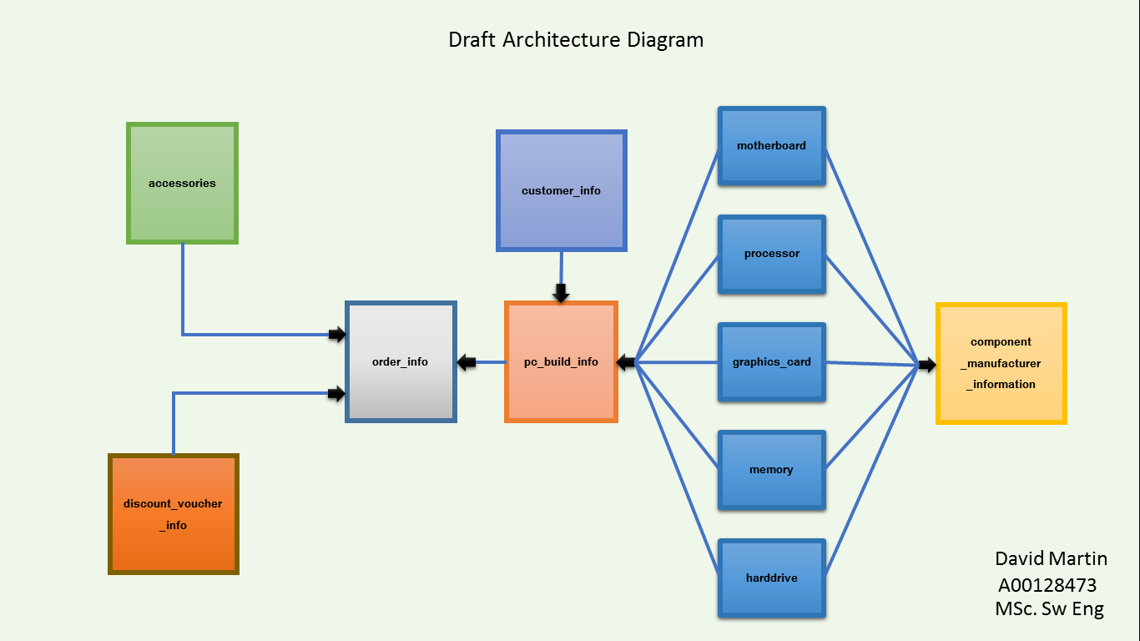

## Initial Draft of Tables and Data fields

Through discussion with the customer we have identified the following table entities will be required. The relevance and purpose of each table is stated below along with their related data fields:

**Table Name:** **Order Info**

**Description**:

The Order table will record all details of a Purchase Request received from a customer order. This table will include fields such as the date on which the purchase order was made and Total Price, including any discounts of the order.

**Data Fields:**

* order_id
  + The Unique Identification Number of the Purchase Order.
* build_id
  + The Unique Identification Number of the Custom PC Build of which the customer has personally configured from the list of components available.

* accessories_id
  + The Unique Identification Number of a computer accessory such as headphones or speakers, of which the customer has added to the Purchase Order.
* discount_voucher_id
  + The Unique Identification Number of a customer discount voucher. Individual vouchers will be created and given to customers to encourage customer loyalty and/or during sale promotions.
* total_price
  + The total price of the Purchase Order in question. This price will include all accessories added and any discount vouchers applied.
* order_date
  + The date of which the Purchase Order record was created.

**Table Name:** **Customer**

**Description**:

The Customer table will record all details of the companies Clients. This table will include fields such the customer’s name, address and other relevant information.

**Data Fields:**

* customer_id
  + The Unique Identification Number of the Customer.
* fname
  + The First name of the Customer
* surname
  + The Surname of the Customer
* address
  + The house number and street address of the Customer.
* town
  + The Customers town of residency.
* city
  + The Customers city of residency.
* Country
  + The Customers city of residency.
* Phone
  + The Customers contact number.
* Email
  + The Customers contact number.

**Table Name:** **Discount Voucher**

**Description**:

The Discount Voucher table will record in relation to the uniquely generated client discount vouchers.

**Data Fields:**

* voucher_id
  + The Unique Identification Number of the Discount Voucher.
* discount(%)
  + The percentage discount of the voucher.
* valid_from
  + The date from which the discount voucher is valid from.
* valid_to
  + The date from which the discount voucher is valid to.

**Table Name:** **Accessories**

**Description**:

The Accessories table will record all information regarding all additional computer related accessories of which the company currently offer to their clients.

**Data Fields:**

* accessory_id
  + The Unique Identification Number of the Accessory.
* description
  + A brief description of the accessory.
* quantity
  + The current in-stock quantity of the accessory in question.
* price
  + The price of the accessory.

**Table Name:** **PC Build Information**

**Description**:

The PC Build Information table will record all of the pc components in which the customer has chosen to be included in their pc build. A customer shall be allowed to save multiple individual pc build configurations while deciding the final configuration of their personal computer.

**Data Fields:**

* build_id
  + The Unique Identification Number of the PC Build.
* customer_id
  + The Unique Identification Number of the Customer who configured the build in question.
* motherboard_id
  + The Unique Identification Number of the Motherboard which will be included in the build.
* processor_id
  + The Unique Identification Number of the Processor which will be included in the build.
* graphics_card_id
  + The Unique Identification Number of the Graphics Card which will be included in the build.
* memory_id
  + The Unique Identification Number of the Memory (ram) which will be included in the build.
* harddrive_id
  + The Unique Identification Number of the Hard Drive of which will be included in the build.

**Table Name:** **Motherboard**

**Description**:

The Motherboard table will record all information in relation to the different types of Motherboard’s which are currently offered as a configuration option for a customer’s pc build.

**Data Fields:**

* motherboard_id
  + The Unique Identification Number of the Motherboard.
* manufacturer_id
  + The Unique Identification Number of the Component Manufacturer.
* description
  + A brief description of the Motherboard.
* price
  + The price of the Motherboard.

**Table Name:** **Processor**

**Description**:

The Processor table will record all information in relation to the different types of CPU’s which are currently offered as a configuration option for a customer’s pc build.

**Data Fields:**

* processor_id
  + The Unique Identification Number of the Processor.
* manufacturer_id
  + The Unique Identification Number of the Component Manufacturer.
* description
  + A brief description of the Processor.
* price
  + The price of the Processor.

**Table Name:** **Graphics Card**

**Description**:

The Graphics Card table will record all information in relation to the different types of Video Cards which are currently offered as a configuration option for a customer’s pc build.

**Data Fields:**

* graphics_card_id
  + The Unique Identification Number of the Graphics Card.
* manufacturer_id
  + The Unique Identification Number of the Component Manufacturer.
* description
  + A brief description of the Graphics Card.
* price
  + The price of the Graphics Card.

**Table Name:** **Memory**

**Description**:

The Memory table will record all information in relation to the different types of RAM which are currently offered as a configuration option for a customer’s pc build.

**Data Fields:**

* memory_id
  + The Unique Identification Number of the Memory.
* manufacturer_id
  + The Unique Identification Number of the Component Manufacturer.
* description
  + A brief description of the Memory.
* price
  + The price of the Memory.

**Table Name:** **Hard Drive**

**Description**:

The Hard Drive table will record all information in relation to the different types of internal storage which are currently offered as a configuration option for a customer’s pc build.

**Data Fields:**

* Harddrive_id
  + The Unique Identification Number of the Hard drive.
* manufacturer_id
  + The Unique Identification Number of the Component Manufacturer.
* description
  + A brief description of the Hard drive.
* price
  + The price of the Hard drive.

**Table Name:** **Component Manufacturer**

**Description**:

The Component Manufacturer table will record all Manufacturer details of the components offered for pc configuration. This table will include fields such the manufacturer’s name, address and other relevant information.

**Data Fields:**

* manufacturer_id
  + The Unique Identification Number of the Manufacturer.
* company_name
  + The Company Name of the Manufacturer.
* Address
  + The number and street address of the Manufacturer.
* Town
  + The town of the Manufacturer.
* City
  + The city of the Manufacturer.
* Country
  + The country of the Manufacturer.
* Phone
  + The Manufacturer’s contact number.

## Initial Draft of Tables and Data Fields in Tabular Form

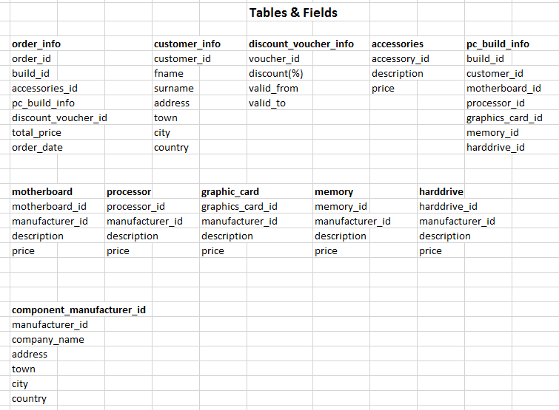

## Customer Concerns Regarding Database Functionality

The Customer has stated the following in relation to the Business Functionality of which the Database we are construction will have to adhere to:

* A Client must be allowed to order multiple Accessories with any one order.
* A Client must be allowed to order multiple Components with any one order.
* A Client may have multiple orders placed at any one time.
* All Orders made must reduce the level of stock for each component/accessory to reflect the stock levels after the purchase has been ordered.
* The Payment Method for each customer must be determined based upon the price of an individual order as follows:
  + All orders under 800 euros will have a ‘Cash on Delivery’ Payment Method.
  + All orders over 800 but under 1500 euros will have a ‘Credit Card’ Payment Method.
  + All orders over 1500 euros will have a ‘PayPal’ Payment Method.
* Once an Order has been placed, it is a regular occurrence that the customer will get in contact with the company via phone to update/change the order. The database must be capable to efficiently deal with adding/updating and removing components and accessories from an order when required. Once the said order has been changed, all dynamically calculated fields such as the total price of the order and the quantity in stock of a component or accessory must be updated to reflect these changes.
* The Customer also has provided us with details in relation to the format they wish for certain data fields. Please refer to the ‘Before insert’ trigger for an implementation of these wishes.

# Logical Design

We will now gather all information and data available and begin the logical design of the database. In this chapter I will demonstrate two techniques which are used in the design process of a database data structure. At the end of each method I will summarise the results and then make a decision as to which method I will choose to base the design on the database on and why.

## Normalisation

**Database Normalisation**

Database Normalisation is a technique of organizing the data in the database. Normalization is a systematic approach of decomposing tables to eliminate data redundancy and undesirable characteristics like Insertion, Update and Deletion Anomalies. It is a multi-step process that puts data into tabular form by removing duplicated data from the relation tables.

Normalization is used for mainly two purpose:

* Eliminating redundant (useless) data.
* Ensuring data dependencies make sense i.e. data is logically stored.

Without Normalisation, it becomes difficult to handle and update the database without facing data loss. Insertion, Updating and Deletion anomalies are a very frequent occurrence if a Database is not normalized.

Normalization rules are divided into forms known as “normal forms”. A Normal Form represents the current “state” of the data model.

For example:

* Zero Normal Form (0NF)
* First Normal Form (1NF)
* Second Normal Form (2NF)
* Third Normal Form (3NF)

Although there are more forms beyond third normal form, for the purposes of demonstration, I shall only normalise to the third normal form.

**Zero Normal Form (0NF)**

Zero normal form (0NF) is simply a set of data that has not gone through the process of normalisation. Zero normal form is the classic spreadsheet layout for a database table. All data is inserted into one row in preparation for the normalisation process.

The below diagram depicts a single column in which all data fields that are required for the database are contained. For ease of readability I have separated the fields into two columns.

|  |  |  |  |
| --- | --- | --- | --- |
| order_id |  | processor_id | |
| build_id |  | manufacturer_id | |
| accessories_id | | description | |
| discount_voucher_id | | price |  |
| total_price | | quantity |  |
| order_date | | graphics_card_id | |
| customer_id | | manufacturer_id | |
| fname |  | description | |
| surname |  | price |  |
| address |  | quantity |  |
| town |  | memory_id | |
| city |  | manufacturer_id | |
| country |  | description | |
| voucher_id | | price |  |
| discount(%) | | quantity |  |
| valid_from | | harddrive_id | |
| valid_to |  | manufacturer_id | |
| description | | description | |
| price |  | price |  |
| quantity |  | quantity |  |
| motherboard_id | | manufacturer_id | |
| manufacturer_id | | company_name | |
| description | | address |  |
| price |  | town |  |
| quantity |  | city |  |
|  |  | country |  |
|  |  | phone |  |

We are now ready to perform First Normal Form on this data.

**First Normal Form (1NF)**

**Definition:**

All non-key attributes must be FD on the PK. (There must be PKFD for all attributes.)

**Rules:**

* No repeating groups.
* All values are atomic.
* Uniquely named fields
* Primary Key.

**How to Apply the Rule:**

* Place repeating group into a new table
* Copy the PK (or part of it) from the original table into the new table. This will be a FK in the new table.
* Assign a PK to the new table (typically a composite key of the original and the FK.)

The Primary key is usually a single column, but sometimes more than one column can be combined to create a single primary key. When a Primary Key consists or more than one column, it is called a “**composite key**” and both of these columns will be combined to uniquely identify a record.

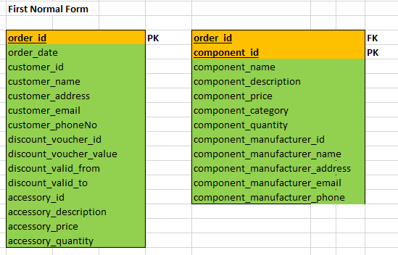

In Step 1, as shown in the above diagram, I have given all fields a unique name and also determined that the “order id” field can be identified as the Primary Key.

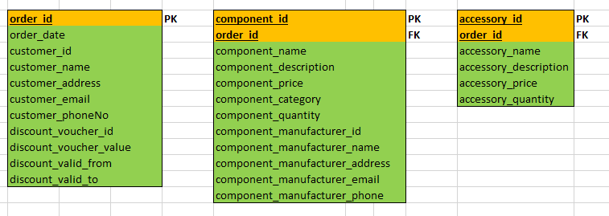

In Step two, I have identified that an Order is made up of a product that consists of numerous components, e.g.: hard drive, memory etc., therefore this data could be viewed as a repeating group

With this approach in mind, I will create a "components" table to store this information about these components.

|  |  |  |  |  |  |  |  |
| --- | --- | --- | --- | --- | --- | --- | --- |
| **Step 2. cont... Component Table Created** | | | |  |  |  |  |
|  |  |  |  |  |  |  |  |
| **order_id** |  |  | **PK** | **order_id** |  |  | **FK** |
| order_total_price | |  |  | **component_id** | |  | **PK** |
| order_date | |  |  | component_description | | |  |
| customer_id | |  |  | component_price | |  |  |
| customer_name | |  |  | component_manufacturer_id | | |  |
| customer_address | |  |  | component_manufacturer_name | | |  |
| discount_voucher_id | | |  | component_manufacturer_address | | |  |
| discount_voucher_value | | |  |  |  |  |  |
| discount_valid_from | | |  |  |  |  |  |
| discount_valid_to | |  |  |  |  |  |  |
| accessory_id | |  |  |  |  |  |  |
| accessory_description | | |  |  |  |  |  |
| accessory_price | |  |  |  |  |  |  |

In Step two, as outlined above I have identified that all data in relation to accessories can be viewed as a repeating group as one order may contain multiple accessories. As per the rules of First form, I shall remove this data to its own table and assign the primary key as a composite key consisting of the “order_id” field and the “accessory_id” field.

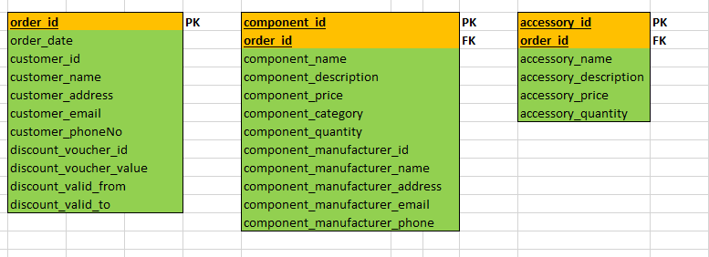

I am now satisfied that the data is in First Normal Form.

**Second Normal Form (2NF)**

**Definition:**

The data model must be in First Normal Form and No partial functional dependencies can exist.

**Rules:**

Move each partially FD non-key column into its own new table.

**How to Apply the Rule:**

* For each partial dependency:
* Move all partially FD columns into a new table
* Copy the determinant into the new table.
* Make the determinant of the partial dependency:
* The PK for the new table, FK to the existing table.

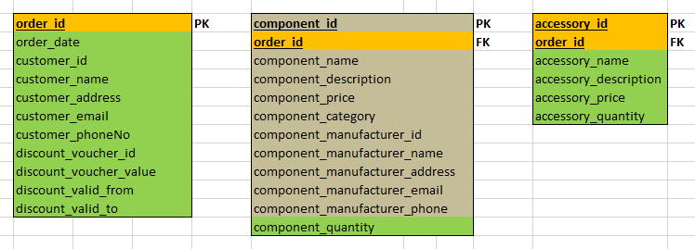

In Step 1 of Second Normal Form I have identified that all information in relation to a component can be identified by the “component_id” field which demonstrates a partial dependency. I will address this by moving all of the component related data into a new table as shown below.

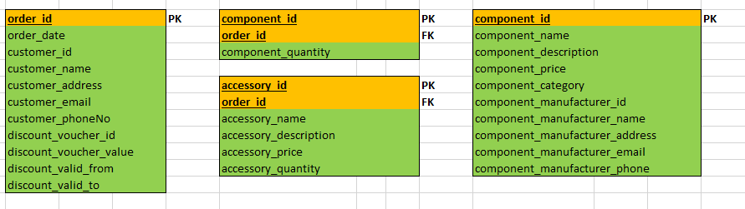

I have also identified that all information in relation to a accessories can be identified by the “accessory_id” field which demonstrates a partial dependency

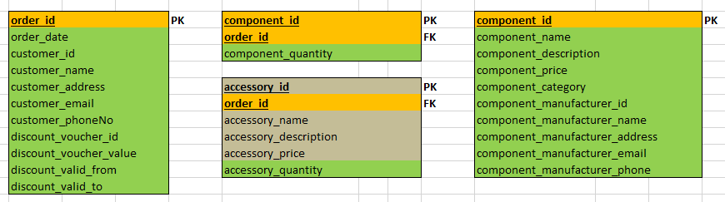

. I will address this by moving all of the accessory related data into a new table as shown below.

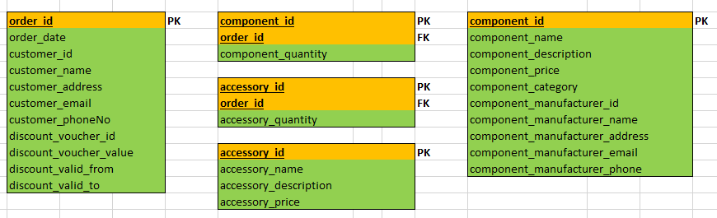

I am now satisfied that the data is in Second Normal Form.

**Third Normal Form (3NF)**

**Definition:**

The data model must be in Second Normal Form and No transitive functional dependencies can exist.

**Rule:**

Move each transitive FD non-key column into its own new table.

**How to Apply the Rule:**

* For each transitive dependency:
* Move all transitive FD columns into a new table.
* Copy the determinant column into the new table.
* Make the determinant of the transitive dependency:
* The PK for the new table.
* The FK for the original table.

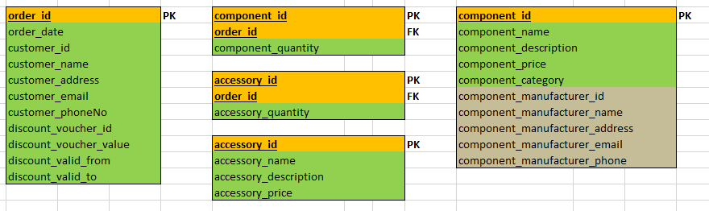

As shown above, I have identified that all data in relation to the component manufacturer has a transitive dependency on the “component_manufacturer_id”. I will therefore apply the rules of Third Normal form to the related fields.

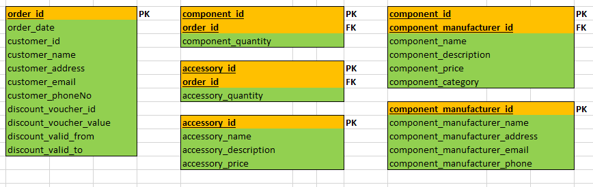

I then identified that all data in relation to discount vouchers has a transitive dependency on the “discount_voucher_id”. I will therefore apply the rules of Third Normal form to the related fields.

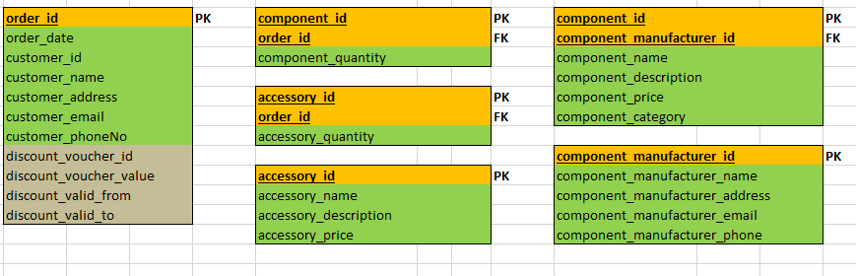

I then identified that all data in relation to customers has a transitive dependency on the “Customer_ID”. I will therefore apply the rules of Third Normal form to the related fields.

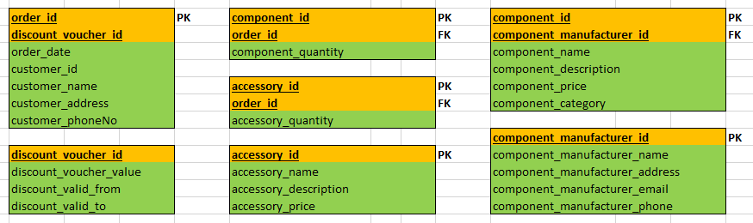

I am now satisfied that the data is in Third Normal Form.

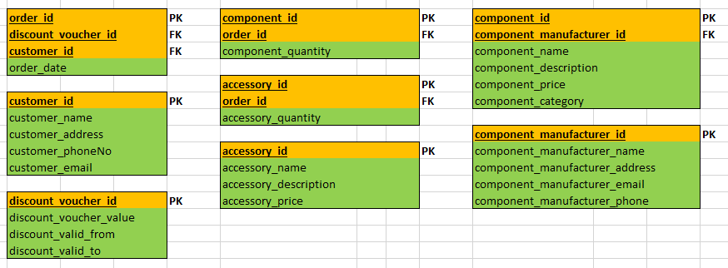

## Entity Relationship Diagram

**ERD Description**

The company stores information about its customers, orders, components, component suppliers, discount vouchers and accessories. The company records the following information about its customers: Customer ID number, name, address, email, phone number.

* The company stores the following information about discount vouchers: Discount voucher ID number, the valid from date, the valid to date and the discount value.
* The company stores the following information regarding components: the component ID number, name, description, category, quantity in stock and price.
* The company stores the following information regarding suppliers: The supplier’s identification number, name, address, email, phone number.
* The company stores the following information regarding accessories: The ID number, name, description, quantity, category and price.
* The company stores the following information regarding orders: Order ID, date.
* Many Customers may create many orders.
* An order contains one discount voucher.
* Many orders contain many accessories.
* Many orders contain many components.
* Many component suppliers supply many components.

**ERD Diagram**

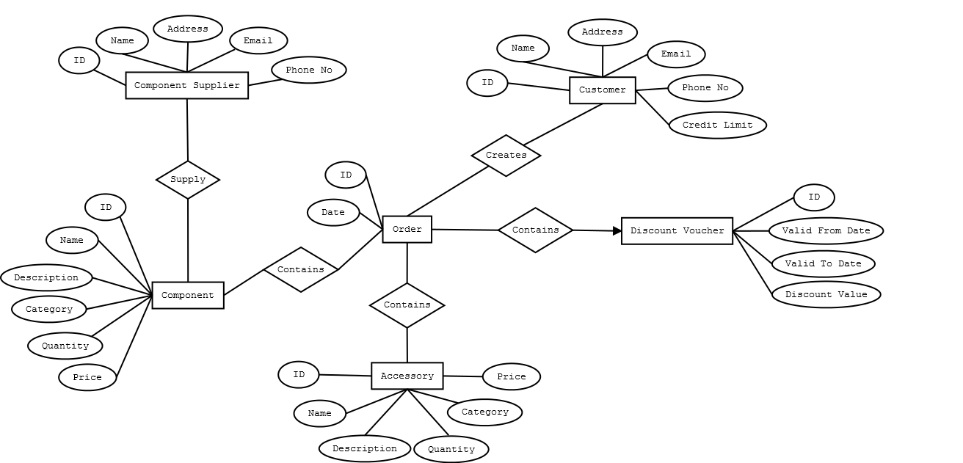

## Final Design

After taking both the normalisation and ERD process into consideration, the below diagram depicts the final design I have chosen to implement on this project.

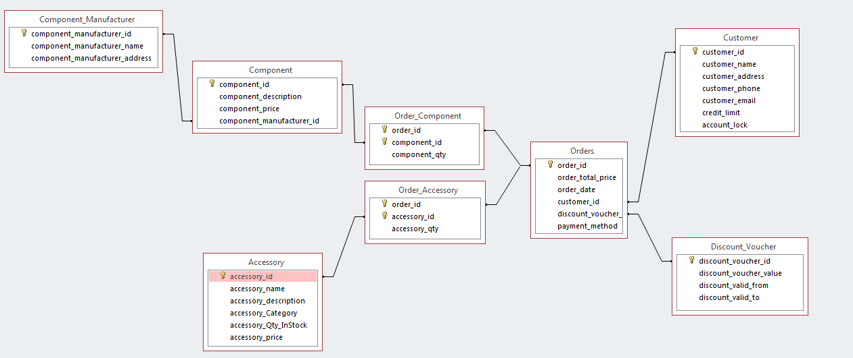

# Physical Design

## Cardinality & Relationships

A record residing on the orders table will be uniquely identified by the Order_ID field.

The orders table will have a many to many relationship with the Order_Componant_Junction table. The orders table will have a many to many relationship with the Order_Accessory_Junction table.

The Orders_Component_Junction table will have two foreign key based on the following two fields with a before insert trigger used for referential integrity.

* Order_ID
* Component_ID

The Orders_Accessory_Junction table will have two foreign key based on the following two fields with a before insert trigger used for referential integrity.

* Order_ID
* Accessory_ID

A record residing on the Accessory table will be uniquely identified by the Accessory_ID field.

The Accessory table will have a one to many relationship with the Orders_Accessory_Junction table.

A record residing on the Component table will be uniquely identified by the Component_ID field. The Component table will have a one to many relationship with the Orders_Component_Junction table.

A record residing on the Component_Manufacturer table will be uniquely identified by the Component_Manufacturer_ID field. The Component_Manufacturer will have a one to many relationship with the Component table.

A record residing on the Customer table will be uniquely identified by the Customer_ID field. The Customer table will have a one to many relationship with the Orders table.

A record residing on the Discount_Voucher table will be uniquely identified by the Discount_Voucher_ID field. The Discount_Voucher table will have a one to many relationship with the Orders table.

**NB.** Both the Orders_Component_Junction and the Orders_Component_Junction table were initially setup to have composite keys based upon the Order_ID field and the Component_ID/Accessory_ID fields. I ran into problems trying to insert fresh data into each of these tables of which I communicated with my lecturerer. Through research, it was suggested that I remove the composite keys from these tables, only referencing these fields as foreign keys to their parent table and then use before insert triggers to enforce referential integrity. Using this method, seemed to solve this problem. Please see the before insert triggers for each of these tables for further details.

## Table Indexing

The following specifies the individual tables, and fields where indexing shall be applied.

**Table Name**: Component

**Indexed Fields**: Component_Name, Component_Description.

ALTER TABLE Component ADD INDEX Component_Index (Component_Name, Component_Description);

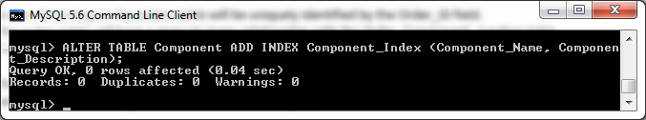

**Table Name**: Accessory

**Indexed Fields**: Accessory_Name, Accessory_Description.

ALTER TABLE Accessory ADD INDEX Accessory_Index (Accessory_Name, Accessory_Description);

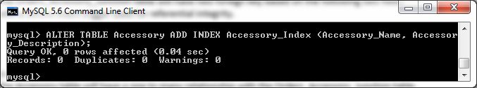

**Table Name**: Customer

**Indexed Fields**: Customer_Name, Customer_Address.

ALTER TABLE Customer ADD INDEX Customer_Index (Customer_Name, Customer_Address);

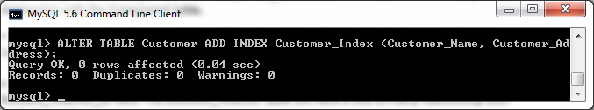

## SQL Schema

This section will show the SQL Schema for the database.

-- Component_Manufacturer table;

**create** **table** Component_Manufacturer **(**

Manu_ID **int** **NOT** **NULL** AUTO_INCREMENT**,**

Manu_Name **Varchar(**40**),**

Manu_Address **Varchar(**40**),**

Manu_Country **Varchar(**40**),**

Manu_Email **Varchar(**40**),**

Manu_Phone **Varchar(**10**),**

Web_Site **Varchar(**40**),**

**Constraint** Comp_Manu_ManuID_Pk **Primary** **Key** **(**Manu_ID**),**

**Constraint** manu_email_unique **UNIQUE** **(**Manu_Email**));**

-- Component table

**drop** **table** Component**;**

**create** **table** Component **(**

Component_ID **Varchar(**6**)** **NOT** **NULL** **UNIQUE,**

Comp_Manu_ID **int,**

Component_Name **Varchar(**30**),**

Component_Description **Varchar(**70**),**

Component_Category **Varchar(**20**),**

Component_Qty_InStock **int,**

Component_Price **decimal(**6**,**2**),**

**Constraint** Component_Manu_ID_Fk **Foreign** **Key(**Comp_Manu_ID**)** **References** Component_Manufacturer**(**Manu_ID**)** **ON** **DELETE** **CASCADE,**

**Constraint** Component_Component_ID_Pk **Primary** **Key** **(**Component_ID**));**

-- Accessory table

**drop** **table** Accessory**;**

**create** **table** Accessory **(**

Accessory_ID **Varchar(**6**)** **NOT** **NULL** **UNIQUE,**

Accessory_Name **Varchar(**40**),**

Accessory_Description **Varchar(**70**),**

Accessory_Category **Varchar(**40**),**

Accessory_Qty_InStock **int,**

Accessory_Price **decimal(**6**,**2**),**

**Constraint** Accessory_Accessory_ID_Pk **Primary** **Key** **(**Accessory_ID**));**

-- Discount_Voucher table

**drop** **table** Discount_Voucher**;**

**create** **table** Discount_Voucher **(**

Discount_Voucher_ID **Varchar(**6**)** **NOT** **NULL** **UNIQUE,**

Discount_Voucher_Value **decimal(**6**,**2**),**

Discount_Voucher_Valid_From **Varchar(**14**),**

Discount_Voucher_Valid_To **Varchar(**14**),**

**Constraint** Discount_V_ID_Pk **Primary** **Key** **(**Discount_Voucher_ID**));**

-- Customer table

**drop** **table** Customer**;**

**create** **table** Customer **(**

Customer_ID **int** **NOT** **NULL** AUTO_INCREMENT**,**

Customer_Name **Varchar(**40**),**

Customer_Address **Varchar(**30**),**

Customer_Phone **Varchar(**10**),**

Customer_Email **Varchar(**30**),**

Credit_Limit **decimal(**6**,**2**),**

Account_Lock **int,**

**Constraint** Customer_Customer_ID_Pk **Primary** **Key** **(**Customer_ID**));**

-- Orders table

**drop** **table** Orders**;**

**create** **table** Orders **(**

Order_ID **Varchar(**6**)** **NOT** **NULL** **UNIQUE,**

Discount_Voucher_ID **Varchar(**6**),**

Customer_ID **int** **NOT** **NULL** AUTO_INCREMENT**,**

Order_Date **Varchar(**20**),**

Payment_Method **Varchar(**20**),**

Total_Price **Decimal(**6**,**2**),**

**Primary** **Key** **(**Order_ID**),**

**Foreign** **Key(**Discount_Voucher_ID**)** **References** Discount_Voucher**(**Discount_Voucher_ID**)** **ON** **DELETE** **CASCADE,**

**Foreign** **Key(**Customer_ID**)** **References** Customer**(**Customer_ID**)** **ON** **DELETE** **CASCADE);**

-- Orders_Component_Junction table

**drop** **table** Orders_Component_Junction**;**

**create** **table** Orders_Component_Junction**(**

Component_ID **Varchar(**6**)** **NOT** **NULL,**

Order_ID **Varchar(**6**)** **NOT** **NULL,**

Component_Qty **int,**

**Foreign** **Key(**Component_ID**)** **References** Component**(**Component_ID**)** **ON** **DELETE** **CASCADE,**

**Foreign** **Key(**Order_ID**)** **References** Orders**(**Order_ID**)** **ON** **DELETE** **CASCADE);**

-- Orders_Accessory_Junction table

**drop** **table** Orders_Accessory_Junction**;**

**create** **table** Orders_Accessory_Junction**(**

Accessory_ID **Varchar(**6**)** **NOT** **NULL,**

Order_ID **Varchar(**6**)** **NOT** **NULL,**

Accessory_Qty **int,**

**Foreign** **Key(**Accessory_ID**)** **References** Accessory**(**Accessory_ID**)** **ON** **DELETE** **CASCADE,**

**Foreign** **Key(**Order_ID**)** **References** Orders**(**Order_ID**)** **ON** **DELETE** **CASCADE);**

## Inserts

The tables shall then be populated with data for testing. Extensive testing shall be performed on these inserts in the Triggers section.

**Insert** **into** Component_Manufacturer **values** **(**1**,**'Intel'**,**'City Center, Dublin'**,** 'Ireland'**,** 'supply@Intel.com'**,**'086123456'**,**'www.Intel.com'**);**

**Insert** **into** Component_Manufacturer **values** **(**2**,**'Western Digital'**,**'City Center, Galway'**,**'Ireland'**,**'supply@WesternD.com'**,**'086123456'**,**'www.WesternD.com'**);**

**Insert** **into** Component_Manufacturer **values** **(**3**,**'Seagate'**,**'City Center, Cork'**,**'Ireland'**,**'supply@Seagate.com'**,**'086123456'**,**'www.Seagate.com'**);**

**Insert** **into** Component_Manufacturer **values** **(**4**,**'NVidia'**,**'City Center, Limerk'**,**'Ireland'**,**'supply@NVidia.com'**,**'086123456'**,**'www.NVidia.com'**);**

**Insert** **into** Component_Manufacturer **values** **(**5**,**'AMD'**,**'City Center, Waterford'**,**'Ireland'**,**'supply@AMD.com'**,**'086123456'**,**'www.AMD.com'**);**

**Insert** **into** Component_Manufacturer **values** **(**6**,**'Corsair'**,**'City Center, Belfast'**,**'Ireland'**,**'supply@Corsair.com'**,**'086123456'**,**'www.Corsair.com'**);**

**Insert** **into** Component_Manufacturer **values** **(**7**,**'Kingston'**,**'City Center, London'**,**'United Kingdom'**,**'supply@Kingston.com'**,**'086123456'**,**'www.Kingston.com'**);**

**Insert** **into** Component_Manufacturer **values** **(**8**,**'Lenovo'**,**'City Center, Barcelona'**,**'Spain'**,**'supply@Lenovo.com'**,**'086123456'**,**'www.Lenovo.com'**);**

**Insert** **into** Component_Manufacturer **values** **(**9**,**'Toshiba'**,**'City Center, Dallas'**,**'United States'**,**'supply@Toshiba.com'**,**'086123456'**,**'www.Toshiba.com'**);**

**Insert** **into** Component_Manufacturer **values** **(**10**,**'Hewlett Packard'**,**'City Center, Brussels'**,**'Belgium'**,**'supply@HP.com'**,**'086123456'**,**'www.HP.com'**);**

**Insert** **into** Component_Manufacturer **values** **(**11**,**'ASUS'**,**'City Center, Munich'**,**'Germany'**,**'supply@Asus.com'**,**'086123456'**,**'www.Asus.com'**);**

**Insert** **into** Component **values** **(**'C100'**,**1**,**'Intel i5 2700K'**,**'Intel Processor'**,** 'Processor'**,** 10**,** 249.99**);**

**Insert** **into** Component **values** **(**'C101'**,**2**,**'WD 300GB HD'**,**'WD Internal Sata Harddrive'**,** 'Storage'**,** 10**,** 99.99**);**

**Insert** **into** Component **values** **(**'C102'**,**3**,**'SG 500GB HD'**,**'SG 500GB EIDE Harddrive'**,**'Storage'**,**10**,** 149.99**);**

**Insert** **into** Component **values** **(**'C103'**,**4**,**'NVidia Z77 MB'**,**'NVidia Z77 Extreme4 Motherboard'**,**'MotherBoard'**,** 15**,** 129.99**);**

**Insert** **into** Component **values** **(**'C104'**,**5**,**'SAPPHIRE R9 GC'**,**'SAPPHIRE AMD R9 280 Graphics Card '**,**'Video Card'**,**15**,** 249.99**);**

**Insert** **into** Component **values** **(**'C105'**,**5**,**'Corsair ATX Gaming Case'**,**'Corsair Mid-Tower ATX Gaming Case with Red LED Fan - Black'**,**'Case'**,** 15**,** 249.99**);**

**Insert** **into** Component **values** **(**'C106'**,**1**,**'Corsair Vengeance 8GB RAM'**,**'Corsair Vengeance 8GB (2x4GB) DDR3 1600 Mhz'**,**'RAM'**,**10**,**249.99**);**

**Insert** **into** Component **values** **(**'C107'**,**2**,**'EVGA GeForce 8400'**,**'1 GB DDR3 PCI-E 2.0 16X DVI/HDMI/VGA Graphics Card'**,**'Video Card'**,** 10**,** 229.99**);**

**Insert** **into** Component **values** **(**'C108'**,**3**,**'MSI NVIDIA GeForce'**,**'2GB GDDR3 VGA/DVI/HDMI Low Profile PCI-Express'**,**'Video Card'**,**5**,** 149.99**);**

**Insert** **into** Component **values** **(**'C109'**,**5**,**'ASUS GeForce 210'**,**'1GB 64-bit DDR3 PCI Express 2.0 x16 Low Profile Ready'**,**'Video Card'**,**5**,** 249.99**);**

**Insert** **into** Component **values** **(**'C110'**,**5**,**'AMD A6-6400K '**,**'3.9GHz Socket FM2 65W Dual-Core Desktop Processor'**,**'Processors'**,**1**,**219.99**);**

**SELECT** **\*** **FROM** Component**;**

**Insert** **into** Accessory **values** **(**'A100'**,**'Razer Naga 2014 Mouse'**,**'Razer Naga 2014 Expert MMO Gaming Mouse'**,**'Mouse'**,** 10**,**94.99**);**

**Insert** **into** Accessory **values** **(**'A101'**,**'Razer Blackwidow Keyboard'**,**'Razer Blackwidow Mechanical USB Keyboard'**,**'Keyboard'**,**10**,** 164.99**);**

**Insert** **into** Accessory **values** **(**'A102'**,**'Logitech Z120 Speakers'**,**'Logitech Z120 Stereo 5.1 Speakers'**,**'Speakers'**,**10**,** 99.99**);**

**Insert** **into** Accessory **values** **(**'A103'**,**'Logitech C270 Webcam'**,**'Logitech C270 HD Webcam - Black'**,**'Webcam'**,**5**,** 79.99**);**

**Insert** **into** Accessory **values** **(**'A104'**,**'Microsoft Headset'**,**'Microsoft LifeChat LX-3000 Headset'**,**'Headset'**,**5**,** 129.99**);**

**Insert** **into** Accessory **values** **(**'A105'**,**'GOgroove BassPULSE'**,**'2MX Computer Speakers USB'**,**'Speakers'**,**5**,** 129.99**);**

**Insert** **into** Accessory **values** **(**'A106'**,**'Pesp Backlit Backlight Keyboard'**,**'Backlit Gaming USB Wired Keyboard'**,**'Keyboard'**,**10**,** 129.99**);**

**Insert** **into** Accessory **values** **(**'A107'**,**'EasyAcc Grampus Gaming Mouse'**,**'3600 DPI Ergonomic Optical Laser Gaming Mouse'**,**'Mouse'**,**10**,** 129.99**);**

**Insert** **into** Accessory **values** **(**'A108'**,**'SADES SA-708 Headset'**,**'Stereo Gaming Headphone Headset with Microphone'**,**'Headset'**,**20**,** 129.99**);**

**Insert** **into** Accessory **values** **(**'A109'**,**'Zelotes 5500 Gaming Mouse'**,**'7 Button LED Optical USB Wired Gaming Mouse'**,**'Mouse'**,**20**,** 129.99**);**

**SELECT** **\*** **FROM** Accessory**;**

**Insert** **into** Discount_Voucher **values** **(**'DV100'**,**10.00**,**'January 2015'**,** 'July 2015'**);**

**Insert** **into** Discount_Voucher **values** **(**'DV101'**,**12.5**,**'January 2015'**,** 'July 2015'**);**

**Insert** **into** Discount_Voucher **values** **(**'DV102'**,**15.00**,**'January 2015'**,** 'July 2015'**);**

**Insert** **into** Discount_Voucher **values** **(**'DV103'**,**20.00**,**'January 2015'**,** 'July 2015'**);**

**Insert** **into** Discount_Voucher **values** **(**'DV104'**,**25.00**,**'January 2015'**,** 'July 2015'**);**

**Insert** **into** Discount_Voucher **values** **(**'DV105'**,**10.00**,**'Febuary 2015'**,** 'August 2015'**);**

**Insert** **into** Discount_Voucher **values** **(**'DV106'**,**12.50**,**'February 2015'**,** 'August 2015'**);**

**Insert** **into** Discount_Voucher **values** **(**'DV107'**,**15.00**,**'February 2015'**,** 'August 2015'**);**

**Insert** **into** Discount_Voucher **values** **(**'DV108'**,**20.00**,**'February 2015'**,** 'August 2015'**);**

**Insert** **into** Discount_Voucher **values** **(**'DV109'**,**25.00**,**'February 2015'**,** 'August 2015'**);**

**SELECT** **\*** **FROM** Discount_Voucher**;**

**Insert** **into** Customer **values** **(**1**,**'John Doe'**,**'City Center, Cork'**,** '085-123456'**,** 'John@hotmail.com'**,** 1000**,** 0**);**

**Insert** **into** Customer **values** **(**2**,**'Jane Doe'**,**'City Center, Galway'**,** '085-654321'**,** 'Jane@gmail.com'**,** 1500**,**0**);**

**Insert** **into** Customer **values** **(**3**,**'Joe Bloggs'**,**'City Center, Limerick'**,** '086-987654'**,** 'Joe@yahoo.com'**,** 1200**,** 0**);**

**Insert** **into** Customer **values** **(**4**,**'Mary Bloggs'**,**'City Center, Belfast'**,** '086-987321'**,** 'Mary@ait.ie'**,** 1000**,** 0**);**

**Insert** **into** Customer **values** **(**5**,**'John Martin'**,**'City Center, Westmeath'**,** '087-321987'**,** 'JohnMartin@hotmail.com'**,** 1100**,** 0**);**

**Insert** **into** Customer **values** **(**6**,**'James Doe'**,**'City Center, Wicklow'**,** '087-123456'**,** 'James@hotmail.com'**,** 1300**,** 0**);**

**Insert** **into** Customer **values** **(**7**,**'Mary Martin'**,**'City Center, Galway'**,** '083-654321'**,** 'MaryM@gmail.com'**,** 1200**,** 0**);**

**Insert** **into** Customer **values** **(**8**,**'Tina Walsh'**,**'City Center, Limerick'**,** '083-987654'**,** 'TinaW@yahoo.com'**,** 1000**,** 1**);**

**Insert** **into** Customer **values** **(**9**,**'Mary Ford'**,**'City Center, Belfast'**,** '089-987321'**,** 'MaryF@ait.ie'**,** 1400**,** 1**);**

**Insert** **into** Customer **values** **(**10**,**'David Satriani'**,**'City Center, Waterford'**,** '089-321987'**,** 'DavidS@hotmail.com'**,** 1500**,** 1**);**

**SELECT** **\*** **FROM** Customer**;**

**Insert** **into** Orders **values** **(**'O101'**,** 'DV102'**,** 1**,** '26-02-2015'**,** 'PayPal'**,** 1200.00**);**

**Insert** **into** Orders **values** **(**'O102'**,** 'DV103'**,** 2**,** '27-02-2015'**,**'PayPal'**,** 900.00**);**

**Insert** **into** Orders **values** **(**'O103'**,** 'DV104'**,** 3**,** '28-02-2015'**,** 'PayPal'**,** 1100.00**);**

**Insert** **into** Orders **values** **(**'O104'**,** 'DV105'**,** 4**,** '29-02-2015'**,** 'CreditCard'**,** 800.00**);**

**Insert** **into** Orders **values** **(**'O105'**,** 'DV100'**,** 5**,** '25-02-2015'**,**'CreditCard'**,** 900.00**);**

**Insert** **into** Orders **values** **(**'O106'**,** 'DV102'**,** 6**,** '26-02-2015'**,** 'CreditCard'**,**1200.00**);**

**Insert** **into** Orders **values** **(**'O107'**,** 'DV103'**,** 7**,** '27-02-2015'**,**'Credit'**,**1350.00**);**

**Insert** **into** Orders **values** **(**'O108'**,** 'DV104'**,** 8**,** '28-02-2015'**,**'Credit'**,**1249.99**);**

**Insert** **into** Orders **values** **(**'O109'**,** 'DV105'**,** 9**,** '29-02-2015'**,**'Credit'**,**799.46**);**

**SELECT** **\*** **FROM** Orders**;**

**Insert** **into** Orders_Component_Junction **values** **(**'C100'**,** 'O102'**,** 1**);**

**Insert** **into** Orders_Component_Junction **values** **(**'C101'**,** 'O102'**,** 2**);**

**Insert** **into** Orders_Component_Junction **values** **(**'C102'**,** 'O102'**,** 1**);**

**Insert** **into** Orders_Component_Junction **values** **(**'C103'**,** 'O102'**,** 1**);**

**Insert** **into** Orders_Component_Junction **values** **(**'C104'**,** 'O102'**,** 2**);**

**Insert** **into** Orders_Component_Junction **values** **(**'C105'**,** 'O101'**,** 1**);**

**Insert** **into** Orders_Component_Junction **values** **(**'C106'**,** 'O101'**,** 2**);**

**Insert** **into** Orders_Component_Junction **values** **(**'C107'**,** 'O101'**,** 1**);**

**Insert** **into** Orders_Component_Junction **values** **(**'C108'**,** 'O101'**,** 1**);**

**Insert** **into** Orders_Component_Junction **values** **(**'C109'**,** 'O101'**,** 2**);**

**SELECT** **\*** **FROM** Orders_Component_Junction**;**

**Insert** **into** Orders_Accessory_Junction **values** **(**'A100'**,** 'O101'**,** 2**);**

**Insert** **into** Orders_Accessory_Junction **values** **(**'A101'**,** 'O101'**,** 1**);**

**Insert** **into** Orders_Accessory_Junction **values** **(**'A102'**,** 'O102'**,** 1**);**

**Insert** **into** Orders_Accessory_Junction **values** **(**'A103'**,** 'O102'**,** 2**);**

**Insert** **into** Orders_Accessory_Junction **values** **(**'A104'**,** 'O103'**,** 1**);**

**Insert** **into** Orders_Accessory_Junction **values** **(**'A105'**,** 'O103'**,** 3**);**

**SELECT** **\*** **FROM** Orders_Accessory_Junction**;**

# Table Triggers

#### Automated Logging Procedure - mysql_changesLog

As noted in the Customer concerns section, the customer wishes for all changes to the information stored on the database to be logged for future reference. To facilitate this request, a new table called “mysql_changesLog” will be created to allow the storage of this information.

-- create mysql_changesLog table

**drop** **table** mysql_changesLog**;**

**create** **table** mysql_changesLog**(**

user_id **varchar(**64**),**

tableName **varchar(**64**),**

UserAction **varchar(**64**),**

record_id **varchar(**64**),**

event_time **varchar(**64**),**

event_date **varchar(**64**));**

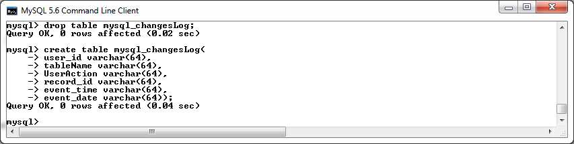

*Screenshot of mysql_changesLog table being created in MySQL console.*

We will now create the procedure that will perform the logging. The “changesLog” procedure will receive three input parameters, namely, the table which the changes have been made to, the change action e.g. update, insert, delete etc. and the unique id of the item that has been affected by this change. Inside the procedure itself, three new variables will be declared, these will be used to hold the following information, the name of the user who has initiated the change, the date that the change has taken place and the time at which the change has taken place. This procedure will be used in numerous “after” triggers to log all changes made to the database tables in question.

-- create changesLog procedure

DELIMITER **//**

**DROP** **PROCEDURE** **IF** **EXISTS** changesLog **//**

**CREATE** **PROCEDURE** changesLog**(IN** theTableName **VARCHAR(**64**),** **IN** theUserAction **VARCHAR(**64**),** **IN** theId **VARCHAR(**64**))**

**BEGIN**

**DECLARE** theUser **varchar(**64**);**

**DECLARE** theDate **varchar(**64**);**

**DECLARE** theTime **varchar(**64**);**

**select** **user()** **into** theUser**;**

**select** **concat(DATE_FORMAT(**now**(),**"%Y%m%d"**))** **into** theDate**;**

**select** **concat(DATE_FORMAT(**now**(),**"%T"**))** **into** theTime**;**

**INSERT** **INTO** mysql_changesLog**(**user_id**,** tableName**,** UserAction**,** record_id**,** event_time**,** event_date**)** **VALUES** **(**theUser**,** theTableName**,** theUserAction**,** theId**,** theTime**,** theDate**);**

**END; //**

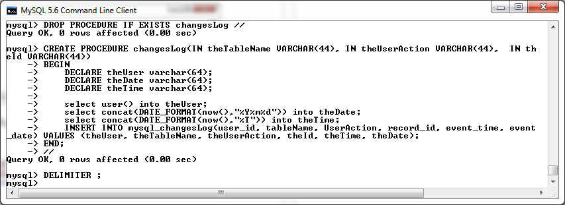

*Screenshot of changesLog procedure being created in MySQL console.*

## Before /After Insert Triggers

**Before Insert on Component Trigger**

The before insert trigger on the components table will be used to validate the following restrictions before a new record can be successfully added to the components table:

* The new entry must specify a component category of one of the following options:
  + Processors
  + Storage
  + Motherboard
  + Video Card
  + Case
  + RAM
* The new entry must reference a manufacturer_id that already exists within the Component_Manufacturer table.
* It company policy to not offer more than 5 components from one individual manufacturer. If the new entry is in breach of this policy, the new entry will be rejected.
* The price of the new entry must not be a negative number.
* The name of the new entry cannot be less than six characters in length.
* The description of the new entry cannot be less than ten characters in length.
* The quantity in stock of the new entry must not be a negative number.

An insert failing to comply with these rules will be rejected and return a suitable error message.

-- create BeforeInsert_Components trigger

DELIMITER **//**

**DROP** **TRIGGER** **IF** **EXISTS** BeforeInsert_Components **//**

**CREATE** **TRIGGER** BeforeInsert_Components

**BEFORE** **INSERT**

**ON** Component

**FOR** **EACH** **ROW**

**BEGIN**

**DECLARE** FOUND_MANU_ID**,** NO_OF_COMPS **INT;**

**SELECT** **COUNT(*)** **INTO** FOUND_MANU_ID

**FROM** Component_Manufacturer

**WHERE** Manu_ID **=** **NEW.**Comp_Manu_ID**;**

**SELECT** **COUNT(*)** **INTO** NO_OF_COMPS

**FROM** Component

**WHERE** Component**.**Comp_Manu_ID **=** **NEW.**Comp_Manu_ID**;**

**IF** **NEW.**Component_Category **NOT** **IN(**'Processors'**,**'Storage'**,**'MotherBoard'**,** 'Video Card'**,**

'Case'**,** 'RAM'**)** **THEN**

SIGNAL **SQLSTATE** '45000' **SET** MESSAGE_TEXT **=** 'INVALID CATEGORY Entered'**;**

ELSEIF FOUND_MANU_ID **<=** 0 **THEN**

SIGNAL **SQLSTATE** '45000' **SET** MESSAGE_TEXT **=** 'INVALID MANUFACTURER_ID - Manufacturer ID

does not exist.'**;**

ELSEIF NO_OF_COMPS **>=** 5 **THEN**

SIGNAL **SQLSTATE** '45000' **SET** MESSAGE_TEXT **=** 'BREACH OF COMPANY POLICY - It it company

policy to not offer more than 5 components from one individual manufacturer.'**;**

ELSEIF **NEW.**Component_Price **<** 0 **THEN**

SIGNAL **SQLSTATE** '45000' **SET** MESSAGE_TEXT **=** 'Price cannot be a NEGATIVE NUMBER. '**;**

ELSEIF **LENGTH(NEW.**Component_Name**)** **<** 6 **THEN**

SIGNAL **SQLSTATE** '45000' **SET** MESSAGE_TEXT **=** 'Component Name CANNOT BE LESS THAN SIX

CHARACTERS in lenght'**;**

ELSEIF **LENGTH(NEW.**Component_Description**)** **<** 10 **THEN**

SIGNAL **SQLSTATE** '45000' **SET** MESSAGE_TEXT **=** 'Component Description CANNOT BE LESS THAN

TEN CHARACTERS in lenght'**;**

ELSEIF **NEW.**Component_Qty_InStock **<=** 0 **THEN**

SIGNAL **SQLSTATE** '45000' **SET** MESSAGE_TEXT **=** 'Component Quantity In Stock cannot be a

NEGATIVE NUMBER. '**;**

**END** **IF;**

**END** **//**

DELIMITER **;**

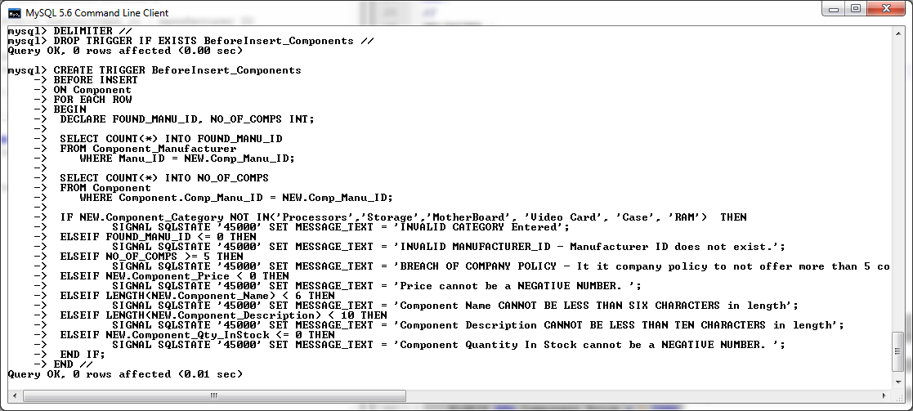

*Screenshot of BeforeInsert_Components trigger being created in MySQL console.*

**After Insert on Component Trigger**

The after insert trigger on the components table will be used to call the “changesLog” procedure to log all changes that have being made to the Components table.

-- create AfterInsert_Components trigger

DELIMITER **//**

**DROP** **TRIGGER** **IF** **EXISTS** AfterInsert_Components **//**

**CREATE** **TRIGGER** AfterInsert_Components

**AFTER** **INSERT**

**ON** Component

**FOR** **EACH** **ROW**

**BEGIN**

**call** changesLog**(**'Component'**,** 'Inserted'**,** **NEW.**Component_ID**);**

**END** **//**

DELIMITER **;**

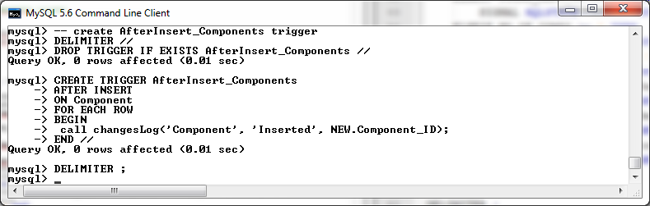

**Testing the Before and After Insert Triggers on the Component Table**

Attempt an insert with an invalid component category :

**Insert** **into** Component **values** **(**'C250'**,**10000**,**'AMD A6-6400K '**,**'3.9GHz Socket FM2 65W Dual-Core Desktop Processor'**,**'INVALID_CATEGORY'**,**10**,**10**);**

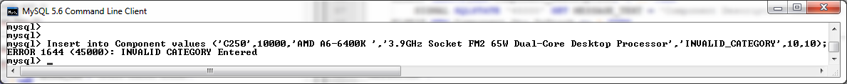

Attempt an insert with an invalid manufacturer id :

**Insert** **into** Component **values** **(**'C250'**,**10000**,**'AMD A6-6400K '**,**'3.9GHz Socket FM2 65W Dual-Core Desktop Processor'**,**'Speakers'**,**10**,**10**);**

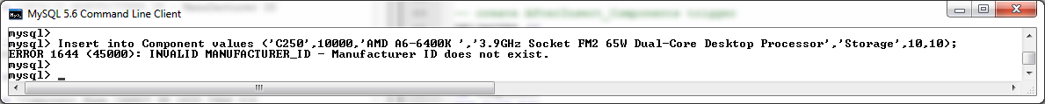

Attempt an insert with that breaches the component manufacturer company policy:

**Insert** **into** Component **values** **(**'C113'**,**5**,**'AMD A6-6400K '**,**'3.9GHz Socket FM2 65W Dual-Core Desktop Processor'**,**'Processors'**,**1**,**219.99**);**

**Insert** **into** Component **values** **(**'C114'**,**5**,**'AMD A6-6400K '**,**'3.9GHz Socket FM2 65W Dual-Core Desktop Processor'**,**'Processors'**,**1**,**219.99**);**



Attempt an insert with an invalid price :

**Insert** **into** Component **values** **(**'C250'**,**1**,**'AMD A6-6400K '**,**'3.9GHz Socket FM2 65W Dual-Core Desktop Processor'**,**'Storage'**,**10**,-**100**);**



Attempt an insert with an invalid name :

**Insert** **into** Component **values** **(**'C250'**,**1**,**'CPU'**,**'3.9GHz Socket FM2 65W Dual-Core Desktop Processor'**,**'Storage'**,**10**,** 100.00**);**



Attempt an insert with an invalid description :

**Insert** **into** Component **values** **(**'C250'**,**1**,**'AMD A6-6400K '**,**'A CPU'**,**'Storage'**,**10**,** 100.00**);**



Attempt an insert with an invalid Quantity in Stock value :

**Insert** **into** Component **values** **(**'C250'**,**1**,**'AMD A6-6400K '**,**'3.9GHz Socket FM2 65W Dual-Core Desktop Processor'**,**'Storage'**,-**10**,** 100.00**);**



Attempt a Valid insert.

**Insert** **into** Component **values** **(**'C250'**,**1**,**'AMD A6-6400K '**,**'3.9GHz Socket FM2 65W Dual-Core Desktop Processor'**,**'Storage'**,**10**,** 100.00**);**



Verify entry with a select statement on the table.

**SELECT** **\*** **FROM** Component **WHERE** Comp_Manu_ID **=** 1**;**

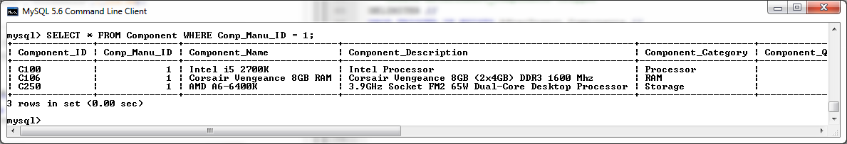

Test to ensure that the After Insert Trigger has called the changesLog Procedure and updated the log table to confirm the entry of record C250 on the Component table.

**SELECT** **\*** **FROM** mysql_changesLog**;**

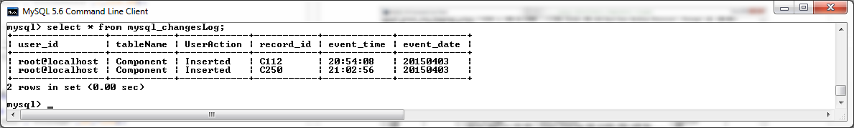

**Component Manufacturer Table Triggers**

**Before Insert on Component Manufacturer Trigger**

The before insert trigger on the components manufacturers table will be used to validate the following restrictions before a new record can be successfully added to the components table:

* The name of the new entry cannot be less than six characters in length.
* The address of the new entry cannot be less than ten characters in length.
* The country of the new entry cannot be less than four characters in length.
* The email of the new entry must contain an “@” symbol.
* The phone number of the new entry must contain a “-“symbol.
* The website address of the new entry must end with “.com“, “.ie” or “.eu”.

An insert failing to comply with these rules will be rejected and return a suitable error message.

-- create BeforeInsert_CompManu trigger

DELIMITER **//**

**DROP** **TRIGGER** **IF** **EXISTS** BeforeInsert_CompManu **//**

**CREATE** **TRIGGER** BeforeInsert_CompManu

**BEFORE** **INSERT**

**ON** Component_Manufacturer

**FOR** **EACH** **ROW**

**BEGIN**

**IF** **LENGTH(NEW.**Manu_Name**)** **<** 6 **THEN**

SIGNAL **SQLSTATE** '45000' **SET** MESSAGE_TEXT **=** 'Component Manufacturer Name CANNOT BE LESS

THAN SIX CHARACTERS in length'**;**

ELSEIF **LENGTH(NEW.**Manu_Address**)** **<** 10 **THEN**

SIGNAL **SQLSTATE** '45000' **SET** MESSAGE_TEXT **=** 'Component Manufacturer Address CANNOT BE

LESS THAN TEN CHARACTERS in length'**;**

ELSEIF **LENGTH(NEW.**Manu_Country**)** **<** 4 **THEN**

SIGNAL **SQLSTATE** '45000' **SET** MESSAGE_TEXT **=** 'Component Manufacturer country CANNOT BE

LESS THAN Four CHARACTERS in length'**;**

ELSEIF **NEW.**Manu_Email **NOT** **LIKE** '%@%' **THEN**

SIGNAL **SQLSTATE** '45000' **SET** MESSAGE_TEXT **=** 'Component Manufacturer email must contain

an @ symbol.'**;**

ELSEIF **NEW.**Manu_Phone **NOT** **LIKE** '%-%' **THEN**

SIGNAL **SQLSTATE** '45000' **SET** MESSAGE_TEXT **=** 'Component Manufacturer phone must contain

an - symbol.'**;**

ELSEIF **NEW.**Web_Site **NOT** **LIKE** '%.com' **AND** **NEW.**Web_Site **NOT** **LIKE** '%.ie' **AND** **NEW.**Web_Site **NOT** **LIKE** '%.eu' **THEN**

SIGNAL **SQLSTATE** '45000' **SET** MESSAGE_TEXT **=** 'Component Manufacturer website address of

the new entry must end with .com, .ie or .eu.'**;**

**END** **IF;**

**END** **//**

DELIMITER **;**

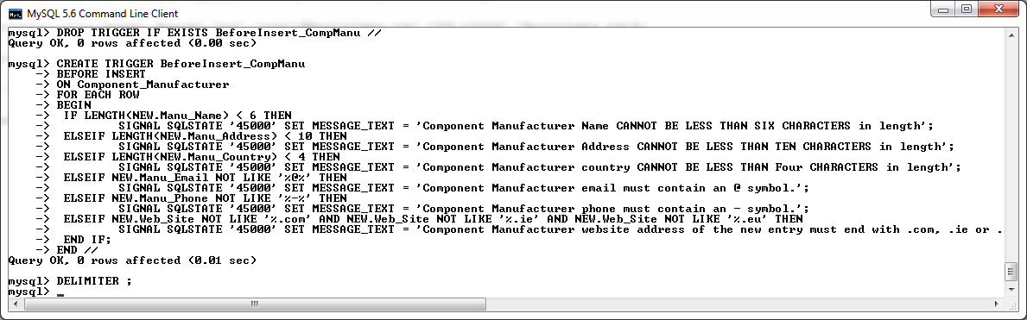

*Screenshot of BeforeInsert_CompManu trigger being created in MySQL console.*

**After Insert on Component_Manufacturer Trigger**

The after insert trigger on the Component_Manufacturer table will be used to call the “changesLog” procedure to log all changes that have being made to the Component_Manufacturer table.

-- create AfterInsert_CompManu trigger

DELIMITER **//**

**DROP** **TRIGGER** **IF** **EXISTS** AfterInsert_CompManu **//**

**CREATE** **TRIGGER** AfterInsert_CompManu

**AFTER** **INSERT**

**ON** Component_Manufacturer

**FOR** **EACH** **ROW**

**BEGIN**

**call** changesLog**(**'Component_Manufacturer'**,** 'Inserted'**,** **NEW.**Manu_ID**);**

**END** **//**

DELIMITER **;**

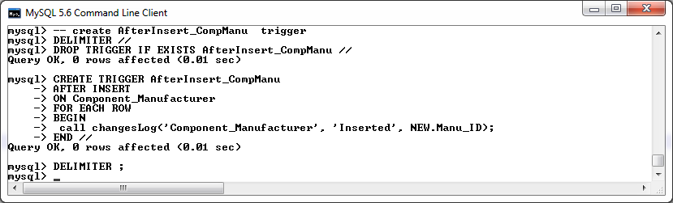

*Screenshot of AfterInsert_CompManu trigger being created in MySQL console.*

**Testing the Before and After Insert Triggers on the Component Manufacturer Table**

Attempt an insert with an invalid component manufacturer name :

**Insert** **into** Component_Manufacturer **values** **(**13**,**'ASUS'**,**'City Center, Munich'**,**'Germany'**,**'supply@Asus.com'**,**'086123456'**,**'www.Asus.com'**);**

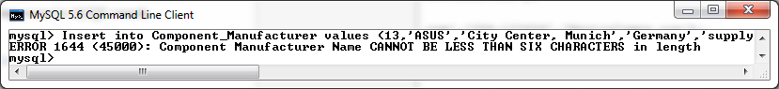

Attempt an insert with an invalid component manufacturer address :

**Insert** **into** Component_Manufacturer **values** **(**13**,**'MartinComponents'**,**'Eire'**,**'Germany'**,**'supply@Asus.com'**,**'086123456'**,**'www.Asus.com'**);**

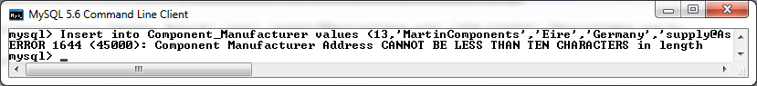

Attempt an insert with an invalid component manufacturer country :

**Insert** **into** Component_Manufacturer **values** **(**14**,**'MartinComponents'**,**'City Center, Munich'**,**'not'**,**'supply@MartinComps.com'**,**'086-123456'**,**'MartinComps.com'**);**

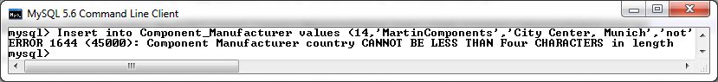

Attempt an insert with an invalid component manufacturer email :

**Insert** **into** Component_Manufacturer **values** **(**14**,**'MartinComponents'**,**'City Center, Munich'**,**'Germany'**,**'supplyMartinComps.com'**,**'086-123456'**,**'MartinComps.com'**);**

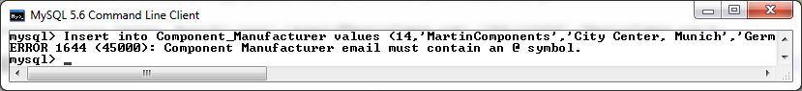

Attempt an insert with an invalid component manufacturer phone number :

**Insert** **into** Component_Manufacturer **values** **(**14**,**'MartinComponents'**,**'City Center, Munich'**,**'Germany'**,**'supply@MartinComps.com'**,**'086123456'**,**'MartinComps.com'**);**

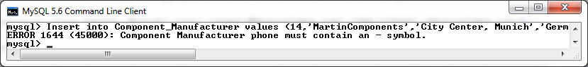

Attempt an insert with an invalid component manufacturer website address:

**Insert** **into** Component_Manufacturer **values** **(**14**,**'MartinComponents'**,**'City Center, Munich'**,**'Germany'**,**'supply@MartinComps.com'**,**'086-123456'**,**'MartinComps.ger'**);**

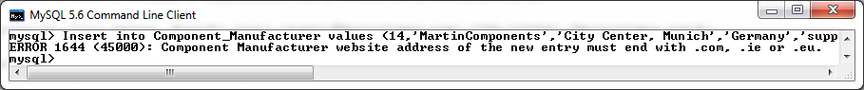

Attempt a Valid insert.

**Insert** **into** Component_Manufacturer **values** **(**14**,**'MartinComponents'**,**'City Center, Munich'**,**'Germany'**,**'supply@MartinComps.com'**,**'086-123456'**,**'MartinComps.com'**);**



Verify entry with a select statement on the table.

**SELECT** **\*** **FROM** Component_Manufacturer **WHERE** Manu_ID **=** 14**;**

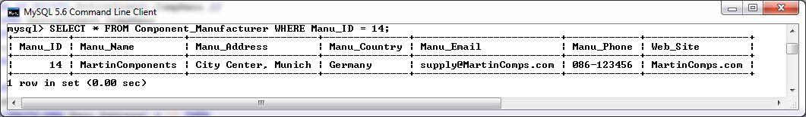

Test to ensure that the After Insert Trigger has called the changesLog Procedure and updated the log table to confirm the entry of record 14 on the Component Manufacturer table.

**SELECT** **\*** **FROM** mysql_changesLog**;**

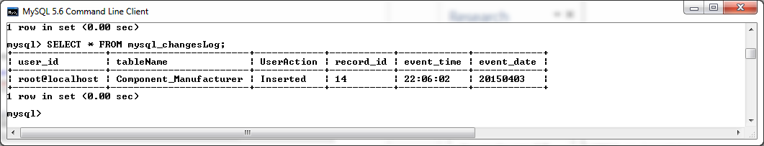

**Accessory Table Triggers**

**Before Insert on Accessory Trigger**

The before insert trigger on the Accessory table will be used to validate the following restrictions before a new record can be successfully added to the Accessory table:

* The name of the new entry cannot be less than six characters in length.
* The description of the new entry cannot be less than ten characters in length.
* The new entry must specify an accessory category of one of the following options:
  + Mouse
  + Keyboard
  + Speakers
  + Headset
  + Webcam
* The quantity in stock of the new entry must be not be a negative number.
* The price number of the new entry cannot be less than the average price of all components in its category'.

An insert failing to comply with these rules will be rejected and return a suitable error message.

-- create BeforeInsert_Accessory trigger

DELIMITER **//**

**DROP** **TRIGGER** **IF** **EXISTS** BeforeInsert_Accessory **//**

**CREATE** **TRIGGER** BeforeInsert_Accessory

**BEFORE** **INSERT**

**ON** Accessory

**FOR** **EACH** **ROW**

**BEGIN**

**DECLARE** V_Avg_Price **decimal(**6**,**2**);**

**SELECT** **AVG(**Accessory_Price**)** **into** V_Avg_Price

**FROM** Accessory

**WHERE** Accessory_Category **=** **New.**Accessory_Category**;**

**IF** **LENGTH(NEW.**Accessory_Name**)** **<** 6 **THEN**

SIGNAL **SQLSTATE** '45000' **SET** MESSAGE_TEXT **=** 'Accessory Name CANNOT BE LESS THAN SIX CHARACTERS in length'**;**

ELSEIF **LENGTH(NEW.**Accessory_Description**)** **<** 10 **THEN**

SIGNAL **SQLSTATE** '45000' **SET** MESSAGE_TEXT **=** 'Accessory Description CANNOT BE LESS THAN TEN CHARACTERS in length'**;**

ELSEIF **NEW.**Accessory_Category **NOT** **IN(**'Mouse'**,**'Keyboard'**,**'Speakers'**,** 'Headset'**,** 'Webcam'**)** **THEN**

SIGNAL **SQLSTATE** '45000' **SET** MESSAGE_TEXT **=** 'INVALID CATEGORY Entered'**;**

ELSEIF **NEW.**Accessory_Qty_InStock **<** 0 **THEN**

SIGNAL **SQLSTATE** '45000' **SET** MESSAGE_TEXT **=** 'Component Quantity In Stock must be greater than zero.'**;**

ELSEIF **NEW.**Accessory_Price **<** V_Avg_Price **THEN**

SIGNAL **SQLSTATE** '45000' **SET** MESSAGE_TEXT **=** 'Accessory Price cannot be less than the average price of all components in its category'**;**

**END** **IF;**

**END** **//**

DELIMITER **;**

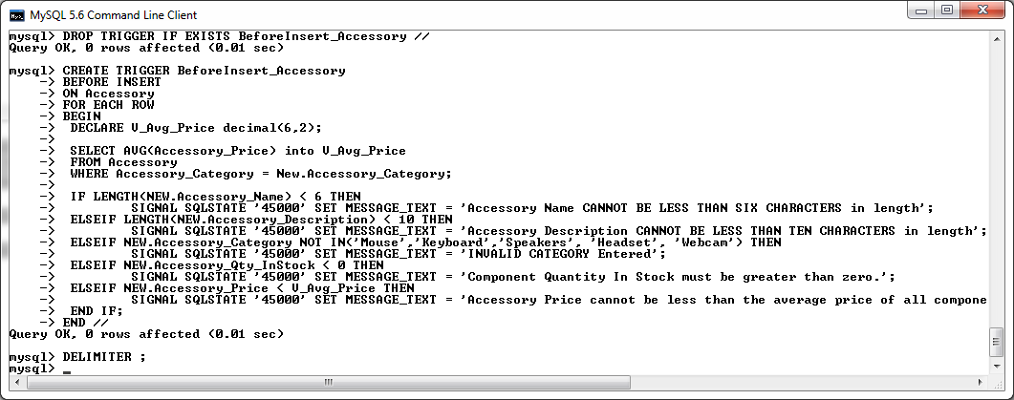

*Screenshot of BeforeInsert_Accessory trigger being created in MySQL console.*

**After Insert on Accessory Trigger**

The after insert trigger on the components table will be used to call the “changesLog” procedure to log all changes that have being made to the Accessory table.

-- create AfterInsert_Accessory trigger

DELIMITER **//**

**DROP** **TRIGGER** **IF** **EXISTS** AfterInsert_Accessory **//**

**CREATE** **TRIGGER** AfterInsert_Accessory

**AFTER** **INSERT**

**ON** Accessory

**FOR** **EACH** **ROW**

**BEGIN**

**call** changesLog**(**'Accessory'**,** 'Inserted'**,** **NEW.**Accessory_ID**);**

**END** **//**

DELIMITER **;**

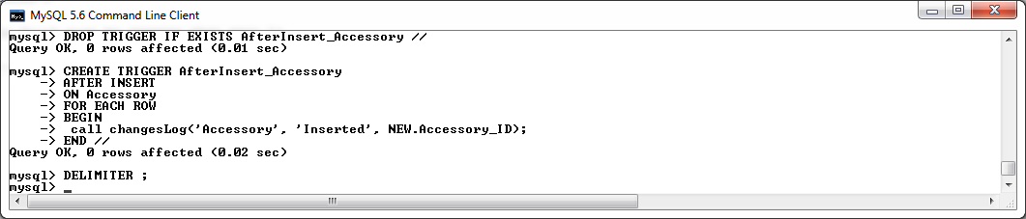

*Screenshot of AfterInsert_Accessory trigger being created in MySQL console.*

**Testing the Before and After Insert Triggers on the Accessory Table**

Attempt an insert with an invalid Accessory name :

**Insert** **into** Accessory **values** **(**'A900'**,**'test'**,**'7 Button LED Optical USB Wired Gaming Mouse'**,**'Mouse'**,**20**,** 129.99**);**



Attempt an insert with an invalid Accessory description :

**Insert** **into** Accessory **values** **(**'A900'**,**'Naga Razer Mouse'**,**'test'**,**'Mouse'**,**20**,** 129.99**);**



Attempt an insert with an invalid Accessory category :

**Insert** **into** Accessory **values** **(**'A900'**,**'Naga Razer Mouse'**,**'7 Button LED Optical USB Wired Gaming Mouse'**,**'invalid'**,**20**,** 129.99**);**



Attempt an insert with an invalid Accessory Quantity In Stock :

**Insert** **into** Accessory **values** **(**'A900'**,**'Naga Razer Mouse'**,**'7 Button LED Optical USB Wired Gaming Mouse'**,**'Mouse'**,-**10**,** 129.99**);**



Attempt an insert with an invalid Accessory Price :

**Insert** **into** Accessory **values** **(**'A900'**,**'Naga Razer Mouse'**,**'7 Button LED Optical USB Wired Gaming Mouse'**,**'Mouse'**,**10**,** 20.00**);**



Attempt a Valid insert.

**Insert** **into** Accessory **values** **(**'A999'**,**'Zelotes 5500 Gaming Mouse'**,**'7 Button LED Optical USB Wired Gaming Mouse'**,**'Mouse'**,**20**,** 129.99**);**

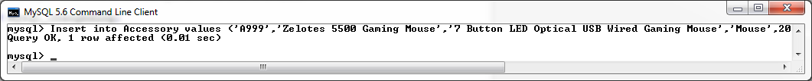

Verify entry with a select statement on the table.

**SELECT** **\*** **FROM** Accessory **WHERE** Accessory_ID **=** 'A999'**;**

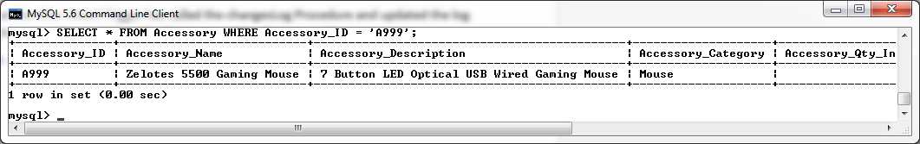

Test to ensure that the After Insert Trigger has called the changesLog Procedure and updated the log table to confirm the entry of record A999 on the Accessory table.

**SELECT** **\*** **FROM** mysql_changesLog**;**

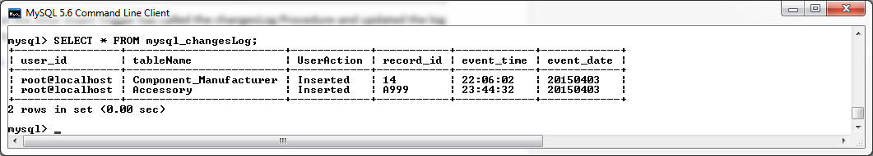

**Customer Table Triggers**

**Before Insert on Customer Trigger**

The before insert trigger on the Customer table will be used to validate the following restrictions before a new record can be successfully added to the Customer table:

* The name of the new entry cannot be less than six characters in length.
* The address of the new entry cannot be less than ten characters in length.
* The email of the new entry must contain an “@” symbol.
* The phone number of the new entry must contain a “-“symbol.
* The Customer Credit Limit cannot exceed the Credit Limit of all current Customers whose account is not locked.
* A Customer Account cannot be locked on creation.

An insert failing to comply with these rules will be rejected and return a suitable error message.

--create BeforeInsert_Customer Trigger

DELIMITER **//**

**DROP** **TRIGGER** **IF** **EXISTS** BeforeInsert_Customer **//**

**CREATE** **TRIGGER** BeforeInsert_Customer

**BEFORE** **INSERT**

**ON** Customer

**FOR** **EACH** **ROW**

**BEGIN**

**DECLARE** V_Avg_Credit_Limit **decimal(**6**,**2**);**

**SELECT** **AVG(**Credit_Limit**)** **into** V_Avg_Credit_Limit

**FROM** Customer

**WHERE** Account_Lock **=** 0**;**

**IF** **LENGTH(NEW.**Customer_Name**)** **<** 6 **THEN**

SIGNAL **SQLSTATE** '45000' **SET** MESSAGE_TEXT **=** 'Customer Name CANNOT BE LESS THAN SIX

CHARACTERS in length'**;**

ELSEIF **LENGTH(NEW.**Customer_Address**)** **<** 10 **THEN**

SIGNAL **SQLSTATE** '45000' **SET** MESSAGE_TEXT **=** 'Customer Address CANNOT BE LESS THAN TEN

CHARACTERS in length'**;**

ELSEIF **NEW.**Customer_Email **NOT** **LIKE** '%@%' **THEN**

SIGNAL **SQLSTATE** '45000' **SET** MESSAGE_TEXT **=** 'Customer email must contain an @ symbol.'**;**

ELSEIF **NEW.**Customer_Phone **NOT** **LIKE** '%-%' **THEN**

SIGNAL **SQLSTATE** '45000' **SET** MESSAGE_TEXT **=** 'Customer phone must contain an - symbol.'**;**

ELSEIF **NEW.**Credit_Limit **>** V_Avg_Credit_Limit **THEN**

SIGNAL **SQLSTATE** '45000' **SET** MESSAGE_TEXT **=** 'Customer Credit_Limit can not exceed the

Credit Limit of all current Customers whoes account is not locked.'**;**

ELSEIF **NEW.**Account_Lock **=** 1 **THEN**

SIGNAL **SQLSTATE** '45000' **SET** MESSAGE_TEXT **=** 'A Customer Account cannot be locked on

creation.'**;**

**END** **IF;**

**END** **//**

DELIMITER **;**

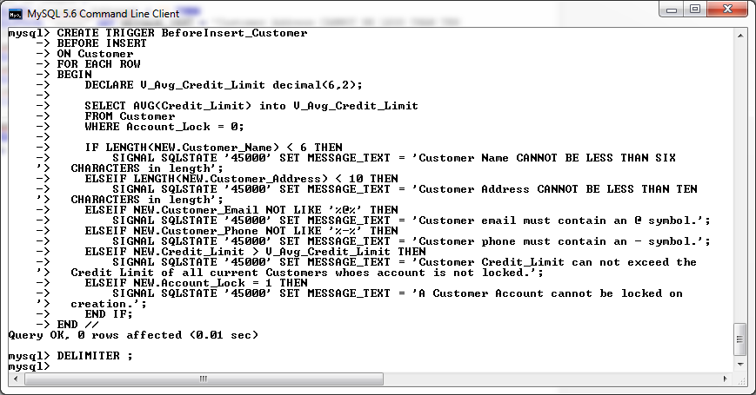

*Screenshot of BeforeInsert_Customer trigger being created in MySQL console.*

**After Insert on Customer Trigger**

The after insert trigger on the components table will be used to call the “changesLog” procedure to log all changes that have being made to the Customer table.

-- create AfterInsert_Customer trigger

DELIMITER **//**

**DROP** **TRIGGER** **IF** **EXISTS** AfterInsert_Customer **//**

**CREATE** **TRIGGER** AfterInsert_Customer

**AFTER** **INSERT**

**ON** Customer

**FOR** **EACH** **ROW**

**BEGIN**

**call** changesLog**(**'Customer'**,** 'Inserted'**,** **NEW.**Customer_ID**);**

**END** **//**

DELIMITER **;**

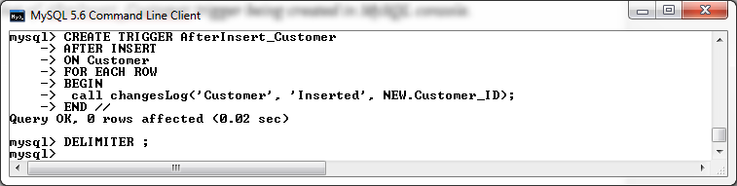

*Screenshot of AfterInsert_Customer trigger being created in MySQL console.*

**Testing the Before and After Insert Triggers on the Customer Table**

Attempt an insert with an invalid Customer Name :

**Insert** **into** Customer **values** **(**100**,**'test'**,**'City Center, Waterford'**,** '089-321987'**,** 'DavidM@hotmail.com'**,** 600**,** 0**);**

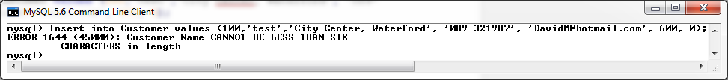

Attempt an insert with an invalid Customer Address :

**Insert** **into** Customer **values** **(**100**,**'David Martin'**,**'test'**,** '089-321987'**,** 'DavidM@hotmail.com'**,** 600**,** 0**);**

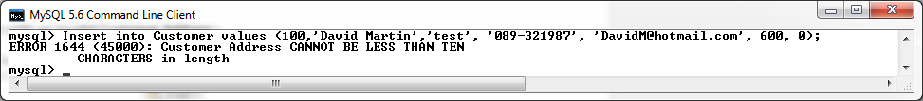

Attempt an insert with an invalid Customer Email :

**Insert** **into** Customer **values** **(**100**,**'David Martin'**,**'City Center, Waterford'**,** '089-321987'**,** 'DavidMhotmail.com'**,** 600**,** 0**);**

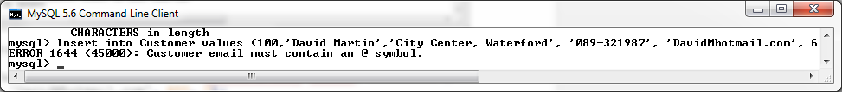

Attempt an insert with an invalid Customer Phone No :

**Insert** **into** Customer **values** **(**100**,**'David Martin'**,**'City Center, Waterford'**,** '089321987'**,** 'DavidM@hotmail.com'**,** 600**,** 0**);**

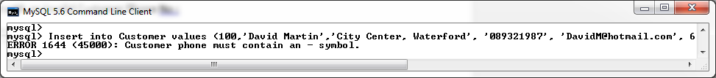

Attempt an insert with an invalid Customer Credit Limit :

**Insert** **into** Customer **values** **(**100**,**'David Martin'**,**'City Center, Waterford'**,** '089-321987'**,** 'DavidM@hotmail.com'**,** 1600**,** 0**);**

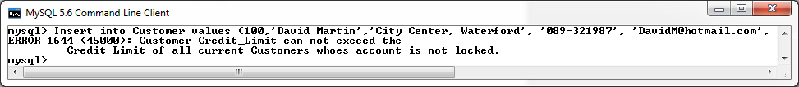

Attempt an insert with an invalid Customer Account Locked status :

**Insert** **into** Customer **values** **(**100**,**'David Martin'**,**'City Center, Waterford'**,** '089-321987'**,** 'DavidM@hotmail.com'**,** 600**,** 1**);**

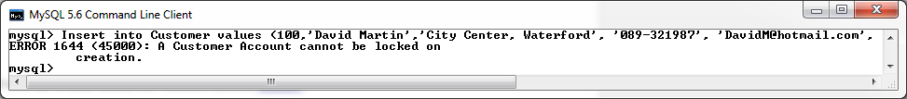

Attempt a Valid insert.

**Insert** **into** Customer **values** **(**100**,**'David Martin'**,**'City Center, Waterford'**,** '089-321987'**,** 'DavidM@hotmail.com'**,** 600**,** 0**);**

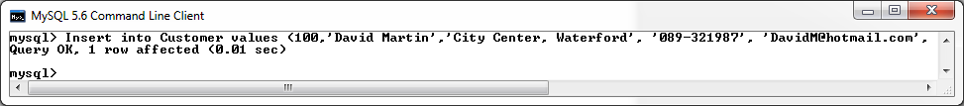

Verify entry with a select statement on the table.

**SELECT** **\*** **FROM** Customer **WHERE** Customer_ID **=** 100**;**

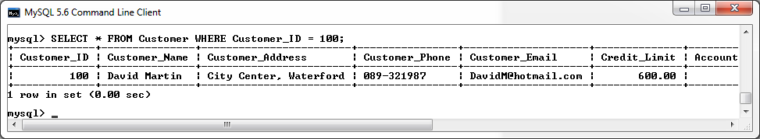

Test to ensure that the After Insert Trigger has called the changesLog Procedure and updated the log table to confirm the entry of record 100 on the Customer table.

**SELECT** **\*** **FROM** mysql_changesLog**;**

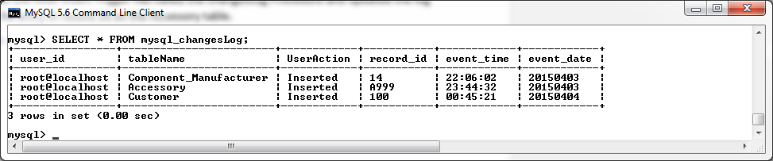

**Orders_Component_Junction Table Triggers**

**Before Insert on Orders_Component_Junction Table**

The before insert trigger on the Orders_Component_Junction table will be used to validate the following restrictions before a new record can be successfully added to the Orders_Component_Junction table:

* A record referencing the new Order ID and Component ID must not already exist in the table (**cardinality**).
* The Order ID of the new entry must exist within the Orders table.
* The Component ID of the new entry must exist within the Component table.
* The Quantity of the new entry must be greater than zero.
* The component referenced in the new entry must have sufficient In House Stock to fulfil the new order.

An insert failing to comply with these rules will be rejected and return a suitable error message.

DELIMITER **//**

**DROP** **TRIGGER** **IF** **EXISTS** BeforeInsert_Orders_Comp_Junct**//**

**CREATE** **TRIGGER** BeforeInsert_Orders_Comp_Junct

**BEFORE** **INSERT**

**ON** Orders_Component_Junction

**FOR** **EACH** **ROW**

**BEGIN**

**DECLARE** FOUND_COMP_ID**,** FOUND_ORDER_ID**,** FOUND_IDENTICAL_ENTRY**,** INSTOCK_QTY_CHECK **INT;**

**SELECT** **COUNT(*)** **INTO** FOUND_COMP_ID

**FROM** Component

**WHERE** Component**.**Component_ID **=** **NEW.**Component_ID**;**

**SELECT** Component_Qty_InStock **INTO** INSTOCK_QTY_CHECK

**FROM** Component

**WHERE** Component**.**Component_ID **=** **NEW.**Component_ID**;**

**SELECT** **COUNT(*)** **INTO** FOUND_ORDER_ID

**FROM** Orders

**WHERE** Orders**.**Order_ID **=** **NEW.**Order_ID**;**

**SELECT** **COUNT(*)** **INTO** FOUND_IDENTICAL_ENTRY

**FROM** Orders_Component_Junction

**WHERE** Orders_Component_Junction**.**ORDER_ID **=** **NEW.**ORDER_ID **AND** Orders_Component_Junction**.**COMPONENT_ID **=** **NEW.**COMPONENT_ID**;**

**IF(**FOUND_IDENTICAL_ENTRY **>** 0**)** **THEN**

SIGNAL **SQLSTATE** '45000' **SET** MESSAGE_TEXT **=** 'DUPLICATE ENTRY - An entry for this order

and component already exists.'**;**

ELSEIF **(**INSTOCK_QTY_CHECK **-** **NEW.**Component_Qty **<** 0 **)** **THEN**

SIGNAL **SQLSTATE** '45000' **SET** MESSAGE_TEXT **=** 'INSUFFICIENT COMPONENTS IN STOCK TO

FULFILL ORDER.'**;**

ELSEIF FOUND_COMP_ID **<=** 0 **THEN**

SIGNAL **SQLSTATE** '45000' **SET** MESSAGE_TEXT **=** 'INVALID COMPONENT_ID - COMPONENT ID does

not exist.'**;**

ELSEIF FOUND_ORDER_ID **<=** 0 **THEN**

SIGNAL **SQLSTATE** '45000' **SET** MESSAGE_TEXT **=** 'INVALID ORDER_ID - ORDER ID does not

exist.'**;**

ELSEIF **NEW.**Component_Qty **<=** 0 **THEN**

SIGNAL **SQLSTATE** '45000' **SET** MESSAGE_TEXT **=** 'Component Quantity cannot be ZERO or a

NEGATIVE NUMBER. '**;**

**END** **IF;**

**END** **//**

DELIMITER **;**

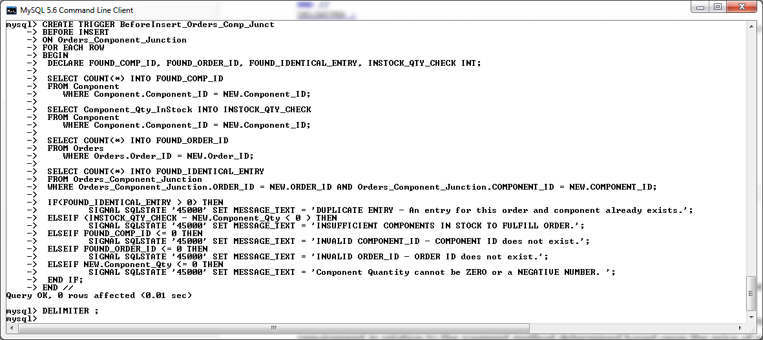*Screenshot of BeforeInsert_Orders_Comp_Junct trigger being created in MySQL console.*

**After Insert on Orders_ Component _Junction Table**

The after insert trigger on the Orders_ Component _Junction table will be used to call the “changesLog” procedure to log all changes that have being made to the Orders_Component_Junction table. This trigger will also be used to facilitate the customer requirement in relation to the payment method determined based upon the price of each order (As stated in the customer concerns section).

The after insert trigger will act as follows:

Whenever a new component is added to an Orders_Component_Junction, the Total_Price field of the order in question will be updated to reflect this. First, the Component_Price of included in the new entry will be determined by referencing the Components table. Once this price has being retrieved, the figure will be then multiplied by the component quantity as specified in the new Orders_Component_Junction entry. Then the Total_Price field of the Order specified in the new entry will be updated to reflect the previous Total_Price, plus the increase to this total with the addition of the new components being by new entry in the Orders_Component_Junction table.

The After Insert trigger will then determine the payment method required for the order based upon the updated Order price as follows:

If the total price of the order is eight hundred euros or less, the payment method required shall be ‘Cash on Delivery’.

If the total price of the order exceeds eight hundred euros but is less than fourteen hundred euros, the payment method required shall be ‘Credit Card’.

If the total price of the order exceeds fourteen hundred euros, the payment method required shall be ‘PayPal’.

Finally, if any modifications have been made to the payment method of an order, the ‘changesLog’ procedure will be called, with custom parameters for each scenario, to make a log of all changes performed by this trigger.

The above logic shall incorporate the customer requirements in relation to updating the total price of an order when a new component is added to the pc build, as well as facilitating the payment methods required for each order based on their individual price. For an explanation of this customer requirement, please refer to the customer concerns section.

**DROP** **TRIGGER** **IF** **EXISTS** AfterInsert_Orders_Comp_Junct **//**

**CREATE** **TRIGGER** AfterInsert_Orders_Comp_Junct

**AFTER** **INSERT**

**ON** Orders_Component_Junction

**FOR** **EACH** **ROW**

**BEGIN**

**DECLARE** myMsg **Varchar(**60**);**

**DECLARE** V_Comp_Price**,** V_Total_Price **Decimal(**6**,**2**);**

**SELECT** Component_Price **into** V_Comp_Price

**FROM** Component

**WHERE** Component**.**Component_ID **=** **NEW.**Component_ID**;**

**Update** Orders

**SET** Total_Price **=** Total_Price **+** **(NEW.**Component_Qty**\***V_Comp_Price**)**

**WHERE** Orders**.**Order_ID **=** **NEW.**Order_ID**;**

**SELECT** Total_Price **into** V_Total_Price

**FROM** Orders

**WHERE** Orders**.**Order_ID **=** **NEW.**Order_ID**;**

**IF(**V_Total_Price **<=** 800.00**)** **THEN**

**UPDATE** Orders

**SET** Payment_Method **=** 'Cash On Delivery'

**WHERE** Orders**.**Order_ID **=** **NEW.**Order_ID**;**

**SELECT** **concat(**'Order ID : '**,NEW.**Order_ID**,**' Payment Method Changed

to Cash On Delivery'**)** **into** myMsg**;**

**call** changesLog**(**'New Component Added to Order '**,** 'Inserted'**,**

myMsg**);**

ELSEIF**(**V_Total_Price **>** 800.00 **AND** V_Total_Price **<=** 1400.00**)** **THEN**

**UPDATE** Orders

**SET** Payment_Method **=** 'Credit Card'

**WHERE** Orders**.**Order_ID **=** **NEW.**Order_ID**;**

**SELECT** **concat(**'Order ID : '**,NEW.**Order_ID**,**' Payment Method Changed

to Credit Card'**)** **into** myMsg**;**

**call** changesLog**(**'New Component Added to Order '**,** 'Inserted'**,**

myMsg**);**

ELSEIF**(**V_Total_Price **>** 1400.00**)** **THEN**

**UPDATE** Orders

**SET** Payment_Method **=** 'PayPal'

**WHERE** Orders**.**Order_ID **=** **NEW.**Order_ID**;**

**SELECT** **concat(**'Order ID : '**,NEW.**Order_ID**,**' Payment Method Changed

to PayPal'**)** **into** myMsg**;**

**call** changesLog**(**'New Component Added to Order '**,** 'Inserted'**,**

myMsg**);**

**END** **IF;**

**SELECT** **concat(**'Order ID : '**,NEW.**Order_ID**,**' Component ID :

'**,NEW.**Component_ID**)** **into** myMsg**;**

**call** changesLog**(**'Orders_Component_Junction'**,** 'Inserted'**,** myMsg**);**

**END** **//**

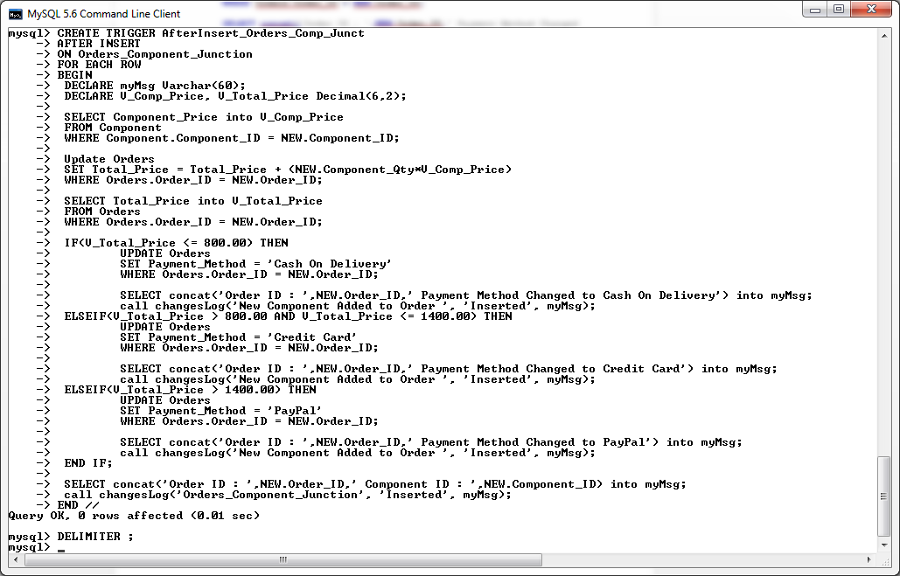

*Screenshot of AfterInsert_Orders_Comp_Junct trigger being created in MySQL console.*

**Testing the Before and After Insert Triggers on the Orders_Component_Junction Table**

**Test Before Insert Trigger**

Attempt an insert with a duplicate entry:

**Insert** **into** Orders_Component_Junction **values** **(**'C109'**,** 'O101'**,** 2**);**

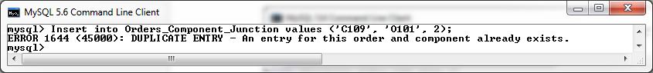

Attempt an insert with a component that has insufficient in house stock to fulfil the order :

**SELECT** **\*** **FROM** Component **WHERE** Component_ID **=** 'C100'**;**

**Insert** **into** Orders_Component_Junction **values** **(**'C100'**,** 'O101'**,** 100**);**

**SELECT** **\*** **FROM** Component **WHERE** Component_ID **=** 'C100'**;**

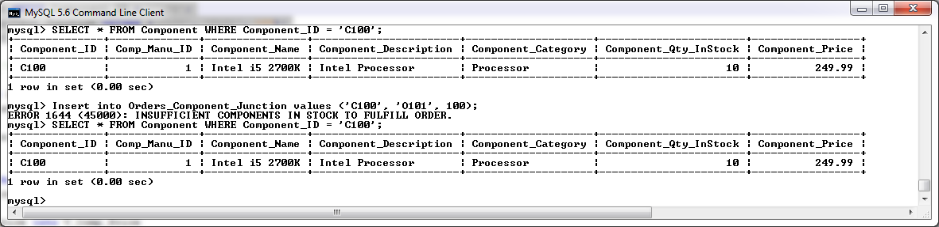

Attempt an insert with an invalid Order ID :

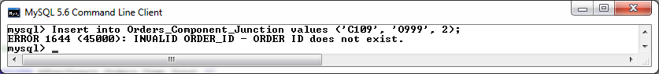

Attempt an insert with an invalid Component ID :

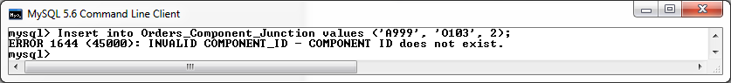

Attempt an insert with an invalid Component Quantity:

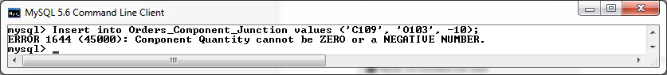

Attempt a Valid insert and ensure the the referenced component has its in stock quantity updated to reflect the order.

**SELECT** **\*** **FROM** Component **WHERE** COMPONENT_ID **=** 'C100'**;**

**Insert** **into** Orders_Component_Junction **values** **(**'C100'**,** 'O101'**,** 2**);**

**SELECT** **\*** **FROM** Component **WHERE** COMPONENT_ID **=** 'C100'**;**

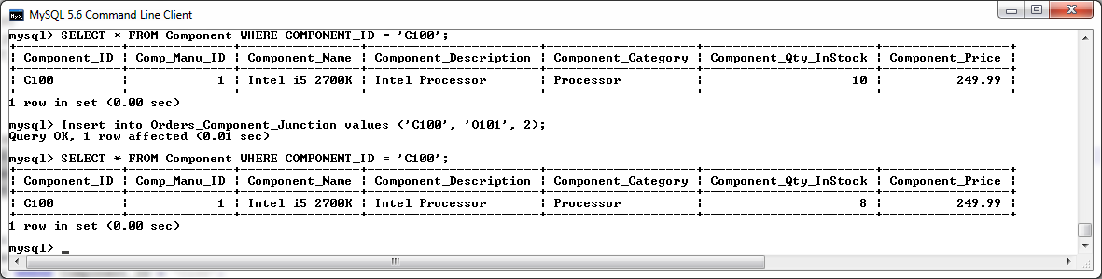

Verify entry with a select statement on the table.

**SELECT** **\*** **FROM** Orders_Component_Junction **WHERE** COMPONENT_ID **=** 'C100' **AND** ORDER_ID **=** 'O101'**;**

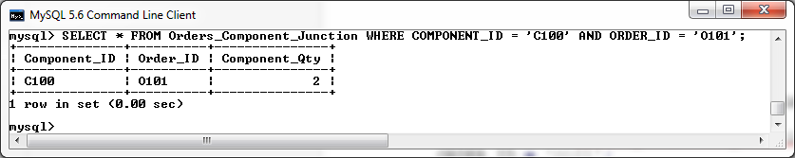

Test to ensure that the After Insert Trigger has called the changesLog Procedure and updated the log table to confirm the entry of the new record in the Orders_Component_Junction table.

**SELECT** **\*** **FROM** mysql_changesLog**;**

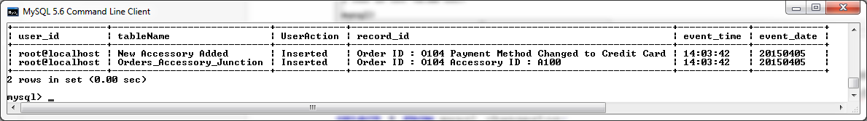

#### Test After Insert Trigger

First, we will create a new Order with a Payment_Method of ‘Cash on Delievery’ and a Total_Price of 0.00 euros.

**Insert** **into** Orders **values** **(**'O999'**,** 'DV105'**,** 9**,** '29-02-2015'**,**'Cash On Delivery'**,**0.00**);**

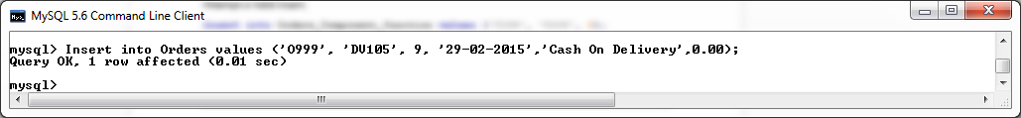

To confirm its entry we will perform a SELECT statement to retrieve the Payment_Method and Total_Price of the record.

**SELECT** total_price**,** payment_method **FROM** Orders **WHERE** ORder_Id **=** 'O999'**;**

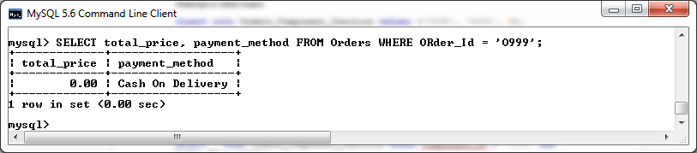

I will now begin adding components to this order via the Orders_Component_Junction table and validate that both the Total_Price and Payment_Method of the order are being updated as desired.

**SELECT** total_price**,** payment_method **FROM** Orders **WHERE** Order_Id **=** 'O999'**;**

**Insert** **into** Orders_Component_Junction **values** **(**'C109'**,** 'O999'**,** 4**);**

**SELECT** total_price**,** payment_method **FROM** Orders **WHERE** Order_Id **=** 'O999'**;**

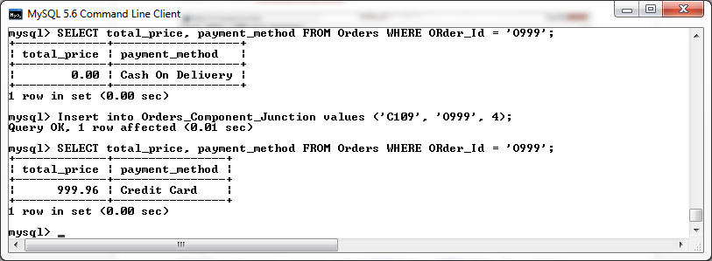

From the above screenshot we can now see that after 4 components valued at 249.99 euros each have being added to our new order through the junction table, the Total_Price of the order has being updated to reflect the addition of the recently added components, and also, because the Total_price field now exceeds eight hundred euros but is less than fourteen hundred euros, the payment method has been changed to reflect ‘Credit Card’ as desired.

I will now add another 2 of the same component to this order.

**SELECT** total_price**,** payment_method **FROM** Orders **WHERE** Order_Id **=** 'O999'**;**

**Insert** **into** Orders_Component_Junction **values** **(**'C109'**,** 'O999'**,** 2**);**

**SELECT** total_price**,** payment_method **FROM** Orders **WHERE** Order_Id **=** 'O999'**;**

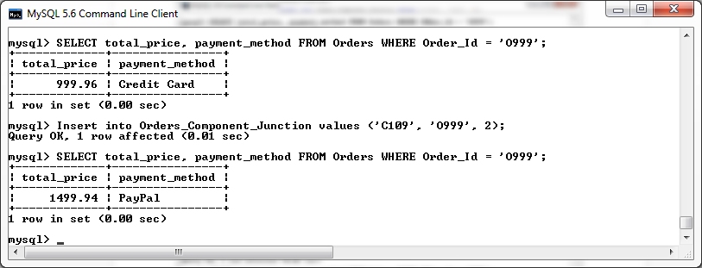

From the above screenshot we can now see that after another 2 components valued at 249.99 euros each have being added to our new order through the junction table, the Total_Price of the order has being updated to reflect the addition of these recently added components, and also, because the Total_price field now exceeds fourteen hundred euros, the payment method has been changed to reflect ‘Paypal’ as desired.

I shall now see if these changes made to the new order have been recorded in the log table.

**select** **\*** **from** mysql_changesLog**;**

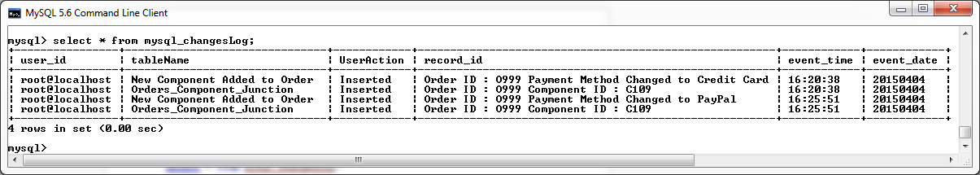

From the above screenshot we can see that the procedure has successfully logged all changes made to the order during testing.

**Orders_Accessory_Junction Table Triggers**

**Before Insert on Orders_Accessory_Junction Table**

The before insert trigger on the Orders_Accessory_Junction table will be used to validate the following restrictions before a new record can be successfully added to the Orders_Accessory_Junction table:

* A record referencing the new Order ID and Accessory ID must not already exist in the table (**cardinality**).
* The Order ID of the new entry must exist within the Orders table.
* The Accessory ID of the new entry must exist within the Accessory table.
* The Quantity of the new entry must be greater than zero.
* If a record has been successfully added to the table, the accessory referenced in the entry shall have its In Stock quantity on the Accessory table reduced by the amount ordered.
* There Accessory referenced in the new entry must have sufficient stock to fulfil the order before the new entry can be made.

An insert failing to comply with these rules will be rejected and return a suitable error message.

DELIMITER **//**

**DROP** **TRIGGER** **IF** **EXISTS** BeforeInsert_Orders_Acc_Junct**//**

**CREATE** **TRIGGER** BeforeInsert_Orders_Acc_Junct

**BEFORE** **INSERT**

**ON** Orders_Accessory_Junction

**FOR** **EACH** **ROW**

**BEGIN**

**DECLARE** FOUND_ORDER_ID**,** FOUND_ACCESSORY_ID**,** FOUND_IDENTICAL_ENTRY**,** INSTOCK_QTY_CHECK **INT;**

**SELECT** **COUNT(*)** **INTO** FOUND_ORDER_ID

**FROM** Orders

**WHERE** Orders**.**Order_ID **=** **NEW.**Order_ID**;**

**SELECT** Accessory_Qty_InStock **INTO** INSTOCK_QTY_CHECK

**FROM** Accessory

**WHERE** Accessory**.**Accessory_ID **=** **NEW.**Accessory_ID**;**

**SELECT** **COUNT(*)** **INTO** FOUND_ACCESSORY_ID

**FROM** Accessory

**WHERE** Accessory**.**Accessory_ID **=** **NEW.**Accessory_ID**;**

**SELECT** **COUNT(*)** **INTO** FOUND_IDENTICAL_ENTRY

**FROM** Orders_Accessory_Junction

**WHERE** Orders_Accessory_Junction**.**ORDER_ID **=** **NEW.**ORDER_ID **AND** Orders_Accessory_Junction**.**Accessory_ID **=** **NEW.**Accessory_ID**;**

**IF(**FOUND_IDENTICAL_ENTRY **>** 0**)** **THEN**

SIGNAL **SQLSTATE** '45000' **SET** MESSAGE_TEXT **=** 'DUPLICATE ENTRY - An entry for this order

and accessory already exists.'**;**

ELSEIF **(**INSTOCK_QTY_CHECK **-** **NEW.**Accessory_Qty **<** 0 **)** **THEN**

SIGNAL **SQLSTATE** '45000' **SET** MESSAGE_TEXT **=** 'INSUFFICIENT ACCESSORIES IN STOCK TO FULFILL ORDER.'**;**

ELSEIF FOUND_ORDER_ID **<=** 0 **THEN**

SIGNAL **SQLSTATE** '45000' **SET** MESSAGE_TEXT **=** 'INVALID ORDER_ID - ORDER ID does not

exist.'**;**

ELSEIF FOUND_ACCESSORY_ID **<=** 0 **THEN**

SIGNAL **SQLSTATE** '45000' **SET** MESSAGE_TEXT **=** 'INVALID ACCESSORY_ID - ACCESSORY ID does

not exist.'**;**

ELSEIF **NEW.**Accessory_Qty **<=** 0 **THEN**

SIGNAL **SQLSTATE** '45000' **SET** MESSAGE_TEXT **=** 'Accessory Quantity cannot be ZERO or a

NEGATIVE NUMBER. '**;**

**ELSE**

**UPDATE** Accessory

**SET** Accessory_Qty_InStock **=** Accessory_Qty_InStock **-** **NEW.**Accessory_Qty

**WHERE** Accessory**.**Accessory_ID **=** **NEW.**Accessory_ID**;**

**END** **IF;**

**END** **//**

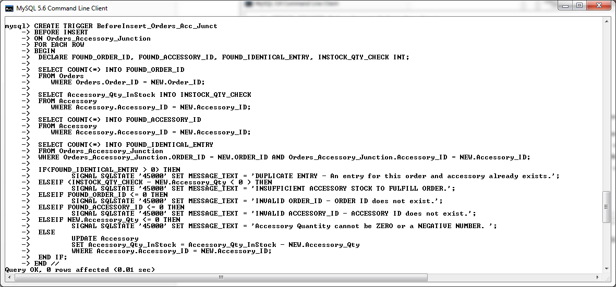

*Screenshot of BeforeInsert_Orders_Acc_Junct trigger being created in MySQL console.*

**After Insert on Orders_ Accessory _Junction Table**

The after insert trigger on the Orders_ Accessory _Junction table will be used to call the “changesLog” procedure to log all changes that have being made to the Orders_Accessory_Junction table. This trigger will also be used to facilitate the customer requirement in relation to the payment method determined based upon the price of each order (As stated in the customer concerns section).

The after insert trigger will act as follows:

Whenever a new Accessory is added to an Orders_Accessory_Junction, the Total_Price field of the order in question will be updated to reflect this. First, the Accessory_Price of the new entry will be determined by referencing the Accessory table. Once this price has being retrieved, the figure will be then multiplied by the accessory quantity as specified in the new Orders_Accessory_Junction entry. Then the Total_Price field of the Order specified in the new entry will be updated to reflect the previous Total_Price, plus the increase to this total with the addition of the new accessories being by new entry in the Orders_Accessory_Junction table.

As like the After Insert trigger on the Orders_Component_Junction tables, this After Insert trigger is also written to determine the payment method required for the order based upon the updated Order price as follows:

If the total price of the order is eight hundred euros or less, the payment method required shall be ‘Cash on Delivery’.

If the total price of the order exceeds eight hundred euros but is less than fourteen hundred euros, the payment method required shall be ‘Credit Card’.

If the total price of the order exceeds fourteen hundred euros, the payment method required shall be ‘PayPal’.

Finally, if any modifications have been made to the payment method of an order, the ‘changesLog’ procedure will be called, with custom parameters for each scenario, to make a log of all changes performed by this trigger.

The above logic shall incorporate the customer requirements in relation to updating the total price of an order when a new accessory is added to the pc order, as well as facilitating the payment methods required for each order based on their individual price. For an explanation of this customer requirement, please refer to the customer concerns section.

-- create AfterInsert_Orders_Acc_Junct trigger

DELIMITER **//**

**DROP** **TRIGGER** **IF** **EXISTS** AfterInsert_Orders_Acc_Junct **//**

**CREATE** **TRIGGER** AfterInsert_Orders_Acc_Junct

**AFTER** **INSERT**

**ON** Orders_Accessory_Junction

**FOR** **EACH** **ROW**

**BEGIN**

**DECLARE** myMsg **Varchar(**60**);**

**DECLARE** V_Accessory_Price**,** V_Total_Price **Decimal(**6**,**2**);**

**SELECT** Accessory_Price **into** V_Accessory_Price

**FROM** Accessory

**WHERE** Accessory**.**Accessory_ID **=** **NEW.**Accessory_ID**;**

**Update** Orders

**SET** Total_Price **=** Total_Price **+** **(NEW.**Accessory_Qty**\***V_Accessory_Price**)**

**WHERE** Orders**.**Order_ID **=** **NEW.**Order_ID**;**

**SELECT** Total_Price **into** V_Total_Price

**FROM** Orders

**WHERE** Orders**.**Order_ID **=** **NEW.**Order_ID**;**

**IF(**V_Total_Price **<=** 800.00**)** **THEN**

**UPDATE** Orders

**SET** Payment_Method **=** 'Cash On Delivery'

**WHERE** Orders**.**Order_ID **=** **NEW.**Order_ID**;**

**SELECT** **concat(**'Order ID : '**,NEW.**Order_ID**,**' Payment Method Changed

to Cash On Delivery'**)** **into** myMsg**;**

**call** changesLog**(**'New Accessory Added to Order '**,** 'Inserted'**,**

myMsg**);**

ELSEIF**(**V_Total_Price **>** 800.00 **AND** V_Total_Price **<=** 1400.00**)** **THEN**

**UPDATE** Orders

**SET** Payment_Method **=** 'Credit Card'

**WHERE** Orders**.**Order_ID **=** **NEW.**Order_ID**;**

**SELECT** **concat(**'Order ID : '**,NEW.**Order_ID**,**' Payment Method Changed

to Credit Card'**)** **into** myMsg**;**

**call** changesLog**(**'New Accessory Added to Order '**,** 'Inserted'**,**

myMsg**);**

ELSEIF**(**V_Total_Price **>** 1400.00**)** **THEN**

**UPDATE** Orders

**SET** Payment_Method **=** 'PayPal'

**WHERE** Orders**.**Order_ID **=** **NEW.**Order_ID**;**

**SELECT** **concat(**'Order ID : '**,NEW.**Order_ID**,**' Payment Method Changed

to PayPal'**)** **into** myMsg**;**

**call** changesLog**(**'New Accessory Added to Order '**,** 'Inserted'**,**

myMsg**);**

**END** **IF;**

**SELECT** **concat(**'Order ID : '**,NEW.**Order_ID**,**' Accessory ID :

'**,NEW.**Accessory_ID**)** **into** myMsg**;**

**call** changesLog**(**'Orders_Accessory_Junction'**,** 'Inserted'**,** myMsg**);**

**END** **//**

DELIMITER **;**

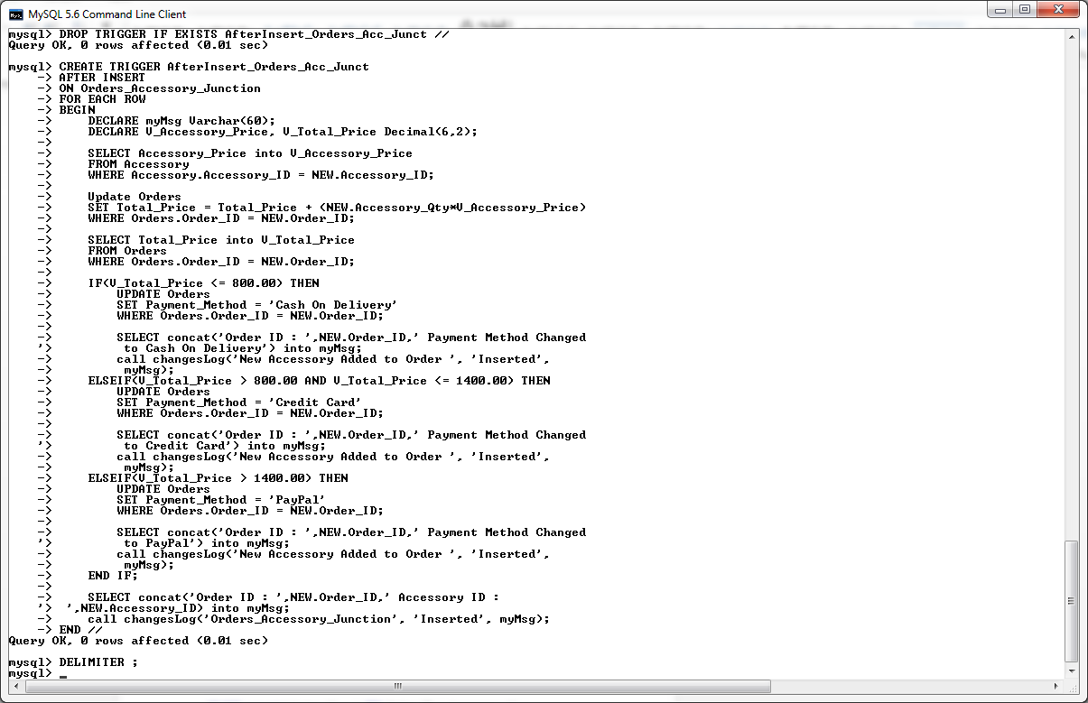

*Screenshot of AfterInsert_Orders_Acc_Junct trigger being created in MySQL console.*

**Testing the Before and After Insert Triggers on the Orders_Accessory_Junction Table**

**Test Before Insert Trigger**

Attempt to insert a duplicate entry :

**Insert** **into** Orders_Accessory_Junction **values** **(**'A105'**,** 'O103'**,** 3**);**

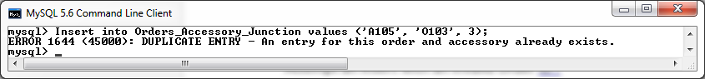

Attempt to insert an accessory quantity that exceeds the current quantity in stock for this accessory :

**SELECT** Accessory_Qty_InStock

**FROM** Accessory

**WHERE** Accessory_ID **=** 'A103'**;**

**Insert** **into** Orders_Accessory_Junction **values** **(**'A103'**,** 'O104'**,** 100**);**

**SELECT** Accessory_Qty_InStock

**FROM** Accessory

**WHERE** Accessory_ID **=** 'A103'**;**

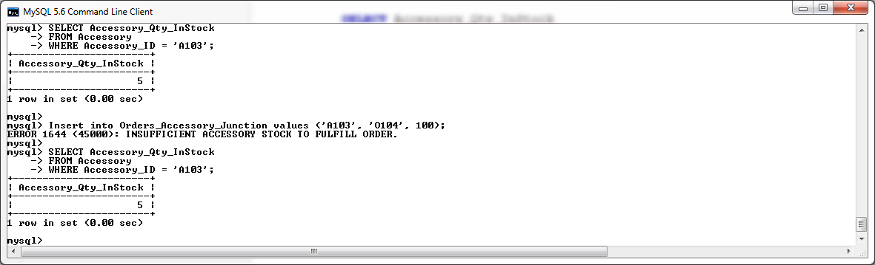

Attempt an insert with an invalid Order ID :

**Insert** **into** Orders_Accessory_Junction **values** **(**'A105'**,** 'O199'**,** 2**);**

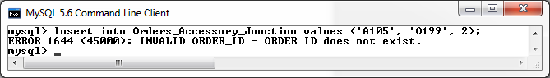

Attempt an insert with an invalid Accessory ID :

**Insert** **into** Orders_Accessory_Junction **values** **(**'A199'**,** 'O103'**,** 2**);**

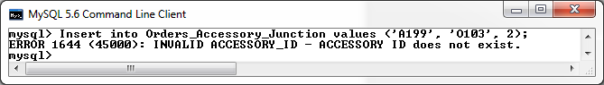

Attempt an insert with an invalid Accessory Quantity :

**Insert** **into** Orders_Accessory_Junction **values** **(**'A105'**,** 'O103'**,** **-**10**);**

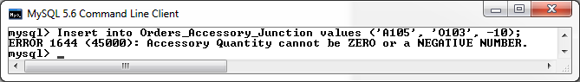

Attempt a Valid insert and ensure that the InStock Quantity in the accessory table is being correctly updated.

**SELECT** Accessory_Qty_InStock

**FROM** Accessory

**WHERE** Accessory_ID **=** 'A100'**;**

**Insert** **into** Orders_Accessory_Junction **values** **(**'A100'**,** 'O104'**,** 2**);**

**SELECT** Accessory_Qty_InStock

**FROM** Accessory

**WHERE** Accessory_ID **=** 'A100'**;**

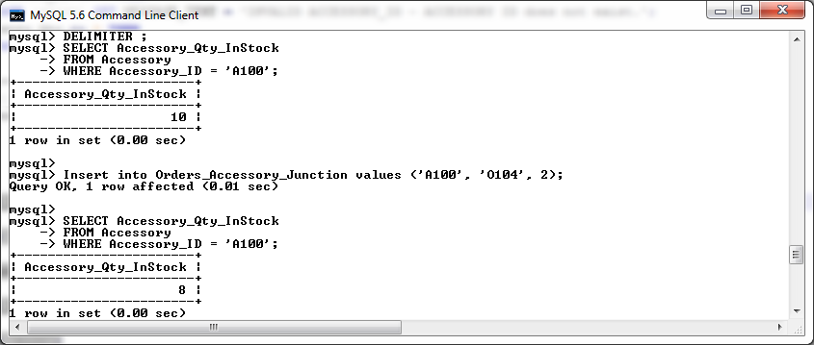

Verify entry with a select statement on the table.

**SELECT** **\*** **FROM** Orders_Accessory_Junction **WHERE** Accessory_ID **=** 'A100' **AND** Order_ID **=** 'O104'**;**

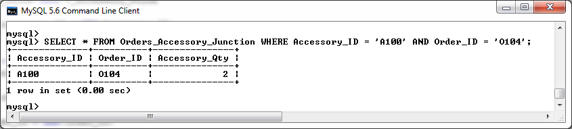

Test to ensure that the After Insert Trigger has called the changesLog Procedure and updated the log table to confirm the entry of the new record in the Orders_Accessory_Junction table.

**SELECT** **\*** **FROM** mysql_changesLog**;**

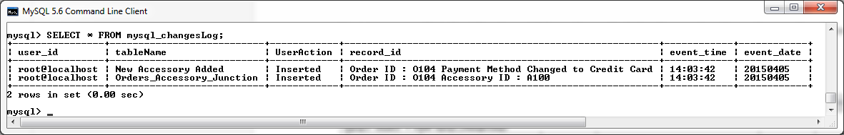

**Test After Insert Trigger**

First, we will create a new Order with a Payment_Method of ‘Cash on Delivery’ and a Total_Price of 0.00 euros.

**Insert** **into** Orders **values** **(**'O911'**,** 'DV105'**,** 9**,** '29-02-2015'**,**'Cash On Delivery'**,**0.00**);**

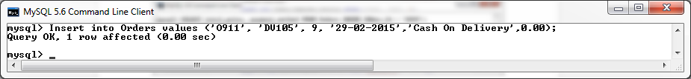

To confirm its entry we will perform a SELECT statement to retrieve the Payment_Method and Total_Price of the record.

**SELECT** total_price**,** payment_method **FROM** Orders **WHERE** Order_Id **=** 'O911'**;**

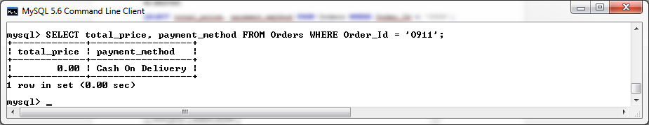

I will now begin adding accessories to this order via the Orders_Accessory_Junction table and validate that both the Total_Price and Payment_Method of the order are being updated as desired.

**SELECT** total_price**,** payment_method **FROM** Orders **WHERE** Order_Id **=** 'O911'**;**

**Insert** **into** Orders_Accessory_Junction **values** **(**'A104'**,** 'O911'**,** 9**);**

**SELECT** total_price**,** payment_method **FROM** Orders **WHERE** Order_Id **=** 'O911'**;**

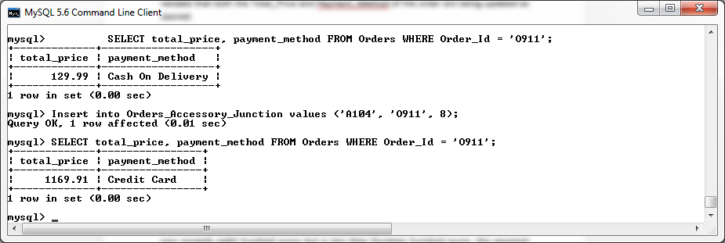

From the above screenshot we can now see that after 9 accessories valued at 129.99 euros each have being added to our new order through the junction table, the Total_Price of the order has being updated to reflect the addition of the recently added components, and also, because the Total_price field now exceeds eight hundred euros but is less than fourteen hundred euros, the payment method has been changed to reflect ‘Credit Card’ as desired.

I will now add another 4 of the same accessories to this order.

**SELECT** total_price**,** payment_method **FROM** Orders **WHERE** Order_Id **=** 'O911'**;**

**Insert** **into** Orders_Accessory_Junction **values** **(**'A104'**,** 'O911'**,** 4**);**

**SELECT** total_price**,** payment_method **FROM** Orders **WHERE** Order_Id **=** 'O911'**;**

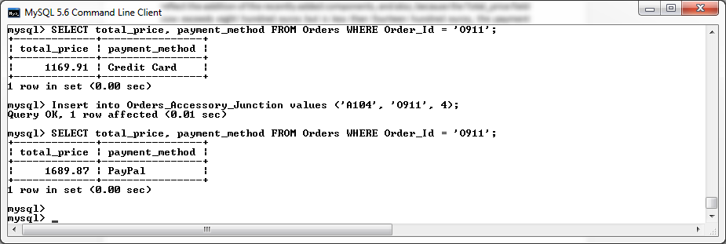

From the above screenshot we can now see that after another 2 accessories valued at 129.99 euros each have being added to our new order through the junction table, the Total_Price of the order has being updated to reflect the addition of these recently added accessories, and also, because the Total_price field now exceeds fourteen hundred euros, the payment method has been changed to reflect ‘Paypal’ as desired.

I shall now see if these changes made to the new order have been recorded in the log table.

**select** **\*** **from** mysql_changesLog**;**

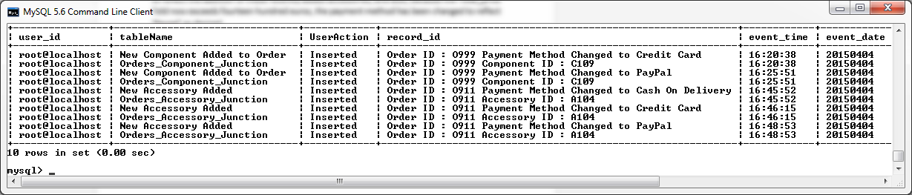

From the above screenshot we can see that the procedure has successfully logged all changes made to the order during testing.

**Before Insert on Orders Table Trigger**

The before insert trigger on the Orders table will be used to validate the following restrictions before a new record can be successfully added to the Orders table:

* The Discount Voucher ID of the new entry must exist within the Discount Voucher table.
* The Customer ID of the new entry must exist within the Customer table.
* The Customer Account that is referred to in the order must not be locked.

-- create BeforeInsert_Orders trigger

DELIMITER **//**

**DROP** **TRIGGER** **IF** **EXISTS** BeforeInsert_Orders**//**

**CREATE** **TRIGGER** BeforeInsert_Orders

**BEFORE** **INSERT**

**ON** Orders

**FOR** **EACH** **ROW**

**BEGIN**

**DECLARE** V_FOUND_DV_ID**,** V_FOUND_CUSTOMER_ID **Varchar(**40**);**

**DECLARE** V_ACCOUNT_LOCKED **int;**

**SELECT** **Count(**Discount_Voucher_ID**)** **into** V_FOUND_DV_ID

**FROM** Discount_Voucher

**WHERE** Discount_Voucher**.**Discount_Voucher_ID **=** **NEW.**Discount_Voucher_ID**;**

**SELECT** **Count(**Customer_ID**)** **into** V_FOUND_CUSTOMER_ID

**FROM** Customer

**WHERE** Customer**.**Customer_ID **=** **NEW.**Customer_ID**;**

**SELECT** Account_Lock **into** V_ACCOUNT_LOCKED

**FROM** Customer

**WHERE** Customer**.**Customer_ID **=** **NEW.**Customer_ID**;**

**IF** V_FOUND_DV_ID **<=** 0 **THEN**

SIGNAL **SQLSTATE** '45000' **SET** MESSAGE_TEXT **=** 'INVALID DISCOUNT_VOUCHER_ID - DISCOUNT VOUCHER ID does not exist.'**;**

ELSEIF V_FOUND_CUSTOMER_ID **<=** 0 **THEN**

SIGNAL **SQLSTATE** '45000' **SET** MESSAGE_TEXT **=** 'INVALID CUSTOMER_ID - CUSTOMER ID does not exist.'**;**

ELSEIF V_ACCOUNT_LOCKED **=** 1 **THEN**

SIGNAL **SQLSTATE** '45000' **SET** MESSAGE_TEXT **=** 'CUSTOMER ACCOUNT IS LOCKED - This Customer is unable to make any orders while his account is locked!.'**;**

**END** **IF;**

**END** **//**

DELIMITER **;**

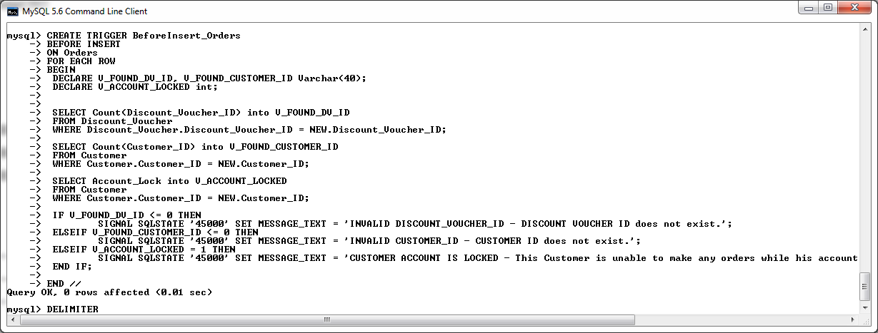

*Screenshot of BeforeInsert_Orders trigger being created in MySQL console.*

**After Insert on Orders Table Trigger**

The After Insert trigger on the Orders table will be used to facilitate updating the customer’s credit limit with a bonus based upon the total price of the order they have placed. This trigger will update the customer’s credit limit based on the following:

* If the order placed is less than one thousand euros, the customer shall receive a credit limit bonus of ten euro.
* If the order placed exceeds one thousand euros but is less than fifteen hundred euros, the customer shall receive a credit limit bonus of twenty euro.
* And finally, for all orders placed that exceed fifteen hundred euros, the customer shall receive a credit limit bonus of fifty euro.

Again, all changes made by this trigger shall be logged using the logChanges procedure.

**DROP** **TRIGGER** **IF** **EXISTS** AfterInsert_Orders **//**

**CREATE** **TRIGGER** AfterInsert_Orders

**AFTER** **INSERT**

**ON** Orders

**FOR** **EACH** **ROW**

**BEGIN**

**DECLARE** V_CREDIT_LIMIT_BONUS **Decimal(**6**,**2**);**

**DECLARE** myMsg **varchar(**40**);**

**IF(NEW.**Total_Price **<** 1000**)** **THEN**

**SET** V_CREDIT_LIMIT_BONUS **=** 10**;**

ELSEIF **(NEW.**Total_Price **>=** 1000 **AND** **NEW.**Total_Price **<** 1500**)** **THEN**

**SET** V_CREDIT_LIMIT_BONUS **=** 20**;**

ELSEIF **(NEW.**Total_Price **>=** 1500**)** **THEN**

**SET** V_CREDIT_LIMIT_BONUS **=** 50**;**

**END** **IF;**

**UPDATE** Customer

**SET** Credit_Limit **=** Credit_Limit **+** V_CREDIT_LIMIT_BONUS

**WHERE** Customer_ID **=** **New.**Customer_ID**;**

**SELECT** **concat(**'Credit Limit Updated by '**,**V_CREDIT_LIMIT_BONUS**)** **into** myMsg**;**

**call** changesLog**(**'Customer'**,** myMsg**,** **NEW.**Customer_ID**);**

**call** changesLog**(**'Order'**,** 'Inserted'**,** **NEW.**Order_ID**);**

**END** **//**

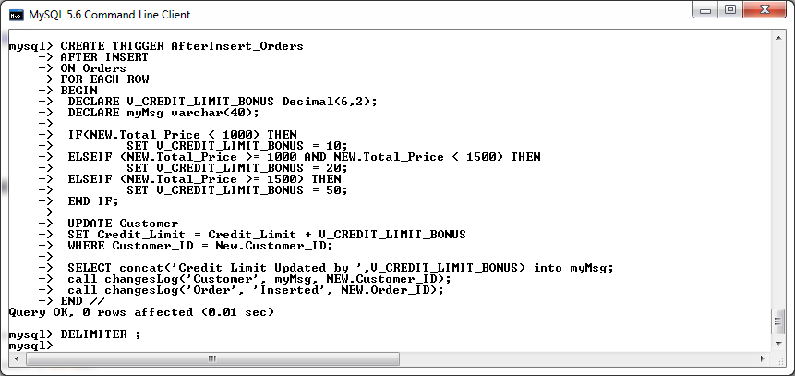

*Screenshot of AfterInsert_Orders trigger being created in MySQL console.*

**Testing the Before and After Insert Triggers on the Orders Table**

**Test Before Insert Trigger**

Attempt an insert with an invalid Discount Voucher :

**Insert** **into** Orders **values** **(**'O222'**,** 'DV999'**,** 1**,** '29-02-2015'**,**'Credit'**,**799.46**);**

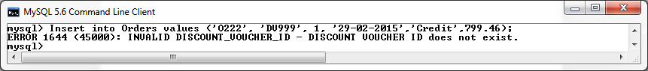

Attempt an insert with an invalid Customer ID:

**Insert** **into** Orders **values** **(**'O222'**,** 'DV105'**,** 999**,** '29-02-2015'**,**'Credit'**,**799.46**);**

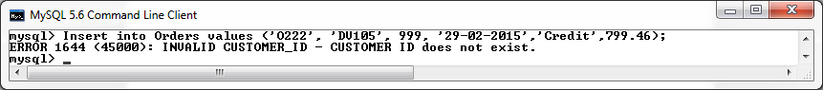

Attempt an insert with an Customer Account that is locked :

**Insert** **into** Orders **values** **(**'O222'**,** 'DV105'**,** 9**,** '29-02-2015'**,**'Credit'**,**799.46**);**

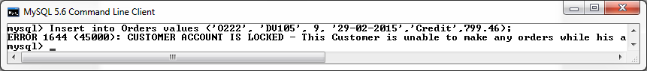

Attempt a Valid insert.

**Insert** **into** Orders **values** **(**'O123'**,** 'DV105'**,** 1**,** '29-02-2015'**,**'Credit'**,**799.46**);**

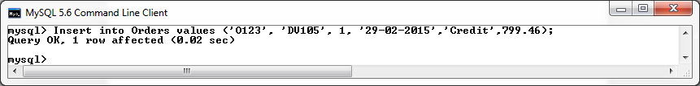

Verify entry with a select statement on the table.

**SELECT** **\*** **FROM** Orders **WHERE** Order_ID **=** 'O123'**;**

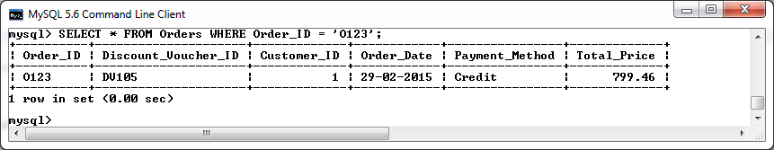

Test to ensure that the After Insert Trigger has called the changesLog Procedure and updated the log table to confirm the entry of the new record in the Orders_Accessory_Junction table.

**SELECT** **\*** **FROM** mysql_changesLog**;**

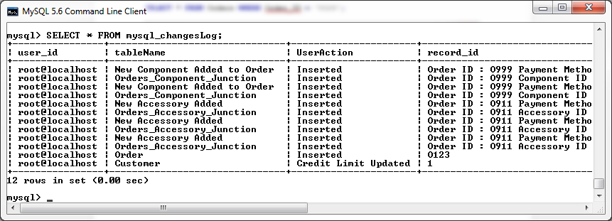

**Test After Insert Trigger**

Verify that the customer credit limit is been updated in respect to the order total.

Test that an order under one thousand euro increases the customer credit limit by ten euro.

**SELECT** Credit_Limit **FROM** Customer **WHERE** Customer_ID **=** 1**;**

**Insert** **into** Orders **values** **(**'O222'**,** 'DV105'**,** 1**,** '29-02-2015'**,**'Credit'**,**799.46**);**

**SELECT** Credit_Limit **FROM** Customer **WHERE** Customer_ID **=** 1**;**

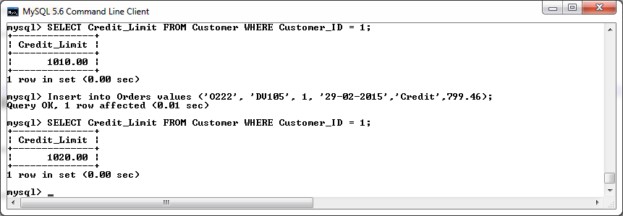

Test that an order which exceed one thousand euro and is less than fifteen hundred euro, increases the customer credit limit by twenty euro.

**SELECT** Credit_Limit **FROM** Customer **WHERE** Customer_ID **=** 1**;**

**Insert** **into** Orders **values** **(**'O223'**,** 'DV105'**,** 1**,** '29-02-2015'**,**'Credit'**,**1200.00**);**

**SELECT** Credit_Limit **FROM** Customer **WHERE** Customer_ID **=** 1**;**

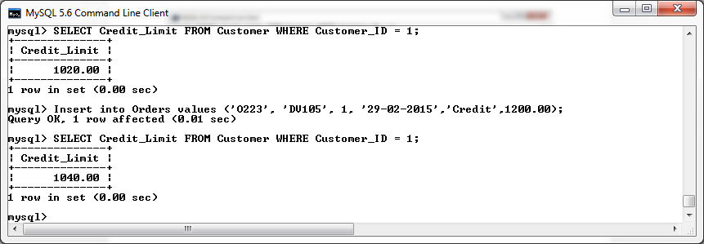

Test that an order that exceeds fifteen hundred euro increases the customer credit limit by fifty euro.

**SELECT** Credit_Limit **FROM** Customer **WHERE** Customer_ID **=** 1**;**

**Insert** **into** Orders **values** **(**'O224'**,** 'DV105'**,** 1**,** '29-02-2015'**,**'Credit'**,**1650.00**);**

**SELECT** Credit_Limit **FROM** Customer **WHERE** Customer_ID **=** 1**;**

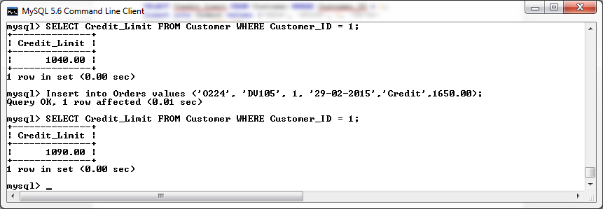

Verify that the changesLog procedure has updated the log table to reflect the changes made.

**select** **\*** **from** mysql_changesLog**;**

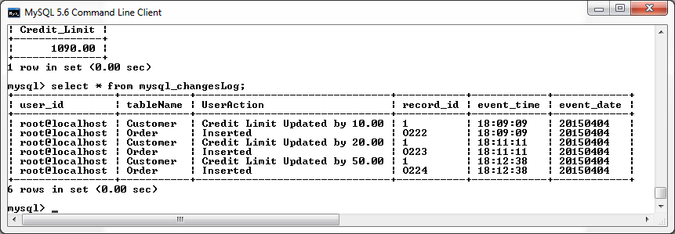

## Before /After Update Triggers

**Before Update on Components Table Trigger**

The before Update trigger on the components table will be used to validate the following restrictions before a record can be successfully updated on the components table:

* The updated entry must specify a component category of one of the following options:
  + Processors
  + Storage
  + Motherboard
  + Video Card
  + Case
  + RAM
* The updated entry must reference a manufacturer_id that already exists within the Component_Manufacturer table.
* It company policy to not offer more than 5 components from one individual manufacturer. If the updated entry is in breach of this policy, the new entry will be rejected.
* The price of the updated entry must not be a negative number.
* The name of the updated entry cannot be less than six characters in length.
* The description of the updated entry cannot be less than ten characters in length.
* The quantity in stock of the updated entry must not be a negative number.

An update failing to comply with these rules will be rejected and return a suitable error message.

-- create BeforeUpdate_Components trigger

DELIMITER **//**

**DROP** **TRIGGER** **IF** **EXISTS** BeforeUpdate_Components **//**

**CREATE** **TRIGGER** BeforeUpdate_Components

**BEFORE** **UPDATE**

**ON** Component

**FOR** **EACH** **ROW**

**BEGIN**

**DECLARE** FOUND_MANU_ID**,** NO_OF_COMPS **INT;**

**SELECT** **COUNT(*)** **INTO** FOUND_MANU_ID

**FROM** Component_Manufacturer

**WHERE** Manu_ID **=** **NEW.**Comp_Manu_ID**;**

**SELECT** **COUNT(*)** **INTO** NO_OF_COMPS

**FROM** Component

**WHERE** Component**.**Comp_Manu_ID **=** **NEW.**Comp_Manu_ID**;**

**IF** **(NEW.**Component_Category **!=** **OLD.**Component_Category**)** **AND** **(NEW.**Component_Category **NOT** **IN(**'Processors'**,**'Storage'**,**'MotherBoard'**,** 'Video

Card'**,**'Case'**,** 'RAM'**))** **THEN**

SIGNAL **SQLSTATE** '45000' **SET** MESSAGE_TEXT **=** 'INVALID CATEGORY Entered'**;**

ELSEIF **(NEW.**Comp_Manu_ID **!=** **OLD.**Comp_Manu_ID**)** **AND** **(**FOUND_MANU_ID **<=** 0**)** **THEN**

SIGNAL **SQLSTATE** '45000' **SET** MESSAGE_TEXT **=** 'INVALID MANUFACTURER_ID –

Manufacturer ID does not exist.'**;**

ELSEIF **(NEW.**Component_ID **!=** **OLD.**Component_ID**)** **AND** **(**NO_OF_COMPS **>=** 5**)** **THEN**

SIGNAL **SQLSTATE** '45000' **SET** MESSAGE_TEXT **=** 'BREACH OF COMPANY POLICY - It

it company policy to not offer more than 5 components from one individual

manufacturer.'**;**

ELSEIF **(NEW.**Component_Price **!=** **OLD.**Component_Price**)** **AND** **(NEW.**Component_Price **<** 0**)** **THEN**

SIGNAL **SQLSTATE** '45000' **SET** MESSAGE_TEXT **=** 'Price cannot be a NEGATIVE

NUMBER. '**;**

ELSEIF **(NEW.**Component_Name **!=** **OLD.**Component_Name**)** **AND** **(LENGTH(NEW.**Component_Name**))** **<** 6 **THEN**

SIGNAL **SQLSTATE** '45000' **SET** MESSAGE_TEXT **=** 'Component Name CANNOT BE LESS

THAN SIX CHARACTERS in lenght'**;**

ELSEIF **(NEW.**Component_Description **!=** **OLD.**Component_Description**)** **AND** **(LENGTH(NEW.**Component_Description**))** **<** 10 **THEN**

SIGNAL **SQLSTATE** '45000' **SET** MESSAGE_TEXT **=** 'Component Description CANNOT BE

LESS THAN TEN CHARACTERS in lenght'**;**

ELSEIF **(NEW.**Component_Qty_InStock **!=** **OLD.**Component_Qty_InStock**)** **AND** **(NEW.**Component_Qty_InStock **<=** 0**)** **THEN**

SIGNAL **SQLSTATE** '45000' **SET** MESSAGE_TEXT **=** 'Component Quantity In Stock

cannot be a NEGATIVE NUMBER. '**;**

**END** **IF;**

**END** **//**

DELIMITER **;**

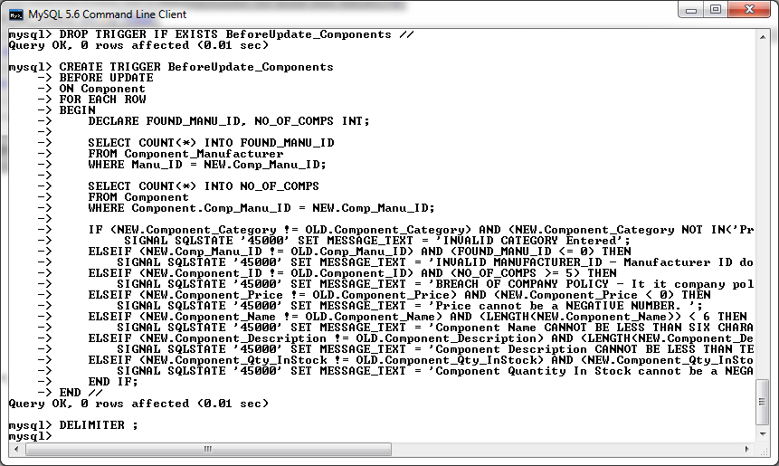

*Screenshot of BeforeUpdate_Components trigger being created in MySQL console.*

**After Update on Component Trigger**

The after Update trigger on the components table will be used to call the “changesLog” procedure to log all changes that have being made to the Components table.

-- create AfterUpdate_Components trigger

DELIMITER **//**

**DROP** **TRIGGER** **IF** **EXISTS** AfterUpdate_Components **//**

**CREATE** **TRIGGER** AfterUpdate_Components

**AFTER** **UPDATE**

**ON** Component

**FOR** **EACH** **ROW**

**BEGIN**

**call** changesLog**(**'Component'**,** 'Updated'**,** **NEW.**Component_ID**);**

**END** **//**

DELIMITER **;**

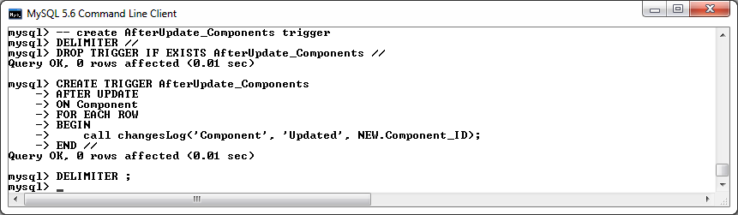

*Screenshot of AfterUpdate_Components trigger being created in MySQL console.*

**Testing the Before and After Update Triggers on the Component Table**

Attempt an update with an invalid category then a valid category, then verify update with a select statement on the component record :

**UPDATE** Component

**SET** Component_Category **=** 'Invalid'

**WHERE** Component_ID **=** 'C100'**;**

**UPDATE** Component

**SET** Component_Category **=** 'Processors'

**WHERE** Component_ID **=** 'C100'**;**

**SELECT** **\*** **FROM** Component **WHERE** Component_ID **=** 'C100'**;**

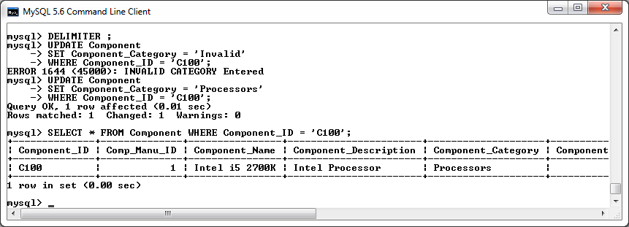

Attempt an update with an invalid Price then a valid Price, then verify update with a select statement on the component record :

**UPDATE** Component

**SET** Component_Price **=** **-**10

**WHERE** Component_ID **=** 'C100'**;**

**UPDATE** Component

**SET** Component_Price **=** 100

**WHERE** Component_ID **=** 'C100'**;**

**SELECT** **\*** **FROM** Component **WHERE** Component_ID **=** 'C100'**;**

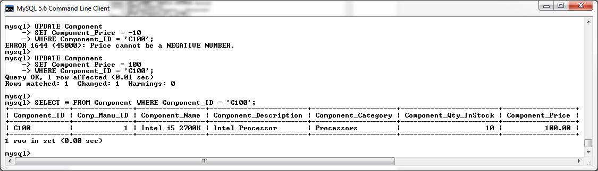

Attempt an update with an invalid Manufacturer ID then a valid Manufacturer ID, then verify update with a select statement on the component record :

**UPDATE** Component

**SET** Component_Price **=** **-**10

**WHERE** Component_ID **=** 'C100'**;**

**UPDATE** Component

**SET** Component_Price **=** 100

**WHERE** Component_ID **=** 'C100'**;**

**SELECT** **\*** **FROM** Component **WHERE** Component_ID **=** 'C100'**;**

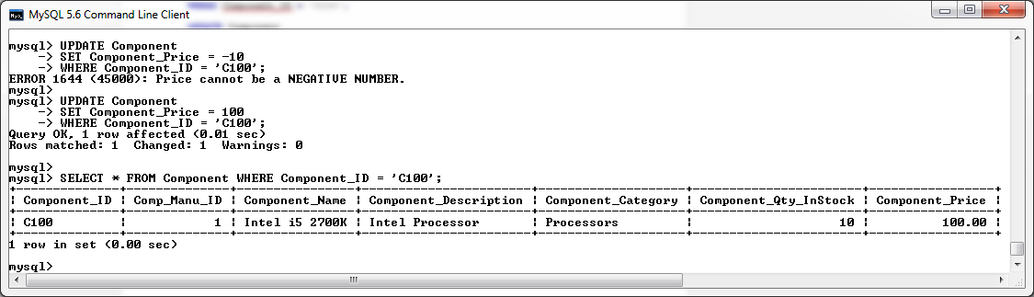

Attempt an update with an invalid Manufacturer ID then a valid Manufacturer ID, then verify update with a select statement on the component record :

**UPDATE** Component

**SET** Comp_Manu_ID **=** 999

**WHERE** Component_ID **=** 'C100'**;**

**UPDATE** Component

**SET** Comp_Manu_ID **=** 1

**WHERE** Component_ID **=** 'C100'**;**

**SELECT** **\*** **FROM** Component **WHERE** Component_ID **=** 'C100'**;**

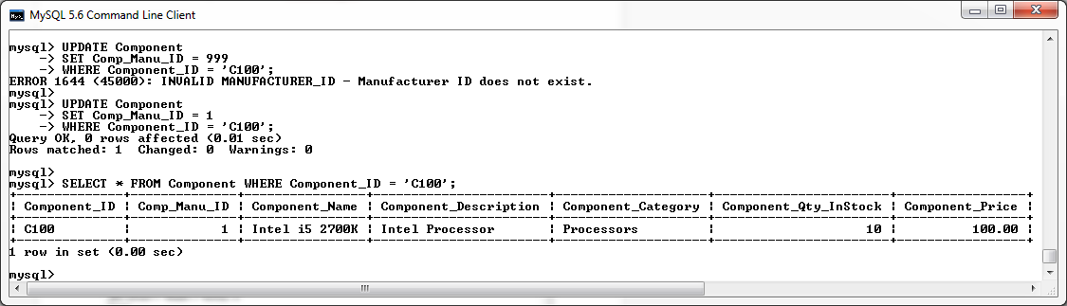

Attempt an update with an invalid Component Name then a valid Component Name, then verify update with a select statement on the component record :

**UPDATE** Component

**SET** Component_Name **=** 'test'

**WHERE** Component_ID **=** 'C100'**;**

**UPDATE** Component

**SET** Component_Name **=** 'newTestName'

**WHERE** Component_ID **=** 'C100'**;**

**SELECT** **\*** **FROM** Component **WHERE** Component_ID **=** 'C100'**;**

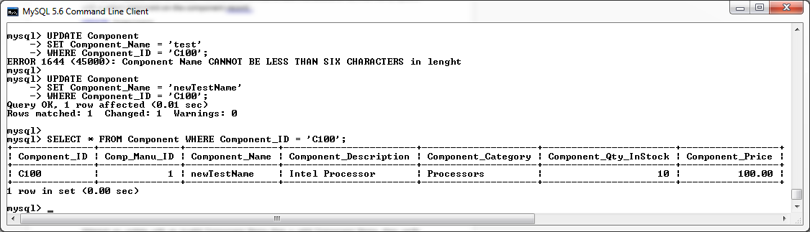

Attempt an update with an invalid Component Description then a valid Component Description, then verify update with a select statement on the component record :

**UPDATE** Component

**SET** Component_Description **=** 'test'

**WHERE** Component_ID **=** 'C100'**;**

**UPDATE** Component

**SET** Component_Description **=** 'valid comp description'

**WHERE** Component_ID **=** 'C100'**;**

**SELECT** **\*** **FROM** Component **WHERE** Component_ID **=** 'C100'**;**

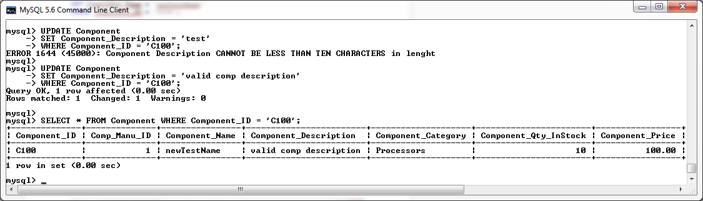

Attempt an update with an invalid Component Quantity then a valid Component Quantity, then verify update with a select statement on the component record :

**UPDATE** Component

**SET** Component_Qty_InStock **=** **-**10

**WHERE** Component_ID **=** 'C100'**;**

**UPDATE** Component

**SET** Component_Qty_InStock **=** 15

**WHERE** Component_ID **=** 'C100'**;**

**SELECT** **\*** **FROM** Component **WHERE** Component_ID **=** 'C100'**;**

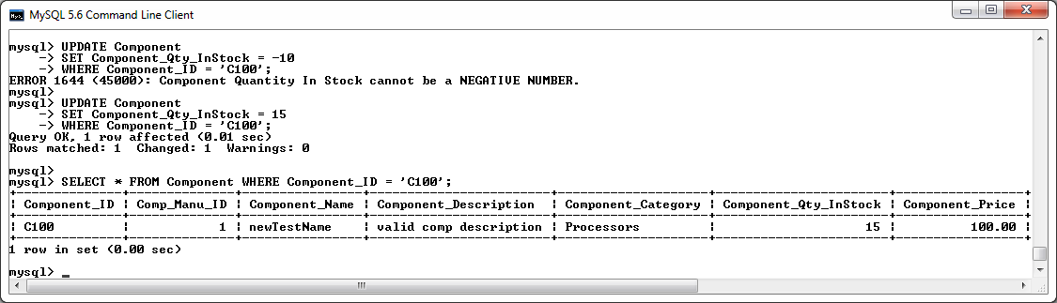

Verify all changes have been logged by the After Update trigger calling the changesLog Procedure.

**SELECT** **\*** **FROM** mysql_changesLog**;**

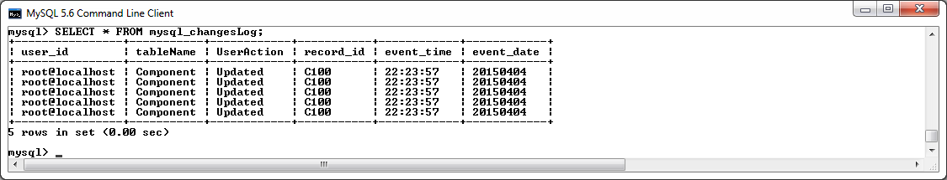

**Before Update on Component Manufacturer Trigger**

The before update trigger on the components manufacturers table will be used to validate the following restrictions before an update record can be successfully performed on the components table:

* The name of the updated entry cannot be less than six characters in length.
* The address of the updated entry cannot be less than ten characters in length.
* The country of the updated entry cannot be less than four characters in length.
* The email of the updated entry must contain an “@” symbol.
* The phone number of the updated entry must contain a “-“symbol.
* The website address of the updated entry must end with “.com“, “.ie” or “.eu”.

An update failing to comply with these rules will be rejected and return a suitable error message.

-- create BeforeUpate_CompManu trigger

DELIMITER **//**

**DROP** **TRIGGER** **IF** **EXISTS** BeforeUpate_CompManu **//**

**CREATE** **TRIGGER** BeforeUpate_CompManu

**BEFORE** **UPDATE**

**ON** Component_Manufacturer

**FOR** **EACH** **ROW**

**BEGIN**

**IF** **(NEW.**Manu_Name **!=** **OLD.**Manu_Name**)** **AND** **(LENGTH(NEW.**Manu_Name**)** **<** 6**)** **THEN**

SIGNAL **SQLSTATE** '45000' **SET** MESSAGE_TEXT **=** 'Component Manufacturer Name CANNOT BE LESS

THAN SIX CHARACTERS in length'**;**

ELSEIF **(NEW.**Manu_Address **!=** **OLD.**Manu_Address**)** **AND** **(LENGTH(NEW.**Manu_Address**)** **<** 10**)** **THEN**

SIGNAL **SQLSTATE** '45000' **SET** MESSAGE_TEXT **=** 'Component Manufacturer Address CANNOT BE

LESS THAN TEN CHARACTERS in length'**;**

ELSEIF **(NEW.**Manu_Country **!=** **OLD.**Manu_Country**)** **AND** **(LENGTH(NEW.**Manu_Country**)** **<** 4**)** **THEN**

SIGNAL **SQLSTATE** '45000' **SET** MESSAGE_TEXT **=** 'Component Manufacturer country CANNOT BE

LESS THAN Four CHARACTERS in length'**;**

ELSEIF **(NEW.**Manu_Email **!=** **OLD.**Manu_Email**)** **AND** **(NEW.**Manu_Email **NOT** **LIKE** '%@%'**)** **THEN**

SIGNAL **SQLSTATE** '45000' **SET** MESSAGE_TEXT **=** 'Component Manufacturer email must contain

an @ symbol.'**;**

ELSEIF **(NEW.**Manu_Phone **!=** **OLD.**Manu_Phone**)** **AND** **(NEW.**Manu_Phone **NOT** **LIKE** '%-%'**)** **THEN**

SIGNAL **SQLSTATE** '45000' **SET** MESSAGE_TEXT **=** 'Component Manufacturer phone must contain

an - symbol.'**;**

ELSEIF **(NEW.**Web_Site **!=** **OLD.**Web_Site**)** **AND** **(NEW.**Web_Site **NOT** **LIKE** '%.com' **AND** **NEW.**Web_Site **NOT** **LIKE** '%.ie' **AND** **NEW.**Web_Site **NOT** **LIKE** '%.eu'**)** **THEN**

SIGNAL **SQLSTATE** '45000' **SET** MESSAGE_TEXT **=** 'Component Manufacturer website address of

the new entry must end with .com, .ie or .eu.'**;**

**END** **IF;**

**END** **//**

DELIMITER **;**

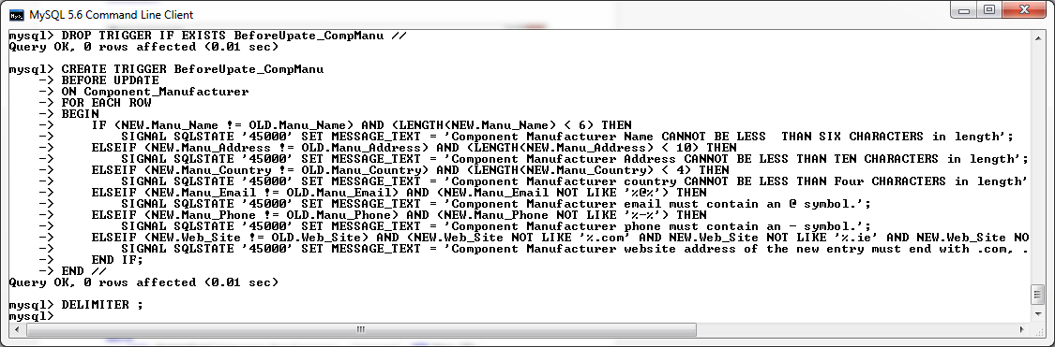

*Screenshot of BeforeUpdate_CompManu trigger being created in MySQL console.*

**After Insert on Component_Manufacturer Trigger**

The after update trigger on the Component_Manufacturer table will be used to call the “changesLog” procedure to log all changes that have being made to the Component_Manufacturer table.

-- create AfterUpdate_CompManu trigger

DELIMITER **//**

**DROP** **TRIGGER** **IF** **EXISTS** AfterUpdate_CompManu **//**

**CREATE** **TRIGGER** AfterUpdate_CompManu

**AFTER** **UPDATE**

**ON** Component_Manufacturer

**FOR** **EACH** **ROW**

**BEGIN**

**call** changesLog**(**'Component_Manufacturer'**,** 'Updated'**,** **NEW.**Manu_ID**);**

**END** **//**

DELIMITER **;**

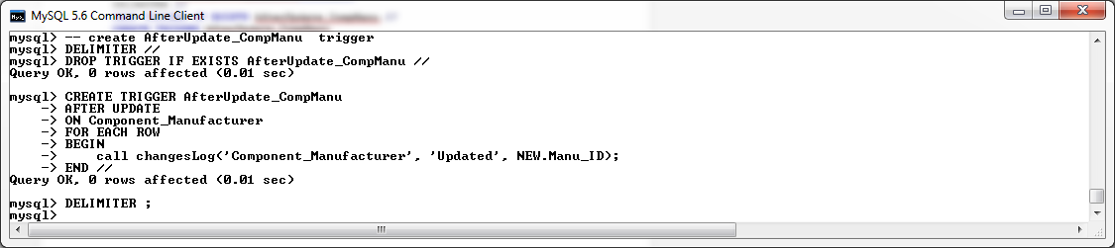

*Screenshot of AfterInsert_CompManu trigger being created in MySQL console.*

**Testing the Before and After Update Triggers on the Component Manufacturer Table**

Attempt an update with an invalid Manufacturer Name then a valid Manufacturer Name, then verify update with a select statement on the component manufacturer record :

**UPDATE** Component_Manufacturer

**SET** Manu_Name **=** 'test'

**WHERE** Manu_ID **=** 4**;**

**UPDATE** Component_Manufacturer

**SET** Manu_Name **=** 'MartinInc'

**WHERE** Manu_ID **=** 4**;**

**SELECT** **\*** **FROM** Component_Manufacturer **WHERE** Manu_ID **=** 4**;**

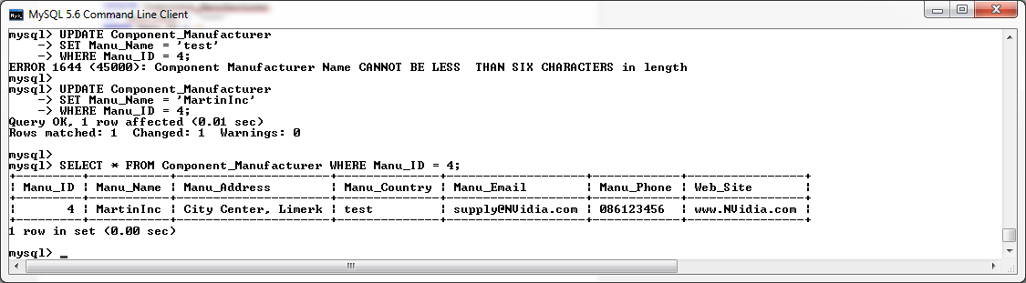

Attempt an update with an invalid Manufacturer Address then a valid Manufacturer Address, then verify update with a select statement on the component manufacturer record :

**UPDATE** Component_Manufacturer

**SET** Manu_Address **=** 'test'

**WHERE** Manu_ID **=** 4**;**

**UPDATE** Component_Manufacturer

**SET** Manu_Address **=** 'Main Street, Galway'

**WHERE** Manu_ID **=** 4**;**

**SELECT** **\*** **FROM** Component_Manufacturer **WHERE** Manu_ID **=** 4**;**

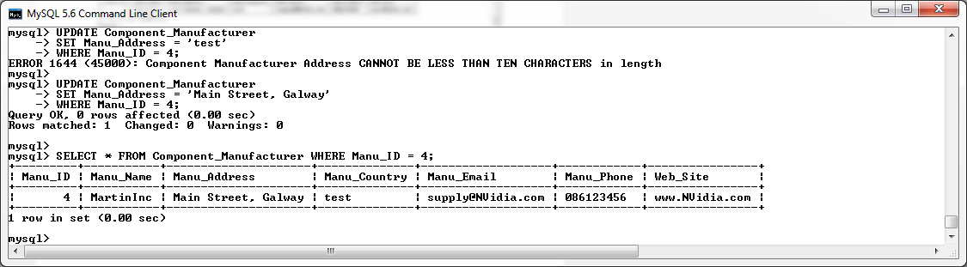

Attempt an update with an invalid Manufacturer Country then a valid Manufacturer Country, then verify update with a select statement on the component manufacturer record :

**UPDATE** Component_Manufacturer

**SET** Manu_Country **=** 'bad'

**WHERE** Manu_ID **=** 4**;**

**UPDATE** Component_Manufacturer

**SET** Manu_Country **=** 'Ireland'

**WHERE** Manu_ID **=** 4**;**

**SELECT** **\*** **FROM** Component_Manufacturer **WHERE** Manu_ID **=** 4**;**

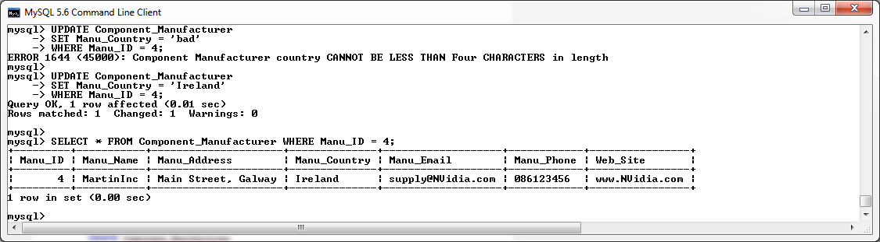

Attempt an update with an invalid Manufacturer Email then a valid Manufacturer Email, then verify update with a select statement on the component manufacturer record :

**UPDATE** Component_Manufacturer

**SET** Manu_Email **=** 'testemail.com'

**WHERE** Manu_ID **=** 4**;**

**UPDATE** Component_Manufacturer

**SET** Manu_Email **=** 'test@email.com'

**WHERE** Manu_ID **=** 4**;**

**SELECT** **\*** **FROM** Component_Manufacturer **WHERE** Manu_ID **=** 4**;**

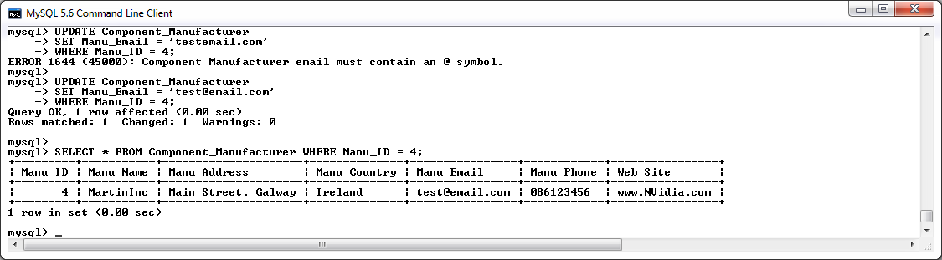

Attempt an update with an invalid Manufacturer Phone then a valid Manufacturer Phone, then verify update with a select statement on the component manufacturer record :

**UPDATE** Component_Manufacturer

**SET** Manu_Phone **=** '086654321'

**WHERE** Manu_ID **=** 4**;**

**UPDATE** Component_Manufacturer

**SET** Manu_Phone **=** '086-654321'

**WHERE** Manu_ID **=** 4**;**

**SELECT** **\*** **FROM** Component_Manufacturer **WHERE** Manu_ID **=** 4**;**

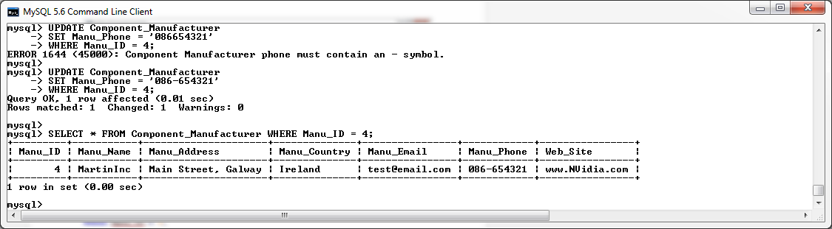

Attempt an update with an invalid Manufacturer Website then a valid Manufacturer Website, then verify update with a select statement on the component manufacturer record :

**UPDATE** Component_Manufacturer

**SET** Web_Site **=** 'bad_website'

**WHERE** Manu_ID **=** 4**;**

**UPDATE** Component_Manufacturer

**SET** Web_Site **=** 'testAddress.com'

**WHERE** Manu_ID **=** 4**;**

**SELECT** **\*** **FROM** Component_Manufacturer **WHERE** Manu_ID **=** 4**;**

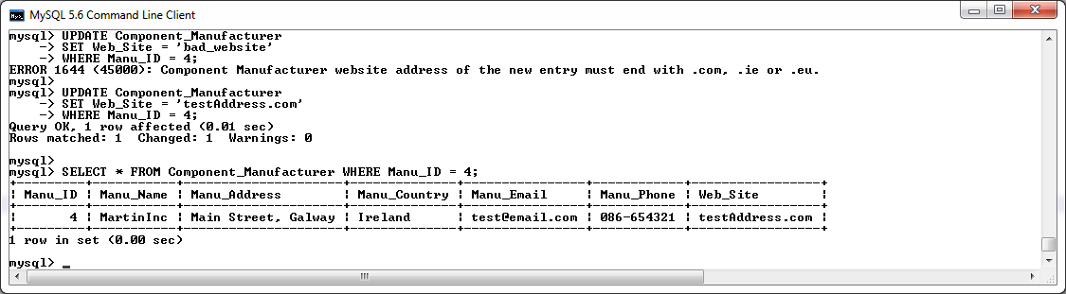

Verify all changes have been logged by the After Update trigger calling the changesLog Procedure.

**SELECT** **\*** **FROM** mysql_changesLog**;**

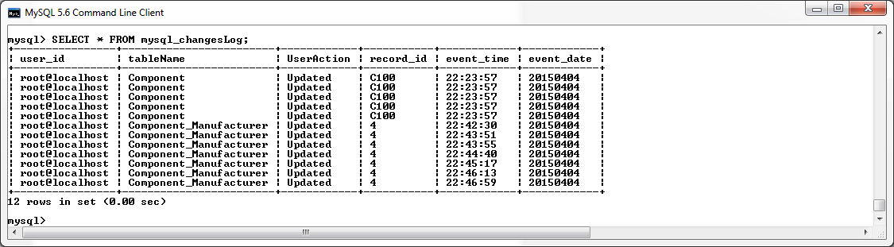

**Before Update on Accessory Trigger**

The before update trigger on the Accessory table will be used to validate the following restrictions before an update can be successfully made to the Accessory table:

* The name of the updated entry cannot be less than six characters in length.
* The description of the updated entry cannot be less than ten characters in length.
* The updated entry must specify an accessory category of one of the following options:
  + Mouse
  + Keyboard
  + Speakers
  + Headset
  + Webcam
* The quantity in stock of the updated entry must be not be a negative number.
* The price number of the updated entry cannot be less than the average price of all components in its category'.

An update failing to comply with these rules will be rejected and return a suitable error message.

-- create BeforeUpdate_Accessory trigger

DELIMITER **//**

**DROP** **TRIGGER** **IF** **EXISTS** BeforeUpdate_Accessory **//**

**CREATE** **TRIGGER** BeforeUpdate_Accessory

**BEFORE** **UPDATE**

**ON** Accessory

**FOR** **EACH** **ROW**

**BEGIN**

**DECLARE** V_Avg_Price **decimal(**6**,**2**);**

**SELECT** **AVG(**Accessory_Price**)** **into** V_Avg_Price

**FROM** Accessory

**WHERE** Accessory_Category **=** **New.**Accessory_Category**;**

**IF** **(NEW.**Accessory_Name **!=** **OLD.**Accessory_Name**)** **AND** **(LENGTH(NEW.**Accessory_Name**)** **<** 6**)** **THEN**

SIGNAL **SQLSTATE** '45000' **SET** MESSAGE_TEXT **=** 'Accessory Name CANNOT BE LESS THAN SIX

CHARACTERS in length'**;**

ELSEIF **(NEW.**Accessory_Description **!=** **OLD.**Accessory_Description**)** **AND** **(LENGTH(NEW.**Accessory_Description**)** **<** 10**)** **THEN**

SIGNAL **SQLSTATE** '45000' **SET** MESSAGE_TEXT **=** 'Accessory Description CANNOT BE LESS THAN

TEN CHARACTERS in length'**;**

ELSEIF **(NEW.**Accessory_Category **!=** **OLD.**Accessory_Category**)** **AND** **(NEW.**Accessory_Category **NOT** **IN(**'Mouse'**,**'Keyboard'**,**'Speakers'**,** 'Headset'**,** 'Webcam'**))** **THEN**

SIGNAL **SQLSTATE** '45000' **SET** MESSAGE_TEXT **=** 'INVALID CATEGORY Entered'**;**

ELSEIF **(NEW.**Accessory_Qty_InStock **!=** **OLD.**Accessory_Qty_InStock**)** **AND** **(NEW.**Accessory_Qty_InStock **<** 0**)** **THEN**

SIGNAL **SQLSTATE** '45000' **SET** MESSAGE_TEXT **=** 'Component Quantity In Stock must be

greater than zero.'**;**

ELSEIF **(NEW.**Accessory_Price **!=** **OLD.**Accessory_Price**)** **AND** **(NEW.**Accessory_Price **<** V_Avg_Price**)** **THEN**

SIGNAL **SQLSTATE** '45000' **SET** MESSAGE_TEXT **=** 'Accessory Price cannot be less than the

average price of all components in its category'**;**

**END** **IF;**

**END** **//**

DELIMITER **;**

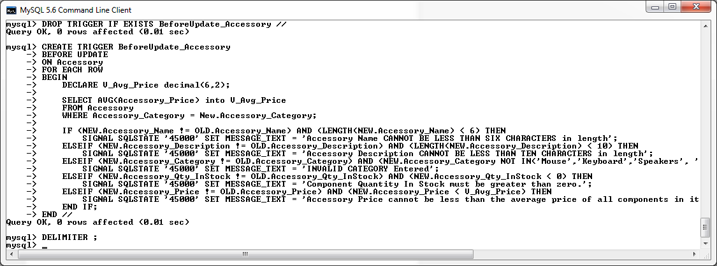

*Screenshot of BeforeUpdate_Accessory trigger being created in MySQL console.*

**After Update on Accessory Trigger**

The after update trigger on the components table will be used to call the “changesLog” procedure to log all changes that have being made to the Accessory table.

-- create AfterInsert_Accessory trigger

DELIMITER **//**

**DROP** **TRIGGER** **IF** **EXISTS** AfterInsert_Accessory **//**

**CREATE** **TRIGGER** AfterInsert_Accessory

**AFTER** **INSERT**

**ON** Accessory

**FOR** **EACH** **ROW**

**BEGIN**

**call** changesLog**(**'Accessory'**,** 'Inserted'**,** **NEW.**Accessory_ID**);**

**END** **//**

DELIMITER **;**

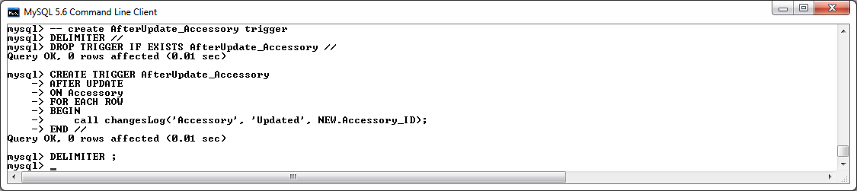

*Screenshot of AfterUpdate_Accessory trigger being created in MySQL console.*

**Testing the Before and After Update Triggers on the Accessory Table**

Attempt an update with an invalid Accessory Name then a valid Accessory Name, then verify update with a select statement on the accessory record :

**UPDATE** Accessory

**SET** Accessory_Name **=** 'test'

**WHERE** Accessory_ID **=** 'A100'**;**

**UPDATE** Accessory

**SET** Accessory_Name **=** 'AValidName'

**WHERE** Accessory_ID **=** 'A100'**;**

**SELECT** **\*** **FROM** Accessory **WHERE** Accessory_ID **=** 'A100'**;**

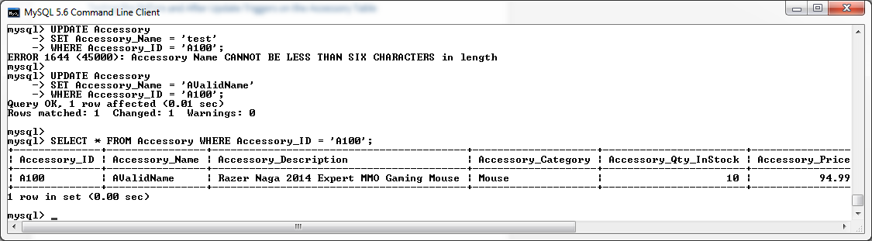

Attempt an update with an invalid Accessory Description then a valid Accessory Description, then verify update with a select statement on the accessory record :

**UPDATE** Accessory

**SET** Accessory_Description **=** 'test'

**WHERE** Accessory_ID **=** 'A100'**;**

**UPDATE** Accessory

**SET** Accessory_Description **=** 'AValidDescription'

**WHERE** Accessory_ID **=** 'A100'**;**

**SELECT** **\*** **FROM** Accessory **WHERE** Accessory_ID **=** 'A100'**;**

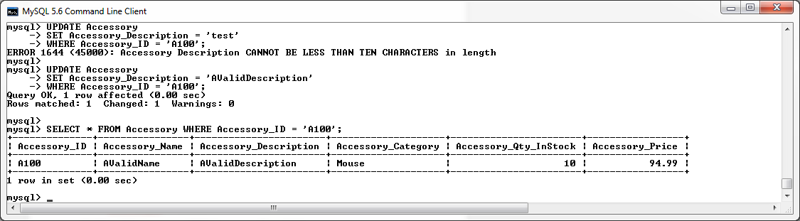

Attempt an update with an invalid Accessory Category then a valid Accessory Category, then verify update with a select statement on the accessory record :

**UPDATE** Accessory

**SET** Accessory_Category **=** 'test'

**WHERE** Accessory_ID **=** 'A100'**;**

**UPDATE** Accessory

**SET** Accessory_Category **=** 'Keyboard'

**WHERE** Accessory_ID **=** 'A100'**;**

**SELECT** **\*** **FROM** Accessory **WHERE** Accessory_ID **=** 'A100'**;**

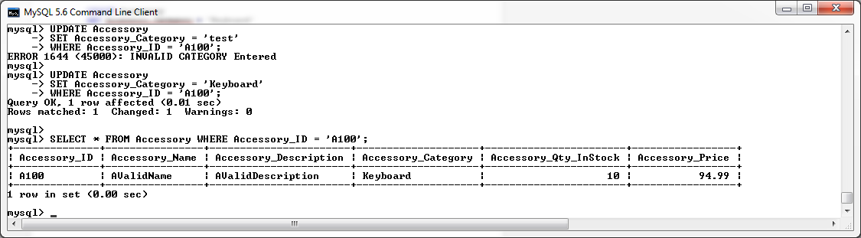

Attempt an update with an invalid Accessory Quantity_InStock then a valid Accessory Quantity_InStock, then verify update with a select statement on the accessory record :

**UPDATE** Accessory

**SET** Accessory_Qty_InStock **=** **-**10

**WHERE** Accessory_ID **=** 'A100'**;**

**UPDATE** Accessory

**SET** Accessory_Qty_InStock **=** 10

**WHERE** Accessory_ID **=** 'A100'**;**

**SELECT** **\*** **FROM** Accessory **WHERE** Accessory_ID **=** 'A100'**;**

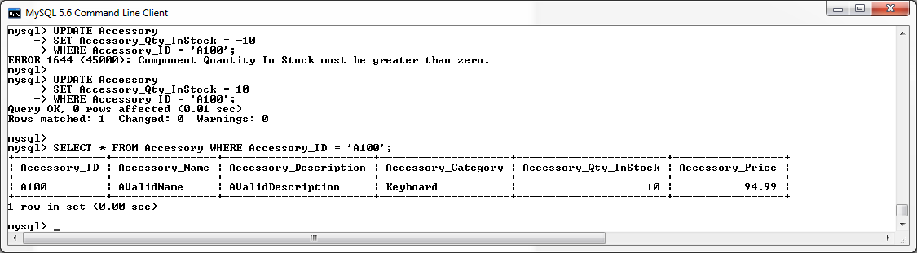

Attempt an update with an invalid Accessory Price then a valid Accessory Price, then verify update with a select statement on the accessory record :

**UPDATE** Accessory

**SET** Accessory_Price **=** 60

**WHERE** Accessory_ID **=** 'A100'**;**

**UPDATE** Accessory

**SET** Accessory_Price **=** 1000

**WHERE** Accessory_ID **=** 'A100'**;**

**SELECT** **\*** **FROM** Accessory **WHERE** Accessory_ID **=** 'A100'**;**

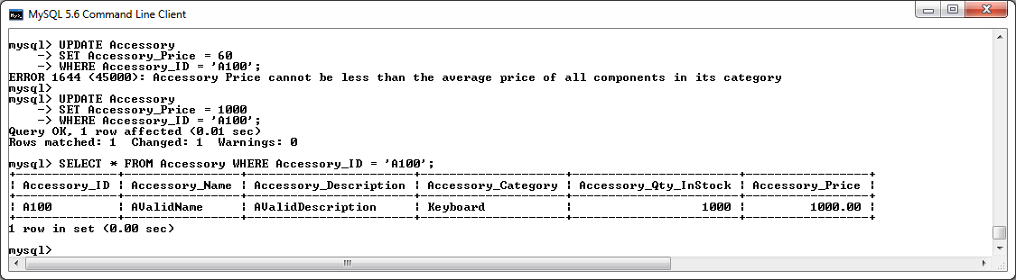

Verify all changes have been logged by the After Update trigger calling the changesLog Procedure.

**SELECT** **\*** **FROM** mysql_changesLog**;**

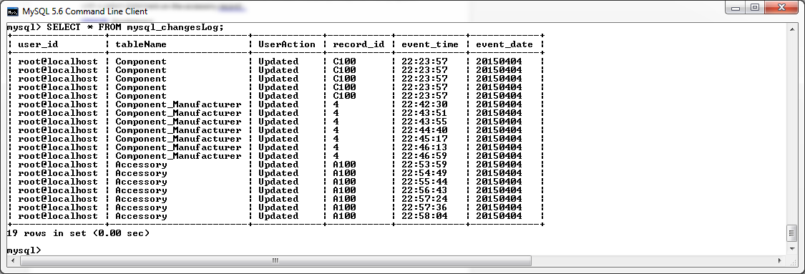

**Before Update on Customer Trigger**

The before update trigger on the Customer table will be used to validate the following restrictions before an update can be successfully made to the Customer table:

* The name of the updated entry cannot be less than six characters in length.
* The address of the updated entry cannot be less than ten characters in length.
* The email of the updated entry must contain an “@” symbol.
* The phone number of the updated entry must contain a “-“symbol.
* The updated Customer Credit Limit cannot exceed the Credit Limit of all current Customers whose account is not locked.

An update failing to comply with these rules will be rejected and return a suitable error message.

DELIMITER **//**

**DROP** **TRIGGER** **IF** **EXISTS** BeforeUpdate_Customer **//**

**CREATE** **TRIGGER** BeforeUpdate_Customer

**BEFORE** **UPDATE**

**ON** Customer

**FOR** **EACH** **ROW**

**BEGIN**

**DECLARE** V_Avg_Credit_Limit **decimal(**6**,**2**);**

**SELECT** **AVG(**Credit_Limit**)** **into** V_Avg_Credit_Limit

**FROM** Customer

**WHERE** Account_Lock **=** 0**;**

**IF** **(OLD.**Customer_Name **!=** **NEW.**Customer_Name**)** **AND** **(LENGTH(NEW.**Customer_Name**)** **<** 6**)** **THEN**

SIGNAL **SQLSTATE** '45000' **SET** MESSAGE_TEXT **=** 'Customer Name CANNOT BE LESS THAN SIX

CHARACTERS in length'**;**

ELSEIF **(OLD.**Customer_Address **!=** **NEW.**Customer_Address**)** **AND** **(LENGTH(NEW.**Customer_Address**)** **<** 10**)** **THEN**

SIGNAL **SQLSTATE** '45000' **SET** MESSAGE_TEXT **=** 'Customer Address CANNOT BE LESS THAN TEN

CHARACTERS in length'**;**

ELSEIF **(OLD.**Customer_Email **!=** **NEW.**Customer_Email**)** **AND** **(NEW.**Customer_Email **NOT** **LIKE** '%@%'**)** **THEN**

SIGNAL **SQLSTATE** '45000' **SET** MESSAGE_TEXT **=** 'Customer email must contain an @ symbol.'**;**

ELSEIF **(OLD.**Customer_Phone **!=** **NEW.**Customer_Phone**)** **AND** **(NEW.**Customer_Phone **NOT** **LIKE** '%-%'**)** **THEN**

SIGNAL **SQLSTATE** '45000' **SET** MESSAGE_TEXT **=** 'Customer phone must contain an - symbol.'**;**

ELSEIF **(OLD.**Credit_Limit **!=** **NEW.**Credit_Limit**)** **AND** **(NEW.**Credit_Limit **>** V_Avg_Credit_Limit**)** **THEN**

SIGNAL **SQLSTATE** '45000' **SET** MESSAGE_TEXT **=** 'Customer Credit_Limit can not exceed the

Credit Limit of all current Customers whoes account is not locked.'**;**

**END** **IF;**

**END** **//**

DELIMITER **;**

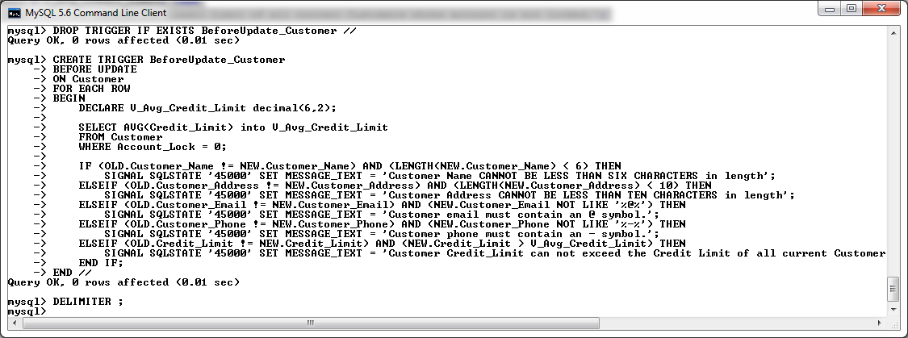

*Screenshot of BeforeUpdate_Customer trigger being created in MySQL console.*

**After Update on Customer Trigger**

The after update trigger on the customer table will be used to call the “changesLog” procedure to log all changes that have being made to the Customer table.

DELIMITER **//**

**DROP** **TRIGGER** **IF** **EXISTS** AfterUpdate_Customer **//**

**CREATE** **TRIGGER** AfterUpdate_Customer

**AFTER** **UPDATE**

**ON** Customer

**FOR** **EACH** **ROW**

**BEGIN**

**call** changesLog**(**'Customer'**,** 'Updated'**,** **NEW.**Customer_ID**);**

**END** **//**

DELIMITER **;**

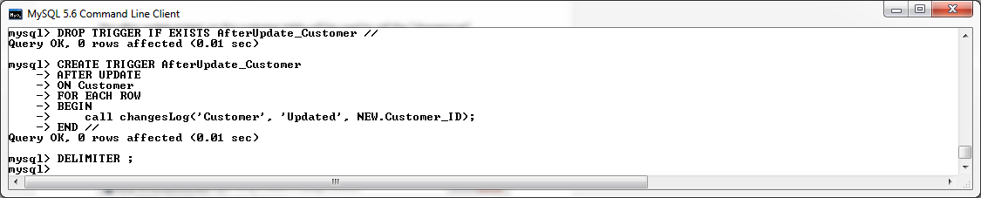

*Screenshot of AfterUpdate_Customer trigger being created in MySQL console.*

**Testing the Before and After Update Triggers on the Customer Table**

Attempt an update with an invalid Customer Name then a valid Customer Name, then verify update with a select statement on the customer record :

**UPDATE** Customer

**SET** Customer_Name **=** 'test'

**WHERE** Customer_ID **=** 1**;**

**UPDATE** Customer

**SET** Customer_Name **=** 'David J Martin'

**WHERE** Customer_ID **=** 1**;**

**SELECT** **\*** **FROM** Customer **WHERE** Customer_ID **=** 1**;**

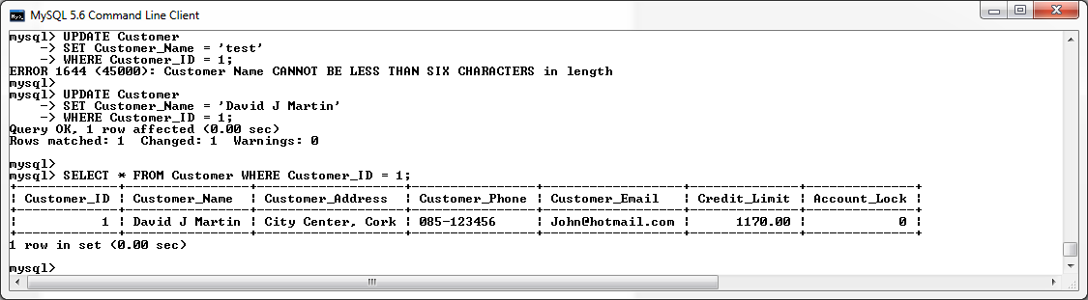

Attempt an update with an invalid Customer Address then a valid Customer Address, then verify update with a select statement on the customer record :

**UPDATE** Customer

**SET** Customer_Address **=** 'test'

**WHERE** Customer_ID **=** 1**;**

**UPDATE** Customer

**SET** Customer_Address **=** 'Main Street, Galway'

**WHERE** Customer_ID **=** 1**;**

**SELECT** **\*** **FROM** Customer **WHERE** Customer_ID **=** 1**;**

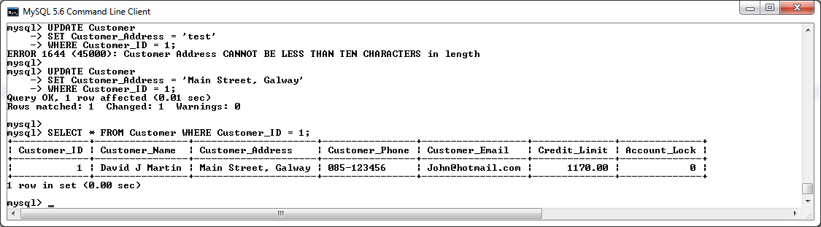

Attempt an update with an invalid Customer Email then a valid Customer Email, then verify update with a select statement on the customer record :

**UPDATE** Customer

**SET** Customer_Email **=** 'testemail'

**WHERE** Customer_ID **=** 1**;**

**UPDATE** Customer

**SET** Customer_Email **=** 'test1@email.com'

**WHERE** Customer_ID **=** 1**;**

**SELECT** **\*** **FROM** Customer **WHERE** Customer_ID **=** 1**;**

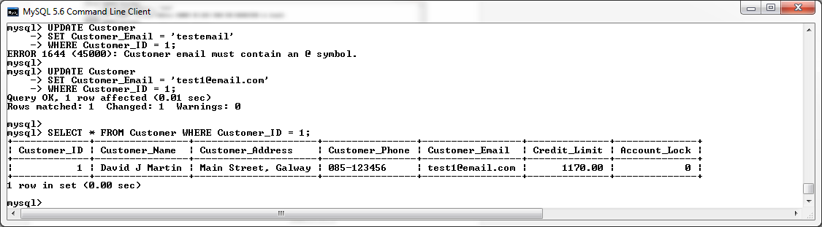

Attempt an update with an invalid Customer Phone No then a valid Customer Phone No, then verify update with a select statement on the customer record :

**UPDATE** Customer

**SET** Customer_Phone **=** '086123456'

**WHERE** Customer_ID **=** 1**;**

**UPDATE** Customer

**SET** Customer_Phone **=** '086-123456'

**WHERE** Customer_ID **=** 1**;**

**SELECT** **\*** **FROM** Customer **WHERE** Customer_ID **=** 1**;**

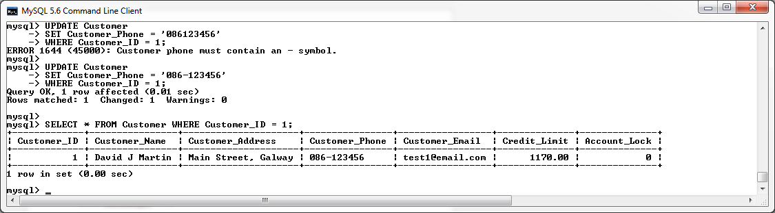

Attempt an update with an invalid Customer Credit Limit then a valid Customer Credit Limit, then verify update with a select statement on the customer record :

**UPDATE** Customer

**SET** Credit_Limit **=** 2000.00

**WHERE** Customer_ID **=** 1**;**

**UPDATE** Customer

**SET** Credit_Limit **=** 100.00

**WHERE** Customer_ID **=** 1**;**

**SELECT** **\*** **FROM** Customer **WHERE** Customer_ID **=** 1**;**

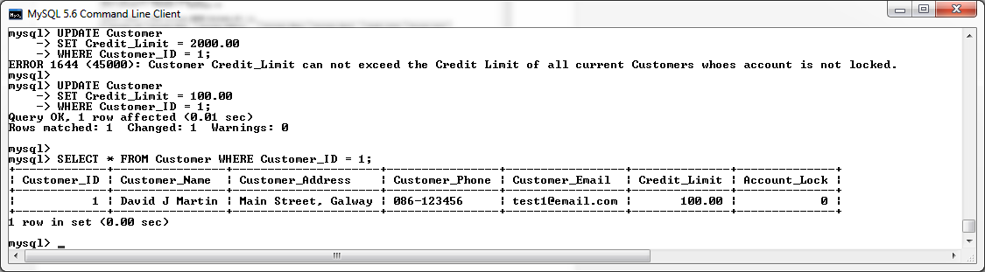

Verify all changes have been logged by the After Update trigger calling the changesLog Procedure.

**SELECT** **\*** **FROM** mysql_changesLog**;**

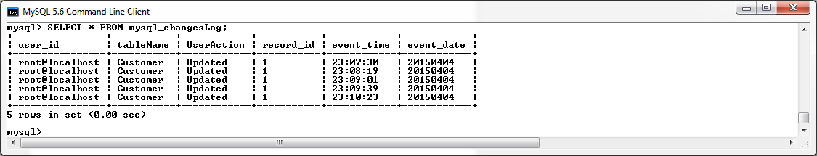

**Before Update on Orders_Component_Junction Table**

The before update trigger on the Orders_Component_Junction table will be used to validate the following restrictions before an update can be successfully made to the Orders_Component_Junction table:

* The Order ID of the updated entry must exist within the Orders table.
* The Component ID of the updated entry must exist within the Component table.
* The Quantity of the updated entry must be greater than zero.
* The In House Stock in the Accessory table must be updated if there has been a change in the quantity ordered.

An update failing to comply with these rules will be rejected and return a suitable error message.

-- create BeforeUpdate_Orders_Comp_Junct trigger

DELIMITER **//**

**DROP** **TRIGGER** **IF** **EXISTS** BeforeUpdate_Orders_Comp_Junct**//**

**CREATE** **TRIGGER** BeforeUpdate_Orders_Comp_Junct

**BEFORE** **UPDATE**

**ON** Orders_Component_Junction

**FOR** **EACH** **ROW**

**BEGIN**

**DECLARE** FOUND_COMP_ID**,** FOUND_ORDER_ID **INT;**

**DECLARE** INSTOCK_QTY_CHECK **int;**

**IF(NEW.**Component_ID **!=** **OLD.**Component_ID**)** **THEN**

**SELECT** **COUNT(*)** **INTO** FOUND_COMP_ID

**FROM** Component

**WHERE** Component**.**Component_ID **=** **NEW.**Component_ID**;**

**ELSE**

**SELECT** **COUNT(*)** **INTO** FOUND_COMP_ID

**FROM** Component

**WHERE** Component**.**Component_ID **=** **OLD.**Component_ID**;**

**END** **IF;**

**IF(NEW.**Order_ID **!=** **OLD.**Order_ID**)** **THEN**

**SELECT** **COUNT(*)** **INTO** FOUND_ORDER_ID

**FROM** Orders

**WHERE** Orders**.**Order_ID **=** **NEW.**Order_ID**;**

**ELSE**

**SELECT** **COUNT(*)** **INTO** FOUND_ORDER_ID

**FROM** Orders

**WHERE** Orders**.**Order_ID **=** **OLD.**Order_ID**;**

**END** **IF;**

**SELECT** Component_Qty_InStock **INTO** INSTOCK_QTY_CHECK

**FROM** Component

**WHERE** Component**.**Component_ID **=** **NEW.**Component_ID**;**

**IF** **(NEW.**Component_Qty **>** **OLD.**Component_Qty**)** **AND** **(**INSTOCK_QTY_CHECK **-** **(NEW.**Component_Qty**-**

**OLD.**Component_Qty**)** **>=**0 **)** **THEN**

**UPDATE** COMPONENT

**SET** Component_Qty_InStock **=** Component_Qty_InStock **-** **(NEW.**Component_Qty**-**

**OLD.**Component_Qty**)**

**WHERE** COMPONENT**.**COMPONENT_ID **=** **NEW.**COMPONENT_ID**;**

ELSEIF **(NEW.**Component_Qty **>** **OLD.**Component_Qty**)** **AND** **(**INSTOCK_QTY_CHECK **–**

**(NEW.**Component_Qty**-OLD.**Component_Qty**)** **<**0 **)** **THEN**

SIGNAL **SQLSTATE** '45000' **SET** MESSAGE_TEXT **=** 'INSUFFICIENT COMPONENTS IN STOCK TO

FULFILL ORDER.'**;**

ELSEIF**(NEW.**Component_Qty **<** **OLD.**Component_Qty**)** **THEN**

**UPDATE** COMPONENT

**SET** Component_Qty_InStock **=** Component_Qty_InStock **+** **(OLD.**Component_Qty**-**

**NEW.**Component_Qty**)**

**WHERE** COMPONENT**.**COMPONENT_ID **=** **NEW.**COMPONENT_ID**;**

**END** **IF;**

**IF** FOUND_COMP_ID **<=** 0 **THEN**

SIGNAL **SQLSTATE** '45000' **SET** MESSAGE_TEXT **=** 'INVALID COMPONENT_ID - COMPONENT ID does not exist.'**;**

ELSEIF FOUND_ORDER_ID **<=** 0 **THEN**

SIGNAL **SQLSTATE** '45000' **SET** MESSAGE_TEXT **=** 'INVALID ORDER_ID - ORDER ID does not exist.'**;**

ELSEIF **(NEW.**Component_Qty **!=** **OLD.**Component_Qty**)** **AND** **(NEW.**Component_Qty **<=** 0**)** **THEN**

SIGNAL **SQLSTATE** '45000' **SET** MESSAGE_TEXT **=** 'Component Quantity cannot be ZERO or a NEGATIVE NUMBER. '**;**

**END** **IF;**

**END** **//**

DELIMITER **;**

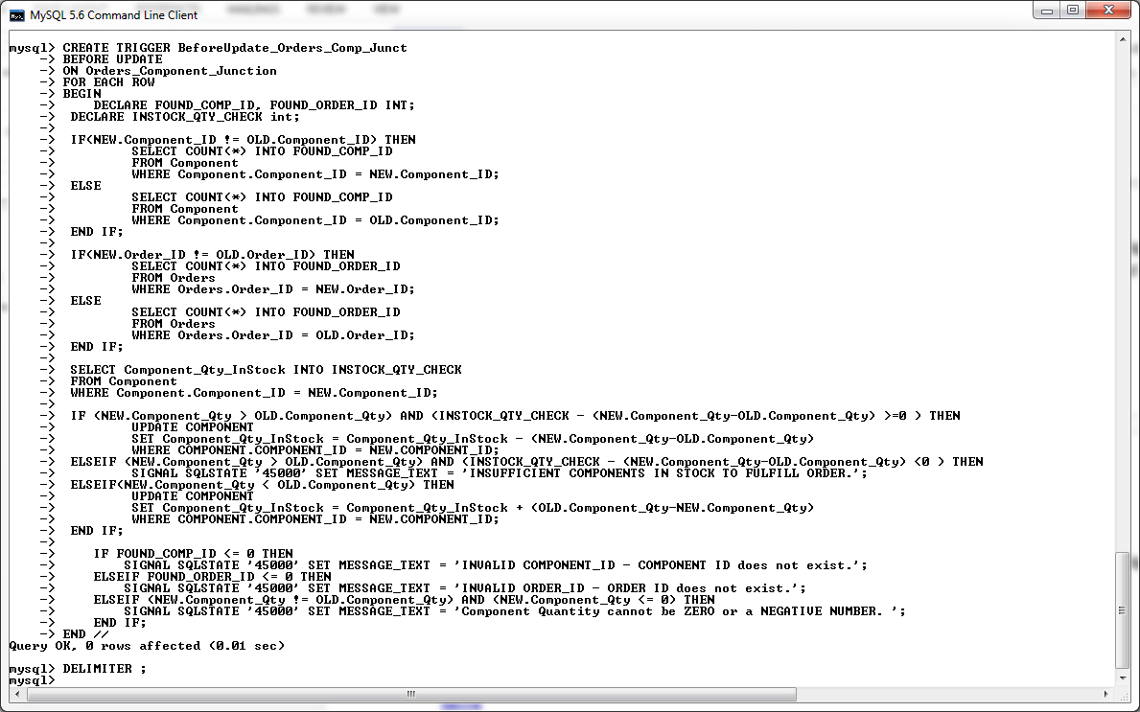

*Screenshot of BeforeUpdate_Orders_Comp_Junct trigger being created in MySQL console.*

**After Update on Orders_ Component _Junction Table**

The After update on Order_Component_Junction contains the same logic as the after Insert trigger described previously in this section. It will be used to implement the requirements as specified by the customer. Please see the description of the after insert on Order_Component_Junction trigger for more information. This trigger shall also update the Total_price of the related order if there has been a change in quantity to a component made by an update.

DELIMITER **//**

**DROP** **TRIGGER** **IF** **EXISTS** AfterUpdate_Orders_Comp_Junct **//**

**CREATE** **TRIGGER** AfterUpdate_Orders_Comp_Junct

**AFTER** **UPDATE**

**ON** Orders_Component_Junction

**FOR** **EACH** **ROW**

**BEGIN**

**DECLARE** myMsg **Varchar(**60**);**

**DECLARE** V_Comp_Price**,** V_Total_Price **Decimal(**6**,**2**);**

**SELECT** Component_Price **into** V_Comp_Price

**FROM** Component

**WHERE** Component**.**Component_ID **=** **NEW.**Component_ID**;**

**IF(NEW.**Component_Qty **>** **OLD.**Component_Qty**)** **THEN**

**Update** Orders

**SET** Total_Price **=** Total_Price **+** **((NEW.**Component_Qty**-OLD.**Component_Qty**)\***V_Comp_Price**)**

**WHERE** Orders**.**Order_ID **=** **NEW.**Order_ID**;**

ELSEIF**(NEW.**Component_Qty **<** **OLD.**Component_Qty**)** **THEN**

**Update** Orders

**SET** Total_Price **=** Total_Price **-** **((OLD.**Component_Qty**-NEW.**Component_Qty**)\***V_Comp_Price**)**

**WHERE** Orders**.**Order_ID **=** **NEW.**Order_ID**;**

**END** **IF;**

**IF(NEW.**Order_ID **!=** **OLD.**Order_ID**)** **THEN**

**SELECT** Total_Price **into** V_Total_Price

**FROM** Orders

**WHERE** Orders**.**Order_ID **=** **NEW.**Order_ID**;**

**ELSE**

**SELECT** Total_Price **into** V_Total_Price

**FROM** Orders

**WHERE** Orders**.**Order_ID **=** **OLD.**Order_ID**;**

**END** **IF;**

**IF(**V_Total_Price **<=** 800.00**)** **THEN**

**UPDATE** Orders

**SET** Payment_Method **=** 'Cash On Delivery'

**WHERE** Orders**.**Order_ID **=** **NEW.**Order_ID**;**

**SELECT** **concat(**'Order ID : '**,NEW.**Order_ID**,**' Payment Method Changed to Cash On

Delivery'**)** **into** myMsg**;**

**call** changesLog**(**'New Component Added to Order '**,** 'Updated'**,** myMsg**);**

ELSEIF**(**V_Total_Price **>** 800.00 **AND** V_Total_Price **<=** 1400.00**)** **THEN**

**UPDATE** Orders

**SET** Payment_Method **=** 'Credit Card'

**WHERE** Orders**.**Order_ID **=** **NEW.**Order_ID**;**

**SELECT** **concat(**'Order ID : '**,NEW.**Order_ID**,**' Payment Method Changed to Credit Card'**)**

**into** myMsg**;**

**call** changesLog**(**'New Component Added to Order '**,** 'Updated'**,** myMsg**);**

ELSEIF**(**V_Total_Price **>** 1400.00**)** **THEN**

**UPDATE** Orders

**SET** Payment_Method **=** 'PayPal'

**WHERE** Orders**.**Order_ID **=** **NEW.**Order_ID**;**

**SELECT** **concat(**'Order ID : '**,NEW.**Order_ID**,**' Payment Method Changed to PayPal'**)** **into**

myMsg**;**

**call** changesLog**(**'New Component Added to Order '**,** 'Updated'**,** myMsg**);**

**END** **IF;**

**SELECT** **concat(**'Order ID : '**,NEW.**Order_ID**,**' Component ID : '**,NEW.**Component_ID**)** **into** myMsg**;**

**call** changesLog**(**'Orders_Component_Junction'**,** 'Updated'**,** myMsg**);**

**END** **//**

DELIMITER **;**

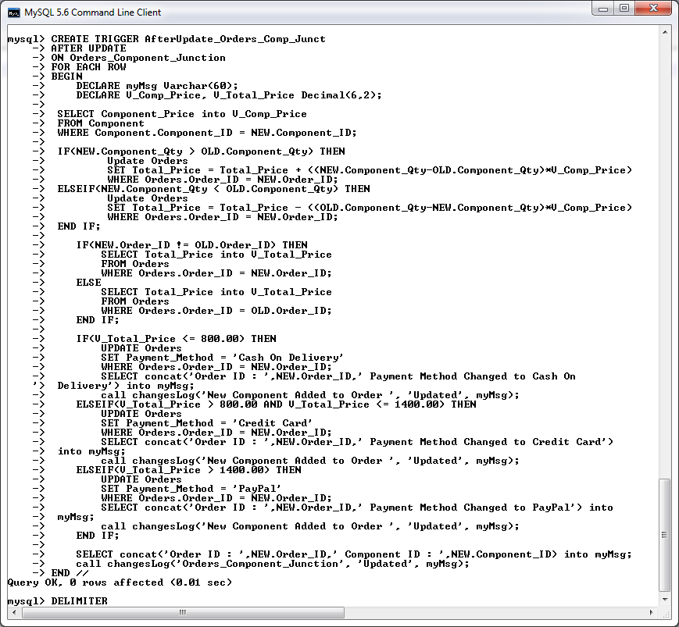*Screenshot of AfterUpdate_Orders_Comp_Junct trigger being created in MySQL console.*

**Testing the Before and After Update Triggers on the Orders_Comp_Junct Table**

Attempt an update with an invalid Component ID then a valid Component ID, then verify update with a select statement on the Orders_Comp_Junct record :

**UPDATE** Orders_Component_Junction

**SET** Component_ID **=** 'C444'

**WHERE** Order_ID **=** 'O101'**;**

**UPDATE** Orders_Component_Junction

**SET** Component_ID **=** 'C105'

**WHERE** Order_ID **=** 'O999' **AND** Component_ID **=** 'C106' **AND** Component_Qty **=** 4**;**

**SELECT** **\*** **FROM** Orders_Component_Junction **WHERE** Order_ID **=** 'O999' **AND** Component_ID **=** 'C105' **AND** Component_Qty **=** 4**;**

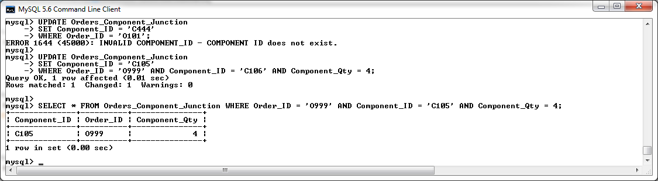

Attempt an update with an invalid Order ID then a valid Order ID, then verify update with a select statement on the Orders_Comp_Junct record :

**UPDATE** Orders_Component_Junction

**SET** Order_Id **=** 'O787'

**WHERE** Order_ID **=** 'O999'**;**

**UPDATE** Orders_Component_Junction

**SET** Order_Id **=** 'O101'

**WHERE** Order_ID **=** 'O999' **AND** Component_ID **=** 'C105' **AND** Component_Qty **=** 4**;**

**SELECT** **\*** **FROM** Orders_Component_Junction **WHERE** Order_ID **=** 'O101' **AND** Component_ID **=** 'C105' **AND** Component_Qty **=** 4**;**

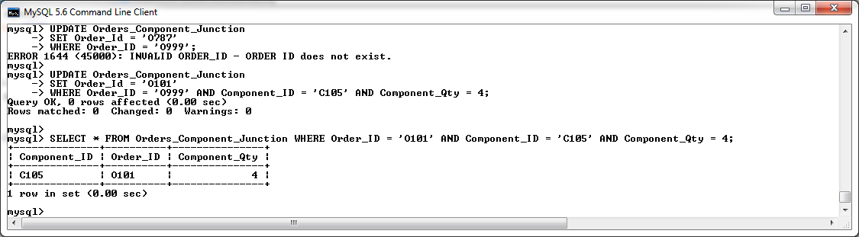

Attempt an update with an invalid Component Qty then a valid Component Qty, then verify update with a select statement on the Orders_Comp_Junct record :

**Create dummy data**

**Insert** **into** Orders_Component_Junction **values** **(**'C100'**,** 'O101'**,** 5**);**

**Set component stock to 10**

**Update** COMPONENT

**SET** Component_Qty_InStock **=** 10

**WHERE** COMPONENT_ID **=** 'C100'**;**

Test that the quantity in the Component table is being updated to reflect the update to the new quantity.

**SELECT** **\*** **FROM** Component **WHERE** COMPONENT_ID **=** 'C100'**;**

**UPDATE** Orders_Component_Junction

**SET** Component_Qty **=** 6

**WHERE** ORDER_ID **=** 'O101' **AND** COMPONENT_ID **=** 'C100'**;**

**SELECT** **\*** **FROM** Component **WHERE** COMPONENT_ID **=** 'C100'**;**

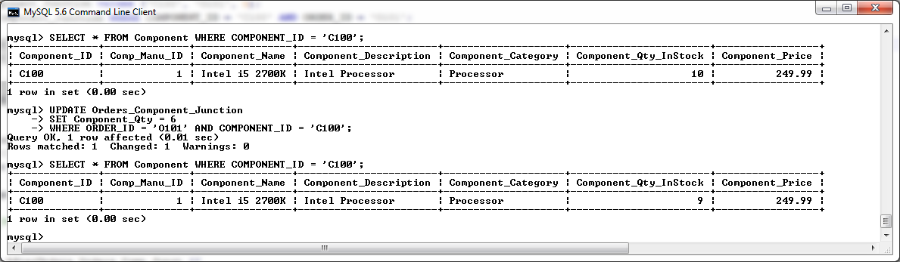

As you can see from the above info, the previous entry in the Orders_Component_Junction table had an order quantity of 5 for Component ID ‘C100’. I then performed an update to this record to reflect an increase of 1 to the quantity ordered (e.g. the component_qty was updated from a value of 5 to a value of 6). Once this update was verified to be legitimate, the quantity in stock for Component ID ‘C100’ was updated to reflect this change in the order (e.g. as there was an increase in the quantity of 1, the component in stock quantity was then changed from 10 to 9 by the trigger).

We shall now test an Update that decreases the quantity of a component ordered to ensure that the Component table will be updated correctly to reflect this.

**SELECT** **\*** **FROM** Component **WHERE** COMPONENT_ID **=** 'C100'**;**

**UPDATE** Orders_Component_Junction

**SET** Component_Qty **=** 5

**WHERE** ORDER_ID **=** 'O101' **AND** COMPONENT_ID **=** 'C100'**;**

**SELECT** **\*** **FROM** Component **WHERE** COMPONENT_ID **=** 'C100'**;**

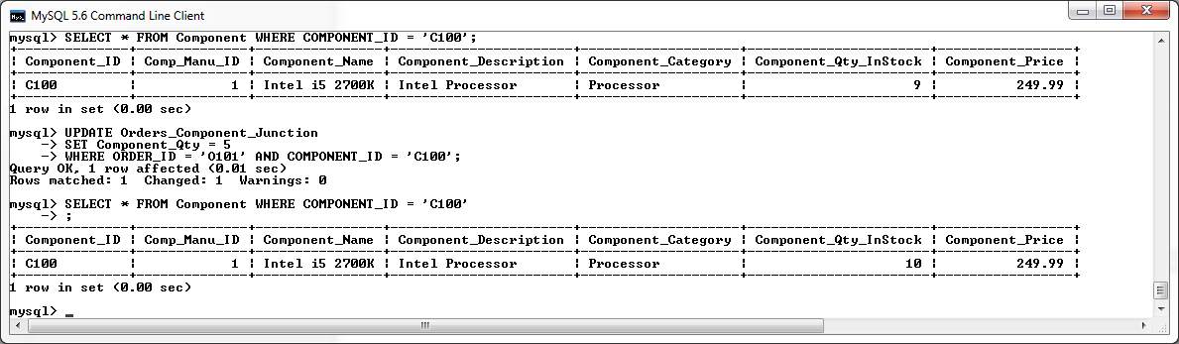

As you can see from the above info, the previous entry in the Orders_Component_Junction table had an order quantity of 6 for Component ID ‘C100’. I then performed an update to this record to reflect a decrease of 1 to the quantity ordered (e.g. the component_qty was updated from a value of 6 to a value of 5). Once this update was verified to be legitimate, the quantity in stock for Component ID ‘C100’ was updated to reflect this change in the order (e.g. as there was an decrease of 1 in the quantity or the order and then the component in stock quantity was then changed from 9 to 10 by the trigger).

**Testing the After Update Triggers on the Orders_Component_Junction Table**

Decrease the quantity of a Component and test to ensure that the Total_Price of the orders table is updated to reflect the change.

**SELECT** Component_Price **FROM** Component **WHERE** Component_ID **=** 'C101'**;**

**SELECT** **\*** **FROM** Orders **WHERE** ORDER_ID **=** 'O102'**;**

**SELECT** Component_Qty **FROM** Orders_Component_Junction **WHERE** Component_ID **=** 'C101' **AND** Order_ID **=** 'O102'**;**

**UPDATE** Orders_Component_Junction

**SET** Component_Qty **=** 1

**WHERE** Component_ID **=** 'C101' **AND** Order_ID **=** 'O102'**;**

**SELECT** Component_Qty **FROM** Orders_Component_Junction **WHERE** Component_ID **=** 'C101' **AND** Order_ID **=** 'O102'**;**

**SELECT** **\*** **FROM** Orders **WHERE** ORDER_ID **=** 'O102'**;**

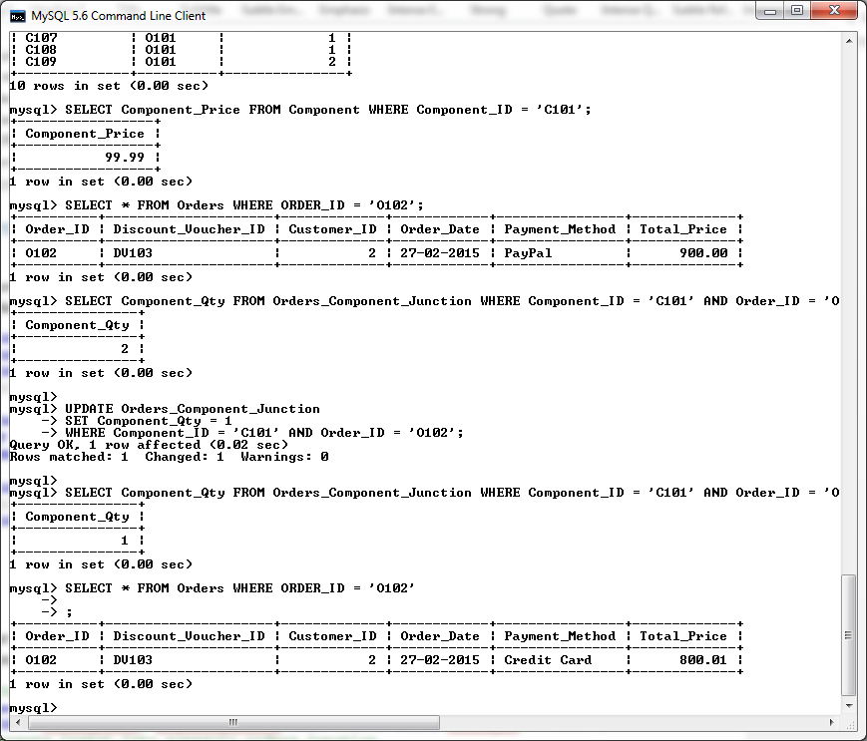

Increase the quantity of a Component and test to ensure that the Total_Price of the orders table is updated to reflect the change.

**SELECT** Component_Price **FROM** Component **WHERE** Component_ID **=** 'C101'**;**

**SELECT** **\*** **FROM** Orders **WHERE** ORDER_ID **=** 'O102'**;**

**SELECT** Component_Qty **FROM** Orders_Component_Junction **WHERE** Component_ID **=** 'C101' **AND** Order_ID **=** 'O102'**;**

**UPDATE** Orders_Component_Junction

**SET** Component_Qty **=** 2

**WHERE** Component_ID **=** 'C101' **AND** Order_ID **=** 'O102'**;**

**SELECT** Component_Qty **FROM** Orders_Component_Junction **WHERE** Component_ID **=** 'C101' **AND** Order_ID **=** 'O102'**;**

**SELECT** **\*** **FROM** Orders **WHERE** ORDER_ID **=** 'O102'**;**

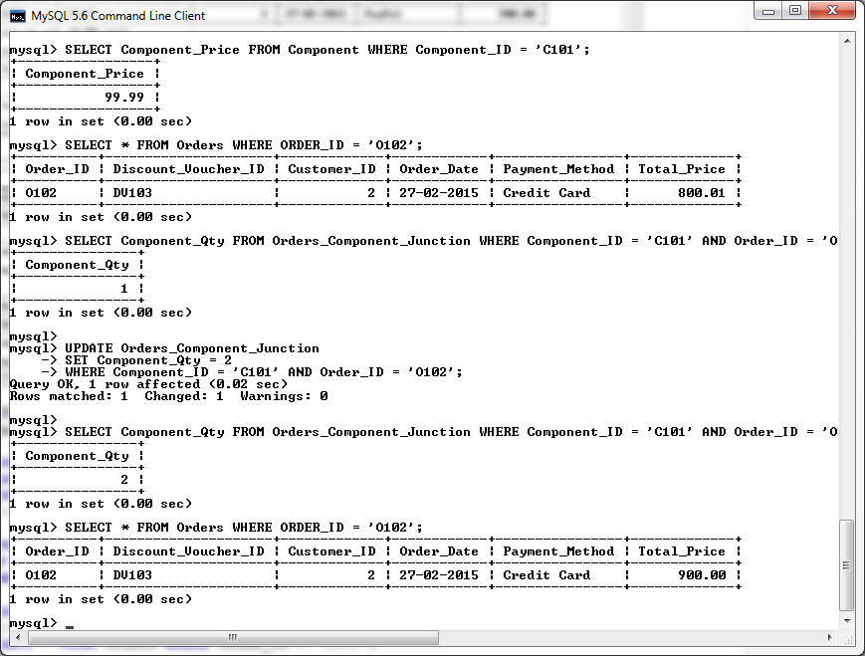

Test the After Update trigger to ensure that it is changing Order payment method as specified by the customer requirements.

--Create new ORDER

**Insert** **into** Orders **values** **(**'O335'**,** 'DV105'**,** 3**,** '29-02-2015'**,**'PayPal'**,**0.00**);**

**SELECT** total_Price**,** payment_method **FROM** Orders **WHERE** Order_ID **=** 'O335'**;**

--create insert into acessory_orders_junction

**SELECT** total_Price**,** payment_method **FROM** Orders **WHERE** Order_ID **=** 'O335'**;**

**Insert** **into** Orders_Component_Junction **values** **(**'C100'**,** 'O335'**,** 1**);**

**SELECT** **\*** **FROM** Orders_Component_Junction**;**

**SELECT** total_Price**,** payment_method **FROM** Orders **WHERE** Order_ID **=** 'O335'**;**

**Update** Orders_Component_Junction

**SET** Component_Qty **=** 3

**WHERE** Order_ID **=** 'O335' **AND** COMPONENT_ID **=** 'C100'**;**

**SELECT** total_Price**,** payment_method **FROM** Orders **WHERE** Order_ID **=** 'O335'**;**

**Update** Orders_Component_Junction

**SET** Component_Qty **=** 4

**WHERE** Order_ID **=** 'O335' **AND** COMPONENT_ID **=** 'C100'**;**

**SELECT** total_Price**,** payment_method **FROM** Orders **WHERE** Order_ID **=** 'O335'**;**

**Update** Orders_Component_Junction

**SET** Component_Qty **=** 15

**WHERE** Order_ID **=** 'O335' **AND** COMPONENT_ID **=** 'C100'**;**

**SELECT** total_Price**,** payment_method **FROM** Orders **WHERE** Order_ID **=** 'O335'**;**

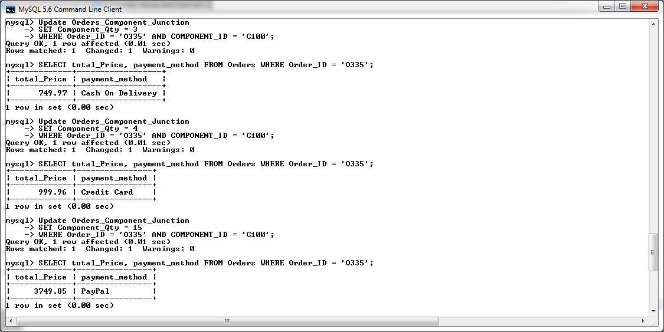

Verify all changes have been logged by the After Update trigger calling the changesLog Procedure.

**SELECT** **\*** **FROM** mysql_changesLog**;**

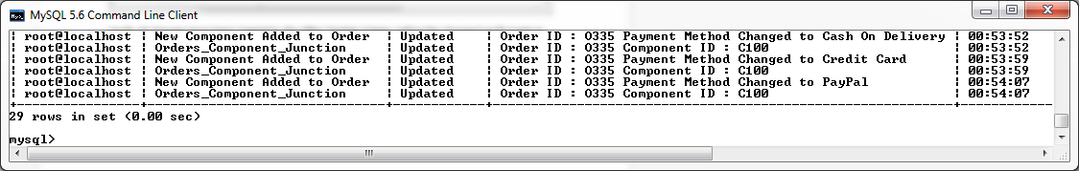

**Before Update on Orders_Accessory_Junction Table**

The before update trigger on the Orders_Accessory_Junction table will be used to validate the following restrictions before and record can be successfully updated in the Orders_Accessory_Junction table:

* The Order ID of the updated entry must exist within the Orders table.
* The Accessory ID of the updated entry must exist within the Accessory table.
* The Quantity of the updated entry must be greater than zero.
* The Accessory of and entry to this table cannot be changed with an update statement.
* After an Update to the quantity of an accessory, the Orders table shall be updated to reflect the new Total price of the order.

An insert failing to comply with these rules will be rejected and return a suitable error message.

DELIMITER **//**

**DROP** **TRIGGER** **IF** **EXISTS** BeforeUpdate_Orders_Acc_Junct**//**

**CREATE** **TRIGGER** BeforeUpdate_Orders_Acc_Junct

**BEFORE** **UPDATE**

**ON** Orders_Accessory_Junction

**FOR** **EACH** **ROW**

**BEGIN**

**DECLARE** FOUND_ORDER_ID**,** FOUND_ACCESSORY_ID **INT;**

**DECLARE** INSTOCK_QTY_CHECK **int;**

**IF(NEW.**Order_ID **!=** **OLD.**Order_ID**)** **THEN**

**SELECT** **COUNT(*)** **INTO** FOUND_ORDER_ID

**FROM** Orders

**WHERE** Orders**.**Order_ID **=** **NEW.**Order_ID**;**

**ELSE**

**SELECT** **COUNT(*)** **INTO** FOUND_ORDER_ID

**FROM** Orders

**WHERE** Orders**.**Order_ID **=** **OLD.**Order_ID**;**

**END** **IF;**

**IF(NEW.**Accessory_ID **!=** **OLD.**Accessory_ID**)** **THEN**

**SELECT** **COUNT(*)** **INTO** FOUND_ACCESSORY_ID

**FROM** Accessory

**WHERE** Accessory**.**Accessory_ID **=** **NEW.**Accessory_ID**;**

**ELSE**

**SELECT** **COUNT(*)** **INTO** FOUND_ACCESSORY_ID

**FROM** Accessory

**WHERE** Accessory**.**Accessory_ID **=** **OLD.**Accessory_ID**;**

**END** **IF;**

**SELECT** ACCESSORY_Qty_InStock **INTO** INSTOCK_QTY_CHECK

**FROM** ACCESSORY

**WHERE** ACCESSORY**.**ACCESSORY_ID **=** **NEW.**ACCESSORY_ID**;**

**IF** **(NEW.**Accessory_Qty **>** **OLD.**Accessory_Qty**)** **AND** **(**INSTOCK_QTY_CHECK **-** **(NEW.**Accessory_Qty**-**

**OLD.**Accessory_Qty**)** **>=**0 **)** **THEN**

**UPDATE** ACCESSORY

**SET** ACCESSORY_Qty_InStock **=** ACCESSORY_Qty_InStock **-** **(NEW.**Accessory_Qty**-**

**OLD.**Accessory_Qty**)**

**WHERE** ACCESSORY**.**ACCESSORY_ID **=** **NEW.**ACCESSORY_ID**;**

ELSEIF **(NEW.**Accessory_Qty **>** **OLD.**Accessory_Qty**)** **AND** **(**INSTOCK_QTY_CHECK **–**

**(NEW.**Accessory_Qty**-OLD.**Accessory_Qty**)** **<**0 **)** **THEN**

SIGNAL **SQLSTATE** '45000' **SET** MESSAGE_TEXT **=** 'INSUFFICIENT COMPONENTS IN STOCK TO

FULFILL ORDER.'**;**

ELSEIF**(NEW.**Accessory_Qty **<** **OLD.**Accessory_Qty**)** **THEN**

**UPDATE** ACCESSORY

**SET** ACCESSORY_Qty_InStock **=** ACCESSORY_Qty_InStock **+** **(OLD.**Accessory_Qty**-**

**NEW.**Accessory_Qty**)**

**WHERE** ACCESSORY**.**ACCESSORY_ID **=** **NEW.**ACCESSORY_ID**;**

**END** **IF;**

**IF** FOUND_ORDER_ID **<=** 0 **THEN**

SIGNAL **SQLSTATE** '45000' **SET** MESSAGE_TEXT **=** 'INVALID ORDER_ID - ORDER ID does not

exist.'**;**

ELSEIF **NEW.**ACCESSORY_ID **!=** **OLD.**ACCESSORY_ID **THEN**

SIGNAL **SQLSTATE** '45000' **SET** MESSAGE_TEXT **=** 'Accessory ID cannot be changed with an

update. Please delete the record and insert a new record to replace an Accessory.'**;**

ELSEIF FOUND_ACCESSORY_ID **<=** 0 **THEN**

SIGNAL **SQLSTATE** '45000' **SET** MESSAGE_TEXT **=** 'INVALID ACCESSORY_ID - ACCESSORY ID does

not exist.'**;**

ELSEIF **(NEW.**Accessory_Qty **!=** **OLD.**Accessory_Qty**)** **AND** **(NEW.**Accessory_Qty **<=** 0**)** **THEN**

SIGNAL **SQLSTATE** '45000' **SET** MESSAGE_TEXT **=** 'Accessory Quantity cannot be ZERO or a

NEGATIVE NUMBER. '**;**

**END** **IF;**

**END** **//**

DELIMITER **;**

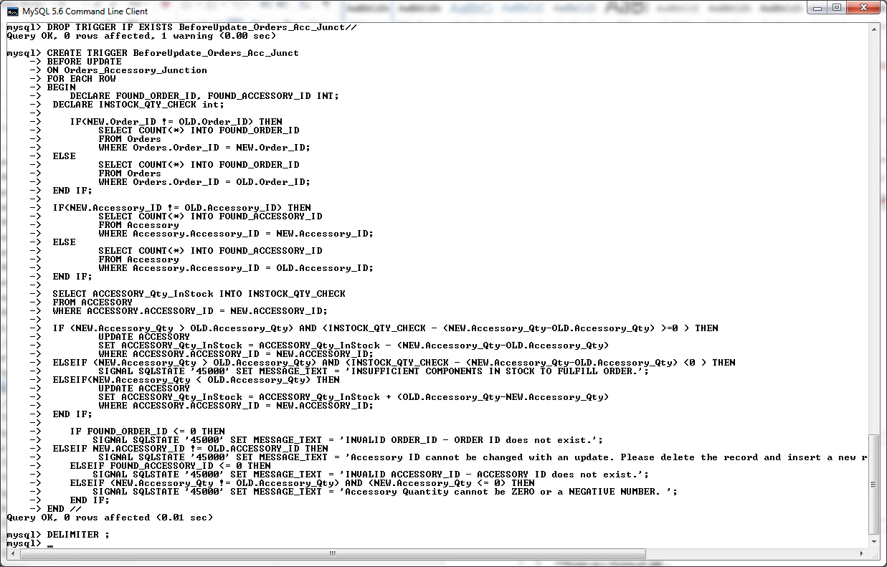

**After Update on Orders_ Accessory _Junction Table**

The After update on Order_Accessory_Junction contains the same logic as the after Insert trigger described previously in this section. It will be used to implement the requirements as specified by the customer. Please see the description of the after insert on Order_Accessory_Junction trigger for more information. In addition to this, this trigger will modify the total price of an order is the quantity of an accessory has being changed by an update to a record residing on this table.

DELIMITER **//**

**DROP** **TRIGGER** **IF** **EXISTS** AfterUPDATE_Orders_Acc_Junct **//**

**CREATE** **TRIGGER** AfterUPDATE_Orders_Acc_Junct

**AFTER** **UPDATE**

**ON** Orders_Accessory_Junction

**FOR** **EACH** **ROW**

**BEGIN**

**DECLARE** myMsg **Varchar(**60**);**

**DECLARE** V_Accessory_Price**,** V_Total_Price **Decimal(**6**,**2**);**

**SELECT** Accessory_Price **into** V_Accessory_Price

**FROM** Accessory

**WHERE** Accessory**.**Accessory_ID **=** **OLD.**Accessory_ID**;**

**IF(NEW.**Accessory_Qty **>** **OLD.**Accessory_Qty**)** **THEN**

**Update** Orders

**SET** Total_Price **=** Total_Price **+** **((NEW.**Accessory_Qty**-OLD.**Accessory_Qty**)\***V_Accessory_Price**)**

**WHERE** Orders**.**Order_ID **=** **NEW.**Order_ID**;**

ELSEIF**(NEW.**Accessory_Qty **<** **OLD.**Accessory_Qty**)** **THEN**

**Update** Orders

**SET** Total_Price **=** Total_Price **-** **((OLD.**Accessory_Qty**-NEW.**Accessory_Qty**)\***V_Accessory_Price**)**

**WHERE** Orders**.**Order_ID **=** **NEW.**Order_ID**;**

**END** **IF;**

**IF** **(**V_Total_Price **<=** 800.00**)** **THEN**

**UPDATE** Orders

**SET** Payment_Method **=** 'Cash On Delivery'

**WHERE** Orders**.**Order_ID **=** **NEW.**Order_ID**;**

**SELECT** **concat(**'Order ID : '**,NEW.**Order_ID**,**' Payment Method Changed to Cash On

Delivery'**)** **into** myMsg**;**

**call** changesLog**(**'New Accessory Added to Order '**,** 'Updated'**,**

myMsg**);**

ELSEIF**(**V_Total_Price **>** 800.00 **AND** V_Total_Price **<=** 1400.00**)** **THEN**

**UPDATE** Orders

**SET** Payment_Method **=** 'Credit Card'

**WHERE** Orders**.**Order_ID **=** **NEW.**Order_ID**;**

**SELECT** **concat(**'Order ID : '**,NEW.**Order_ID**,**' Payment Method Changed to Credit Card'**)**

**into** myMsg**;**

**call** changesLog**(**'New Accessory Added to Order '**,** 'Updated'**,**

myMsg**);**

ELSEIF**(**V_Total_Price **>** 1400.00**)** **THEN**

**UPDATE** Orders

**SET** Payment_Method **=** 'PayPal'

**WHERE** Orders**.**Order_ID **=** **NEW.**Order_ID**;**

**SELECT** **concat(**'Order ID : '**,NEW.**Order_ID**,**' Payment Method Changed to PayPal'**)** **into** myMsg**;**

**call** changesLog**(**'New Accessory Added to Order '**,** 'Updated'**,** myMsg**);**

**END** **IF;**

**SELECT** **concat(**'Order ID : '**,NEW.**Order_ID**,**' Accessory ID : '**,NEW.**Accessory_ID**)** **into** myMsg**;**

**call** changesLog**(**'Orders_Accessory_Junction'**,** 'Updated'**,** myMsg**);**

**END** **//**

DELIMITER **;**

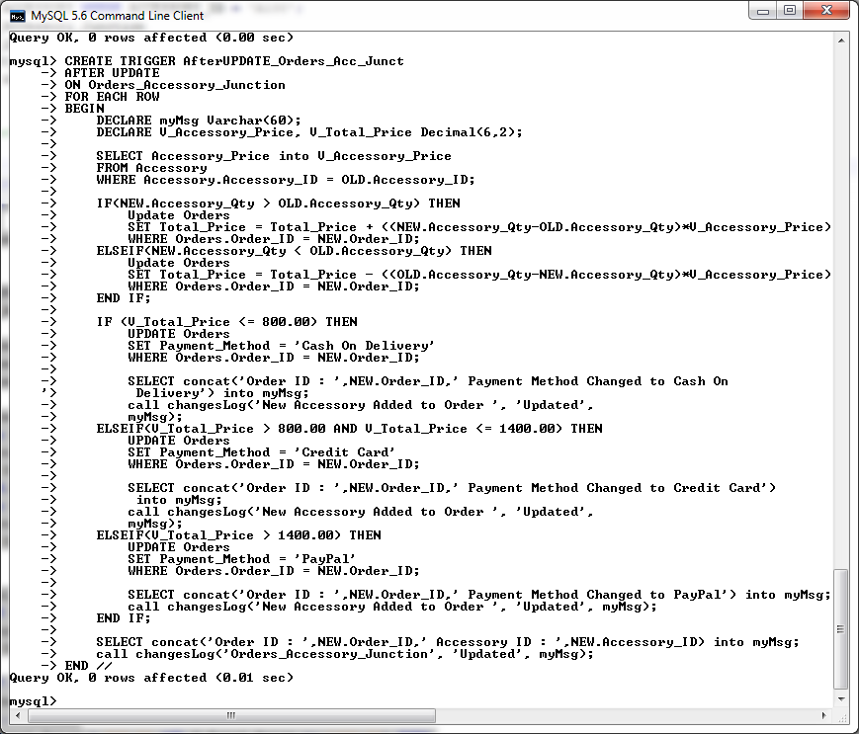

**Testing the Before Update Triggers on the Orders_Accessory_Junct Table**

Attempt an update with an invalid Order ID then a valid Order ID, then verify update with a select statement on the Orders_Accessory_Junct record :

**Update** Orders_Accessory_Junction

**SET** Order_ID **=** 'O300'

**WHERE** Accessory_ID **=** 'A100'**;**

**Update** Orders_Accessory_Junction

**SET** Order_ID **=** 'O101'

**WHERE** Accessory_ID **=** 'A100'**;**

**SELECT** **\*** **FROM** Orders_Accessory_Junction **WHERE** Order_ID **=** 'O101' **AND** Accessory_ID **=** 'A100'**;**

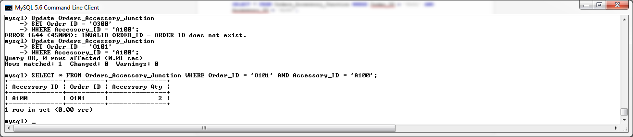

Attempt an update with an invalid Accessory ID then a valid Accessory ID, then verify update with a select statement on the Orders_Accessory_Junct record :

**Update** Orders_Accessory_Junction

**SET** Accessory_ID **=** 'A300'

**WHERE** Order_ID **=** 'O101'**;**

**Update** Orders_Accessory_Junction

**SET** Accessory_ID **=** 'A102'

**WHERE** Order_ID **=** 'O111'**;**

**SELECT** **\*** **FROM** Orders_Accessory_Junction **WHERE** Order_ID **=** 'O111' **AND** Accessory_ID **=** 'A102'**;**

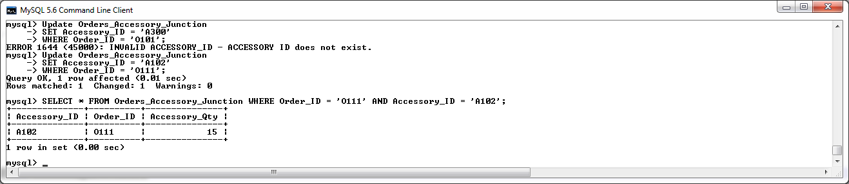

Attempt an update with an invalid Accessory Quantity then a valid Accessory Quantity, then verify update with a select statement on the Orders_Accessory_Junct record :

**Update** Orders_Accessory_Junction

**SET** Accessory_Qty **=** **-**10

**WHERE** Order_ID **=** 'O111' **AND** Accessory_ID **=** 'A102'**;**

**Update** Orders_Accessory_Junction

**SET** Accessory_Qty **=** 10

**WHERE** Order_ID **=** 'O111' **AND** Accessory_ID **=** 'A102'**;**

**SELECT** **\*** **FROM** Orders_Accessory_Junction **WHERE** Order_ID **=** 'O111' **AND** Accessory_ID **=** 'A102'**;**

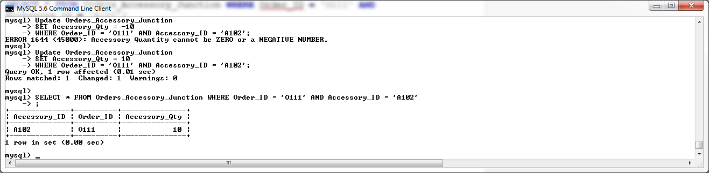

Test that the Quantity_InStock in the Accessory table is being updated to reflect the update to a new update quantity in the junction table entry.

**Create dummy data**

**Insert** **into** Orders_Accessory_Junction **values** **(**'A100'**,** 'O102'**,** 1**);**

**UPDATE** ACCESSORY

**SET** ACCESSORY_Qty_InStock **=** 10

**WHERE** ACCESSORY_ID **=** 'A00'**;**

Perform update on the Accessory Quantity or the Order.

**SELECT** **\*** **FROM** ACCESSORY **WHERE** ACCESSORY_ID **=** 'A100'**;**

**UPDATE** Orders_Accessory_Junction

**SET** Accessory_Qty **=** 2

**WHERE** ACCESSORY_ID **=** 'A100' **AND** ORDER_ID **=** 'O102'**;**

**SELECT** **\*** **FROM** ACCESSORY **WHERE** ACCESSORY_ID **=** 'A100'**;**

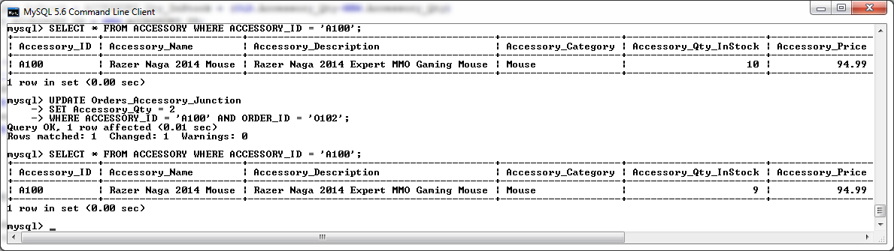

As you can see from the above info, the previous entry in the Orders_Accessory_Junction table had an order quantity of 1 for Component ID ‘C100’. I then performed an update to this record to reflect an increase of 1 to the quantity ordered (e.g. the component_qty was updated from a value of 1 to a value of 2). Once this update was verified to be legitimate, the quantity in stock for Accessory ID ‘A100’ was updated to reflect this change in the order (e.g. as there was an increase in the quantity of 1 in the order, then the in stock quantity for that accessory was changed from 10 to 9 by the trigger).

We shall now test an Update that decreases the quantity of a accessory ordered to ensure that the Accessory table will be updated correctly to reflect this.

**SELECT** **\*** **FROM** ACCESSORY **WHERE** ACCESSORY_ID **=** 'A100'**;**

**UPDATE** Orders_Accessory_Junction

**SET** Accessory_Qty **=** 1

**WHERE** ACCESSORY_ID **=** 'A100' **AND** ORDER_ID **=** 'O102'**;**

**SELECT** **\*** **FROM** ACCESSORY **WHERE** ACCESSORY_ID **=** 'A100'**;**

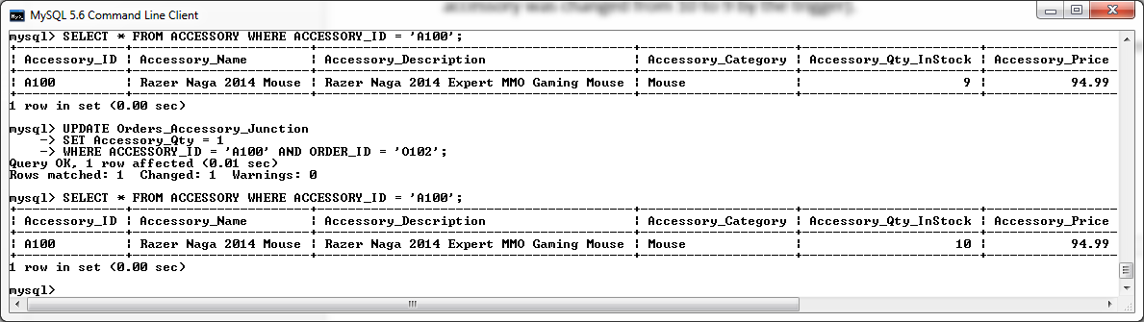

As you can see from the above info, the previous entry in the Orders_Accessory_Junction table had an order quantity of 2 for Component ID ‘A100’. I then performed an update to this record to reflect a decrease of 1 to the quantity ordered (e.g. the component_qty was updated from a value of 2 to a value of 1). Once this update was verified to be legitimate, the quantity in stock for Accessory ID ‘A100’ was updated to reflect this change in the order (e.g. as there was an decrease of 1 in the quantity or the order and then the stock quantity of the Component was then changed from 9 to 10 by the trigger).

**Testing the After Update Triggers on the Orders_Accessory_Junct Table**

Decrease the quantity of an accessory and test to ensure that the Total_Price of the orders table is updated to reflect the change.

**SELECT** Accessory_Price **FROM** Accessory **WHERE** Accessory_ID **=** 'A100'**;**

**SELECT** **\*** **FROM** Orders **WHERE** ORDER_ID **=** 'O101'**;**

**SELECT** Accessory_Qty **FROM** Orders_Accessory_Junction **WHERE** Accessory_ID **=** 'A100' **AND** Order_ID **=** 'O101'**;**

**UPDATE** Orders_Accessory_Junction

**SET** Accessory_Qty **=** 1

**WHERE** Accessory_ID **=** 'A100' **AND** Order_ID **=** 'O101'**;**

**SELECT** Accessory_Qty **FROM** Orders_Accessory_Junction **WHERE** Accessory_ID **=** 'A100' **AND** Order_ID **=** 'O101'**;**

**SELECT** **\*** **FROM** Orders **WHERE** ORDER_ID **=** 'O101'**;**

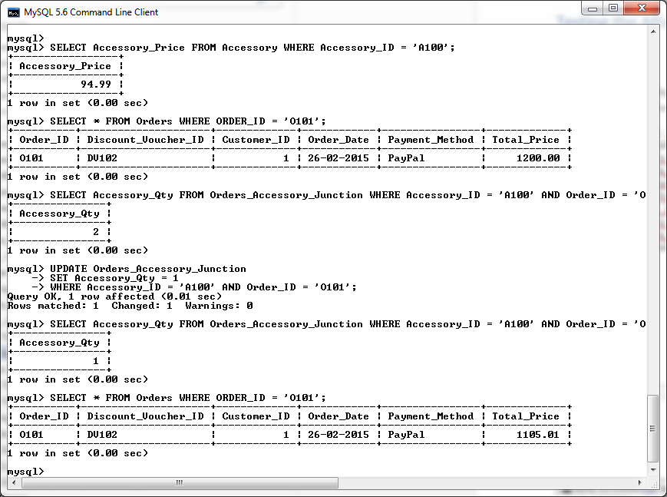

Increase the quantity of an accessory and test to ensure that the Total_Price of the orders table is updated to reflect the change.

**SELECT** Accessory_Price **FROM** Accessory **WHERE** Accessory_ID **=** 'A100'**;**

**SELECT** **\*** **FROM** Orders **WHERE** ORDER_ID **=** 'O101'**;**

**SELECT** Accessory_Qty **FROM** Orders_Accessory_Junction **WHERE** Accessory_ID **=** 'A100' **AND** Order_ID **=** 'O101'**;**

**UPDATE** Orders_Accessory_Junction

**SET** Accessory_Qty **=** 2

**WHERE** Accessory_ID **=** 'A100' **AND** Order_ID **=** 'O101'**;**

**SELECT** Accessory_Qty **FROM** Orders_Accessory_Junction **WHERE** Accessory_ID **=** 'A100' **AND** Order_ID **=** 'O101'**;**

**SELECT** **\*** **FROM** Orders **WHERE** ORDER_ID **=** 'O101'**;**

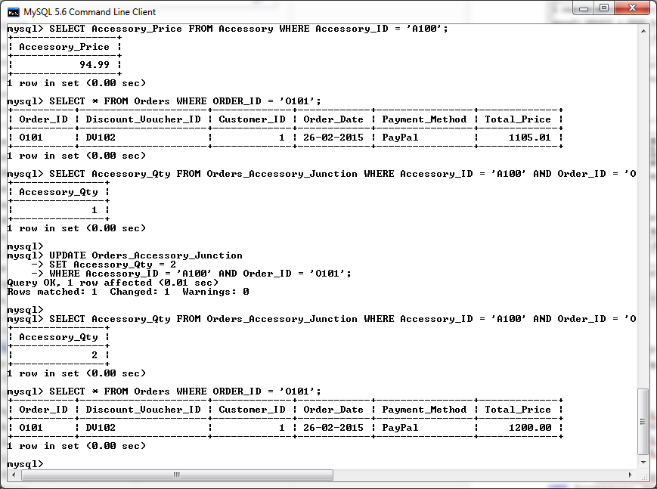

Test the After Update trigger to ensure that it is changing Order payment method as specified by the customer requirements.

--Create new ORDER

**Insert** **into** Orders **values** **(**'O111'**,** 'DV105'**,** 9**,** '29-02-2015'**,**'PayPal'**,**0.00**);**

**SELECT** total_Price**,** payment_method **FROM** Orders **WHERE** Order_ID **=** 'O111'**;**

--create insert into acessory_orders_junction

**SELECT** total_Price**,** payment_method **FROM** Orders **WHERE** Order_ID **=** 'O111'**;**

**Insert** **into** Orders_Accessory_Junction **values** **(**'A101'**,** 'O111'**,** 1**);**

**SELECT** total_Price**,** payment_method **FROM** Orders **WHERE** Order_ID **=** 'O111'**;**

**Update** Orders_Accessory_Junction

**SET** Accessory_Qty **=** 3

**WHERE** Order_ID **=** 'O111' **AND** Accessory_ID **=** 'A101'**;**

**SELECT** total_Price**,** payment_method **FROM** Orders **WHERE** Order_ID **=** 'O111'**;**

**Update** Orders_Accessory_Junction

**SET** Accessory_Qty **=** 7

**WHERE** Order_ID **=** 'O111' **AND** Accessory_ID **=** 'A101'**;**

**SELECT** total_Price**,** payment_method **FROM** Orders **WHERE** Order_ID **=** 'O111'**;**

**Update** Orders_Accessory_Junction

**SET** Accessory_Qty **=** 15

**WHERE** Order_ID **=** 'O111' **AND** Accessory_ID **=** 'A101'**;**

**SELECT** total_Price**,** payment_method **FROM** Orders **WHERE** Order_ID **=** 'O111'**;**

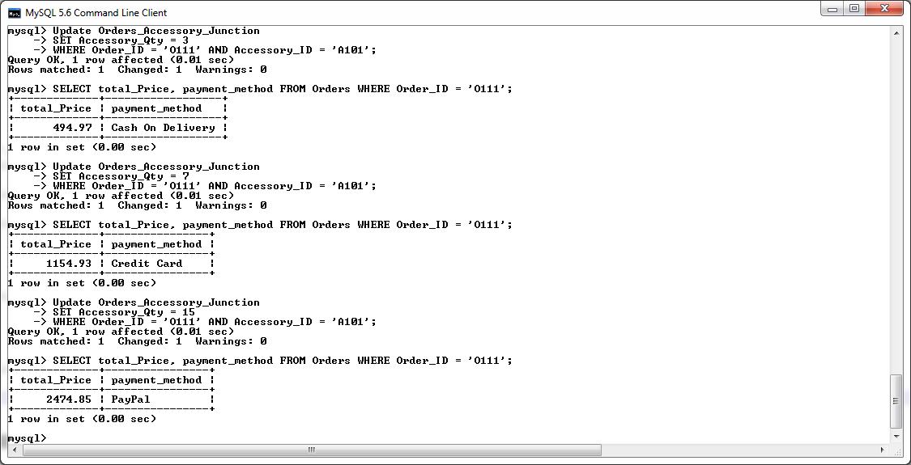

Verify all changes have been logged by the After Update trigger calling the changesLog Procedure.

**SELECT** **\*** **FROM** mysql_changesLog**;**

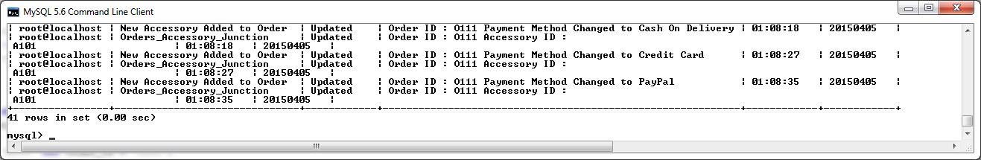

**Before Update on Orders Table Trigger**

The before update trigger on the Orders table will be used to validate the following restrictions before an updated record can be successfully added to the Orders table:

* The Discount Voucher ID of the updated entry must exist within the Discount Voucher table.
* The Customer ID of the updated entry must exist within the Customer table.

-- create BeforeUpdate_Orders trigger

DELIMITER **//**

**DROP** **TRIGGER** **IF** **EXISTS** BeforeUpdate_Orders**//**

**CREATE** **TRIGGER** BeforeUpdate_Orders

**BEFORE** **UPDATE**

**ON** Orders

**FOR** **EACH** **ROW**

**BEGIN**

**DECLARE** V_FOUND_DV_ID**,** V_FOUND_CUSTOMER_ID **Varchar(**40**);**

**IF(NEW.**Discount_Voucher_ID **!=** **OLD.**Discount_Voucher_ID**)** **THEN**

**SELECT** **Count(**Discount_Voucher_ID**)** **into** V_FOUND_DV_ID

**FROM** Discount_Voucher

**WHERE** Discount_Voucher**.**Discount_Voucher_ID **=** **NEW.**Discount_Voucher_ID**;**

**ELSE**

**SELECT** **Count(**Discount_Voucher_ID**)** **into** V_FOUND_DV_ID

**FROM** Discount_Voucher

**WHERE** Discount_Voucher**.**Discount_Voucher_ID **=** **OLD.**Discount_Voucher_ID**;**

**END** **IF;**

**IF(NEW.**Customer_ID **!=** **OLD.**Customer_ID**)** **THEN**

**SELECT** **Count(**Customer_ID**)** **into** V_FOUND_CUSTOMER_ID

**FROM** Customer

**WHERE** Customer**.**Customer_ID **=** **NEW.**Customer_ID**;**

**ELSE**

**SELECT** **Count(**Customer_ID**)** **into** V_FOUND_CUSTOMER_ID

**FROM** Customer

**WHERE** Customer**.**Customer_ID **=** **OLD.**Customer_ID**;**

**END** **IF;**

**IF** V_FOUND_DV_ID **<=** 0 **THEN**

SIGNAL **SQLSTATE** '45000' **SET** MESSAGE_TEXT **=** 'INVALID DISCOUNT_VOUCHER_ID - DISCOUNT

VOUCHER ID does not exist.'**;**

ELSEIF V_FOUND_CUSTOMER_ID **<=** 0 **THEN**

SIGNAL **SQLSTATE** '45000' **SET** MESSAGE_TEXT **=** 'INVALID CUSTOMER_ID - CUSTOMER ID does not

exist.'**;**

**END** **IF;**

**END** **//**

DELIMITER **;**

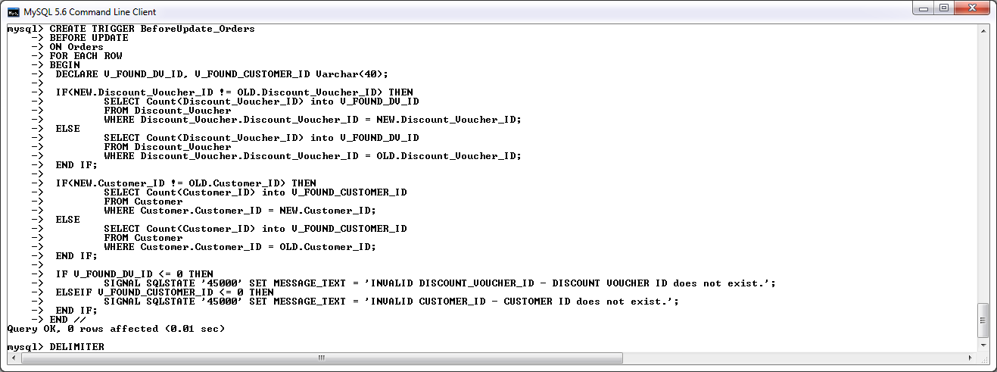

**After Update on Orders Table**

The After update on Orders Trigger contains the same logic as the after Insert trigger described previously in this section. It will be used to implement the requirements as specified by the customer. Please see the description of the after insert on Orders trigger for more information.

-- create AfterUpdate_Orders trigger

DELIMITER **//**

**DROP** **TRIGGER** **IF** **EXISTS** AfterUpdate_Orders **//**

**CREATE** **TRIGGER** AfterUpdate_Orders

**AFTER** **UPDATE**

**ON** Orders

**FOR** **EACH** **ROW**

**BEGIN**

**DECLARE** V_CREDIT_LIMIT_BONUS **Decimal(**6**,**2**);**

**DECLARE** myMsg **varchar(**40**);**

**IF(NEW.**Total_Price **!=** **OLD.**Total_Price**)** **AND** **(NEW.**Total_Price **<** 1000**)** **THEN**

**SET** V_CREDIT_LIMIT_BONUS **=** 10**;**

ELSEIF **(NEW.**Total_Price **!=** **OLD.**Total_Price**)** **AND** **(NEW.**Total_Price **>=** 1000 **AND** **NEW.**Total_Price **<** 1500**)** **THEN**

**SET** V_CREDIT_LIMIT_BONUS **=** 20**;**

ELSEIF **(NEW.**Total_Price **!=** **OLD.**Total_Price**)** **AND** **(NEW.**Total_Price **>=** 1500**)** **THEN**

**SET** V_CREDIT_LIMIT_BONUS **=** 50**;**

**END** **IF;**

**IF(NEW.**Total_Price **!=** **OLD.**Total_Price**)** **THEN**

**UPDATE** Customer

**SET** Credit_Limit **=** Credit_Limit **+** V_CREDIT_LIMIT_BONUS

**WHERE** Customer_ID **=** **New.**Customer_ID**;**

**call** changesLog**(**'Customer'**,** myMsg**,** **NEW.**Customer_ID**);**

**call** changesLog**(**'Order'**,** 'Updated'**,** **NEW.**Order_ID**);**

**ELSE**

**call** changesLog**(**'Customer'**,** myMsg**,** **OLD.**Customer_ID**);**

**call** changesLog**(**'Order'**,** 'Updated'**,** **OLD.**Order_ID**);**

**END** **IF;**

**SELECT** **concat(**'Credit Limit Updated by '**,**V_CREDIT_LIMIT_BONUS**)** **into** myMsg**;**

**END** **//**

DELIMITER **;**

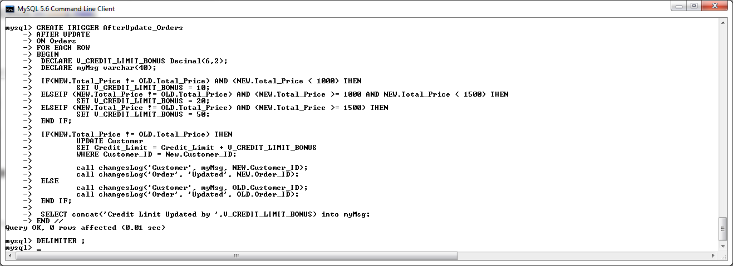

**Testing the Before Update Trigger on the Orders Table**

Attempt an update with an invalid Discount ID then a valid Discount ID, then verify update with a select statement on the Orders record :

**UPDATE** Orders

**SET** DISCOUNT_VOUCHER_ID **=** 'DV999'

**WHERE** Order_ID **=** 'O102'**;**

**UPDATE** Orders

**SET** DISCOUNT_VOUCHER_ID **=** 'DV100'

**WHERE** Order_ID **=** 'O102'**;**

**SELECT** **\*** **FROM** Orders **WHERE** Order_ID **=** 'O102' **AND** DISCOUNT_VOUCHER_ID **=** 'DV100'**;**

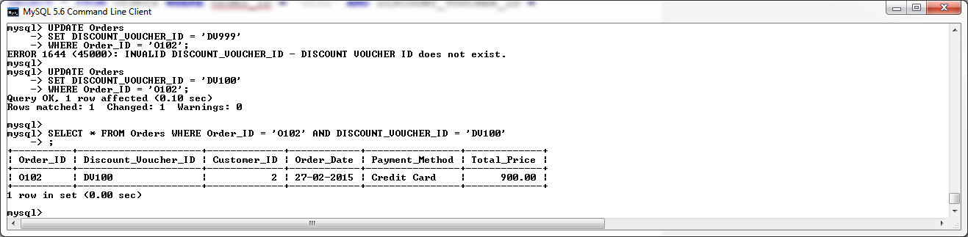

Attempt an update with an invalid Customer ID then a valid Customer ID, then verify update with a select statement on the Orders record :

**UPDATE** Orders

**SET** Customer_ID **=** 987

**WHERE** Order_ID **=** 'O102'**;**

**UPDATE** Orders

**SET** Customer_ID **=** 1

**WHERE** Order_ID **=** 'O102'**;**

**SELECT** **\*** **FROM** Orders **WHERE** Order_ID **=** 'O102' **AND** Customer_ID **=** 1**;**

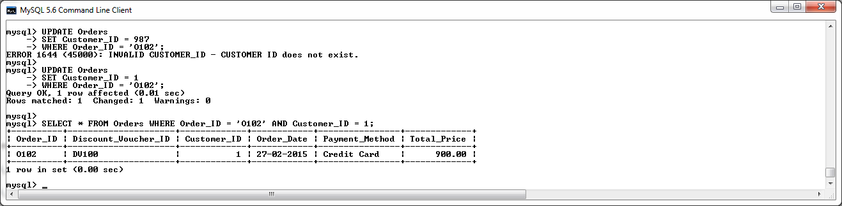

**Testing the After Update Trigger on the Orders Table**

Verify that the customer credit limit is been updated in respect to the order total.

Test that an update to an order under one thousand euro increases the customer credit limit by ten euro.

**SELECT** Credit_Limit **FROM** Customer **WHERE** Customer_ID **=** 1**;**

**UPDATE** Orders

**SET** Total_Price **=** 900.00

**WHERE** Order_ID **=** 'O222'**;**

**SELECT** Credit_Limit **FROM** Customer **WHERE** Customer_ID **=** 1**;**

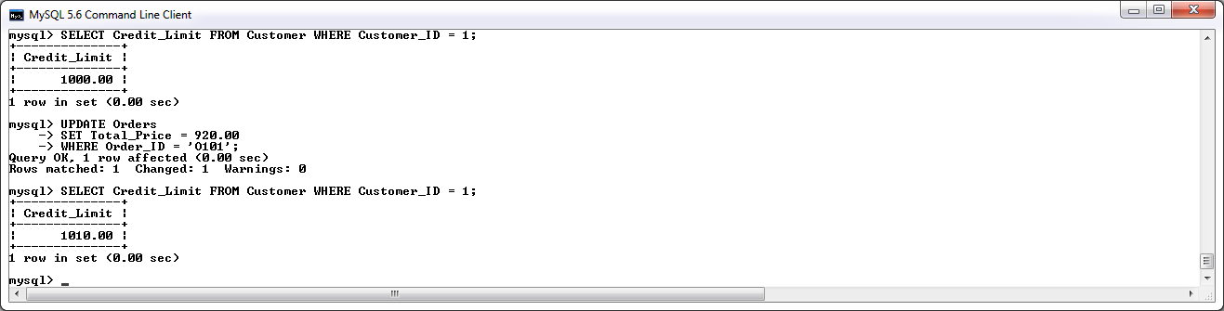

Test that an update to an order that exceeds one thousand euro but is less than fifteen hundred euro increases the customer credit limit by twenty euro.

**SELECT** Credit_Limit **FROM** Customer **WHERE** Customer_ID **=** 1**;**

**UPDATE** Orders

**SET** Total_Price **=** 1200.00

**WHERE** Order_ID **=** 'O101'**;**

**SELECT** Credit_Limit **FROM** Customer **WHERE** Customer_ID **=** 1**;**

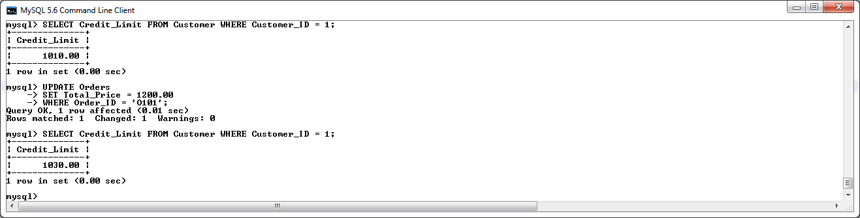

Test that an update to an order that exceeds fifteen hundred euro increases the customer credit limit by fifty euro.

**SELECT** Credit_Limit **FROM** Customer **WHERE** Customer_ID **=** 1**;**

**UPDATE** Orders

**SET** Total_Price **=** 1650.00

**WHERE** Order_ID **=** 'O101'**;**

**SELECT** Credit_Limit **FROM** Customer **WHERE** Customer_ID **=** 1**;**

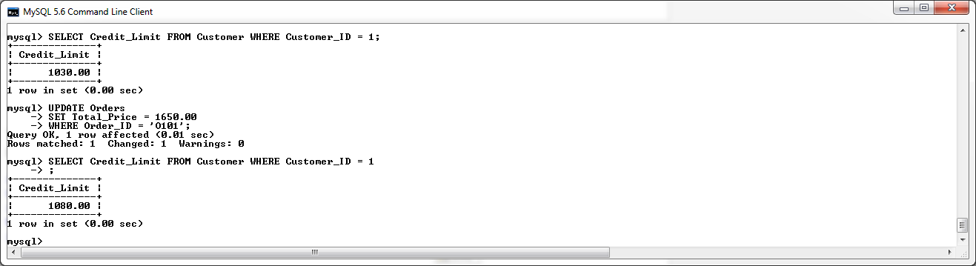

## Before /After Delete Triggers

**After Delete on Orders_Accessory_Junction Trigger**

Where a delete is performed on the Orders_Accessory_Junction Table, this trigger shall reimburse the quantity in stock on the accessory table for the accessory referenced in the deleted record. The Total_Price of the order shall also be updated to reflect the change in accessories to the order.

DELIMITER **//**

**DROP** **TRIGGER** **IF** **EXISTS** AfterDelete_Orders_Acc_Junct**//**

**CREATE** **TRIGGER** AfterDelete_Orders_Acc_Junct

**AFTER** **DELETE**

**ON** Orders_Accessory_Junction

**FOR** **EACH** **ROW**

**BEGIN**

**DECLARE** myMsg **Varchar(**60**);**

**DECLARE** V_Accessory_Price **decimal(**6**,**2**);**

**SELECT** Accessory_Price **into** V_Accessory_Price

**FROM** Accessory

**WHERE** Accessory_ID **=** **OLD.**Accessory_ID**;**

**UPDATE** Orders

**SET** Total_Price **=** Total_Price **-** **(OLD.**Accessory_Qty **\*** V_Accessory_Price**)**

**WHERE** Order_Id **=** **Old.**Order_Id**;**

**UPDATE** Accessory

**SET** ACCESSORY_Qty_InStock **=** ACCESSORY_Qty_InStock **+** **OLD.**Accessory_Qty

**WHERE** Accessory_ID **=** **OLD.**Accessory_ID**;**

**SELECT** **concat(**'Order ID : '**,OLD.**Order_ID**,**' Accessory ID : '**,OLD.**Accessory_ID**)** **into** myMsg**;**

**call** changesLog**(**'Orders_Accessory_Junction'**,** 'DELETED'**,** myMsg**);**

**END** **//**

DELIMITER **;**

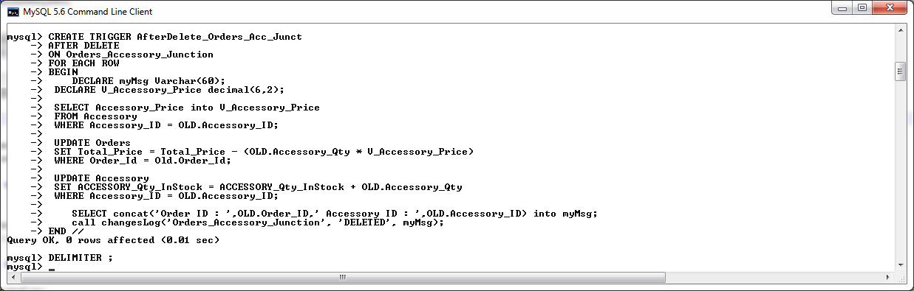

**Testing After Delete on Orders_Accessory_Junction Trigger**

Create dummy data

**Insert** **into** Orders_Accessory_Junction **values** **(**'A100'**,** 'O101'**,** 2**);**

**SELECT** **\*** **FROM** Orders_Accessory_Junction **WHERE** Accessory_ID **=** 'A100' **AND** ORDER_ID **=** 'O101'**;**

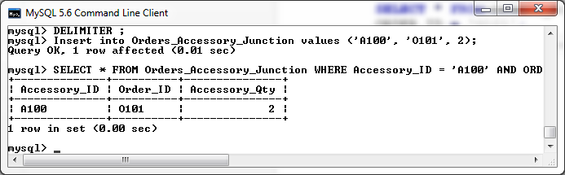

We shall now perform a delete on this record and observe the changes made to the referenced Accessory Quantity in the Accessory table.

**SELECT** **\*** **FROM** Accessory **WHERE** Accessory_ID **=** 'A100'**;**

**DELETE**

**FROM** Orders_Accessory_Junction

**WHERE** Accessory_ID **=** 'A100' **AND** ORDER_ID **=** 'O101'**;**

**SELECT** **\*** **FROM** Accessory **WHERE** Accessory_ID **=** 'A100'**;**

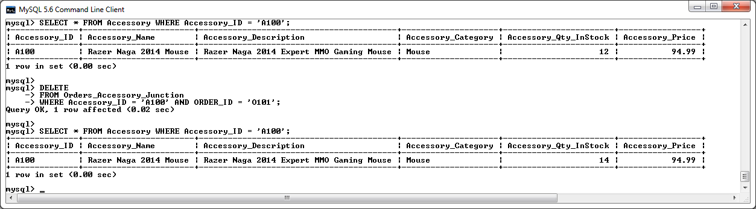

We can see that after the record was deleted, the quantity in stock of the Accessory in question was increased by 2 as desired.

We shall now verify that the deletion has been logged by the changesLog Proceedure.

**SELECT** **\*** **FROM** mysql_changesLog**;**

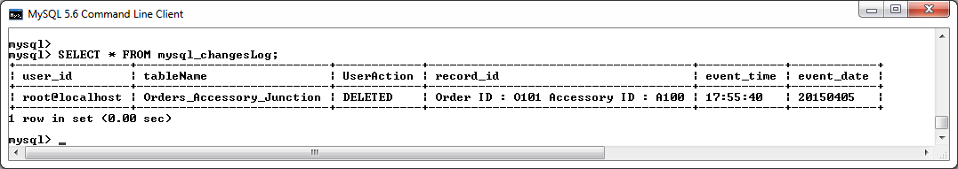

We shall now test to ensure that the Total_price of the Order associated to the deleted record is being updated to reflect the deleted accessory.

**SELECT** Accessory_Price **FROM** Accessory **WHERE** Accessory_ID **=** 'A100'**;**

**SELECT** Accessory_Qty **FROM** Orders_Accessory_Junction **WHERE** Accessory_ID **=** 'A100' **AND** Order_Id **=** 'O101'**;**

**SELECT** Total_Price **FROM** Orders **WHERE** Order_ID **=** 'O101'**;**

**DELETE**

**FROM** Orders_Accessory_Junction

**WHERE** Accessory_ID **=** 'A100' **AND** Order_Id **=** 'O101'**;**

**SELECT** Total_Price **FROM** Orders **WHERE** Order_ID **=** 'O101'**;**

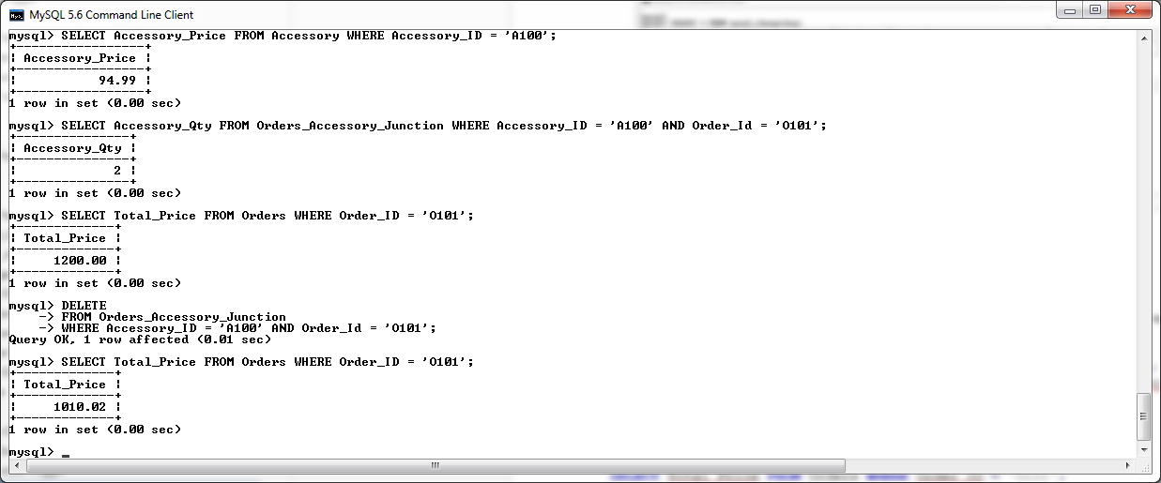

**After Delete on Orders_Component_Junction Trigger**

Where a delete is performed on the Orders_Component_Junction Table, this trigger shall reimburse the quantity in stock on the Component table for the component referenced in the deleted record.

DELIMITER **//**

**DROP** **TRIGGER** **IF** **EXISTS** AfterDelete_Orders_Comp_Junct**//**

**CREATE** **TRIGGER** AfterDelete_Orders_Comp_Junct

**AFTER** **DELETE**

**ON** Orders_Component_Junction

**FOR** **EACH** **ROW**

**BEGIN**

**DECLARE** myMsg **Varchar(**60**);**

**DECLARE** V_Comp_Price **decimal(**6**,**2**);**

**SELECT** Component_Price **into** V_Comp_Price

**FROM** Component

**WHERE** Component_ID **=** **OLD.**Component_ID**;**

**UPDATE** Orders

**SET** Total_Price **=** Total_Price **-** **(OLD.**Component_Qty **\*** V_Comp_Price**)**

**WHERE** Order_Id **=** **Old.**Order_Id**;**

**UPDATE** Component

**SET** Component_Qty_InStock **=** Component_Qty_InStock **+** **OLD.**Component_Qty

**WHERE** Component_ID **=** **OLD.**Component_ID**;**

**SELECT** **concat(**'Order ID : '**,OLD.**Order_ID**,**' Component_ID : '**,OLD.**Component_ID**)** **into** myMsg**;**

**call** changesLog**(**'Orders_Component_Junction'**,** 'DELETED'**,** myMsg**);**

**END** **//**

DELIMITER **;**

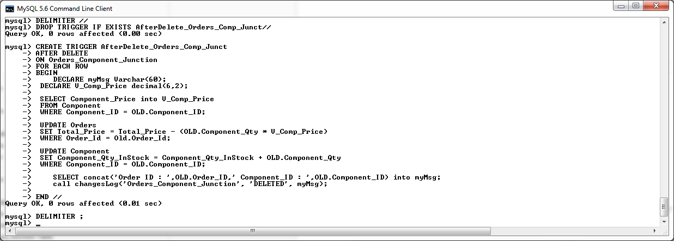

**Testing After Delete on Orders_Component_Junction Trigger**

Create dummy data

**Insert** **into** Orders_Component_Junction **values** **(**'C100'**,** 'O101'**,** 2**);**

**SELECT** **\*** **FROM** Orders_Component_Junction **WHERE** Component_ID **=** 'A100' **AND** ORDER_ID **=** 'O101'**;**

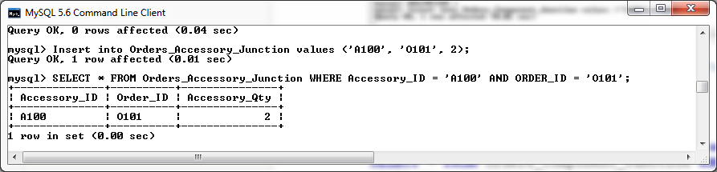

We shall now perform a delete on this record and observe the changes made to the referenced Component Quantity in the Component table.

**SELECT** **\*** **FROM** Component **WHERE** Component_ID **=** 'C100'**;**

**DELETE**

**FROM** Orders_Component_Junction

**WHERE** Component_ID **=** 'C100' **AND** ORDER_ID **=** 'O101'**;**

**SELECT** **\*** **FROM** Component **WHERE** Component_ID **=** 'C100'**;**

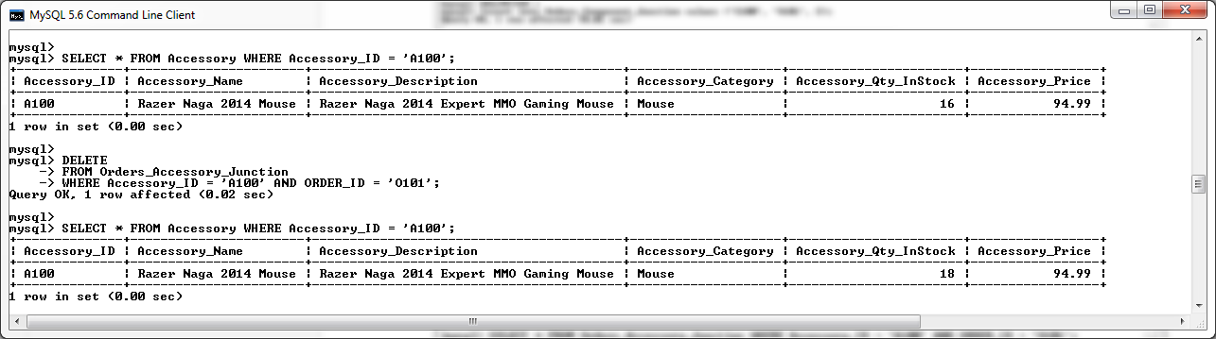

We can see that after the record was deleted, the quantity in stock of the Component in question was increased by 2 as desired.

We shall now verify that the deletion has been logged by the changesLog Proceedure.

**SELECT** **\*** **FROM** mysql_changesLog**;**

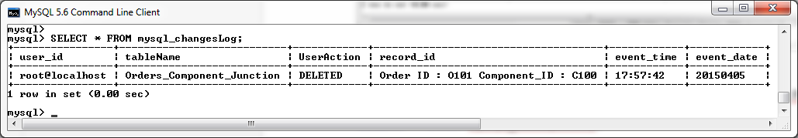

We shall now test to ensure that the Total_price of the Order associated to the deleted record is being updated to reflect the deleted component.

**SELECT** Component_Price **FROM** Component **WHERE** Component_ID **=** 'C100'**;**

**SELECT** Component_Qty **FROM** Orders_Component_Junction **WHERE** Component_ID **=** 'C100' **AND** Order_Id **=** 'O102'**;**

**SELECT** Total_Price **FROM** Orders **WHERE** Order_Id **=** 'O102'**;**

**DELETE**

**FROM** Orders_Component_Junction

**WHERE** Component_ID **=** 'C100' **AND** Order_Id **=** 'O102'**;**

**SELECT** Total_Price **FROM** Orders **WHERE** Order_Id **=** 'O102'**;**

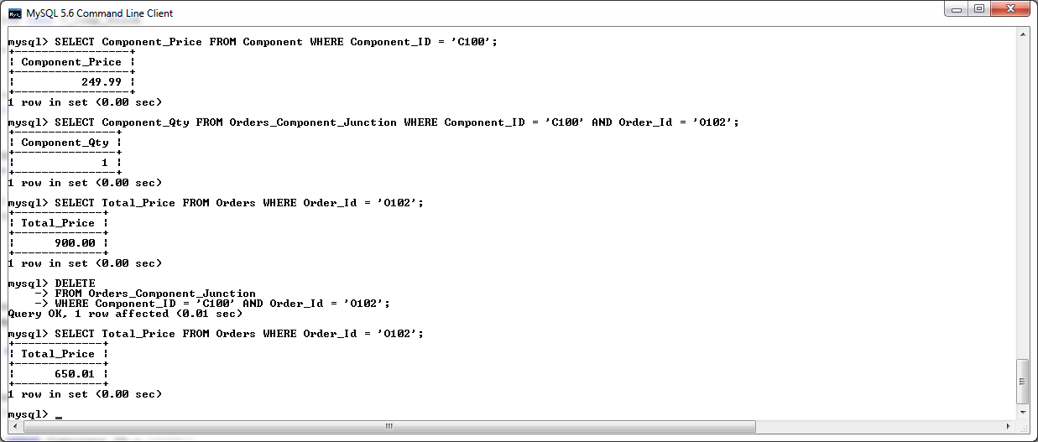

**After Delete on Orders Trigger**

When a delete is performed on the Orders Table, this trigger shall reimburse the Credit Limit on the Customer table for the customer referenced in the deleted record. The value of the reimbursement shall be based upon the total price of the Order being deleted. This purpose of this trigger is to undo any changes made to the customer’s credit limit when the order was first made (see insert triggers on the orders table as described earlier in this section for more detail on changes made to the customer’s credit limit based upon the total price of a new order)

DELIMITER **//**

**DROP** **TRIGGER** **IF** **EXISTS** AfterDelete_Orders **//**

**CREATE** **TRIGGER** AfterDelete_Orders

**AFTER** **DELETE**

**ON** Orders

**FOR** **EACH** **ROW**

**BEGIN**

**DECLARE** V_CREDIT_LIMIT_BONUS **Decimal(**6**,**2**);**

**DECLARE** myMsg **varchar(**60**);**

**IF(OLD.**Total_Price **<** 1000**)** **THEN**

**SET** V_CREDIT_LIMIT_BONUS **=** 10**;**

ELSEIF **(OLD.**Total_Price **>=** 1000 **AND** **OLD.**Total_Price **<** 1500**)** **THEN**

**SET** V_CREDIT_LIMIT_BONUS **=** 20**;**

ELSEIF**(OLD.**Total_Price **>=** 1500**)** **THEN**

**SET** V_CREDIT_LIMIT_BONUS **=** 50**;**

**END** **IF;**

**UPDATE** Customer

**SET** Credit_Limit **=** Credit_Limit **-** V_CREDIT_LIMIT_BONUS

**WHERE** Customer_ID **=** **OLD.**Customer_ID**;**

**SELECT** **concat(**'Customer ID :'**,OLD.**Customer_ID**,**' Credit Limit Decreased

by '**,**V_CREDIT_LIMIT_BONUS**)** **into** myMsg**;**

**call** changesLog**(**'Customer'**,** 'Modified'**,** myMsg**);**

**SELECT** **concat(**'Order ID : '**,OLD.**Order_ID**)** **into** myMsg**;**

**call** changesLog**(**'Orders'**,** 'DELETED'**,** myMsg**);**

**END** **//**

DELIMITER **;**

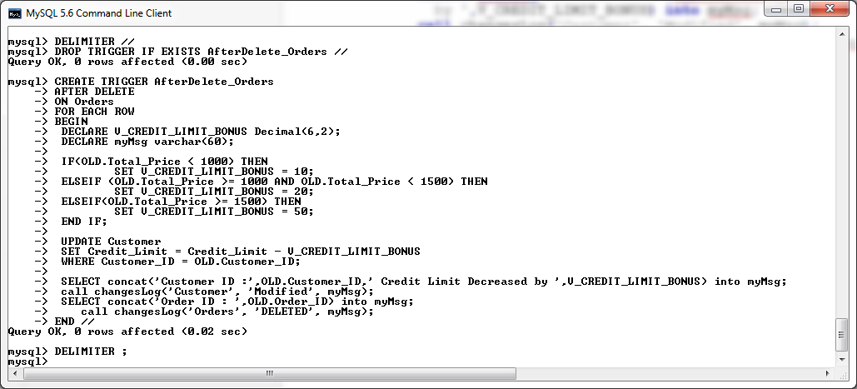

**Testing After Delete on Orders Trigger**

Create dummy data

**Insert** **into** Orders **values** **(**'O110'**,** 'DV105'**,** 1**,** '29-02-2015'**,**'Credit'**,**799.46**);**

**Insert** **into** Orders **values** **(**'O111'**,** 'DV105'**,** 1**,** '29-02-2015'**,**'Credit'**,**1250.00**);**

**Insert** **into** Orders **values** **(**'O112'**,** 'DV105'**,** 1**,** '29-02-2015'**,**'Credit'**,**1650.00**);**

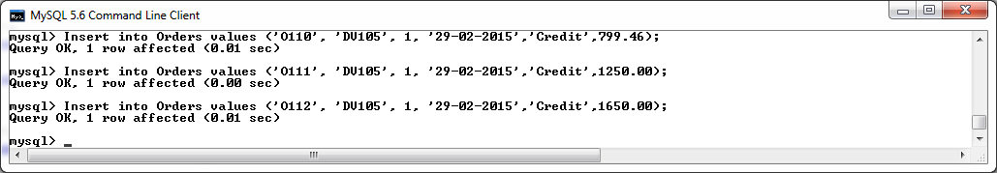

We shall now perform deletes on these record and observe the changes made to the Credit Limit of the referenced Customer in the Customer table.

**SELECT** Credit_Limit **FROM** Customer **WHERE** Customer_ID **=** 1**;**

**DELETE**

**FROM** Orders

**WHERE** ORDER_ID **=** 'O110'**;**

**SELECT** Credit_Limit **FROM** Customer **WHERE** Customer_ID **=** 1**;**

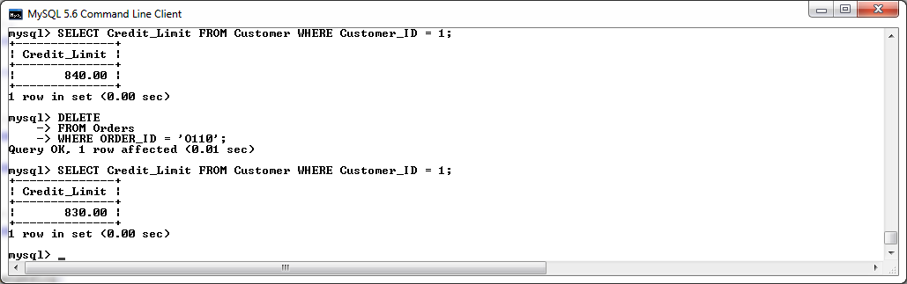

We can see that after the record was deleted, the Credit Limit of the Customer in question was reduced by 10 as desired (e.g. the credit limit was decreased by 10 euros as the total price of the order was less the 1000 euros).

**SELECT** Credit_Limit **FROM** Customer **WHERE** Customer_ID **=** 1**;**

**DELETE**

**FROM** Orders

**WHERE** ORDER_ID **=** 'O111'**;**

**SELECT** Credit_Limit **FROM** Customer **WHERE** Customer_ID **=** 1**;**

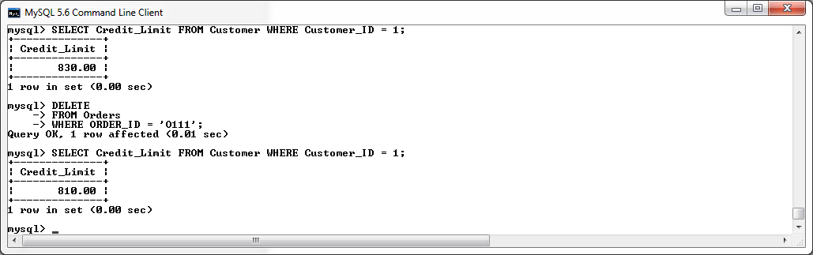

We can see that after the record was deleted, the Credit Limit of the Customer in question was reduced by 20 as desired (e.g. the credit limit was decreased by 20 euros as the total price of the order exceeded 1000 euros but was less than 1500 euros).

**SELECT** Credit_Limit **FROM** Customer **WHERE** Customer_ID **=** 1**;**

**DELETE**

**FROM** Orders

**WHERE** ORDER_ID **=** 'O112'**;**

**SELECT** Credit_Limit **FROM** Customer **WHERE** Customer_ID **=** 1**;**

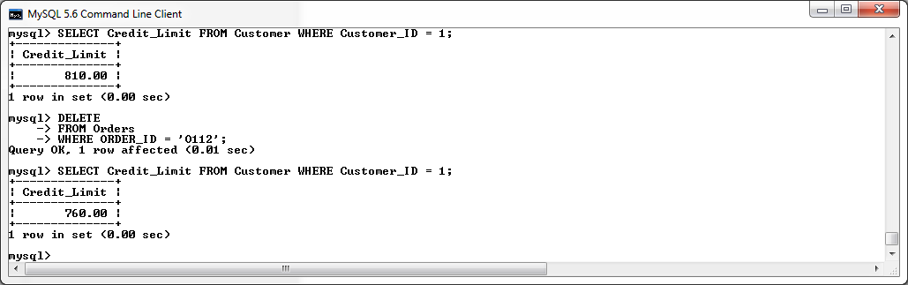

We can see that after the record was deleted, the Credit Limit of the Customer in question was reduced by 50 as desired (e.g. the credit limit was decreased by 50 euros as the total price of the order exceeded 1500 euros).

# Procedures and Functions

## Procedures

**DeleteCustomerAndOrders Procedure**

This trigger was created to help assist database users delete a Customer record (specified by a customer id) and all related Order information currently held in the database in relation to the Customer in question.

To ensure all information in relation to a specific customer is deleted, the following tables must be checked to see if they contain a reference to the customer:

* The Orders table – which in turn will have records associated to the order in the following :
  + The Orders_Accessory_Table
  + The Orders_Component_Table
* And finally, the Customer table.

This procedure must encompass that if the customer in question has more than one order associated with them in the Orders table, all information in relation to these multiple orders will need to be removed. To accomplish this task, the procedure will make use of both a cursor and a for loop. I have commented the code for a breakdown in the steps used to accomplish this task.

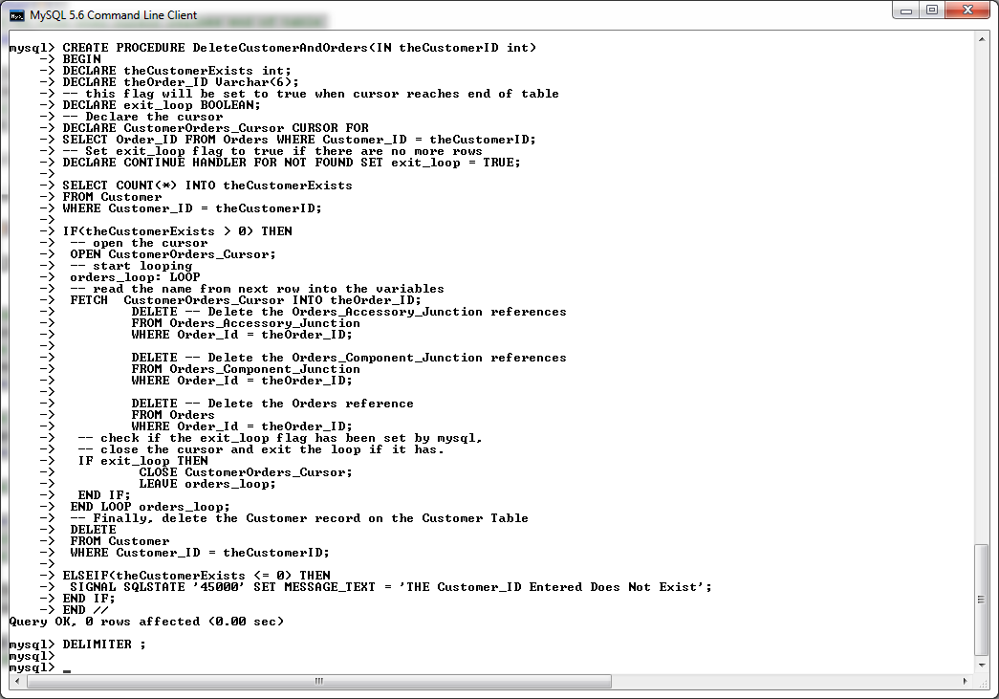

DELIMITER **//**

**DROP** **PROCEDURE** **IF** **EXISTS** DeleteCustomerAndOrders **//**

**CREATE** **PROCEDURE** DeleteCustomerAndOrders**(IN** theCustomerID **int)**

**BEGIN**

**DECLARE** theCustomerExists **int;**

**DECLARE** theOrder_ID **Varchar(**6**);**

-- this flag will be set to true when cursor reaches end of table

**DECLARE** exit_loop **BOOLEAN;**

-- Declare the cursor

**DECLARE** CustomerOrders_Cursor **CURSOR** **FOR**

**SELECT** Order_ID **FROM** Orders **WHERE** Customer_ID **=** theCustomerID**;**

-- Set exit_loop flag to true if there are no more rows

**DECLARE** **CONTINUE** HANDLER **FOR** **NOT** **FOUND** **SET** exit_loop **=** **TRUE;**

**SELECT** **COUNT(*)** **INTO** theCustomerExists

**FROM** Customer

**WHERE** Customer_ID **=** theCustomerID**;**

**IF(**theCustomerExists **>** 0**)** **THEN**

-- open the cursor

**OPEN** CustomerOrders_Cursor**;**

-- start looping

orders_loop**:** **LOOP**

-- read the name from next row into the variables

**FETCH** CustomerOrders_Cursor **INTO** theOrder_ID**;**

**DELETE** -- Delete the Orders_Accessory_Junction references

**FROM** Orders_Accessory_Junction

**WHERE** Order_Id **=** theOrder_ID**;**

**DELETE** -- Delete the Orders_Component_Junction references

**FROM** Orders_Component_Junction

**WHERE** Order_Id **=** theOrder_ID**;**

**DELETE** -- Delete the Orders reference

**FROM** Orders

**WHERE** Order_Id **=** theOrder_ID**;**

-- check if the exit_loop flag has been set by mysql,

-- close the cursor and exit the loop if it has.

**IF** exit_loop **THEN**

**CLOSE** CustomerOrders_Cursor**;**

LEAVE orders_loop**;**

**END** **IF;**

**END** **LOOP** orders_loop**;**

-- Finally, delete the Customer record on the Customer Table

**DELETE**

**FROM** Customer

**WHERE** Customer_ID **=** theCustomerID**;**

ELSEIF**(**theCustomerExists **<=** 0**)** **THEN**

SIGNAL **SQLSTATE** '45000' **SET** MESSAGE_TEXT **=** 'THE Customer_ID Entered Does Not Exist'**;**

**END** **IF;**

**END** **//**

DELIMITER **;**

**Test DeleteCustomerAndOrders Procedure**

**SELECT** **COUNT(*)** **FROM** Customer **WHERE** Customer_ID **=** 2**;**

**SELECT** **COUNT(*)** **FROM** Orders **WHERE** Customer_ID **=** 2**;**

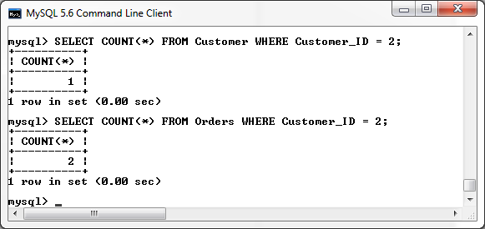

We can see from the results of the above select statements that currently a customer record exists with the customer_id of value 2. Also, this customer has a total of two orders associated with him/her on the orders table.

**SELECT** Order_ID **FROM** Orders **WHERE** Customer_ID **=** 2**;**

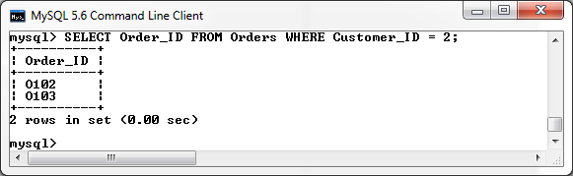

From the above select statement we can see that the customer is associated with Orders ‘O102’ and ‘O103’. We shall now count the number of accessories then components that are currently associated with these order numbers.

**SELECT** **COUNT(*)** **FROM** Orders_Accessory_Junction **WHERE** Order_Id **=**'O102' **OR** Order_Id **=**'O103'**;**

**SELECT** **COUNT(*)** **FROM** Orders_Component_Junction **WHERE** Order_Id **=**'O102' **OR** Order_Id **=**'O103'**;**

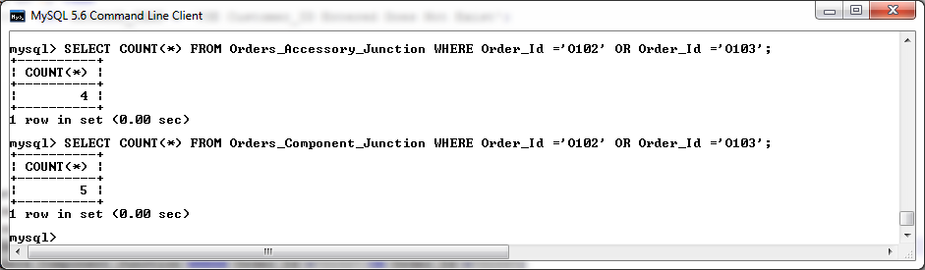

Both of these orders combined have a total of four accessories and five components associated with them.

We shall now call the trigger and observe the results.

**call** DeleteCustomerAndOrders**(**2**);**

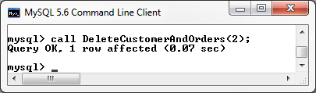

**SELECT** **COUNT(*)** **FROM** Orders_Accessory_Junction **WHERE** Order_Id **=**'O102' **OR** Order_Id **=**'O103'**;**

**SELECT** **COUNT(*)** **FROM** Orders_Component_Junction **WHERE** Order_Id **=**'O102' **OR** Order_Id **=**'O103'**;**

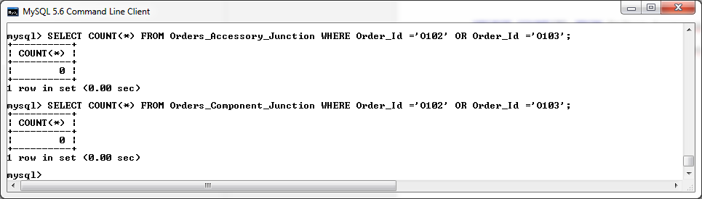

We can see that all accessories and components associated with this customer have been successfully deleted.

**SELECT** **COUNT(*)** **FROM** Customer **WHERE** Customer_ID **=** 2**;**

**SELECT** **COUNT(*)** **FROM** Orders **WHERE** Customer_ID **=** 2**;**

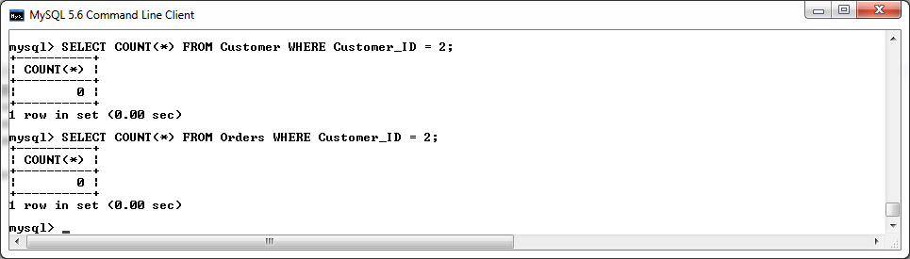

Also, as desired, all orders associated with this customer have been removed along with the customer record related to the specified customer id.

We shall now call the procedure again on the same customer ID to ensure that the procedure handles an instance where a customer id that does not exist is referenced in the procedure call.

**call** DeleteCustomerAndOrders**(**2**);**

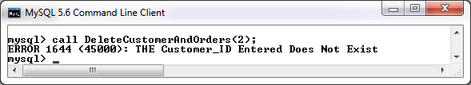

As expected, this error was caught and a suitable error message was displayed.

**DeleteOrder Procedure**

This Procedure shall assist the database user in the circumstance where an Order (specified by order_id) and all associated records (e.g. components and accessories related to the order) need to be removed from the database. On execution of this procedure, all accessories and components related to the order in question shall be removed from the relevant junction tables before the Order record that exists on the Orders table is finally removed.

DELIMITER **//**

**DROP** **PROCEDURE** **IF** **EXISTS** DeleteOrder **//**

**CREATE** **PROCEDURE** DeleteOrder**(IN** theOrderID **Varchar(**6**))**

**BEGIN**

**DECLARE** theOrderExists **int;**

**SELECT** **COUNT(*)** **INTO** theOrderExists

**FROM** Orders

**WHERE** ORDER_ID **=** theOrderID**;**

**IF(**theOrderExists **>** 0**)** **THEN**

**DELETE**

**FROM** Orders_Accessory_Junction

**WHERE** Order_Id **=** theOrderID**;**

**DELETE**

**FROM** Orders_Component_Junction

**WHERE** Order_Id **=** theOrderID**;**

**DELETE**

**FROM** Orders

**WHERE** Order_Id **=** theOrderID**;**

ELSEIF**(**theOrderExists **<=** 0**)** **THEN**

SIGNAL **SQLSTATE** '45000' **SET** MESSAGE_TEXT **=** 'THE ORDER_ID Entered Does Not Exist'**;**

**END** **IF;**

**END;** **//**

DELIMITER **;**

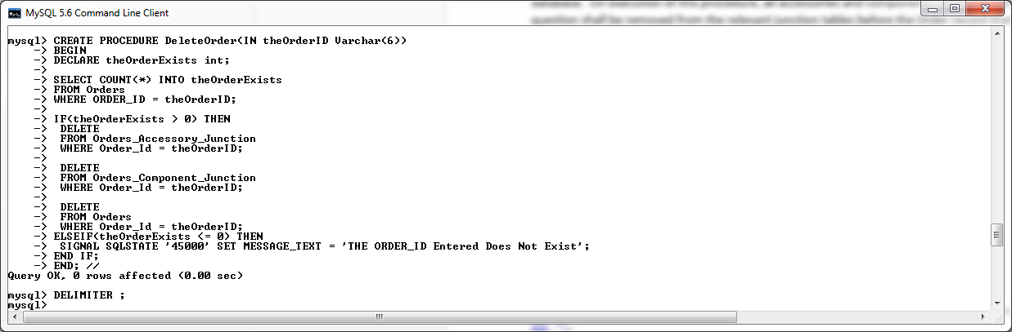

**Test DeleteOrder Procedure**

**SELECT** **\*** **FROM** Orders **WHERE** Order_Id **=** 'O101'**;**

**SELECT** **\*** **FROM** Orders_Accessory_Junction **WHERE** Order_Id **=** 'O101'**;**

**SELECT** **\*** **FROM** Orders_Component_Junction **WHERE** Order_Id **=** 'O101'**;**

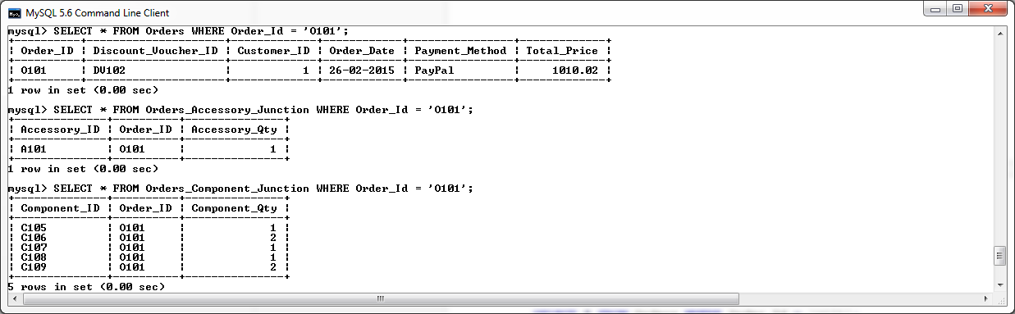

**Call** DeleteOrder**(**'O101'**);**

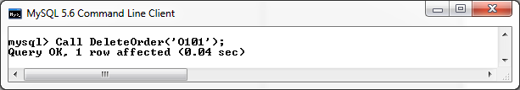

**SELECT** **\*** **FROM** Orders_Component_Junction **WHERE** Order_Id **=** 'O101'**;**

**SELECT** **\*** **FROM** Orders_Accessory_Junction **WHERE** Order_Id **=** 'O101'**;**

**SELECT** **\*** **FROM** Orders **WHERE** Order_Id **=** 'O101'**;**

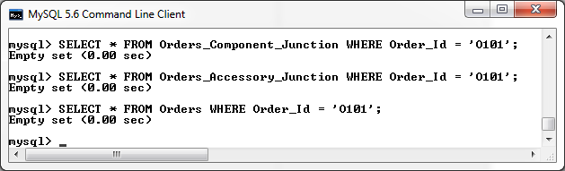

We can see from the above test that both the order record and all associated junction table records have been successfully deleted from the database. Now we shall try and delete the same order again using this procedure to ensure that this error is being caught.

**Call** DeleteOrder**(**'O101'**);**

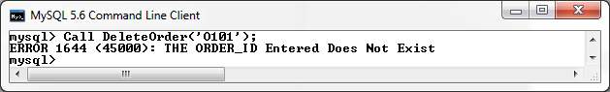

**ShowOrderComponentDetails Procedure**

This Procedure shall assist the database user displaying all the individual components that are current associated with a specified order number. On execution of this procedure, all components related to the order in question shall be displayed.

DELIMITER **//**

**DROP** **PROCEDURE** **IF** **EXISTS** ShowOrderComponentDetails **//**

**CREATE** **PROCEDURE** ShowOrderComponentDetails**(IN** theOrderID **Varchar(**6**))**

**BEGIN**

**DECLARE** theOrderExists **int;**

**SELECT** **COUNT(*)** **INTO** theOrderExists

**FROM** Orders

**WHERE** ORDER_ID **=** theOrderID**;**

**IF(**theOrderExists **>** 0**)** **THEN**

**SELECT** Orders_Component_Junction**.**Component_Id**,** Orders_Component_Junction**.**Component_Qty**,** Component**.**Component_Name

**FROM** Component **,** Orders_Component_Junction

**WHERE** Orders_Component_Junction**.**ORDER_ID **=** theOrderID

**AND** Component**.**Component_Id **=** Orders_Component_Junction**.**Component_Id**;**

ELSEIF**(**theOrderExists **<=** 0**)** **THEN**

SIGNAL **SQLSTATE** '45000' **SET** MESSAGE_TEXT **=** 'THE ORDER_ID Entered Does Not Exist'**;**

**END** **IF;**

**END;** **//**

DELIMITER **;**

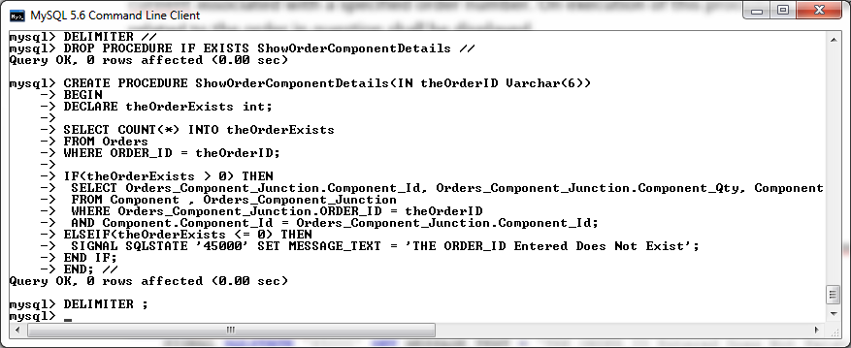

**Test ShowOrderComponentDetails Procedure**

**Call** ShowOrderComponentDetails**(**'O101'**);**

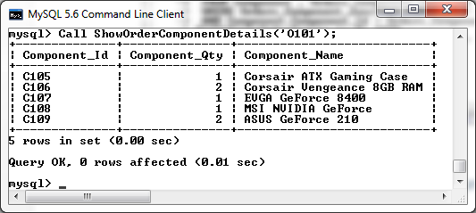

Now we shall try and call this procedure with an order_id that currently does not exist within the database to ensure this exception if been handled correctly.

**Call** ShowOrderComponentDetails**(**'Z999'**);**

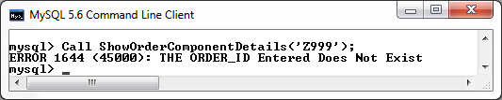

**ShowOrderAccessoryDetails Procedure**

This Procedure shall assist the database user displaying all the individual accessories that are current associated with a specified order number. On execution of this procedure, all accessories related to the order in question shall be displayed.

DELIMITER **//**

**DROP** **PROCEDURE** **IF** **EXISTS** ShowOrderAccessoryDetails **//**

**CREATE** **PROCEDURE** ShowOrderAccessoryDetails**(IN** theOrderID **Varchar(**6**))**

**BEGIN**

**DECLARE** theOrderExists **int;**

**SELECT** **COUNT(*)** **INTO** theOrderExists

**FROM** Orders

**WHERE** ORDER_ID **=** theOrderID**;**

**IF(**theOrderExists **>** 0**)** **THEN**

**SELECT** Orders_Accessory_Junction**.**Accessory_Id**,** Orders_Accessory_Junction**.**Accessory_Qty**,** Accessory**.**Accessory_Name

**FROM** Accessory **,** Orders_Accessory_Junction

**WHERE** Orders_Accessory_Junction**.**ORDER_ID **=** theOrderID

**AND** Accessory**.**Accessory_Id **=** Orders_Accessory_Junction**.**Accessory_Id**;**

ELSEIF**(**theOrderExists **<=** 0**)** **THEN**

SIGNAL **SQLSTATE** '45000' **SET** MESSAGE_TEXT **=** 'THE ORDER_ID Entered Does Not Exist'**;**

**END** **IF;**

**END;** **//**

DELIMITER **;**

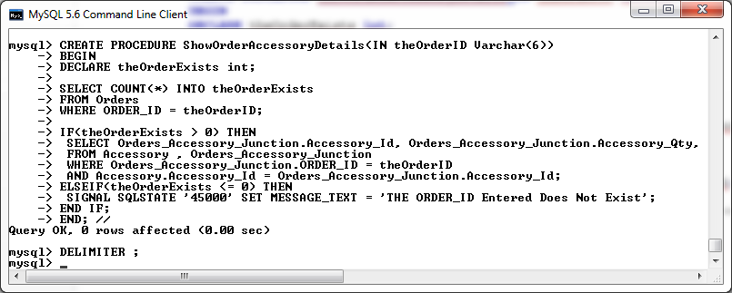

**Test ShowOrderAccessoryDetails Procedure**

Call ShowOrderAccessoryDetails('O101');

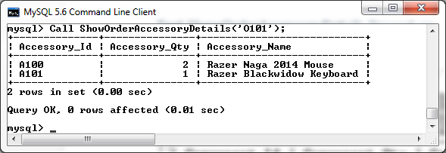

Now we shall try and call this procedure with an order_id that currently does not exist within the database to ensure this exception if been handled correctly.

**Call** ShowOrderAccessoryDetails**(**'Z999'**);**

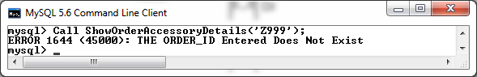

## Functions

**NoOfOrders Function**

This function will return the total number of orders which exits within the Orders table.

DELIMITER **//**

**DROP** **FUNCTION** **IF** **EXISTS** NoCurrentOrders **//**

**CREATE** **FUNCTION** NoCurrentOrders**()** **RETURNS** **int**

**BEGIN**

**DECLARE** NumOfOrders **int;**

**SELECT** **Count(*)** **INTO** NumOfOrders **FROM** Orders**;**

**RETURN** NumOfOrders**;**

**END;//**

DELIMITER **;**

**SELECT** NoCurrentOrders**();**

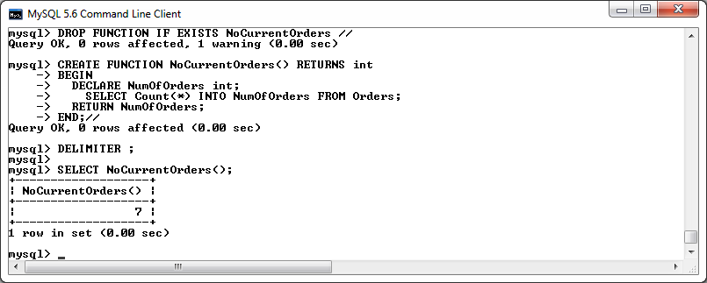

**FindCustomerByOrderNo Function**

This function will return the Customer ID associated with a specific Order Number.

DELIMITER **//**

**DROP** **FUNCTION** **IF** **EXISTS** FindCustomerIdByOrderNo **//**

**CREATE** **FUNCTION** FindCustomerIdByOrderNo**(**OrderId **Varchar** **(**6**))** **RETURNS** **int**

**BEGIN**

**DECLARE** CustomerID **int;**

**SELECT** Customer_ID **INTO** CustomerID **FROM** Orders **WHERE** Order_ID **=** OrderId**;**

**RETURN** CustomerID**;**

**END;//**

DELIMITER **;**

**SELECT** FindCustomerIdByOrderNo**(**'O101'**);**

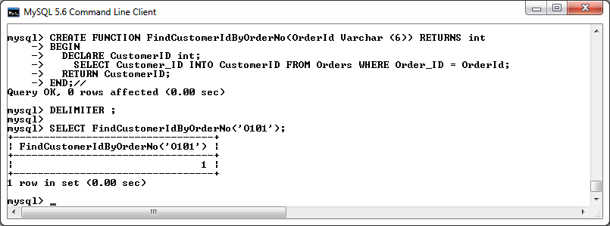

**AvgCostOfComp Function**

This function will return the average cost of all components stored within the database.

DELIMITER **//**

**DROP** **FUNCTION** **IF** **EXISTS** AvgCostOfComp **//**

**CREATE** **FUNCTION** AvgCostOfComp **()** **RETURNS** **Decimal(**6**,** 2**)**

**BEGIN**

**DECLARE** AvgCost **Decimal(**6**,** 2**);**

**SELECT** **Avg(**Component_Price**)** **INTO** AvgCost **FROM** Component**;**

**RETURN** AvgCost**;**

**END;//**

DELIMITER **;**

**SELECT** AvgCostOfComp**();**

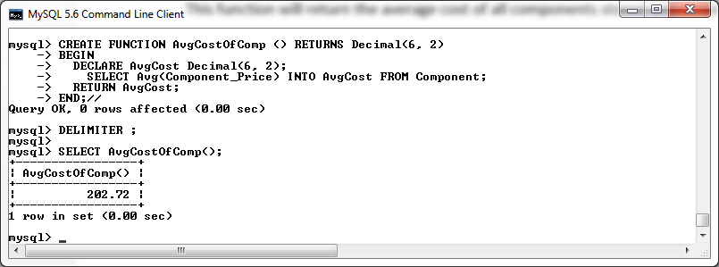

**AvgCostOfAccessories Function**

This function will return the average cost of all accessories stored within the database.

DELIMITER **//**

**DROP** **FUNCTION** **IF** **EXISTS** AvgCostOfAccessories **//**

**CREATE** **FUNCTION** AvgCostOfAccessories **()** **RETURNS** **Decimal(**6**,** 2**)**

**BEGIN**

**DECLARE** AvgCost **Decimal(**6**,** 2**);**

**SELECT** **Avg(**Accessory_Price**)** **INTO** AvgCost **FROM** Accessory**;**

**RETURN** AvgCost**;**

**END;//**

DELIMITER **;**

**SELECT** AvgCostOfAccessories **();**

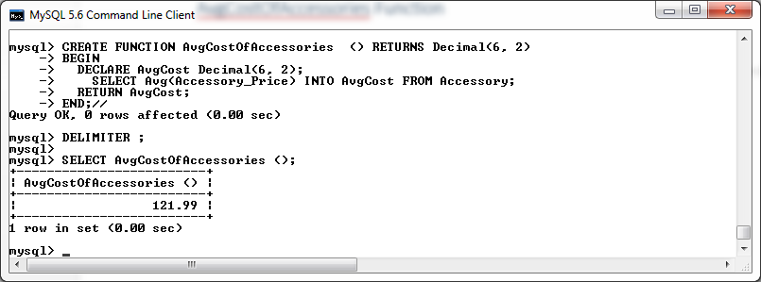

**SumCostOfOrdersByCustomer Function**

This function will return the sum cost of all orders stored within the database made by a specified customer.

DELIMITER **//**

**DROP** **FUNCTION** **IF** **EXISTS** SumCostOfOrdersByCustomer **//**

**CREATE** **FUNCTION** SumCostOfOrdersByCustomer**(**CustId **int)** **RETURNS** **Decimal(**6**,** 2**)**

**BEGIN**

**DECLARE** AvgCost **Decimal(**6**,** 2**);**

**SELECT** **SUM(**Total_Price**)** **INTO** AvgCost **FROM** Orders **WHERE** Customer_ID **=** CustId**;**

**RETURN** AvgCost**;**

**END;//**

DELIMITER **;**

**SELECT** SumCostOfOrdersByCustomer**(**1**);**

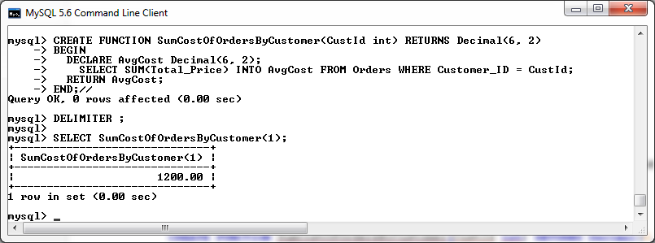

**PaymentMethods Function**

This function will return the number of orders that exist within the database that have the specified payment method.

DELIMITER **//**

**DROP** **FUNCTION** **IF** **EXISTS** PaymentMethods **//**

**CREATE** **FUNCTION** PaymentMethods**(**method **Varchar(**20**))** **RETURNS** **int**

**BEGIN**

**DECLARE** numFound **Decimal(**6**,** 2**);**

**SELECT** **Count(*)** **INTO** numFound **FROM** Orders **WHERE** Payment_Method **=** method**;**

**RETURN** numFound**;**

**END;//**

DELIMITER **;**

**SELECT** PaymentMethods**(**'PayPal'**);**

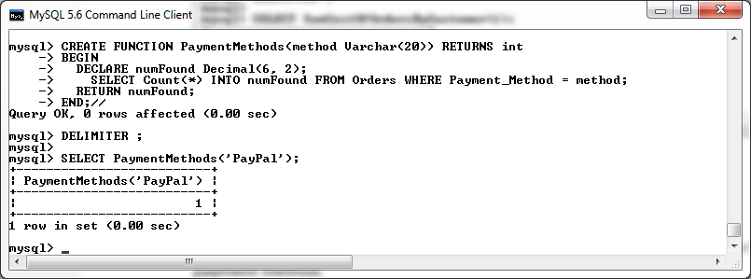

# User Base

## Define Users and their Permissions

As specified by the client, there shall be three different types of Users who will access the database, namely:

* Customers
* Company Employees (sales staff etc.)
* Administrators

## Customer Privileges

The Customer be able to view information regarding what components and accessories can be included in a pc build via the company website which will be linked to the company database. Once they have decided on their custom pc build, they shall place their order via phone to a Company Employee (sales staff). Once an order has being placed, they shall be able to review their order information online via the company website. The Customer shall also have the permission to update their own individual personal details via the company website.

Customer accounts shall have the following access privileges to tables within the database:

**Customer Table**

* Read/Update (read and update their profile information)

**Orders Table**

* Read (read information about the order they have placed)

**Component Table**

* Read (read details of components that are available to add to their order)

**Accessory Table**

* Read (read details of accessories that are available to add to their order)

## Company Employee Privileges

The Company Employee shall be able to create/read/update the orders received from the customer. They shall be able to create/read/update all information regarding both accessories and components that the company current have to offer, including information stored in relation to component manufacturers. Company Employees shall also have read/create/update access to all customer information stored within the database with the ability to lock and unlock customer accounts if necessary. They shall be also able to create/read/update discount vouchers offered to customers by the company.

Company Employee accounts shall have the following access privileges to tables within the database:

**Customer Table**

* Read/Insert/Update

**Orders Table**

* Read/Insert/Update

**Component Table**

* Read/Insert/Update

**Accessory Table**

* Read/Insert/Update

**Orders_Component_Junction Table**

* Read/Insert/Update

**Orders_Accessory_Junction Table**

* Read/Insert/Update

**Discount_Voucher Table**

* Read/Insert/Update

**Component_Manufacturer Table**

* Read/Insert/Update

## Administrator Privileges

An administrator shall have create/read/update/delete privileges to all data stored within the company website. The administrator shall also have the privilege to grant Delete access to Employess Account on the customer table.

Administrator accounts shall have the following access privileges to tables within the database:

**Customer Table**

* Read/Insert/Update/Delete/Grant

**Orders Table**

* Read/Insert/Update/Delete

**Component Table**

* Read/Insert/Update/Delete

**Accessory Table**

* Read/Insert/Update/Delete

**Orders_Component_Junction Table**

* Read/Insert/Update/Delete

**Orders_Accessory_Junction Table**

* Read/Insert/Update/Delete

**Discount_Voucher Table**

* Read/Insert/Update/Delete

**Component_Manufacturer Table**

* Read/Insert/Update/Delete

**mysql_changesLog Table**

* Read/Insert/Update/Delete

## Creating Customer Account Privileges

**Create Customer account**

**CREATE** **USER** 'myCustomer'@'localhost' **IDENTIFIED** **BY** 'customer'**;**

**SELECT** **host,user,**password **from** mysql**.** **user;**

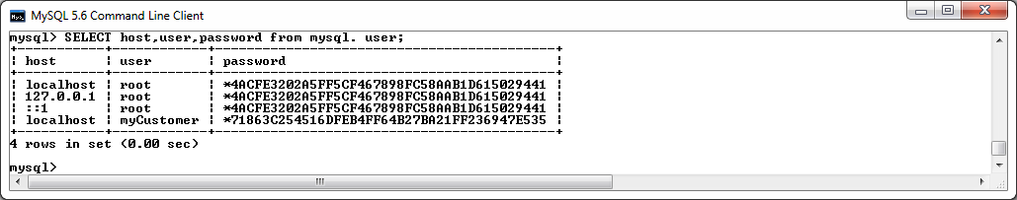

**Grant privileges to tables:**

**GRANT** **SELECT,** **UPDATE** **ON** project**.**Customer **TO** myCustomer@localhost**;**

**GRANT** **SELECT** **ON** project**.**Orders **TO** myCustomer@localhost**;**

**GRANT** **SELECT** **ON** project**.**Component **TO** myCustomer@localhost**;**

**GRANT** **SELECT** **ON** project**.**Accessory **TO** myCustomer@localhost**;**

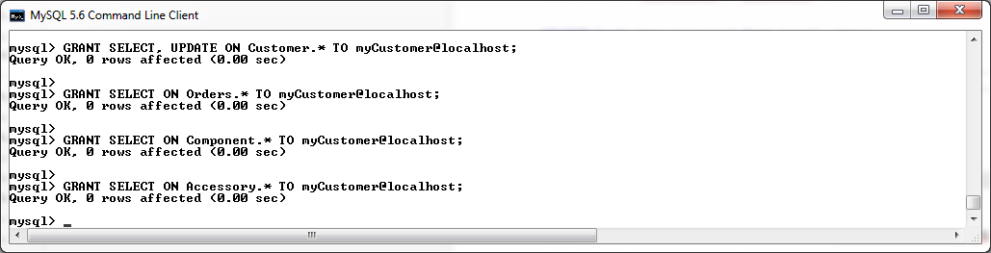

**Testing Customer Account Privileges**

**Log in as Customer from command prompt:**

"C:\Program Files (x86)\MySQL\MySQL Server 5.6\bin\mysql.exe" "--defaults-file=C:\ProgramData\MySQL\MySQL Server 5.6\my.ini" "-umyCustomer" "-pcustomer"

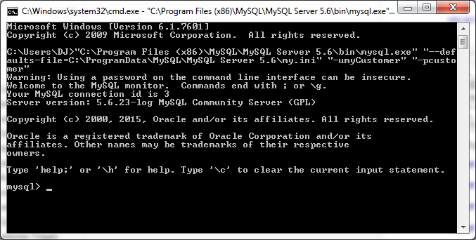

**View Customer Privileges**

show Grants;

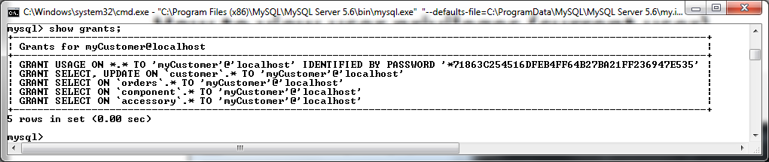

**TEST Privileges on the Customer Table**

**Attempt SELECT on Customer Table.**

**SELECT** **\*** **FROM** Customer **WHERE** Customer_ID **=** 1**;**

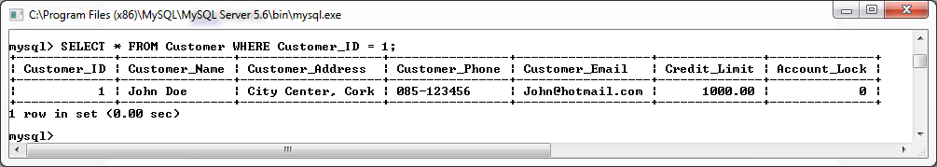

**UPDATE** Customer

**SET** Customer_Name **=** 'MyNewName'

**WHERE** Customer_ID **=** 1**;**

**SELECT** **\*** **FROM** Customer **WHERE** Customer_ID **=** 1**;**

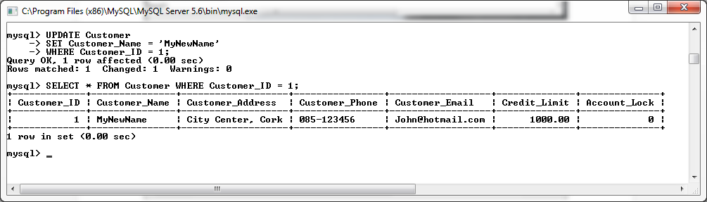

**Attempt Delete on Customer Table.**

**DELETE**

**FROM** Customer

**WHERE** Customer_ID **=** 1**;**

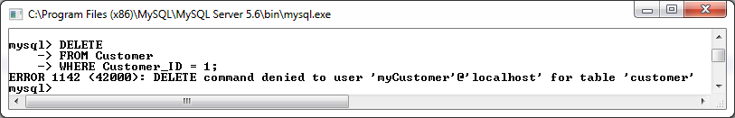

**Attempt Insert on Customer Table.**

**Insert** **into** Customer **values** **(**10**,**'David Satriani'**,**'City Center, Waterford'**,** '089-321987'**,** 'DavidS@hotmail.com'**,** 1500**,** 1**);**

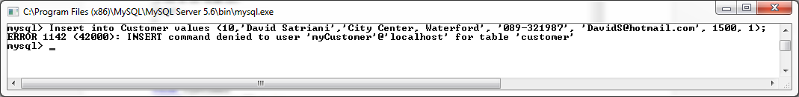

**TEST Privileges On the Orders table.**

**Attempt SELECT On Orders table.**

**SELECT** **\*** **FROM** Orders **WHERE** Customer_ID **=** 1**;**

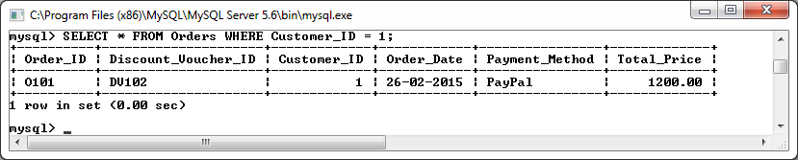

**Attempt Update On Orders table.**

**UPDATE** Orders

**SET** Total_Price **=** 1000.00

**WHERE** Customer_ID **=** 1**;**

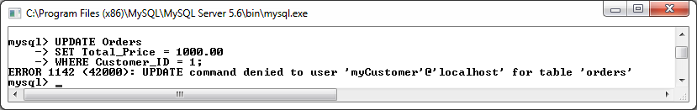

**Attempt DELETE On Orders table.**

**DELETE**

**FROM** Orders

**WHERE** Customer_ID **=** 1**;**

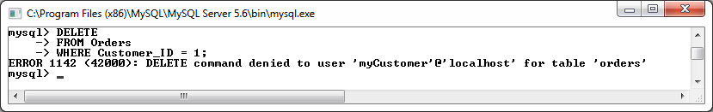

**Attempt INSERT On Orders table.**

**Insert** **into** Orders **values** **(**'O109'**,** 'DV105'**,** 9**,** '29-02-2015'**,**'Credit'**,**799.46**);**

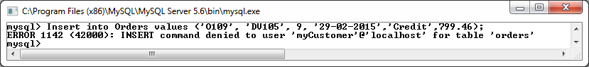

**TEST Privileges On the Component table.**

**Attempt SELECT On Component table.**

**SELECT** **\*** **FROM** Component **WHERE** Component_ID **=** 'C100'**;**

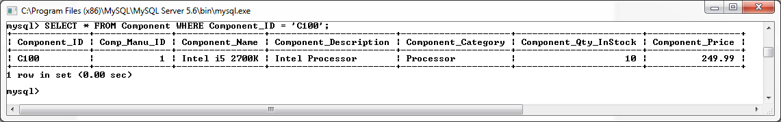

**Attempt Update On Component table.**

**UPDATE** Component

**SET** Component_Name **=** 'MyNewName'

**WHERE** Component_ID **=** 'C100'**;**

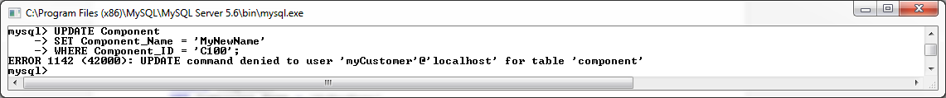

**Attempt DELETE On Component table.**

**DELETE**

**FROM** Component

**WHERE** Component_ID **=** 'C100'**;**

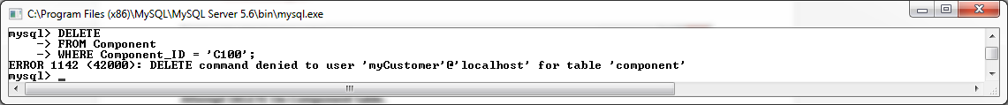

**Attempt INSERT On Component table.**

**Insert** **into** Component **values** **(**'C100'**,**1**,**'Intel i5 2700K'**,**'Intel Processor'**,** 'Processor'**,** 10**,** 249.99**);**



**TEST Privileges On the Accessory table.**

**Attempt SELECT On Accessory table.**

**SELECT** **\*** **FROM** Accessory **WHERE** Accessory_ID **=** 'A100'**;**

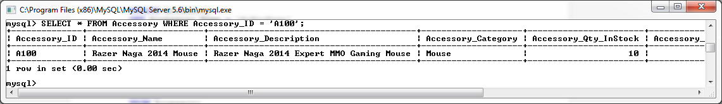

**Attempt Update On Accessory table.**

**UPDATE** Accessory

**SET** Accessory_Name **=** 'MyNewName'

**WHERE** Accessory_ID **=** 'A100'**;**

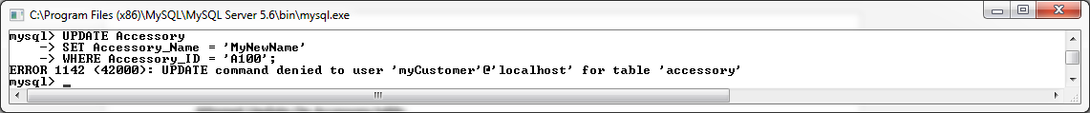

**Attempt DELETE On Accessory table.**

**DELETE**

**FROM** Accessory

**WHERE** Accessory_ID **=** 'A100'**;**

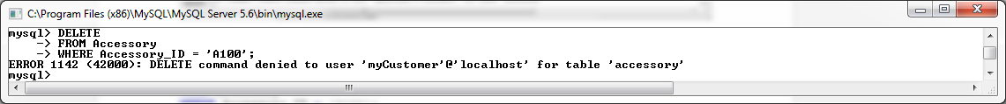

**Attempt INSERT On Accessory table.**

**Insert** **into** Accessory **values** **(**'A100'**,**'Razer Naga 2014 Mouse'**,**'Razer Naga 2014 Expert MMO Gaming Mouse'**,**'Mouse'**,** 10**,**94.99**);**



## Creating Employee Account Privileges

**Create Employee account**

**CREATE** **USER** 'myEmployee'@'localhost' **IDENTIFIED** **BY** 'employee'**;**

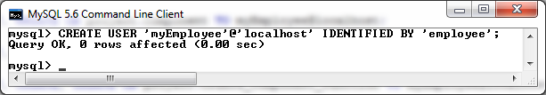

**SELECT** **host,user,**password **from** mysql**.** **user;**

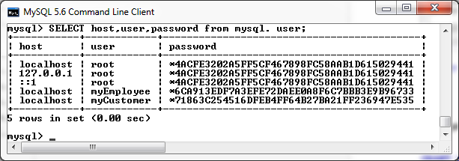

**Grant privileges to tables:**

**GRANT** **SELECT,** **INSERT,** **UPDATE** **ON** project**.**Customer **TO** myEmployee@localhost**;**

**GRANT** **SELECT,** **INSERT,** **UPDATE** **ON** project**.**Orders **TO** myEmployee@localhost**;**

**GRANT** **SELECT,** **INSERT,** **UPDATE** **ON** project**.**Component **TO** myEmployee@localhost**;**

**GRANT** **SELECT,** **INSERT,** **UPDATE** **ON** project**.**Accessory **TO** myEmployee@localhost**;**

**GRANT** **SELECT,** **INSERT,** **UPDATE,** **UPDATE** **ON** project**.**Orders_Component_Junction **TO** myEmployee@localhost**;**

**GRANT** **SELECT,** **INSERT,** **UPDATE** **ON** project**.**Orders_Accessory_Junction **TO** myEmployee@localhost**;**

**GRANT** **SELECT,** **INSERT,** **UPDATE** **ON** project**.**Discount_Voucher **TO** myEmployee@localhost**;**

**GRANT** **SELECT,** **INSERT,** **UPDATE** **ON** project**.**Component_Manufacturer **TO** myEmployee@localhost**;**

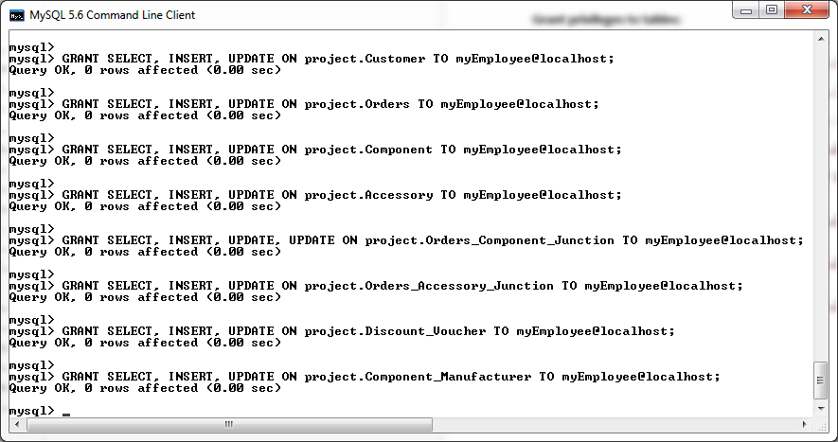

**Testing Employee Account Privileges**

**Log in as Employee from command prompt:**

"C:\Program Files (x86)\MySQL\MySQL Server 5.6\bin\mysql.exe" "--defaults-file=C:\ProgramData\MySQL\MySQL Server 5.6\my.ini" "-umyEmployee" "-pemployee"

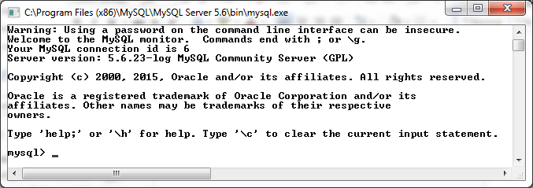

**View Employee Privileges**

show Grants;

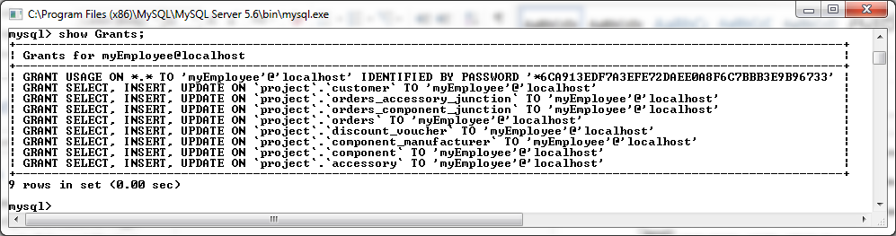

**TEST Privileges on the Customer Table**

**Attempt SELECT on Customer Table.**

**SELECT** **\*** **FROM** Customer **WHERE** Customer_ID **=** 1**;**

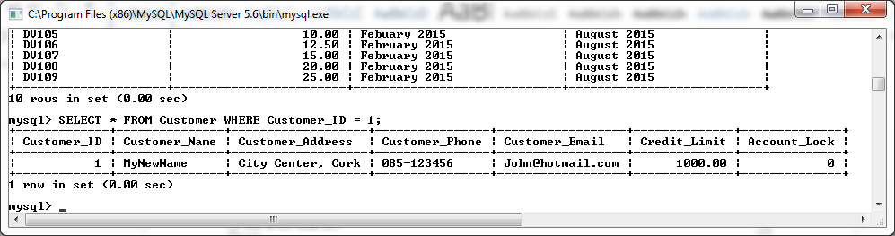

**Attempt Delete on Customer Table.**

**UPDATE** Customer

**SET** Customer_Name **=** 'MyNewName'

**WHERE** Customer_ID **=** 1**;**

**SELECT** **\*** **FROM** Customer **WHERE** Customer_ID **=** 1**;**

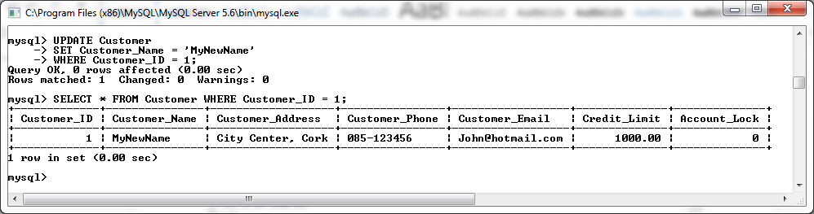

**Attempt Update on Customer Table.**

**DELETE**

**FROM** Customer

**WHERE** Customer_ID **=** 1**;**

**SELECT** **\*** **FROM** Customer **WHERE** Customer_ID **=** 1**;**

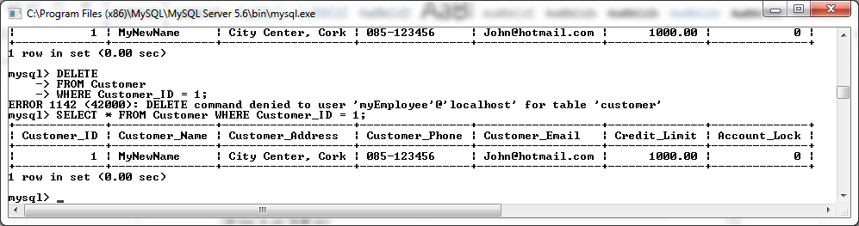

**Attempt Insert on Customer Table.**

**Insert** **into** Customer **values** **(**20**,**'David Satriani'**,**'City Center, Waterford'**,** '089-321987'**,** 'DavidS@hotmail.com'**,** 1500**,** 1**);**

**SELECT** **\*** **FROM** Customer **WHERE** Customer_ID **=** 20**;**

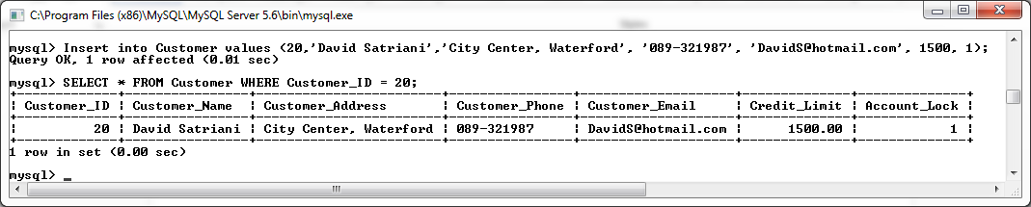

**TEST Privileges on the Orders Table**

**Attempt Select on Orders Table.**

**SELECT** **\*** **FROM** Orders **WHERE** Order_ID **=** 'O101'**;**

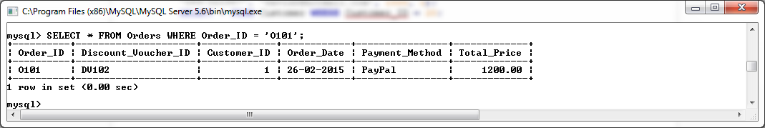

**Attempt Update on Orders Table.**

**UPDATE** Orders

**SET** Total_Price **=** 1000.00

**WHERE** Order_ID **=** 'O101'**;**

**SELECT** **\*** **FROM** Orders **WHERE** Order_ID **=** 'O101'**;**

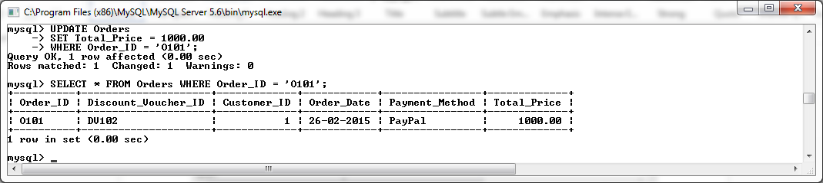

**Attempt Delete on Orders Table.**

**DELETE**

**FROM** Orders

**WHERE** Order_ID **=** 'O101'**;**

**SELECT** **\*** **FROM** Orders **WHERE** Order_ID **=** 'O101'**;**

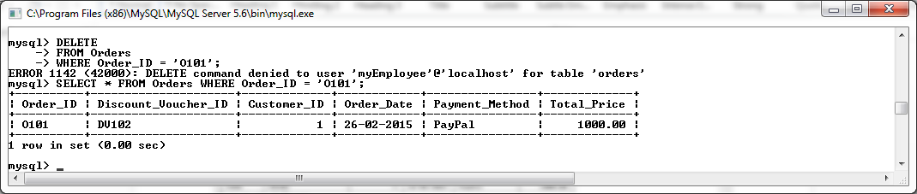

**Attempt Insert on Orders Table.**

**Insert** **into** Orders **values** **(**'O119'**,** 'DV105'**,** 1**,** '29-02-2015'**,**'Credit'**,**799.46**);**

**SELECT** **\*** **FROM** Orders **WHERE** Order_ID **=** 'O119'**;**

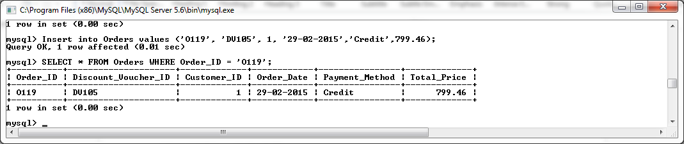

**TEST Privileges on the Component Table**

**Attempt Select on Component Table.**

**SELECT** **\*** **FROM** Component **WHERE** Component_ID **=** 'C100'**;**

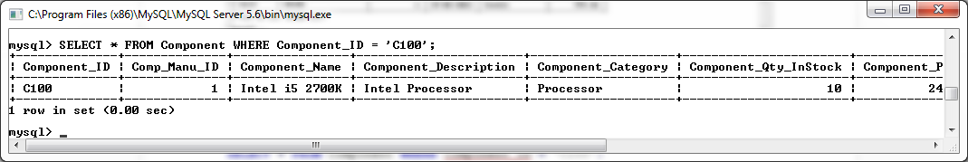

**Attempt Update on Component Table.**

**UPDATE** Component

**SET** Component_Name **=** 'MyNewName'

**WHERE** Component_ID **=** 'C100'**;**

**SELECT** **\*** **FROM** Component **WHERE** Component_ID **=** 'C100'**;**

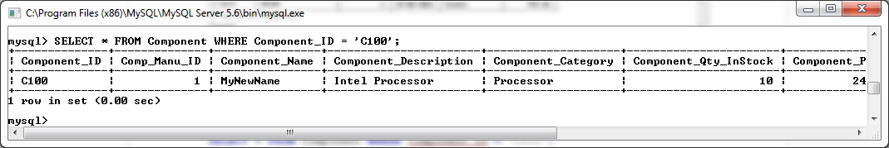

**Attempt Delete on Component Table.**

**DELETE**

**FROM** Component

**WHERE** Component_ID **=** 'C100'**;**

**SELECT** **\*** **FROM** Component **WHERE** Component_ID **=** 'C100'**;**

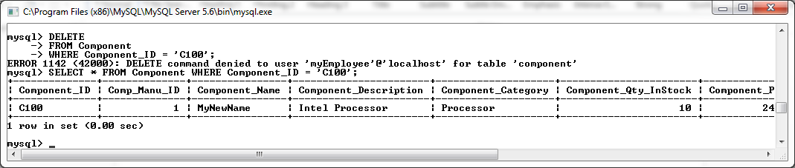

**Attempt Insert on Component Table.**

**Insert** **into** Component **values** **(**'C119'**,**1**,**'Intel i5 2700K'**,**'Intel Processor'**,** 'Processor'**,** 10**,** 249.99**);**

**SELECT** **\*** **FROM** Component **WHERE** Component_ID **=** 'C119'**;**

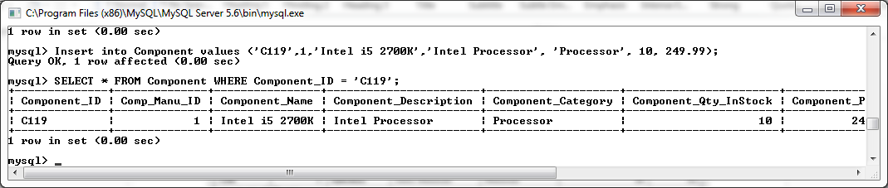

**TEST Privileges on the Accessory Table**

**Attempt Select on Accessory Table.**

**SELECT** **\*** **FROM** Accessory **WHERE** Accessory_ID **=** 'A100'**;**

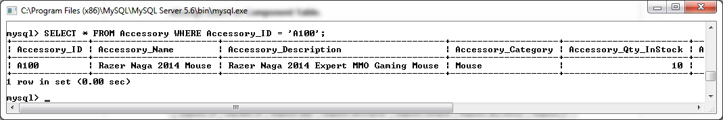

**Attempt Update on Accessory Table.**

**UPDATE** Accessory

**SET** Accessory_Name **=** 'MyNewName'

**WHERE** Accessory_ID **=** 'A100'**;**

**SELECT** **\*** **FROM** Accessory **WHERE** Accessory_ID **=** 'A100'**;**

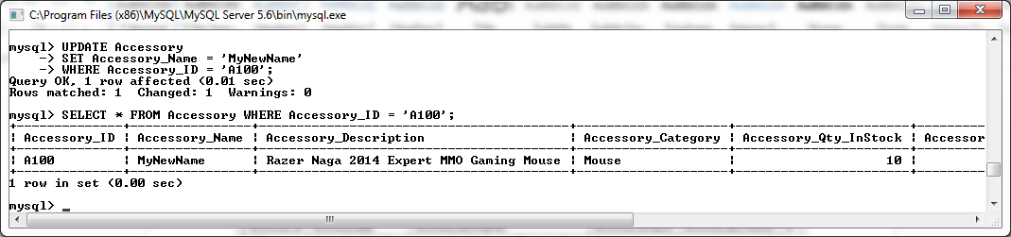

**Attempt Delete on Accessory Table.**

**DELETE**

**FROM** Accessory

**WHERE** Accessory_ID **=** 'A100'**;**

**SELECT** **\*** **FROM** Accessory **WHERE** Accessory_ID **=** 'A100'**;**

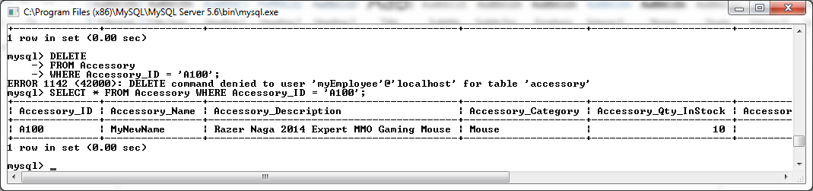

**Attempt Insert on Accessory Table.**

**Insert** **into** Accessory **values** **(**'A999'**,**'Razer Naga 2014 Mouse'**,**'Razer Naga 2014 Expert MMO Gaming Mouse'**,**'Mouse'**,** 10**,**94.99**);**

**SELECT** **\*** **FROM** Accessory **WHERE** Accessory_ID **=** 'A999'**;**

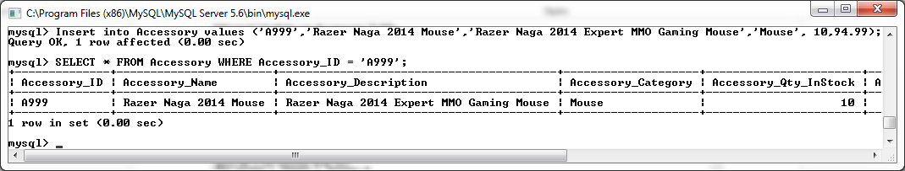

**TEST Privileges on the Orders_Component_Junction Table**

**Attempt Select on Orders_Component_Junction Table.**

**SELECT** **\*** **FROM** Orders_Component_Junction **WHERE** Order_ID **=** 'O102' **AND** Component_ID **=** 'C100'**;**

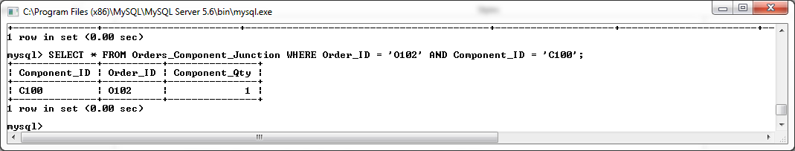

**Attempt Update on Orders_Component_Junction Table.**

**UPDATE** Orders_Component_Junction

**SET** Component_ID **=** 'C105'

**WHERE** Order_ID **=** 'O101' **AND** Component_ID **=** 'C100'**;**

**SELECT** **\*** **FROM** Orders_Component_Junction **WHERE** Order_ID **=** 'O101' **AND** Component_ID **=** 'C105'**;**

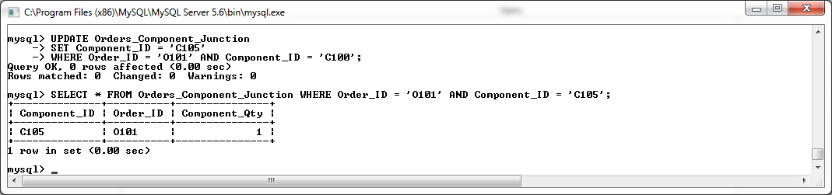

**Attempt Delete on Orders_Component_Junction Table.**

**DELETE**

**FROM** Orders_Component_Junction

**WHERE** Order_ID **=** 'O102' **AND** Component_ID **=** 'C101'**;**

**SELECT** **\*** **FROM** Orders_Component_Junction **WHERE** Order_ID **=** 'O101' **AND** Component_ID **=** 'C105'**;**

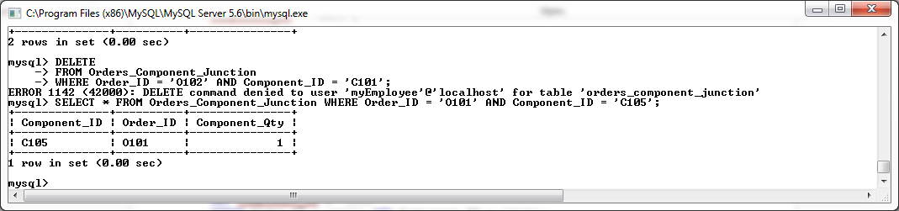

**Attempt Insert on Orders_Component_Junction Table.**

**Insert** **into** Orders_Component_Junction **values** **(**'C100'**,** 'O105'**,** 1**);**

**SELECT** **\*** **FROM** Orders_Component_Junction **WHERE** Order_ID **=** 'O105' **AND** Component_ID **=** 'C100'**;**

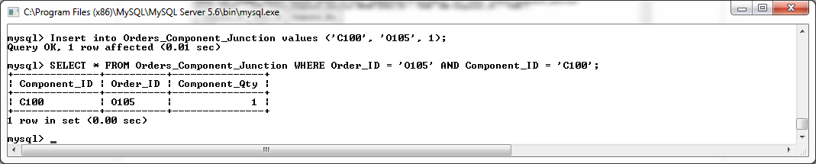

**TEST Privileges on the Orders_Accessory_Junction Table**

**Attempt Select on Orders_Accessory_Junction Table.**

**SELECT** **\*** **FROM** Orders_Accessory_Junction **WHERE** Order_ID **=** 'O101' **AND** Accessory_ID **=** 'A100'**;**

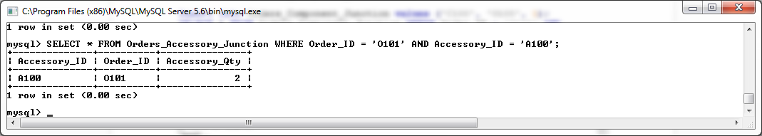

**Attempt Update on Orders_Accessory_Junction Table.**

**UPDATE** Orders_Accessory_Junction

**SET** Accessory_ID **=** 'A102'

**WHERE** Order_ID **=** 'O101' **AND** Accessory_ID **=** 'A100'**;**

**SELECT** **\*** **FROM** Orders_Accessory_Junction **WHERE** Order_ID **=** 'O102' **AND** Accessory_ID **=** 'A102'**;**

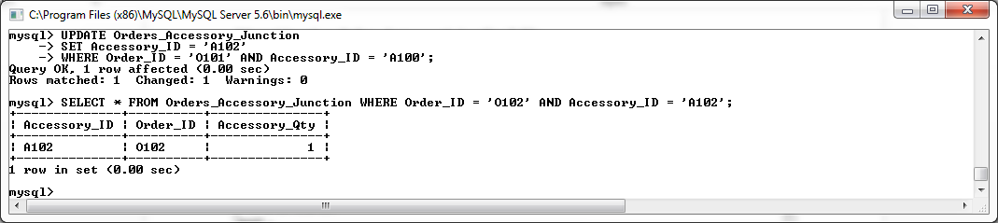

**Attempt Delete on Orders_Accessory_Junction Table.**

**DELETE**

**FROM** Orders_Accessory_Junction

**WHERE** Order_ID **=** 'O102' **AND** Accessory_ID **=** 'A102'**;**

**SELECT** **\*** **FROM** Orders_Accessory_Junction **WHERE** Order_ID **=** 'O102' **AND** Accessory_ID **=** 'A102'**;**

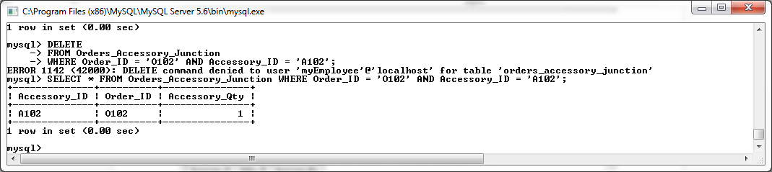

**Attempt Insert on Orders_Accessory_Junction Table.**

**Insert** **into** Orders_Accessory_Junction **values** **(**'A100'**,** 'O105'**,** 2**);**

**SELECT** **\*** **FROM** Orders_Accessory_Junction **WHERE** Order_ID **=** 'O105' **AND** Accessory_ID **=** 'A100'**;**

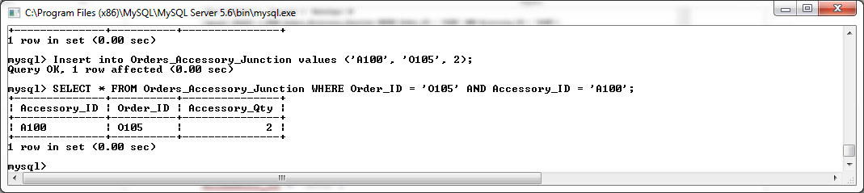

**TEST Privileges on the Discount_Voucher Table**

**Attempt Select on Discount_Voucher Table.**

**SELECT** **\*** **FROM** Discount_Voucher **WHERE** Discount_Voucher_ID **=** 'DV100'**;**

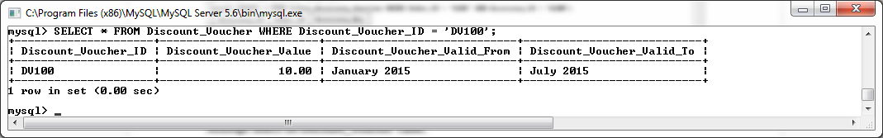

**Attempt Update on Discount_Voucher Table.**

**UPDATE** Discount_Voucher

**SET** Discount_Voucher_Value **=** 25.50

**WHERE** Discount_Voucher_ID **=** 'DV100'**;**

**SELECT** **\*** **FROM** Discount_Voucher **WHERE** Discount_Voucher_ID **=** 'DV100'**;**

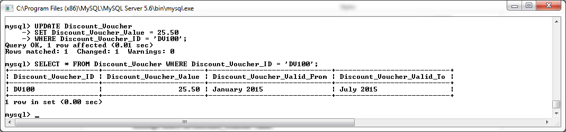

**Attempt Delete on Discount_Voucher Table.**

**DELETE**

**FROM** Discount_Voucher

**WHERE** Discount_Voucher_ID **=** 'DV100';

**SELECT** **\*** **FROM** Discount_Voucher **WHERE** Discount_Voucher_ID **=** 'DV100'**;**

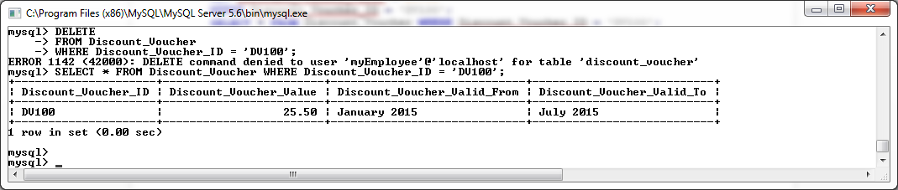

**Attempt Insert on Discount_Voucher Table.**

**Insert** **into** Discount_Voucher **values** **(**'DV200'**,**10.00**,**'January 2015'**,** 'July 2015'**);**

**SELECT** **\*** **FROM** Discount_Voucher **WHERE** Discount_Voucher_ID **=** 'DV200'**;**

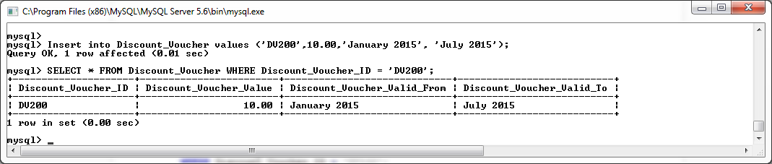

**TEST Privileges on the Component_Manufacturer Table**

**Attempt Select on Component_Manufacturer Table.**

**SELECT** **\*** **FROM** Component_Manufacturer **WHERE** Manu_ID **=** 1**;**

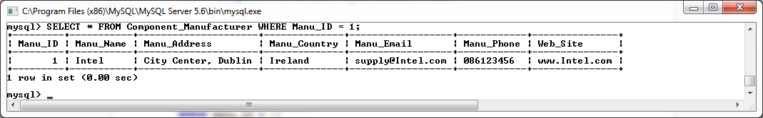

**Attempt Update on Component_Manufacturer Table.**

**UPDATE** Component_Manufacturer

**SET** Manu_Name **=** 'myTest'

**WHERE** Manu_ID **=** 1**;**

**SELECT** **\*** **FROM** Component_Manufacturer **WHERE** Manu_ID **=** 1**;**

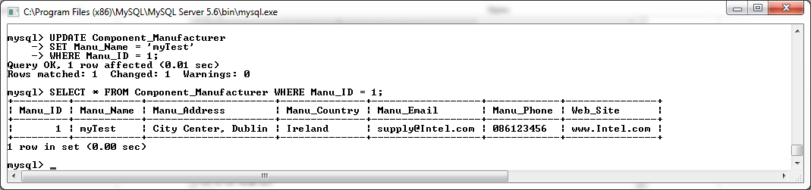

**Attempt Delete on Component_Manufacturer Table.**

**DELETE**

**FROM** Component_Manufacturer

**WHERE** Manu_ID **=** 1**;**

**SELECT** **\*** **FROM** Component_Manufacturer **WHERE** Manu_ID **=** 1**;**

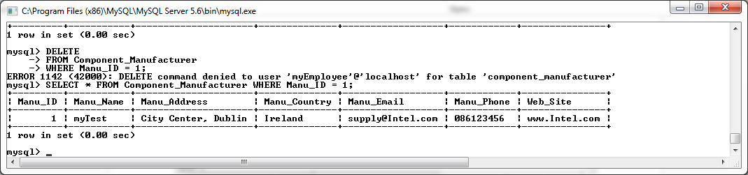

**Attempt Insert on Component_Manufacturer Table.**

**Insert** **into** Component_Manufacturer **values** **(**20**,**'Intel'**,**'City Center, Dublin'**,** 'Ireland'**,** 'supply12@Intel.com'**,**'086123456'**,**'www.Intel.com'**);**

**SELECT** **\*** **FROM** Component_Manufacturer **WHERE** Manu_ID **=** 20**;**

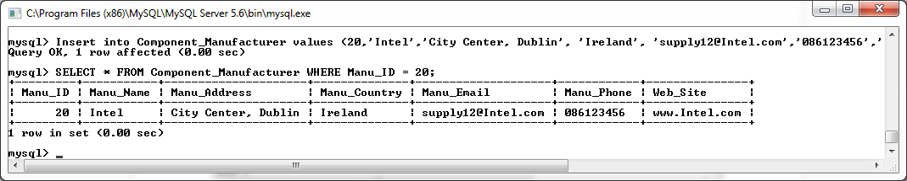

## Creating Administrator Account Privileges

**Create Administrator account**

**CREATE** **USER** 'myAdministrator'@'localhost' **IDENTIFIED** **BY** 'administrator'**;**

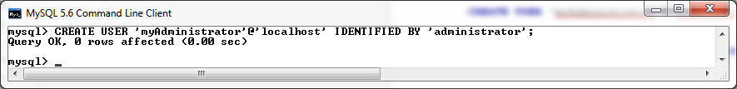

**SELECT** **host,user,**password **from** mysql**.** **user;**

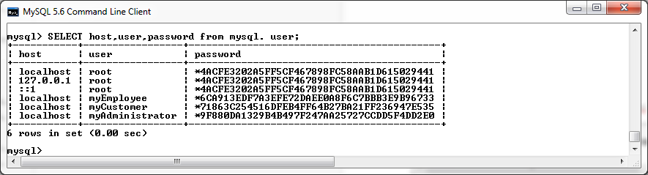

**Grant privileges to tables:**

**GRANT** **SELECT** **ON** project**.**Customer **TO** myAdministrator@localhost **with** **grant** **option;**

**GRANT** **INSERT,** **UPDATE,** **DELETE** **ON** project**.**Customer **TO** myAdministrator@localhost**;**

**GRANT** **SELECT,** **INSERT,** **UPDATE,** **DELETE** **ON** project**.**Orders **TO** myAdministrator@localhost**;**

**GRANT** **SELECT,** **INSERT,** **UPDATE,** **DELETE** **ON** project**.**Component **TO** myAdministrator@localhost**;**

**GRANT** **SELECT,** **INSERT,** **UPDATE,** **DELETE** **ON** project**.**Accessory **TO** myAdministrator@localhost**;**

**GRANT** **SELECT,** **INSERT,** **UPDATE, DELETE ON** project**.**Orders_Component_Junction **TO** myAdministrator@localhost**;**

**GRANT** **SELECT,** **INSERT,** **UPDATE,** **DELETE** **ON** project**.**Orders_Accessory_Junction **TO** myAdministrator@localhost**;**

**GRANT** **SELECT,** **INSERT,** **UPDATE,** **DELETE** **ON** project**.**Discount_Voucher **TO** myAdministrator@localhost**;**

**GRANT** **SELECT,** **INSERT,** **UPDATE,** **DELETE** **ON** project**.**Component_Manufacturer **TO** myAdministrator@localhost**;**

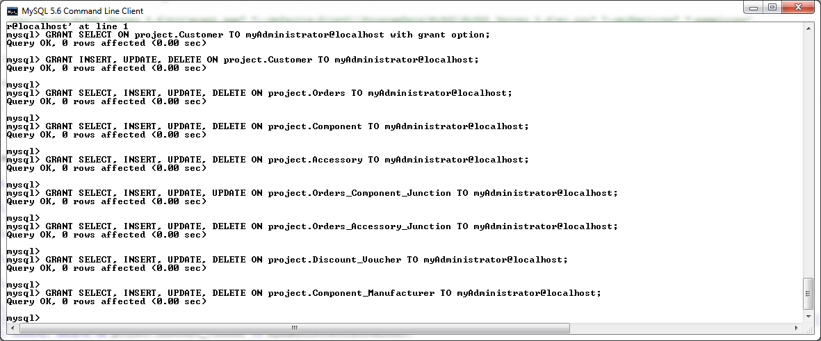

**Testing Administrator Account Privileges**

**Log in as Administrator from command prompt:**

"C:\Program Files (x86)\MySQL\MySQL Server 5.6\bin\mysql.exe" "--defaults-file=C:\ProgramData\MySQL\MySQL Server 5.6\my.ini" "-umyAdministrator" "-padministrator"

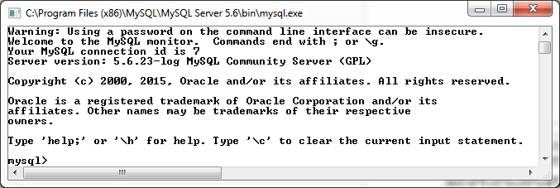

**View Administrator Privileges**

show Grants;

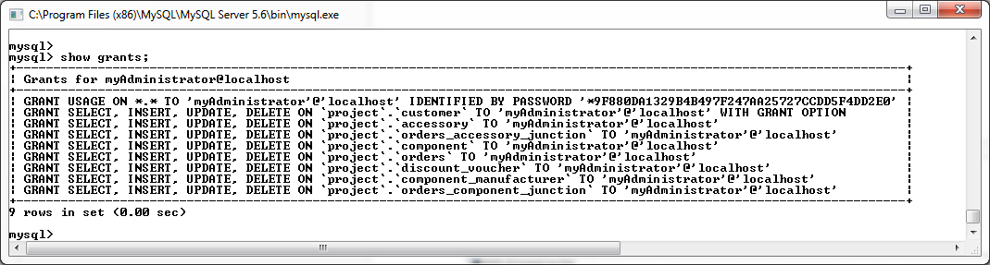

**TEST Privileges on the Customer Table**

**Attempt SELECT on Customer Table.**

**SELECT** **\*** **FROM** Customer **WHERE** Customer_ID **=** 1**;**

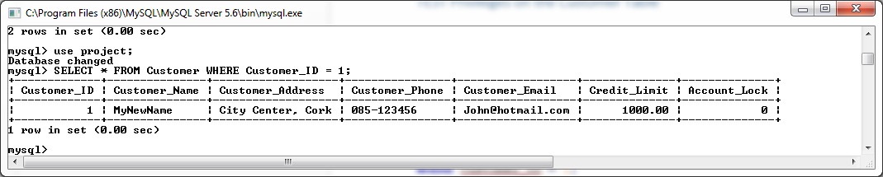

**Attempt Update on Customer Table.**

**UPDATE** Customer

**SET** Customer_Name **=** 'MyNewName'

**WHERE** Customer_ID **=** 1**;**

**SELECT** **\*** **FROM** Customer **WHERE** Customer_ID **=** 1**;**

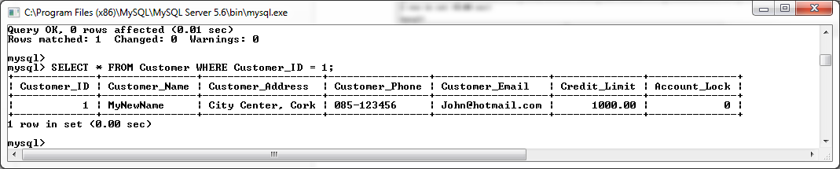

**Attempt Delete on Customer Table.**

**DELETE**

**FROM** Customer

**WHERE** Customer_ID **=** 1**;**

**SELECT** **\*** **FROM** Customer **WHERE** Customer_ID **=** 1**;**

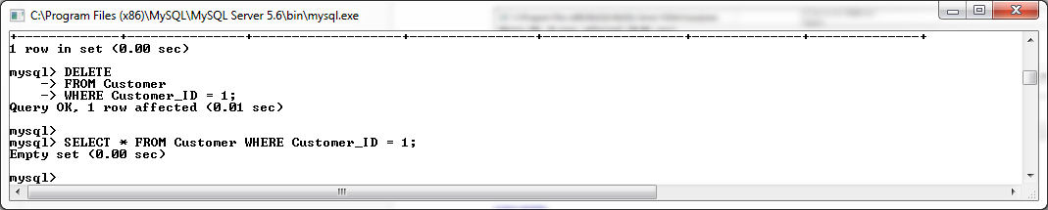

**Attempt Insert on Customer Table.**

**Insert** **into** Customer **values** **(**21**,**'David Satriani'**,**'City Center, Waterford'**,** '089-321987'**,** 'DavidS@hotmail.com'**,** 1500**,** 1**);**

**SELECT** **\*** **FROM** Customer **WHERE** Customer_ID **=** 21**;**

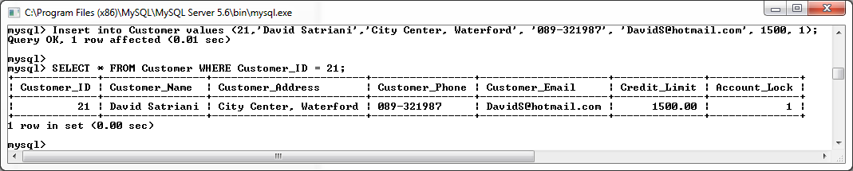

**Attempt Grant DELETE on Customer Table to Employee Account**

**Grant** **Delete** **ON** project**.**Customer **TO** myEmployee@localhost**;**

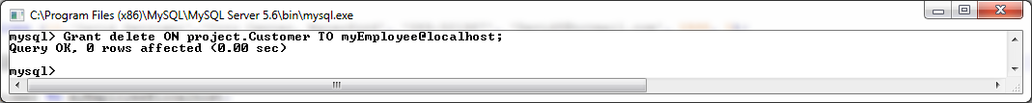

**TEST Privileges on the Orders Table**

**Attempt Select on Orders Table.**

**SELECT** **\*** **FROM** Orders **WHERE** Order_ID **=** 'O102'**;**

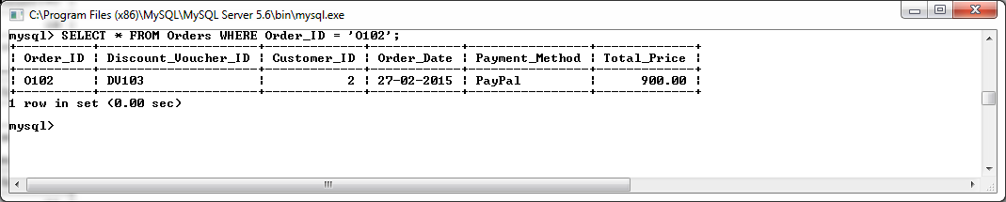

**Attempt Update on Orders Table.**

**UPDATE** Orders

**SET** Total_Price **=** 1500.00

**WHERE** Order_ID **=** 'O102'**;**

**SELECT** **\*** **FROM** Orders **WHERE** Order_ID **=** 'O102'**;**

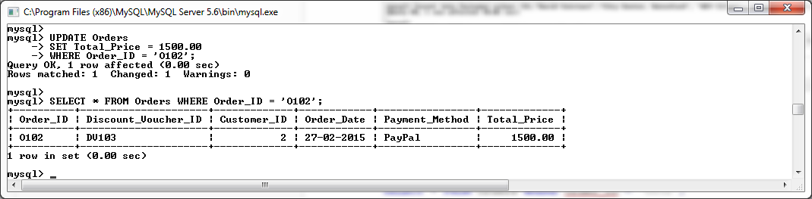

**Attempt Delete on Orders Table.**

**DELETE**

**FROM** Orders

**WHERE** Order_ID **=** 'O102'**;**

**SELECT** **\*** **FROM** Orders **WHERE** Order_ID **=** 'O102'**;**

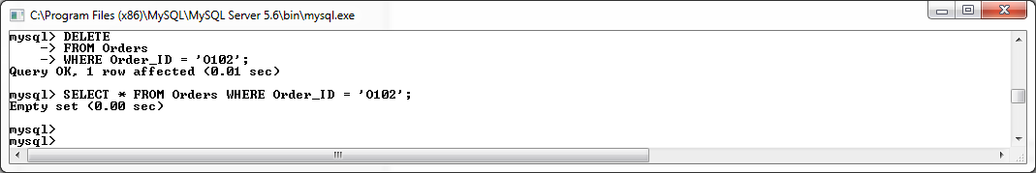

**Attempt Insert on Orders Table.**

**Insert** **into** Orders **values** **(**'O119'**,** 'DV105'**,** 2**,** '29-02-2015'**,**'Credit'**,**799.46**);**

**SELECT** **\*** **FROM** Orders **WHERE** Order_ID **=** 'O119'**;**

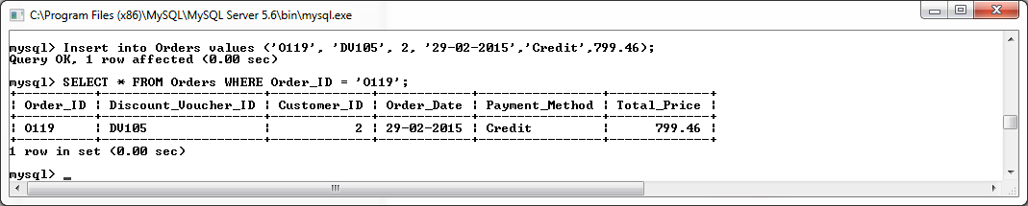

**TEST Privileges on the Component Table**

**Attempt Select on Component Table.**

**SELECT** **\*** **FROM** Component **WHERE** Component_ID **=** 'C100'**;**

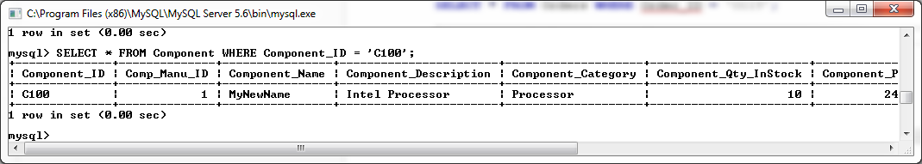

**Attempt Update on Component Table.**

**UPDATE** Component

**SET** Component_Name **=** 'MyName'

**WHERE** Component_ID **=** 'C100'**;**

**SELECT** **\*** **FROM** Component **WHERE** Component_ID **=** 'C100'**;**

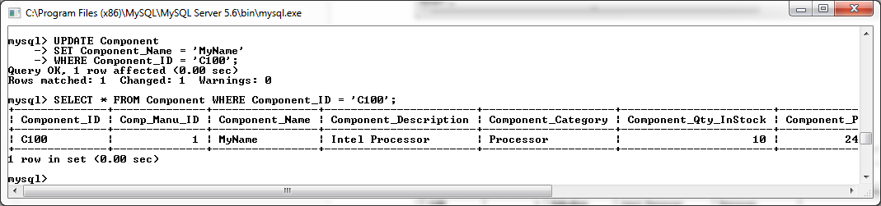

**Attempt Delete on Component Table.**

**DELETE**

**FROM** Component

**WHERE** Component_ID **=** 'C100'**;**

**SELECT** **\*** **FROM** Component **WHERE** Component_ID **=** 'C100'**;**

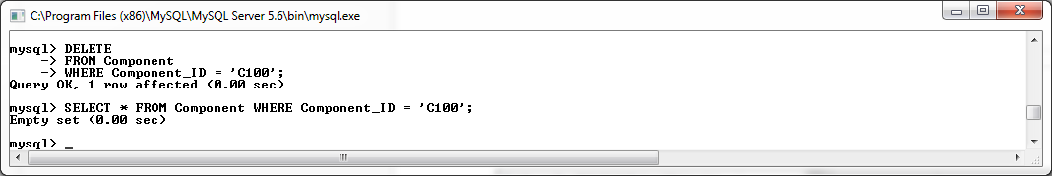

**Attempt Insert on Component Table.**

**Insert** **into** Component **values** **(**'C120'**,**1**,**'Intel i5 2700K'**,**'Intel Processor'**,** 'Processor'**,** 10**,** 249.99**);**

**SELECT** **\*** **FROM** Component **WHERE** Component_ID **=** 'C120'**;**

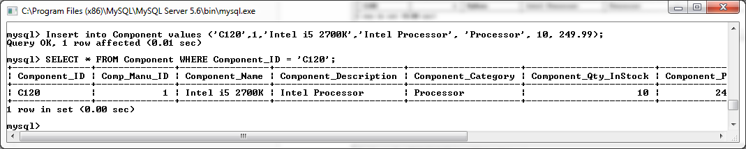

**TEST Privileges on the Accessory Table**

**Attempt Select on Accessory Table.**

**SELECT** **\*** **FROM** Accessory **WHERE** Accessory_ID **=** 'A100'**;**

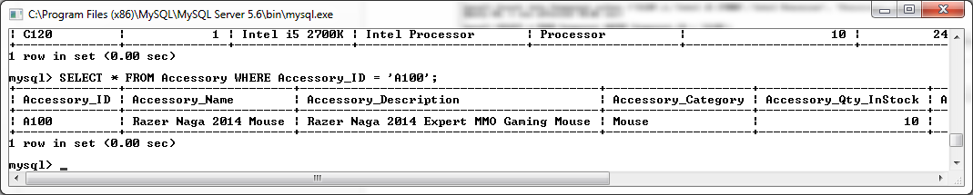

**Attempt Update on Accessory Table.**

**UPDATE** Accessory

**SET** Accessory_Name **=** 'MyNewName'

**WHERE** Accessory_ID **=** 'A100'**;**

**SELECT** **\*** **FROM** Accessory **WHERE** Accessory_ID **=** 'A100'**;**

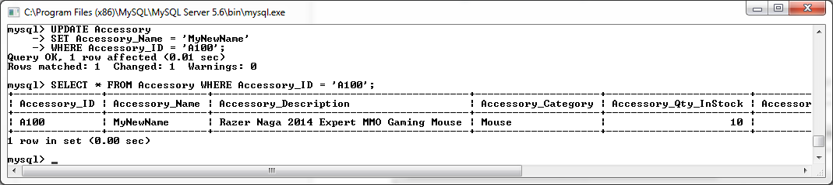

**Attempt Delete on Accessory Table.**

**DELETE**

**FROM** Accessory

**WHERE** Accessory_ID **=** 'A100'**;**

**SELECT** **\*** **FROM** Accessory **WHERE** Accessory_ID **=** 'A100'**;**

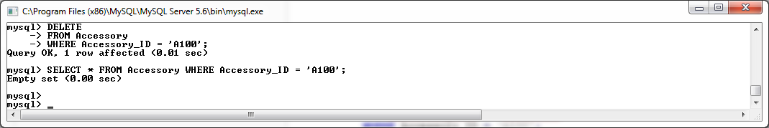

**Attempt Insert on Accessory Table.**

**Insert** **into** Accessory **values** **(**'A999'**,**'Razer Naga 2014 Mouse'**,**'Razer Naga 2014 Expert MMO Gaming Mouse'**,**'Mouse'**,** 10**,**94.99**);**

**SELECT** **\*** **FROM** Accessory **WHERE** Accessory_ID **=** 'A999'**;**

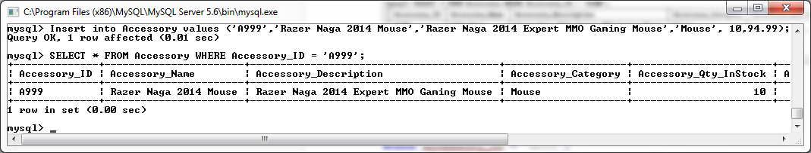

**TEST Privileges on the Orders_Component_Junction Table**

**Attempt Select on Orders_Component_Junction Table.**

**SELECT** **\*** **FROM** Orders_Component_Junction **WHERE** Order_ID **=** 'O102' **AND** Component_ID **=** 'C100'**;**

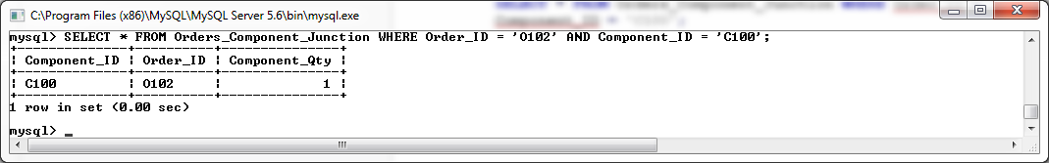

**Attempt Update on Orders_Component_Junction Table.**

**UPDATE** Orders_Component_Junction

**SET** Component_ID **=** 'C101'

**WHERE** Order_ID **=** 'O101' **AND** Component_ID **=** 'C105'**;**

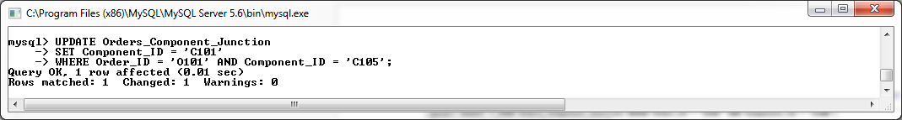

**SELECT** **\*** **FROM** Orders_Component_Junction **WHERE** Order_ID **=** 'O101' **AND** Component_ID **=** 'C101'**;**

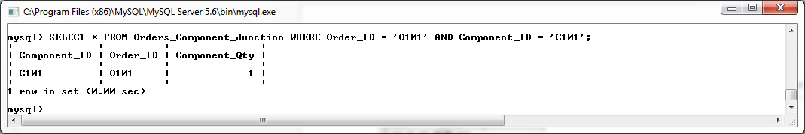

**Attempt Delete on Orders_Component_Junction Table.**

**DELETE**

**FROM** Orders_Component_Junction

**WHERE** Order_ID **=** 'O102' **AND** Component_ID **=** 'C101'**;**

**SELECT** **\*** **FROM** Orders_Component_Junction **WHERE** Order_ID **=** 'O102' **AND** Component_ID **=** 'C101'**;**

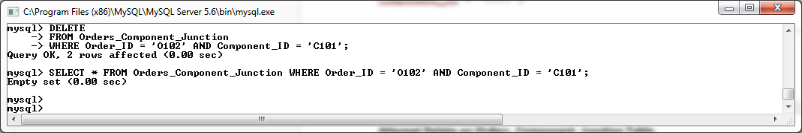

**Attempt Insert on Orders_Component_Junction Table.**

**Insert** **into** Orders_Component_Junction **values** **(**'C100'**,** 'O105'**,** 1**);**

**SELECT** **\*** **FROM** Orders_Component_Junction **WHERE** Order_ID **=** 'O105' **AND** Component_ID **=** 'C100'**;**

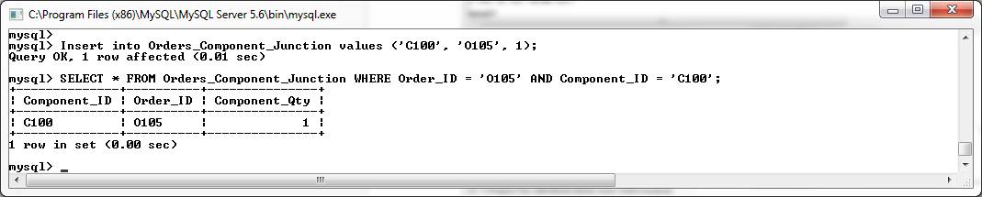

**TEST Privileges on the Orders_Accessory_Junction Table**

**Attempt Select on Orders_Accessory_Junction Table.**

**SELECT** **\*** **FROM** Orders_Accessory_Junction **WHERE** Order_ID **=** 'O101' **AND** Accessory_ID **=** 'A100'**;**

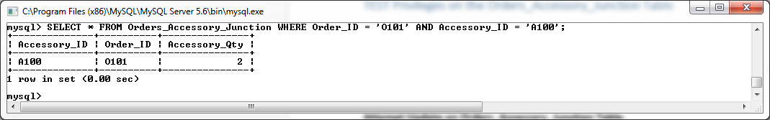

**Attempt Update on Orders_Accessory_Junction Table.**

**UPDATE** Orders_Accessory_Junction

**SET** Accessory_ID **=** 'A102'

**WHERE** Order_ID **=** 'O101' **AND** Accessory_ID **=** 'A100'**;**

**SELECT** **\*** **FROM** Orders_Accessory_Junction **WHERE** Order_ID **=** 'O102' **AND** Accessory_ID **=** 'A102'**;**

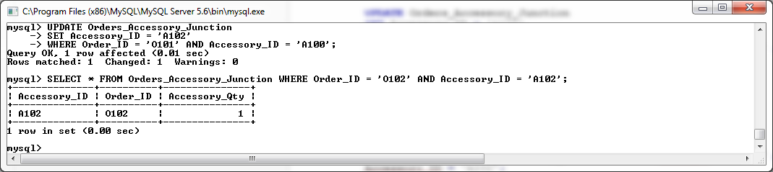

**Attempt Delete on Orders_Accessory_Junction Table.**

**DELETE**

**FROM** Orders_Accessory_Junction

**WHERE** Order_ID **=** 'O102' **AND** Accessory_ID **=** 'A102'**;**

**SELECT** **\*** **FROM** Orders_Accessory_Junction **WHERE** Order_ID **=** 'O102' **AND** Accessory_ID **=** 'A102'**;**

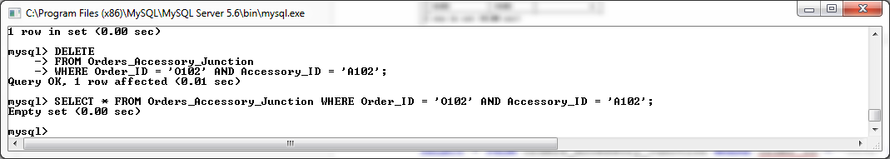

**Attempt Insert on Orders_Accessory_Junction Table.**

**Insert** **into** Orders_Accessory_Junction **values** **(**'A100'**,** 'O105'**,** 2**);**

**SELECT** **\*** **FROM** Orders_Accessory_Junction **WHERE** Order_ID **=** 'O105' **AND** Accessory_ID **=** 'A100'**;**

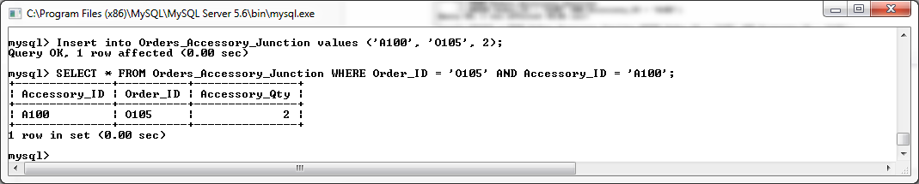

**TEST Privileges on the Discount_Voucher Table**

**Attempt Select on Discount_Voucher Table.**

**SELECT** **\*** **FROM** Discount_Voucher **WHERE** Discount_Voucher_ID **=** 'DV100'**;**

**Attempt Update on Discount_Voucher Table.**

**UPDATE** Discount_Voucher

**SET** Discount_Voucher_Value **=** 25.50

**WHERE** Discount_Voucher_ID **=** 'DV100'**;**

**SELECT** **\*** **FROM** Discount_Voucher **WHERE** Discount_Voucher_ID **=** 'DV100'**;**

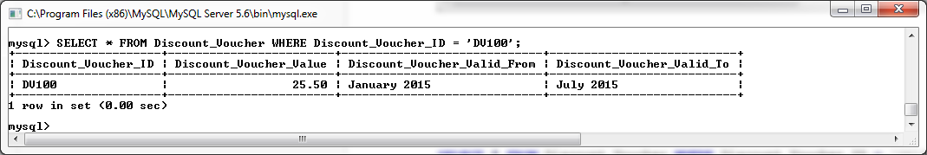

**Attempt Delete on Discount_Voucher Table.**

**DELETE**

**FROM** Discount_Voucher

**WHERE** Discount_Voucher_ID **=** 'DV100';

**SELECT** **\*** **FROM** Discount_Voucher **WHERE** Discount_Voucher_ID **=** 'DV100'**;**

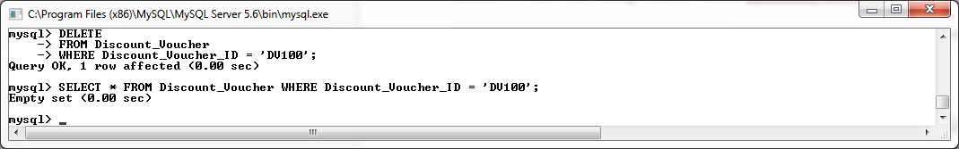

**Attempt Insert on Discount_Voucher Table.**

**Insert** **into** Discount_Voucher **values** **(**'DV201'**,**10.00**,**'January 2015'**,** 'July 2015'**);**

**SELECT** **\*** **FROM** Discount_Voucher **WHERE** Discount_Voucher_ID **=** 'DV201'**;**

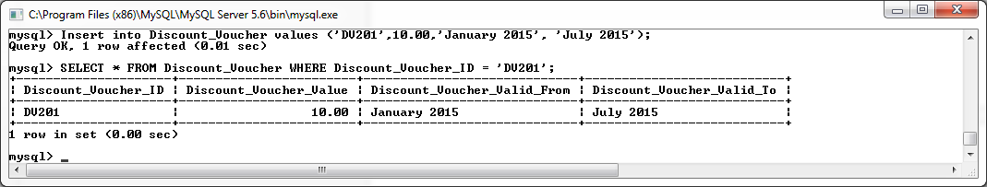

**TEST Privileges on the Component_Manufacturer Table**

**Attempt Select on Component_Manufacturer Table.**

**SELECT** **\*** **FROM** Component_Manufacturer **WHERE** Manu_ID **=** 1**;**

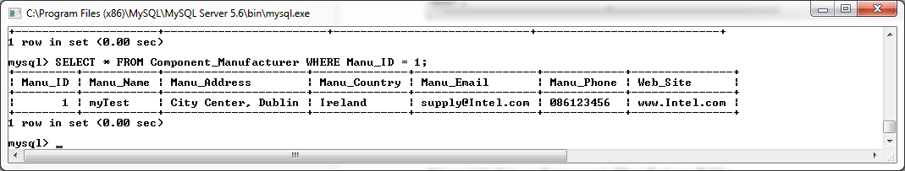

**Attempt Update on Component_Manufacturer Table.**

**UPDATE** Component_Manufacturer

**SET** Manu_Name **=** 'myTest'

**WHERE** Manu_ID **=** 1**;**

**SELECT** **\*** **FROM** Component_Manufacturer **WHERE** Manu_ID **=** 1**;**

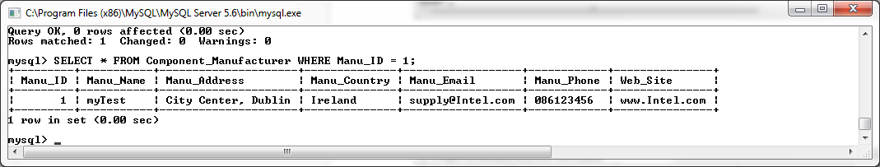

**Attempt Delete on Component_Manufacturer Table.**

**DELETE**

**FROM** Component_Manufacturer

**WHERE** Manu_ID **=** 1**;**

**SELECT** **\*** **FROM** Component_Manufacturer **WHERE** Manu_ID **=** 1**;**

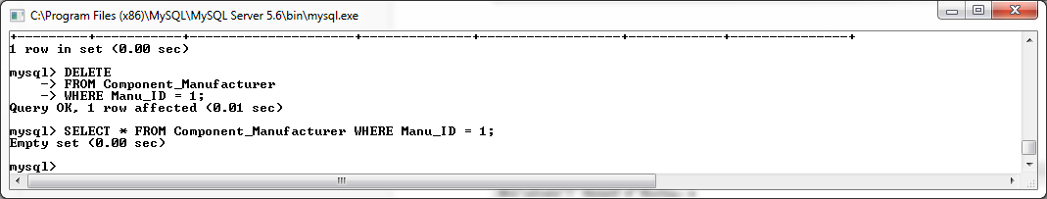

**Attempt Insert on Component_Manufacturer Table.**

**Insert** **into** Component_Manufacturer **values** **(**22**,**'Intel'**,**'City Center, Dublin'**,** 'Ireland'**,** 'supply22@Intel.com'**,**'086123456'**,**'www.Intel.com'**);**

**SELECT** **\*** **FROM** Component_Manufacturer **WHERE** Manu_ID **=** 22**;**

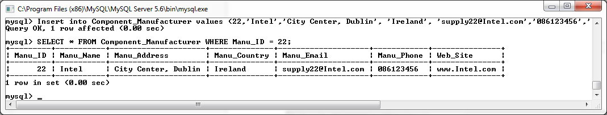

# Front End Technology

The technology I have chosen to implement a frontend onto this MySQL database is Microsoft access. I have chosen this application because of the following reasons:

* Microsoft Access offers connection support for MySQL database by the use of an OBDC driver, which is developed and maintained by Oracle.
* Once a MySQL database is integrated to Access, all triggers can which exist on the MySQL database will also be integrated to the system, allowing them perform the task they were initially design to achieve with minimal disruption and re-coding. Given the large amount of work that was dedicated to triggers in this project, this was an important element which needed to be supported by the frontend technology.
* By the use of forms, Access offers a convenient and simple method to create frames which can contain both single table data and multiple table data as required. Upon these forms, we can implement various features such as buttons, textboxes and labels to integrate user friendliness into the system.
* Access supports a large toolset that can be used to further enhance the MySQL database for the User, such as:
  + Macros
  + Forms
  + Queries
  + Reports
* The OBDC driver used for inter-connectivity supports a large range of operating system platforms including the two most popular platforms in use today, namely, Linux and Windows.

In the following section, I shall demonstrate a basic implementation of Microsoft Access as a frontend to the developed database concept, focusing on the main operation of the database.

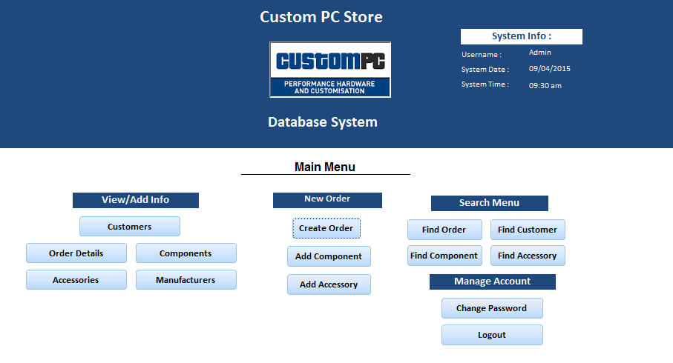

*Prototype design for the Main Menu designed in MSAccess for the MySQL Database*

# Initial Rollout

**Connecting the MySQL to MSAccess**

Once the ODBC driver was downloaded and installed, we connected to the MySQL database by the use of the MSAccess ‘ODBC Database’ option on the ‘External Data’tab.

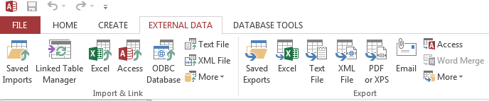

Once this option is selected, we choose the ‘Link the data source by creating a linked table’ option.

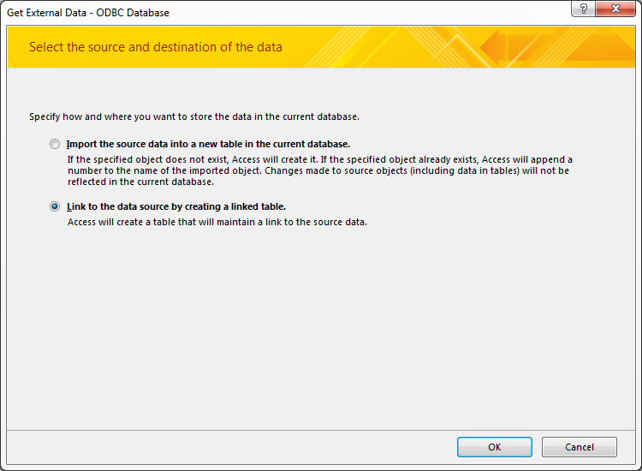

From there we select the Custom DNS connection called ‘SQLTestDatabase’, which we created when the ODBC driver was initially installed to the system.

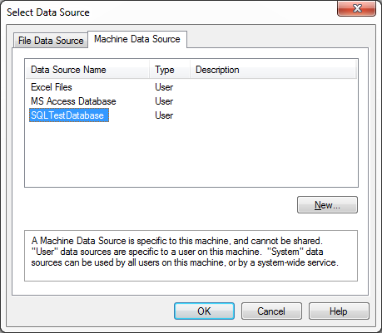

This will then present us with the ‘MySQL Connector/ODBC Data Source Configuration’ screen. From here we can specify the IP address of the MySQL Server which will point to the localhost IP address in this case.

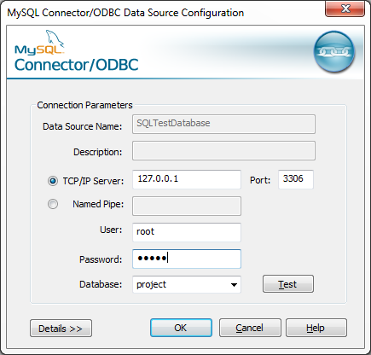

We also specify the Username and Password by which we will connect to MySQL as. By Clicking the ‘Test’ button, a connection will be attempted and if successful, we are shown a list of available databases for which we can connect to. I will select the database called ‘project’ which consists of all tables, triggers, procedures and functions that were created for this project.

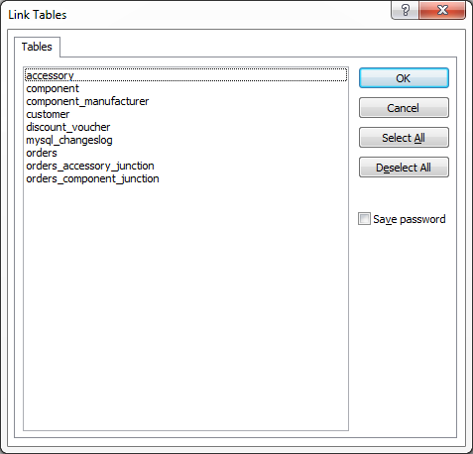

We are then given the option to select which tables residing on the MySQL Database would we link to link to the MSAccess project. In this case I will select to link all tables that exist within the database.

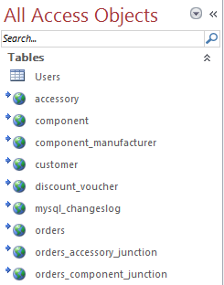

We can now see our linked tables within the MSAccess environment enabling us to begin the process of building our Front End.

Now that a suitable Main Menu is created for our database, I shall attempt to create a new Order and add some components and accessories to the Order to test that out Triggers are still active within this environment.

From the Main menu, I click on the Create Order button, which brings me to a form related to the Orders table. This table allows for creates, reads, updates and deletes on Order records within the link Order table. Below is an example of this form being used in the creation of our new test Order.

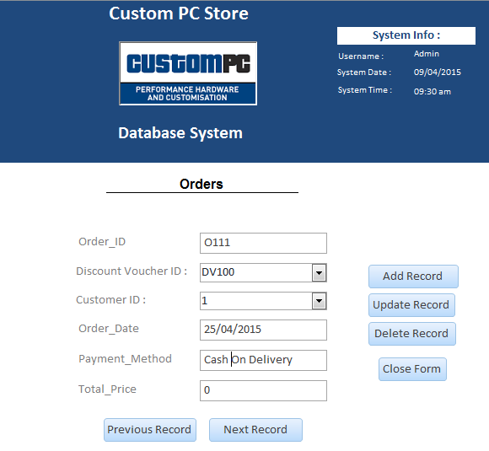

For convenience and user friendliness, I have integrated Combo Boxes for fields that read records from other tables. For example, in the Orders table, the Customer ID field is a foreign key to the Customer ID field residing on the Customer Table. As shown below, the User can select the desired Customer ID from a drop down list.

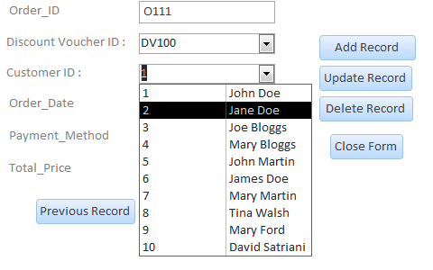

Once the form has been populated with the information in relation to our new test order, I shall check the Orders table to ensure that the new record has being inserted.

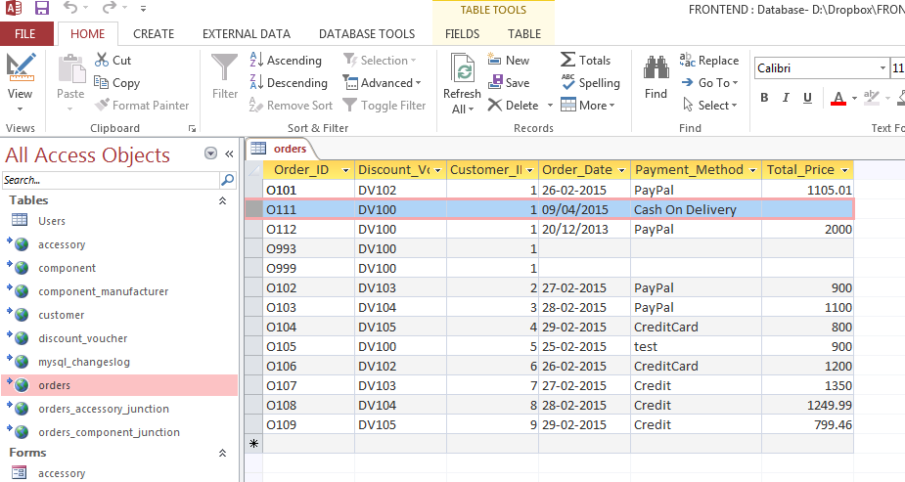

I shall also perform a Select statement on the MySQL command line console to confirm that this order has been inserted to the table.

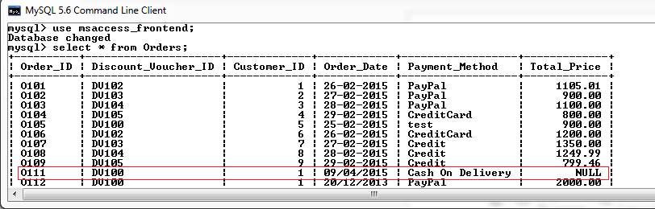

As expected, the new Orders record was successfully inserted.

We shall now add some components to the Order using the ‘Add Components’ Button from the Main Menu. Again we can see the use of Combo Boxes linking to the relevant tables on the Components Form.

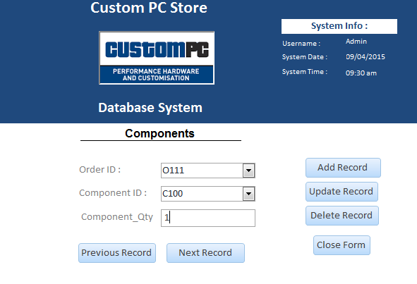

We then confirm that the new record has been inserted into the Orders_Component_Junction table.

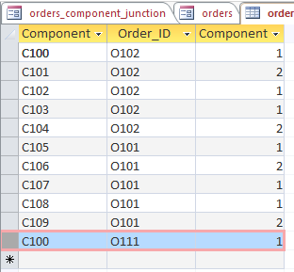

To ensure that our Insert Triggers are working, we shall check to see if the Total Price of the Order record has been updated to reflect the new component being added to the order.

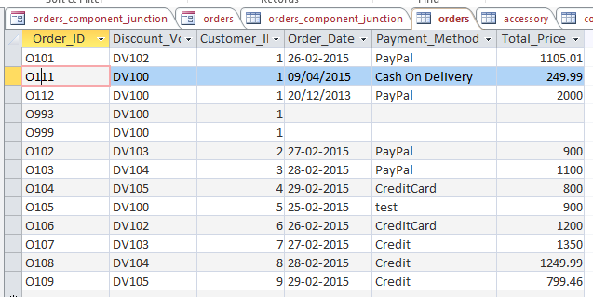

We can see that the Trigger has updated the orders table to reflect the price of the new component added to the Order.

We Shall now proceed to add an accessory to the Order by clicking on the Add Accessory Button on the Main Menu. From here we are presented with the Accessories Form linking to the Orders_Accessory_Junction table.

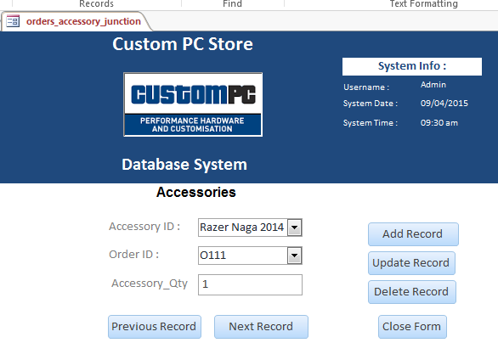

We can see from the below screenshot the accessory has been successfully associated with the order within the Order_Accessory_Junction table.

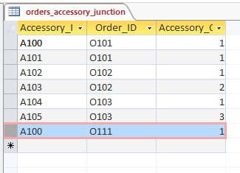

Again, to ensure that our Insert Triggers are working, we shall check to see if the Total Price of the Order record has been updated to reflect the new accessory being added to the order.

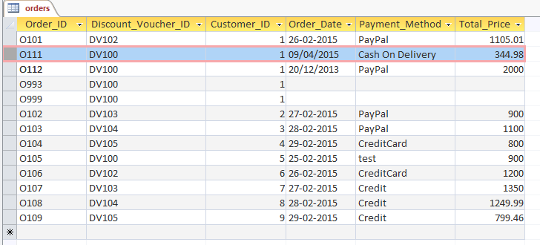

We can see that the Trigger has updated the orders table to reflect the price of the new component added to the Order.

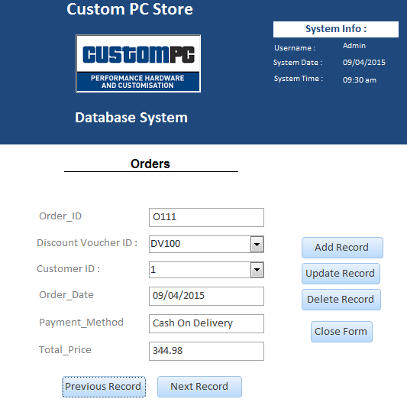

From this sample test and other test that were perform but not documented, we can confirm that the integration of the MySQL database and MSAccess front end has been successful.

## Issues Experienced with MSAccess Front End and the MySQL Database

The main problem I experienced while integrating MS Access as a front end to the MySQL database concerned the user privileges which were set up on the database tables through the MySQL command line. Through research I have become aware that MS Access does not support this feature of MySQL databases.

To overcome this issue with user privileges, I created a new table in MS Access called users. Within the user tables, I have specified the same user accounts that were previously defined from the MySQL command line. This allowed me to develop a login screen for the front end, which will call specific menus, each allowing specific data manipulation actions based on the user privileges.

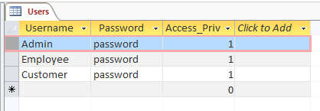

*A screen shot of the user table within MS Access.*

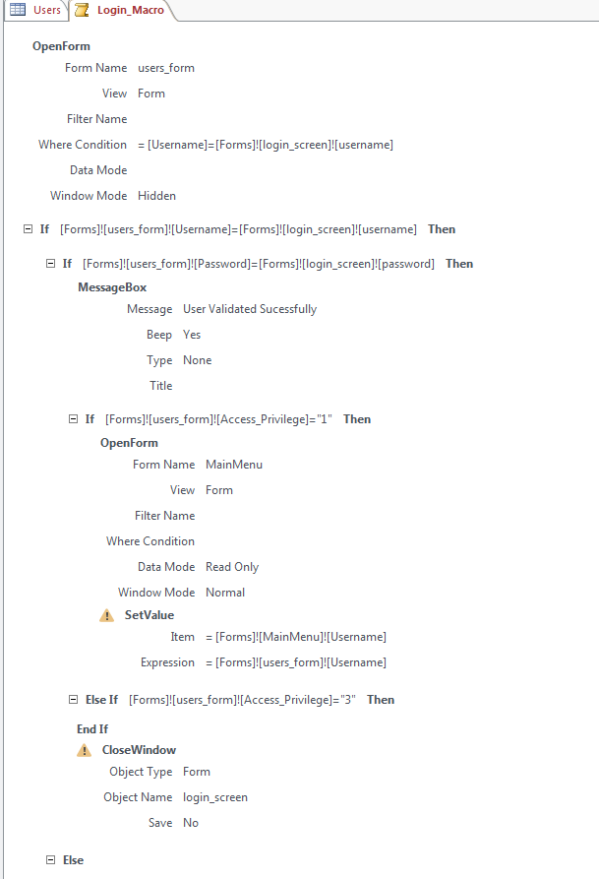

*Sample Screenshot of the Login Macro built in MS Access*

By use of the Login Macro and the Users table, users can login to the Main Menu by providing their login credentials as shown below.

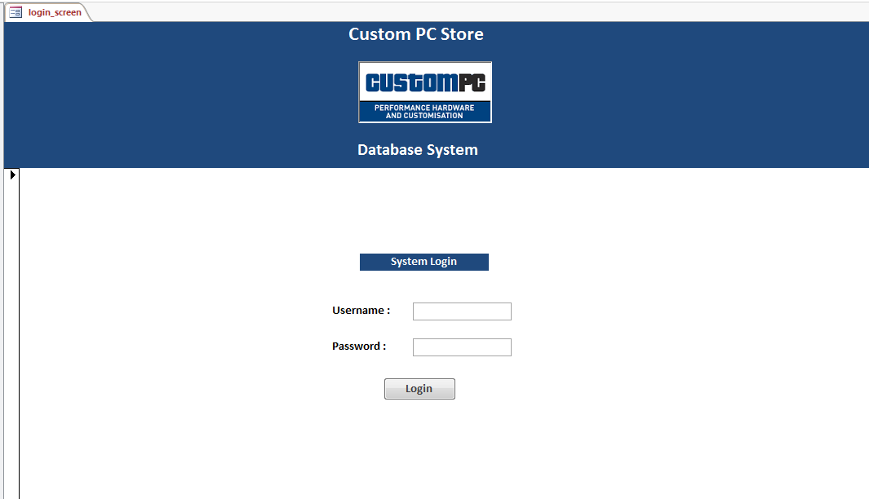

*The Login Screen*

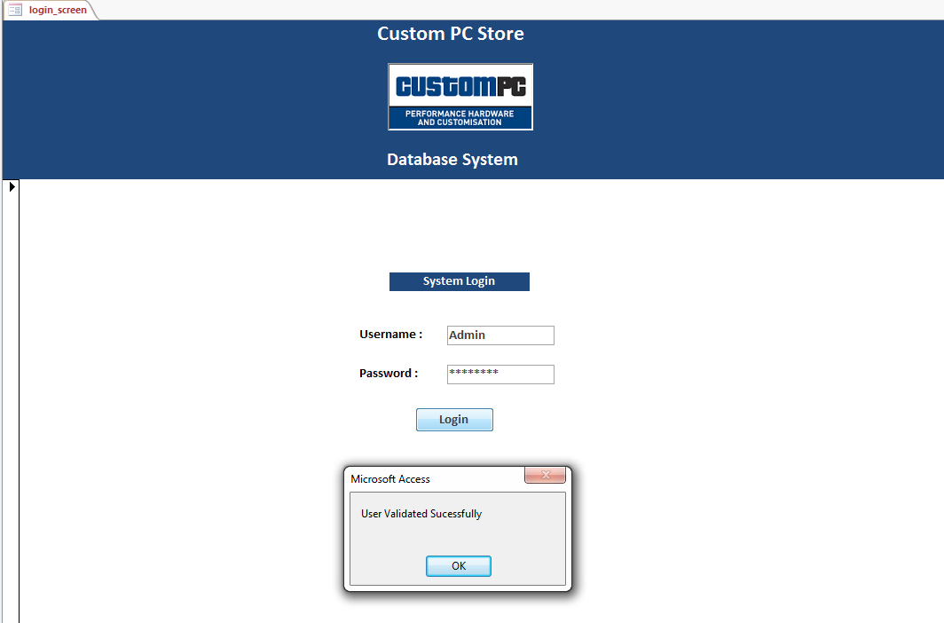

*User credentials successfully validated*



*On Successful Login, the user is brought to the Main Menu*

# Sign Off

## Database User Manual

**The Login Process**

At the Login Screen, enter your Username and Password then click the ‘Login’ Button.

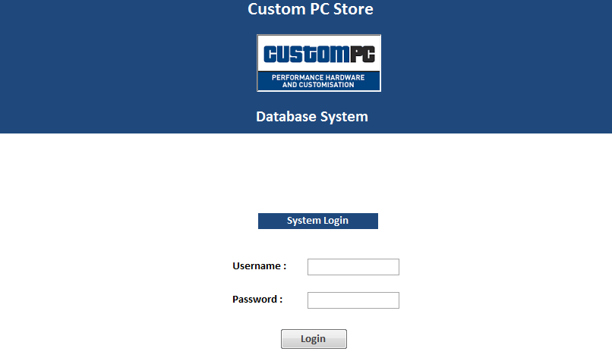

*Login Screen*

If you supplied the correct login credentials a success message will be shown after which you will be brought to the Main Menu.

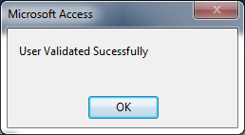

*Successful Login Message*

If you enter an incorrect Username or password, a suitable message will be display to inform you of this as shown below

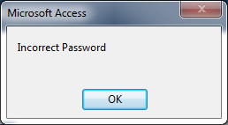

*Incorrect Password Entered*

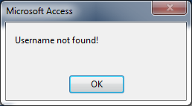

*Incorrect Username Entered*

If either of these messages are displayed, please check your login credentials and attempt the login process again.

**The Main Menu**



*The Main Menu*

The Main menu is broken up into five main panels, namely:

* **System Info Panel**
* **View/Add Info Panel**
* **New Order Panel**
* **Search Menu Panel**
* **Manage Account Panel**

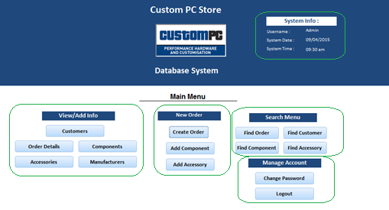

*Main Menu – Five Panels Outlined*

**System Info Panel**

The System Info Panel will display the Username which you are currently logged into the system under, the current System Date and the current System Time.

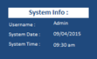

*The System Info Panel*

**View/Add Info**

The View/Add Info Panel allows the User to Create, Update and Delete of records relating to the specific dataset they have chosen.

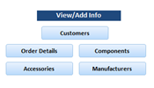

*The View/Add Info Panel*

For Example, if we click on the Customers Button, We will be brought to the customers form as shown below. From here we can navigate through all Customer records by using the Previous and Next Record buttons. An update to a specific record can be performed by changing the required field on the form and then clicking the Update button. Likewise, a record can be deleted by clicking the Delete button and a new record can be created by click on the Create button.

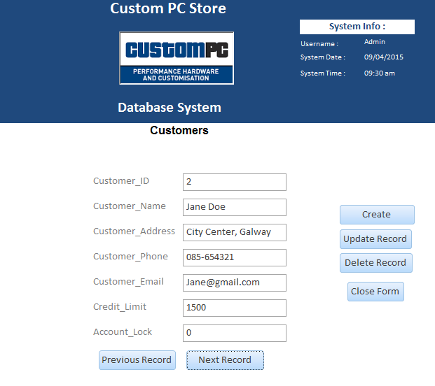

*Screenshot of the Customers Form*

**New Order Panel**

To create a new order, from the Main menu, click on the Create Order button. This displays the form related to the Orders table.

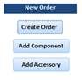

*The New Order Panel*

This Form allows for creates, reads, updates and deletes on Order records within the linked Order table. To create a new Order, populate the required fields and click the Add Record button. Your new Order is now created.



To add a Component to this Order, return to the Main Menu and click the ‘Add Component Button’. This will show the Add Components form. To add a component, select the Order number from the dropdown list, then select the component you wish to add to this order. The click the ‘Add Record’ button to save. The component is now added to the Order.

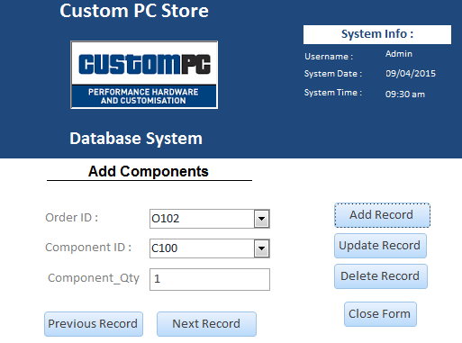

*Screenshot of the Add Components Form*

To add an Accessory to this Order, return to the Main Menu and click the ‘Add Accessory Button’. This will show the Add Accessory form. To add an accessory, select the Order number from the dropdown list, then select the accessory you wish to add to this order. The click the ‘Add Record’ button to save. The accessory is now added to the Order.

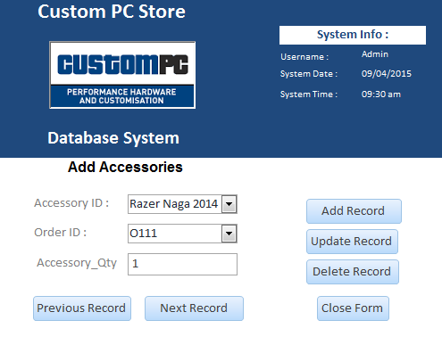

*Screenshot of the Add Components Form*

Details for the new order can then be view from the Main Menu by clicking on the ‘Order Details’ button from the Main Menu.

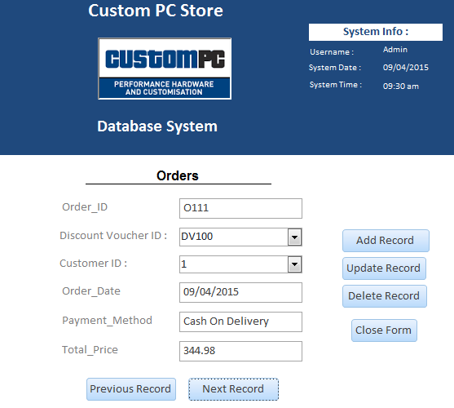

*Screenshot of the View Order Details Form*

**Search Menu Panel**

To perform a search of information held within the database, from the Main Menu, select the button relevant to the information you desire to search for.

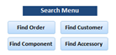

*Search Menu Panel*

For Example, if we click on the ‘Find Customer’ button, the Search Customer Details form will be displayed. From here, enter the customer details you are searching for and click Search. The search results will then be returned.

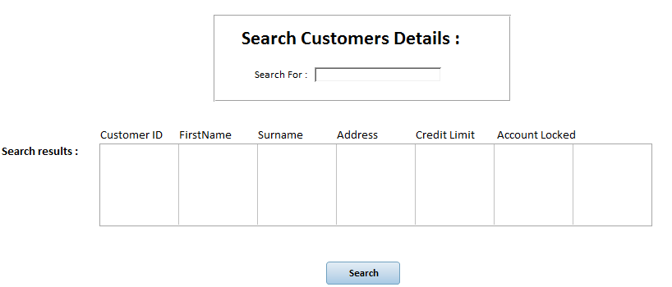

*Screenshot of the Search Customers Form*

**Manage Account**

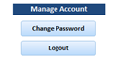

*The Manage Account Panel*

From the manage Account Panel on the Main Menu, a user can select the ‘Change Password’ button. The will display the Change password form which allows a user to define a new password for their account.

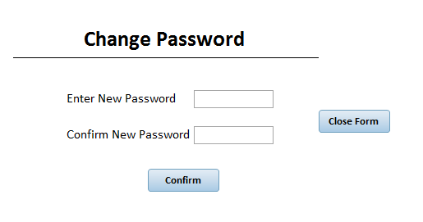

*Screenshot of the Change Password Form*

Clicking on the ‘Logout’ button allows the user to end their current session and will return the User to the Login Screen.